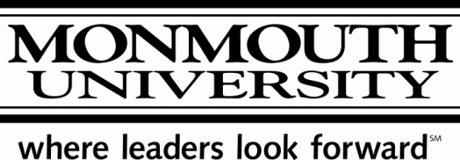

You are cordially invited to a lecture given by the

Honorable James Florio

Governor of New Jersey, 1990-1994

on

“The Politics of Climate Change”

As a member of the US House of Representatives, Jim Florio authored

the landmark Superfund Law that has given him an honored place

in American history. As Governor, he transcended partisanship,

working with others to advance the best interests of New Jersey.

Welcome and Introduction

Mr. Alan Steinberg

Public Servant in Residence at Monmouth University, 2009-2010

Wednesday, March 24, 2010

10:00 – 11:15 am

H.R. Young Auditorium

Bey Hall, Room 113

*Co-sponsored by the Office of Academic Program Initiatives and the Department of Political Science*