Participant preparation before the Short Course

**Reshaping challenging data to produce insightful graphs - a quick start to using R tidyverse tools**

5 April 2022

What to bring to the workshop?

* Curiosity and an interest in wrangling data to produce attractive data visualizations
* A computer with R, RStudio and relevant packages installed before the workshop (instructions below)
* Download the data sets that will be used in the workshop
  + <http://www.users.miamioh.edu/baileraj/ShortCourse-Tidyverse/HNP-Subset-26may21.csv>
  + <http://www.users.miamioh.edu/baileraj/ShortCourse-Tidyverse/country.csv>
* { if time permits } Please bring a data set that you would like to visualize. CSV format is best.

Software installation in preparation of the workshop:

Details for installing the packages – Video description of the following download and installation steps will be sent by ISI

1. Download and install R from <https://cloud.r-project.org/> (screen shot below)

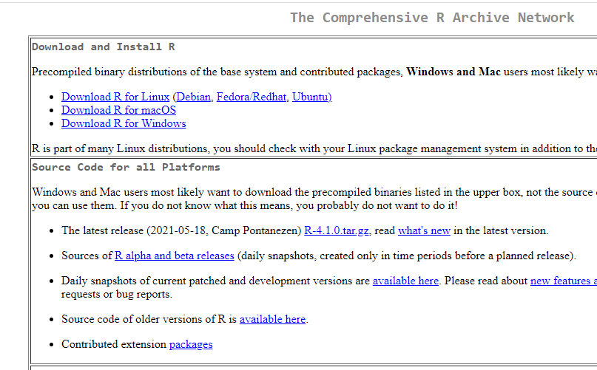

1. Download and install RStudio Desktop (Open Source License) from <https://www.rstudio.com/products/rstudio/download/>

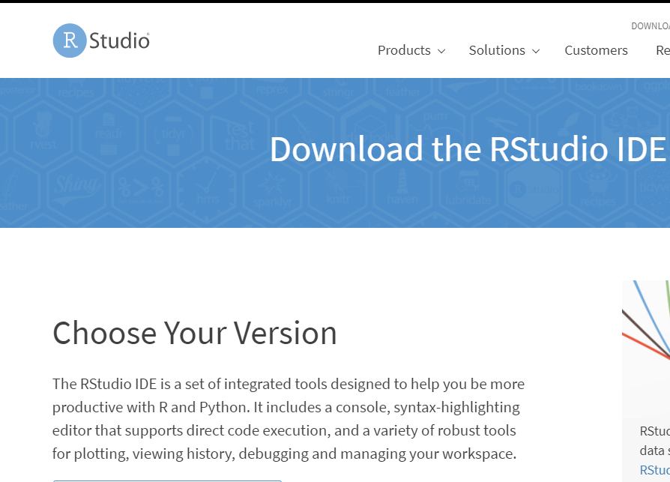

Then select the ‘Desktop’ version for use

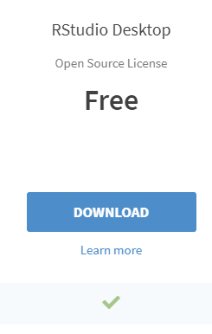

After the installation, launch RStudio.

1. Install packages for the course (done from within RStudio)

In the console window, you can paste the following two lines of code to do this

SCpackList <- c("tidyverse", "stringr", "lubridate", "maps", "countrycode")

install.packages(SCpackList, dependencies=TRUE)

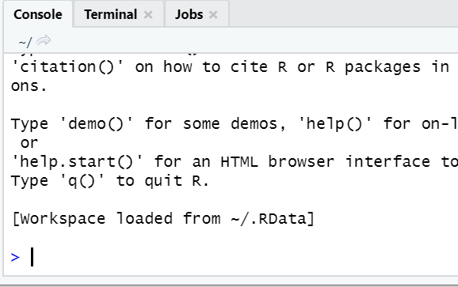

1. { NEW } Other packages to install if you interested: plotly, patchwork

These instructions can be found at

[http://www.users.miamioh.edu/baileraj/ShortCourse-Tidyverse/Tidyverse-ShortCourse-Participant preparation.docx](http://www.users.miamioh.edu/baileraj/ShortCourse-Tidyverse/Tidyverse-ShortCourse-Participant%20preparation.docx)

[http://www.users.miamioh.edu/baileraj/ShortCourse-Tidyverse/Tidyverse-ShortCourse-Participant preparation.pdf](http://www.users.miamioh.edu/baileraj/ShortCourse-Tidyverse/Tidyverse-ShortCourse-Participant%20preparation.pdf)