实验九 JDBC数据库访问技术与DAO设计模式的应用
班级 计本163 学号 201606060101 姓名 白乐荣
实验预习报告
一、实验目的
1. 掌握传统的JDBC数据库访问方法；
2. 掌握基于JNDI数据源的数据库访问方法。
3. 掌握DAO设计模式及其应用方法。
二、实验原理
数据库应用是Web应用开发的一个重要方面。Web应用程序访问数据库有两种方法：传统的方法和使用JNDI数据源的方法。
传统方法访问数据库的步骤是：①加载数据库驱动程序；②建立连接对象；③创建语句对象；④获得结果集；⑤关闭有关连接对象。
使用数据源访问数据库的步骤是：①配置数据源（局部数据源或全局数据源）；②通过JNDI机制查找命名数据源；③通过数据源对象创建连接对象；④其他与传统方法一致。
DAO（Data Access Object）是指数据访问对象，将数据访问方法（通常使用JDBC技术）封装在DAO类中，提高应用程序的灵活性和可复用性，实现业务逻辑和数据访问逻辑分离，使应用维护变得更简单。
三、实验预习内容
1. JDBC常用的类对象与接口有哪些？它们的功能如何？
Driver接口：通过Class.forName()装载特定厂商提供的数据库驱动程序；
DriverManager类：管理驱动程序，通过getConnection()方法建立与数据库的连接。
Connection对象：代表与数据库的连接，不同的数据库驱动程序和连接的URL都不相同
Statement对象：提供在基层连接上运行SQL语句并访问结果。
(1)Statement执行一般的SQL语句，包括插入、删除、更新、查询等。
(2)PreparedStatement称为准备语句，它是将SQL语句中的某些参数暂不指定，而等到执行时再统一指定。
(3)CallableStatement用于执行数据库的存储过程。
ResultSet对象：提供对查询结果集的行访问的方法，并且可以访问结果的不同字段。
2. 使用数据源访问数据库的基本思想是什么？这样做有什么好处？
事先建立若干连接对象，存放在数据库连接池中，供数据访问组件共享。应用程序在启动时只需创建少量的连接对象，不需要为每个HTTP请求都创建一个连接对象，大大降低请求的响应时间。
3. 什么是DAO？DAO设计模式有什么好处？
DAO（Data Access Object）：数据访问对象。
将数据访问方法（通常使用JDBC技术）封装在DAO类中，提高应用程序的灵活性和可复用性。
实现业务逻辑和数据访问逻辑分离，使应用维护变得更简单
实验报告
一、实验目的
1. 掌握传统的JDBC数据库访问方法；
2. 掌握基于JNDI数据源的数据库访问方法。
3. 掌握DAO设计模式及其应用方法。
二、实验要求
1. 实验前进行预习，完成实验预习报告；
2．按照每一项实验内容进行上机实践与编程，将程序源代码和运行结果图附在实验报告中实验内容对应的部分。
3. 实验预习报告和实验报告打印装订在一起。
4. 将每一次实验的源代码按目录组织保存并压缩，按照老师指定的要求进行提交。代码保存方式如：exp09表示实验九Web项目的名称，其下保存各项实验内容的源文件及相关资源，将整个exp09文件夹进行压缩后命名为班级-学号后两位-姓名-实验9，如：计161-01-张三-实验9。
三、实验内容与步骤
1. 使用传统JDBC方法与Model 1模型通过JSP页面访问数据库。
【步骤1】在MySQL数据库test中创建books表，其结构如下：
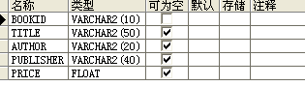
向books表中插入几条记录，如下：
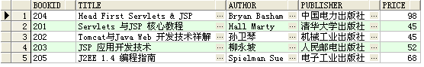注意：需要将数据库的JDBC驱动程序安装到Web应用程序的WEB-INF\lib目录中。
【步骤2】创建模型：编写名称为BookBean.java的JavaBean用于封装图书的信息；编写BookDAO.java，采用传统JDBC方法创建数据库连接，对图书信息进行查询。
【步骤3】创建兼具视图与控制器功能的JSP页面：编写displayBooks.jsp页面，使用<jsp:useBean>动作调用BookDAO查询所有图书的信息，以表格的形式显示所有图书的书号、书名、作者、价格和出版社名称。
实验代码：
DisplayBooks.jsp:
<%@ page language="java" contentType="text/html; charset=UTF-8"
pageEncoding="UTF-8"%>
<%@ page import="java.util.*,com.demo.BookBean,com.demo.BookDAO" %>
<!DOCTYPE html>
<html>
<head>
<meta charset="UTF-8">
<title>书籍信息</title>
</head>
<body>
<table border="1">
<tr>
<td>书籍编号</td><td>书名</td><td>作者</td><td>出版社</td><td>价格</td>
</tr>
<%
BookDAO bookdao = new BookDAO();
ArrayList<BookBean> BookList = bookdao.queryBook();
for(BookBean book:BookList){
%>
<tr>
<td><%=book.getBookID() %></td>
<td><%=book.getTitle() %></td>
<td><%=book.getAuthor() %></td>
<td><%=book.getPublisher() %></td>
<td><%=book.getPrice() %></td>
</tr>
<%
}
%>
</table>

</body>
</html>

BookBean.java:
package com.demo;

import java.io.Serializable;

@SuppressWarnings("serial")
public class BookBean implements Serializable {
private String bookID = null;
private String title = null;
private String author = null;
private String publisher = null;
private float price = 0.0f;
public BookBean() {
}
public BookBean(String bookID, String title, String author,String publisher,float price) {
this.bookID = bookID;
this.title = title;
this.author = author;
this.publisher = publisher;
this.price = price;
}
public String getBookID() {
return bookID;
}
public void setBookID(String bookID) {
this.bookID = bookID;
}
public String getTitle() {
return title;
}
public void setTitle(String title) {
this.title = title;
}
public String getAuthor() {
return author;
}
public void setAuthor(String author) {
this.author = author;
}
public String getPublisher() {
return publisher;
}
public void setPublisher(String publisher) {
this.publisher = publisher;
}
public float getPrice() {
return price;
}
public void setPrice(float price) {
this.price = price;
}

}

BookDAO.java:
package com.demo;

import java.sql.Connection;
import java.sql.DriverManager;
import java.sql.PreparedStatement;
import java.sql.ResultSet;
import java.sql.SQLException;
import java.util.ArrayList;

public class BookDAO {
Connection dbconn = null;
PreparedStatement pstmt = null;
ResultSet rst = null;

//输入用户参数
String dirver = "com.mysql.jdbc.Driver";
String url = "jdbc:mysql://localhost:3306/test";
String username = "root";
String password = "passwd";
//连接数据库
public BookDAO() {
try {
Class.forName(dirver);
dbconn = DriverManager.getConnection(url+"?useUnicode=true&characterEncoding=UTF8", username, password);
}catch(ClassNotFoundException e1) {
System.out.println(e1);
}catch(SQLException e2) {
}
}

//查询所有图书信息
public ArrayList<BookBean> queryBook() {
ArrayList<BookBean> list = new ArrayList<BookBean>();
try {
String sql = "SELECT * FROM books";
pstmt = dbconn.prepareStatement(sql);
rst = pstmt.executeQuery();
while(rst.next()) {
BookBean book = new BookBean();
book.setBookID(rst.getString("bookID"));
book.setTitle(rst.getString("title"));
book.setAuthor(rst.getString("author"));
book.setPublisher(rst.getString("publisher"));
book.setPrice(rst.getFloat("price"));
list.add(book);
}
return list;
}catch(SQLException e) {
e.printStackTrace();
}finally{
try{
if(dbconn!=null)
dbconn.close();
}catch(SQLException se){
}
}
return null;
}
}
实验截图：
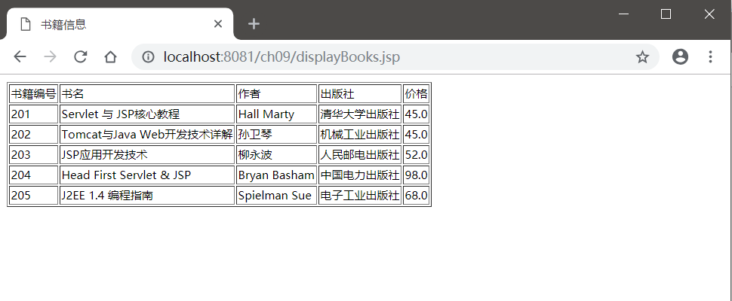

2. 基于实验内容1创建的数据库表和模型，采用MVC设计模式，通过数据源和DAO对象访问数据库。其中JavaBeans实现模型与数据库访问与操作，Servlet实现控制器，JSP页面实现视图。
- 模型包括2个JavaBean：BookBean用于存放图书信息，BookDAO用于访问数据库。
- 控制器包括2个Servlet：BookQueryServlet根据请求参数查询图书信息、BookInsertServlet用来向数据库中插入一条图书信息。
- 视图包括4个JSP页面：bookQuery.jsp显示图书查询表单的页面、bookInsert.jsp显示收集图书信息表单的页面、display.jsp显示查询结果页面、errorPage.jsp显示查询错误页面。
实验代码：
BookBean.java:
package com.demo;

import java.io.Serializable;

@SuppressWarnings("serial")
public class BookBean implements Serializable {
private String bookID = null;
private String title = null;
private String author = null;
private String publisher = null;
private float price = 0.0f;
public BookBean() {
}
public BookBean(String bookID, String title, String author,String publisher,float price) {
this.bookID = bookID;
this.title = title;
this.author = author;
this.publisher = publisher;
this.price = price;
}
public String getBookID() {
return bookID;
}
public void setBookID(String bookID) {
this.bookID = bookID;
}
public String getTitle() {
return title;
}
public void setTitle(String title) {
this.title = title;
}
public String getAuthor() {
return author;
}
public void setAuthor(String author) {
this.author = author;
}
public String getPublisher() {
return publisher;
}
public void setPublisher(String publisher) {
this.publisher = publisher;
}
public float getPrice() {
return price;
}
public void setPrice(float price) {
this.price = price;
}

}

BookDAO.java
package com.demo;

import java.sql.Connection;
import java.sql.DriverManager;
import java.sql.PreparedStatement;
import java.sql.ResultSet;
import java.sql.SQLException;
import java.util.ArrayList;

public class BookDAO {
Connection dbconn = null;
PreparedStatement pstmt = null;
ResultSet rst = null;

//输入用户参数
String dirver = "com.mysql.jdbc.Driver";
String url = "jdbc:mysql://localhost:3306/test";
String username = "root";
String password = "passwd";
//连接数据库
public BookDAO() {
try {
Class.forName(dirver);
dbconn = DriverManager.getConnection(url+"?useUnicode=true&characterEncoding=UTF8", username, password);
}catch(ClassNotFoundException e1) {
System.out.println(e1);
}catch(SQLException e2) {
}
}

//查询所有图书信息
public ArrayList<BookBean> queryBook() {
ArrayList<BookBean> list = new ArrayList<BookBean>();
try {
String sql = "SELECT * FROM books";
pstmt = dbconn.prepareStatement(sql);
rst = pstmt.executeQuery();
while(rst.next()) {
BookBean book = new BookBean();
book.setBookID(rst.getString("bookID"));
book.setTitle(rst.getString("title"));
book.setAuthor(rst.getString("author"));
book.setPublisher(rst.getString("publisher"));
book.setPrice(rst.getFloat("price"));
list.add(book);
}
return list;
}catch(SQLException e) {
e.printStackTrace();
}finally{
try{
if(dbconn!=null)
dbconn.close();
}catch(SQLException se){
}
}
return null;
}

//按书号查询图书信息
public BookBean searchBook(String bookid) {
BookBean book = new BookBean();
try {
String sql = "SELECT * FROM books WHERE bookID=?";
pstmt = dbconn.prepareStatement(sql);
pstmt.setString(1, bookid);
rst = pstmt.executeQuery();
if(rst.next()) {
book.setBookID(rst.getString("bookID"));
book.setTitle(rst.getString("title"));
book.setAuthor(rst.getString("author"));
book.setPublisher(rst.getString("publisher"));
book.setPrice(rst.getFloat("price"));
return book;
}
}catch(SQLException e) {
e.printStackTrace();
}finally{
try{
if(dbconn!=null)
dbconn.close();
}catch(SQLException se){
}
}
return null;
}

//插入一本图书记录
public boolean InsertBook(BookBean book) {
try {
String sql = "INSERT INTO books VALUE(?,?,?,?,?)";
pstmt = dbconn.prepareStatement(sql);
pstmt.setString(1, book.getBookID());
pstmt.setString(2, book.getTitle());
pstmt.setString(3, book.getAuthor());
pstmt.setString(4, book.getPublisher());
pstmt.setFloat(5, book.getPrice());
pstmt.executeUpdate();
pstmt.close();
return true;
}catch(SQLException e) {
e.printStackTrace();
}finally{
try{
dbconn.close();
}catch(SQLException se){
}
}
return false;
}
}

BookInsertServlet.java:
package com.demo;

import java.io.IOException;

import javax.servlet.RequestDispatcher;
import javax.servlet.ServletException;
import javax.servlet.annotation.WebServlet;
import javax.servlet.http.HttpServlet;
import javax.servlet.http.HttpServletRequest;
import javax.servlet.http.HttpServletResponse;

/**
* Servlet implementation class BookInsertServlet
*/
@WebServlet("/BookInsertServlet")
public class BookInsertServlet extends HttpServlet {
private static final long serialVersionUID = 1L;

/**
* @see HttpServlet#HttpServlet()
*/
public BookInsertServlet() {
super();
// TODO Auto-generated constructor stub
}

/**
* @see HttpServlet#doGet(HttpServletRequest request, HttpServletResponse response)
*/
protected void doGet(HttpServletRequest request, HttpServletResponse response) throws ServletException, IOException {
request.setCharacterEncoding("UTF-8");
String message = null;
BookBean book = new BookBean(
request.getParameter("bookid"),request.getParameter("title"),
request.getParameter("anthor"),request.getParameter("publisher"),
Float.parseFloat(request.getParameter("price")));
BookDAO bookdao = new BookDAO();
boolean success = bookdao.InsertBook(book);
if(success) {
message = "成功插入一条记录";
}else {
message = "插入记录错误";
}
request.setAttribute("result", message);
RequestDispatcher view = request.getRequestDispatcher("/bookInsert.jsp");
view.forward(request, response);
}

/**
* @see HttpServlet#doPost(HttpServletRequest request, HttpServletResponse response)
*/
protected void doPost(HttpServletRequest request, HttpServletResponse response) throws ServletException, IOException {
// TODO Auto-generated method stub
doGet(request, response);
}

}

BookQuerySerlvet.java:
package com.demo;

import java.io.IOException;

import javax.servlet.RequestDispatcher;
import javax.servlet.ServletException;
import javax.servlet.annotation.WebServlet;
import javax.servlet.http.HttpServlet;
import javax.servlet.http.HttpServletRequest;
import javax.servlet.http.HttpServletResponse;
import javax.servlet.http.HttpSession;

/**
* Servlet implementation class BookQueryServlet
*/
@WebServlet("/BookQueryServlet")
public class BookQueryServlet extends HttpServlet {
private static final long serialVersionUID = 1L;

/**
* @see HttpServlet#HttpServlet()
*/
public BookQueryServlet() {
super();
// TODO Auto-generated constructor stub
}

/**
* @see HttpServlet#doGet(HttpServletRequest request, HttpServletResponse response)
*/
protected void doGet(HttpServletRequest request, HttpServletResponse response) throws ServletException, IOException {
String bookid = request.getParameter("bookid");
BookDAO bookdao = new BookDAO();
BookBean book = bookdao.searchBook(bookid);
System.out.println(bookid);

if(book!=null) {
HttpSession session = request.getSession();
synchronized(session) {
session.setAttribute("book", book);
}
RequestDispatcher view = request.getRequestDispatcher("/display.jsp");
view.forward(request, response);
}else {
RequestDispatcher view = request.getRequestDispatcher("/errorPage.jsp");
view.forward(request, response);
}
}

/**
* @see HttpServlet#doPost(HttpServletRequest request, HttpServletResponse response)
*/
protected void doPost(HttpServletRequest request, HttpServletResponse response) throws ServletException, IOException {
// TODO Auto-generated method stub
doGet(request, response);
}

}

bookQuery.jsp:
<%@ page language="java" contentType="text/html; charset=UTF-8"
pageEncoding="UTF-8"%>
<!DOCTYPE html>
<html>
<head>
<meta charset="UTF-8">
<title>Book Query</title>
</head>
<body>
<p>请输入一个书号：</p>
<form action="BookQueryServlet" method="post">
<table>
<tr>
<td><input type="text" name="bookid"></td>
</tr>
<tr>
<td><input type="submit" value="提交"></td>
</tr>
</table>
</form>
</body>
</html>

bookInsert.jsp:
<%@ page language="java" contentType="text/html; charset=UTF-8"
pageEncoding="UTF-8"%>
<!DOCTYPE html>
<html>
<head>
<meta charset="UTF-8">
<title>Book Insert</title>
</head>
<body>
<h3>请输入图书信息:</h3>
<%
if(request.getAttribute("result")!=null)
out.print(request.getAttribute("result"));
%>
<form action="BookInsertServlet" method="post">
<table>
<tr>
<td>书号</td>
<td><input type="text" name="bookid"></td>
</tr>
<tr>
<td>书名</td>
<td><input type="text" name="title"></td>
</tr>
<tr>
<td>作者</td>
<td><input type="text" name="author"></td>
</tr>
<tr>
<td>出版社</td>
<td><input type="text" name="publisher"></td>
</tr>
<tr>
<td>单价</td>
<td><input type="text" name="price"></td>
</tr>
<tr>
<td><input type="submit" value="确定"></td>
<td><input type="reset" value="重置"></td>
</tr>
</table>
</form>
</body>
</html>

Display.jsp:
<%@ page language="java" contentType="text/html; charset=UTF-8"
pageEncoding="UTF-8"%>
<jsp:useBean id="book" class="com.demo.BookBean" scope="session">
<jsp:setProperty name="book" property="*"/>
</jsp:useBean>
<!DOCTYPE html>
<html>
<head>
<meta charset="UTF-8">
<title>show book</title>
</head>
<body>
书号：<jsp:getProperty property="bookID" name="book"/><br>
书名：<jsp:getProperty property="title" name="book"/><br>
作者：<jsp:getProperty property="author" name="book"/><br>
出版社：<jsp:getProperty property="publisher" name="book"/><br>
价格：<jsp:getProperty property="price" name="book"/><br>
</body>
</html>

errorPage.jsp:
<%@ page language="java" contentType="text/html; charset=UTF-8"
pageEncoding="UTF-8"%>
<!DOCTYPE html>
<html>
<head>
<meta charset="UTF-8">
<title>Error</title>
</head>
<body>
<h1>对不起，您查找的图书不存在！</h1>
</body>
</html>
实验截图：
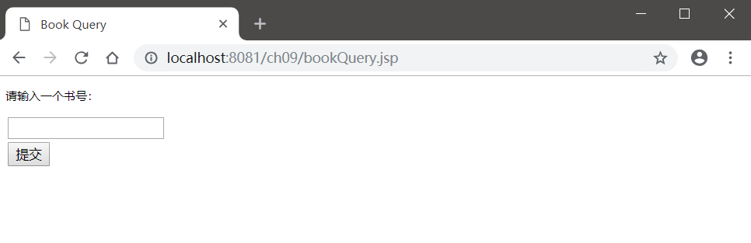
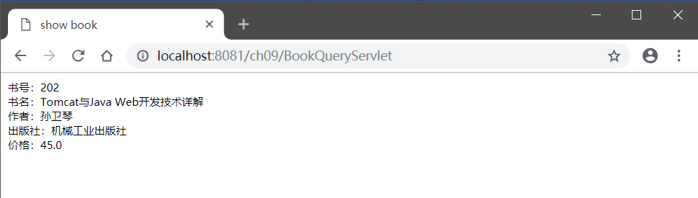
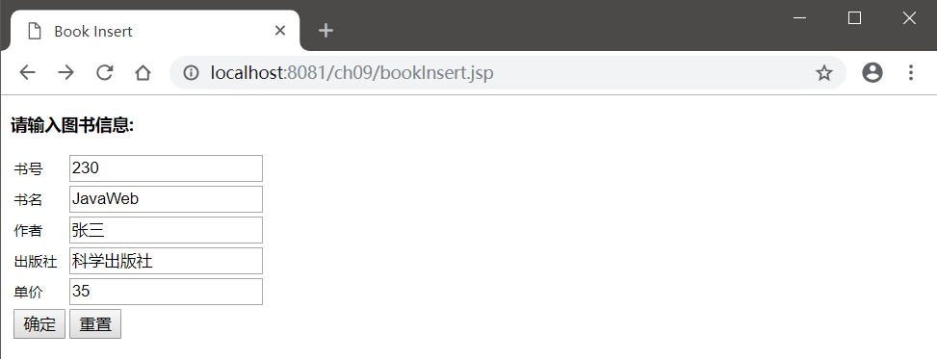
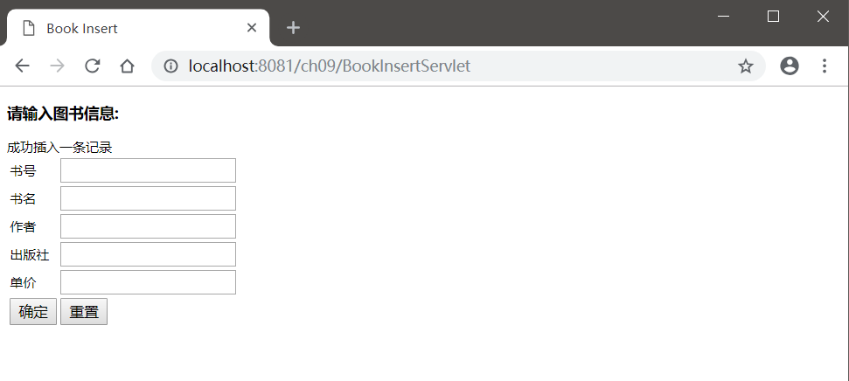
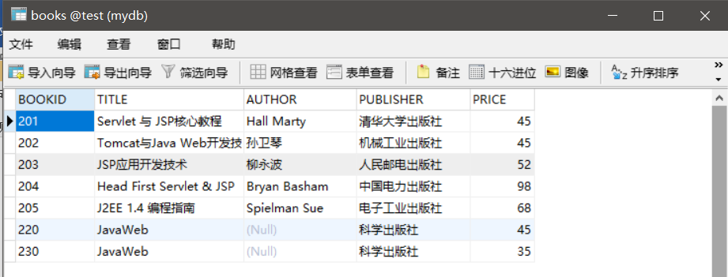
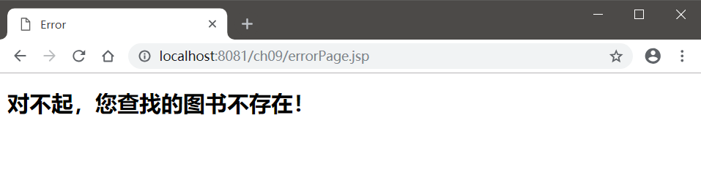
3. DAO设计模式练习。
【步骤1】：使用root用户登录MySQL的test数据库，创建customer表，包括custName、email、phone等字段，设计CustomerBean传输对象，使其实现java.io.Serializable接口。
【步骤2】：创建CustomerDAO类实现数据库访问逻辑，通过该类可以获得一个连接对象，对数据库进行查询、插入、修改和删除操作，最后关闭指定的对象。
【步骤3】：创建insertCustomer.jsp页面，通过一个表单录入向数据库中插入的数据。
实验代码：
Customer.java:
package com.demo;
import java.io.Serializable;

public class Customer {
private String cust_id;
private String cname;
private String email;
private String phone;
public Customer() {
}
public Customer(String cust_id, String cname, String email, String phone) {
this.cname = cname;
this.cust_id = cust_id;
this.email = email;
this.phone = phone;
}
public String getCust_id() {
return cust_id;
}
public void setCust_id(String cust_id) {
this.cust_id = cust_id;
}
public String getCname() {
return cname;
}
public void setCname(String cname) {
this.cname = cname;
}
public String getEmail() {
return email;
}
public void setEmail(String email) {
this.email = email;
}
public String getPhone() {
return phone;
}
public void setPhone(String phone) {
this.phone = phone;
}

}

CustomerDAO.java:
package com.demo;

import java.sql.Connection;
import java.sql.DriverManager;
import java.sql.PreparedStatement;
import java.sql.ResultSet;
import java.sql.SQLException;
import java.util.ArrayList;

import com.demo.Customer;

public class CustomerDAO {
Connection dbconn = null;

String dirver = "com.mysql.jdbc.Driver";
String url = "jdbc:mysql://localhost:3306/test";
String username = "root";
String password = "passwd";
//在构造方法中返回数据对象
public CustomerDAO() {
try {
Class.forName(dirver);
dbconn = DriverManager.getConnection(url+"?useUnicode=true&characterEncoding=UTF8", username, password);
}catch(ClassNotFoundException e1) {
System.out.println(e1);
}catch(SQLException e2) {
}
}

//插入一条客户记录
public boolean addCustomer(Customer customer) {
String sql = "INSERT INTO customers VALUE(?,?,?,?)";
try (
PreparedStatement pstmt = dbconn.prepareStatement(sql)){
pstmt.setString(1, customer.getCust_id());
pstmt.setString(2, customer.getCname());
pstmt.setString(3, customer.getEmail());
pstmt.setString(4, customer.getPhone());
pstmt.executeUpdate();
pstmt.close();
return true;
}catch(SQLException se) {
se.printStackTrace();
return false;
}
}

//按姓名检索客户记录
public Customer findByName(String cname) {
String sql = "SELECT cust_id,cname,email,phone"+"FROM customers WHERE cname=?";
Customer customer = new Customer();
try (
PreparedStatement pstmt = dbconn.prepareStatement(sql)){
pstmt.setString(1, cname);
try(ResultSet rst = pstmt.executeQuery()){
if(rst.next()) {
customer.setCust_id(rst.getString("cust_id"));
customer.setCname(rst.getString("cname"));
customer.setEmail(rst.getString("email"));
customer.setPhone(rst.getString("phone"));
}
}
}catch(SQLException se) {
return null;
}
return customer;
}

//查询所有客户信息
public ArrayList<Customer> findAllCustomer(){
ArrayList<Customer> custList = new ArrayList<Customer>();
String sql = "SELECT * FROM customers";
try(
PreparedStatement pstmt = dbconn.prepareStatement(sql);
ResultSet rst = pstmt.executeQuery()){
while(rst.next()) {
Customer customer = new Customer();
customer.setCust_id(rst.getString("cust_id"));
customer.setCname(rst.getString("cname"));
customer.setEmail(rst.getString("email"));
customer.setPhone(rst.getString("phone"));
custList.add(customer);
}
return custList;
}catch(SQLException e) {
e.printStackTrace();
return null;
}
}

//删除指定客户信息
public boolean delCustomer(String cust_id) {
String sql = "DELETE FROM customers WHERE cust_id=?";
try (PreparedStatement pstmt = dbconn.prepareStatement(sql)){
pstmt.setString(1,cust_id);
pstmt.executeUpdate();
pstmt.close();
return true;
}catch(SQLException se) {
se.printStackTrace();
return false;
}
}
}

insertCustomer.jsp:
<%@ page language="java" contentType="text/html; charset=UTF-8"
pageEncoding="UTF-8"%>
<!DOCTYPE html>
<html>
<head>
<meta charset="UTF-8">
<title>input a customer</title>
</head>
<body>
<%
if(request.getAttribute("result")!=null)
out.print(request.getAttribute("result"));
%>
<h3>请输入一条客户记录：</h3>
<form action="InsertCustomerServlet" method="post">
<table>
<tr>
<td>客户号：</td>
<td><input type="text" name="cust_id"></td>
</tr>
<tr>
<td>客户名：</td>
<td><input type="text" name="cname"></td>
</tr>
<tr>
<td>Email：</td>
<td><input type="text" name="email"></td>
</tr>
<tr>
<td>电话：</td>
<td><input type="text" name="phone"></td>
</tr>
<tr>
<td><input type="submit" value="确定"></td>
<td><input type="reset" value="重置"></td>
</tr>
</table>
</form>
</body>
</html>

InsertCustomerServlet.java:
package com.demo;

import java.io.IOException;

import javax.servlet.RequestDispatcher;
import javax.servlet.ServletException;
import javax.servlet.annotation.WebServlet;
import javax.servlet.http.HttpServlet;
import javax.servlet.http.HttpServletRequest;
import javax.servlet.http.HttpServletResponse;
/**
* Servlet implementation class InsertCustomerServlet
*/
@WebServlet("/InsertCustomerServlet")
public class InsertCustomerServlet extends HttpServlet {
private static final long serialVersionUID = 1L;

/**
* @see HttpServlet#HttpServlet()
*/
public InsertCustomerServlet() {
super();
// TODO Auto-generated constructor stub
}

/**
* @see HttpServlet#doGet(HttpServletRequest request, HttpServletResponse response)
*/
protected void doGet(HttpServletRequest request, HttpServletResponse response) throws ServletException, IOException {
CustomerDAO dao = new CustomerDAO();
Customer customer = new Customer();
String message = null;
try {
customer.setCust_id(request.getParameter("cust_id"));
//将传递来的字符串重新使用utf-8编码，以避免产生乱码
customer.setCname(new String(request.getParameter("cname").getBytes("iso-8859-1"),"utf-8"));
customer.setEmail(new String(request.getParameter("email").getBytes("iso-8859-1"),"utf-8"));
customer.setPhone(new String(request.getParameter("phone").getBytes("iso-8859-1"),"utf-8"));
boolean success = dao.addCustomer(customer);
if(success) {
message = "<li>成功插入一条记录！</li>";
}else {
message = "<li>插入记录错误！</li>";
}
}catch(Exception e) {
message = "<li>记录错误！</li>";
}
request.setAttribute("result", message);
RequestDispatcher rd = getServletContext().getRequestDispatcher("/insertCustomer.jsp");
rd.forward(request, response);
}

/**
* @see HttpServlet#doPost(HttpServletRequest request, HttpServletResponse response)
*/
protected void doPost(HttpServletRequest request, HttpServletResponse response) throws ServletException, IOException {
// TODO Auto-generated method stub
doGet(request, response);
}

}

实验截图：
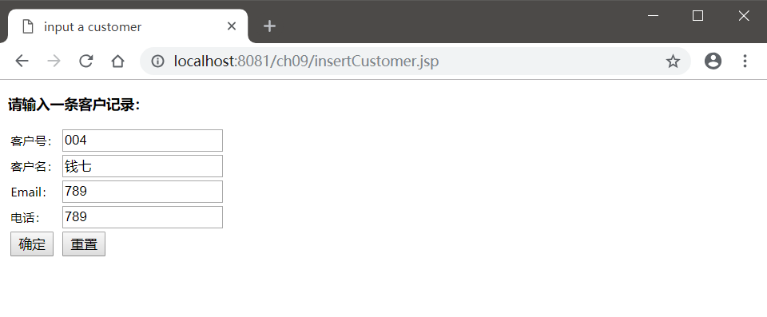
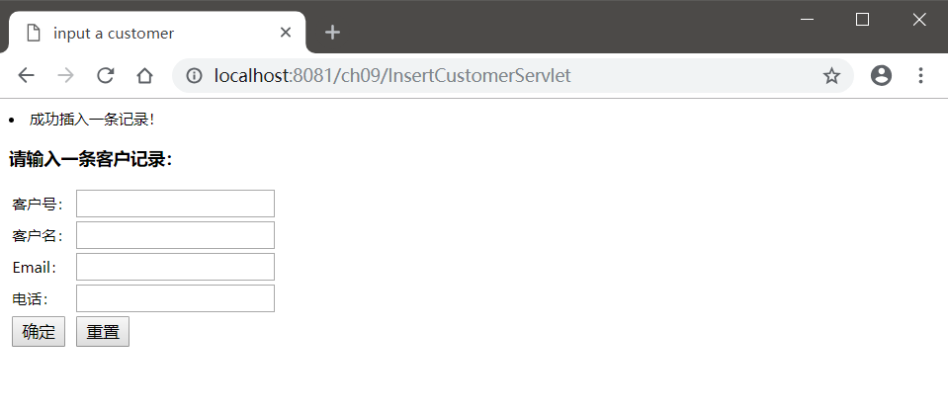
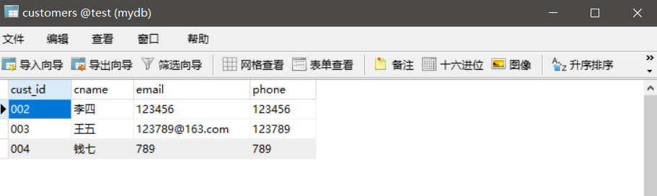
【步骤4】：创建InsertCustomerServlet.java控制器，调用CustomerDAO对象和传输对象，将数据插入到数据库中。
【步骤5】：创建showCustmer.jsp，显示所有客户的信息，每一条客户信息后面增加修改和删除超链接，编写ActionServlet.java控制器，调用DAO和传输对象实现对客户信息的删除和修改功能。
实验代码：
ShowCustomer.java:
<%@ page language="java" contentType="text/html; charset=UTF-8"
pageEncoding="UTF-8"%>
<%@ page import="java.util.*,com.demo.Customer,com.demo.CustomerDAO" %>
<!DOCTYPE html>
<html>
<head>
<meta charset="UTF-8">
<title>客户信息</title>
</head>
<body>
<%
if(request.getAttribute("result")!=null)
out.print(request.getAttribute("result"));
%>
<table border="1">
<tr>
<td>客户号</td><td>客户名</td><td>电子邮箱</td><td>电话</td><td>操作</td>
</tr>
<%
CustomerDAO dao = new CustomerDAO();
ArrayList<Customer> CustomerList = dao.findAllCustomer();
for(Customer customer:CustomerList){
%>
<tr>
<td><%=customer.getCust_id() %></td>
<td><%=customer.getCname() %></td>
<td><%=customer.getEmail() %></td>
<td><%=customer.getPhone() %></td>
<td><a href='ActionServlet?cust_id=<%=customer.getCust_id() %>' onclick="return confirm('是否删除?');">删除</a>
<a href='modifyCustomer.jsp?cust_id=<%=customer.getCust_id() %>'>修改</a>
</td>
</tr>
<%
}
%>
</table>

</body>
</html>

ModifyServlet.java:
package com.demo;

import java.io.IOException;

import javax.servlet.RequestDispatcher;
import javax.servlet.ServletException;
import javax.servlet.annotation.WebServlet;
import javax.servlet.http.HttpServlet;
import javax.servlet.http.HttpServletRequest;
import javax.servlet.http.HttpServletResponse;

/**
* Servlet implementation class ModifyServlet
*/
@WebServlet("/ModifyServlet")
public class ModifyServlet extends HttpServlet {
private static final long serialVersionUID = 1L;

/**
* @see HttpServlet#HttpServlet()
*/
public ModifyServlet() {
super();
// TODO Auto-generated constructor stub
}

/**
* @see HttpServlet#doGet(HttpServletRequest request, HttpServletResponse response)
*/
protected void doGet(HttpServletRequest request, HttpServletResponse response) throws ServletException, IOException {
request.setCharacterEncoding("UTF-8");
String message = null;
String cust_id = request.getParameter("cust_id");
CustomerDAO customerdao = new CustomerDAO();
boolean success1 = customerdao.delCustomer(cust_id);
if(success1) {
message = "修改成功";
}else {
message = "修改失败";
}
Customer customer = new Customer();
try {
customer.setCust_id(request.getParameter("cust_id"));
//将传递来的字符串重新使用utf-8编码，以避免产生乱码
customer.setCname(new String(request.getParameter("cname")));
customer.setEmail(new String(request.getParameter("email").getBytes("iso-8859-1"),"utf-8"));
customer.setPhone(new String(request.getParameter("phone").getBytes("iso-8859-1"),"utf-8"));
//System.out.println(request.getParameter("cname"));
boolean success2 = customerdao.addCustomer(customer);
if(success2) {
message = "<li>修改成功</li>";
}else {
message = "<li>修改失败</li>";
}
}catch(Exception e) {
message = "<li>修改失败</li>";
}
request.setAttribute("result", message);
RequestDispatcher view = request.getRequestDispatcher("/showCustomer.jsp");
view.forward(request, response);
}

/**
* @see HttpServlet#doPost(HttpServletRequest request, HttpServletResponse response)
*/
protected void doPost(HttpServletRequest request, HttpServletResponse response) throws ServletException, IOException {
// TODO Auto-generated method stub
doGet(request, response);
}

}

ActionServlet.java:
package com.demo;

import java.io.IOException;

import javax.servlet.RequestDispatcher;
import javax.servlet.ServletException;
import javax.servlet.annotation.WebServlet;
import javax.servlet.http.HttpServlet;
import javax.servlet.http.HttpServletRequest;
import javax.servlet.http.HttpServletResponse;

/**
* Servlet implementation class ActionServlet
*/
@WebServlet("/ActionServlet")
public class ActionServlet extends HttpServlet {
private static final long serialVersionUID = 1L;

/**
* @see HttpServlet#HttpServlet()
*/
public ActionServlet() {
super();
// TODO Auto-generated constructor stub
}

/**
* @see HttpServlet#doGet(HttpServletRequest request, HttpServletResponse response)
*/
protected void doGet(HttpServletRequest request, HttpServletResponse response) throws ServletException, IOException {
request.setCharacterEncoding("UTF-8");
String message = null;
String cust_id = request.getParameter("cust_id");
CustomerDAO customerdao = new CustomerDAO();
boolean success = customerdao.delCustomer(cust_id);
if(success) {
message = "删除成功";
}else {
message = "删除失败";
}
request.setAttribute("result", message);
RequestDispatcher view = request.getRequestDispatcher("/showCustomer.jsp");
view.forward(request, response);

}

/**
* @see HttpServlet#doPost(HttpServletRequest request, HttpServletResponse response)
*/
protected void doPost(HttpServletRequest request, HttpServletResponse response) throws ServletException, IOException {
// TODO Auto-generated method stub
doGet(request, response);
}

}

modifyCustomer.jsp:
<%@ page language="java" contentType="text/html; charset=UTF-8"
pageEncoding="UTF-8"%>
<!DOCTYPE html>
<html>
<head>
<meta charset="UTF-8">
<title>Modify a customer</title>
</head>
<body>
<%
if(request.getAttribute("result")!=null)
out.print(request.getAttribute("result"));
%>
<form action="ModifyServlet" method="post">
<table>
<tr>
<td>客户号：</td>
<td><input type="text" name="cust_id" value="<%=request.getParameter("cust_id") %>"></td>
</tr>
<tr>
<td>客户名：</td>
<td><input type="text" name="cname" ></td>
</tr>
<tr>
<td>Email：</td>
<td><input type="text" name="email"></td>
</tr>
<tr>
<td>电话：</td>
<td><input type="text" name="phone"></td>
</tr>
<tr>
<td><input type="submit" value="确定"></td>
<td><input type="reset" value="重置"></td>
</tr>
</table>
</form>
</body>
</html>
实验截图：
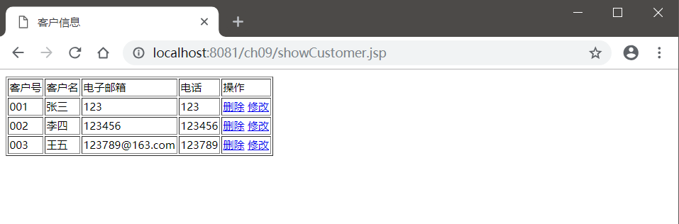
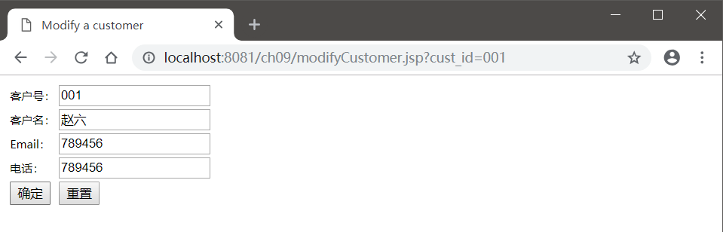
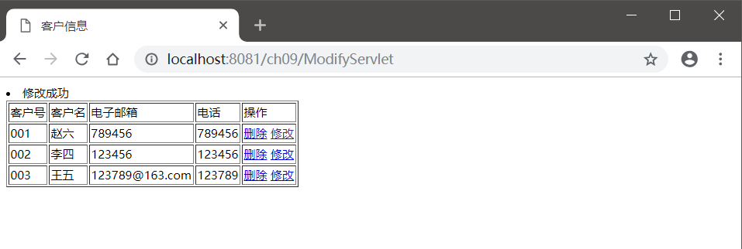
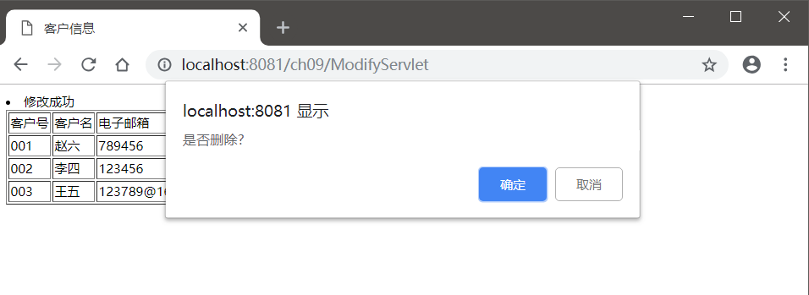
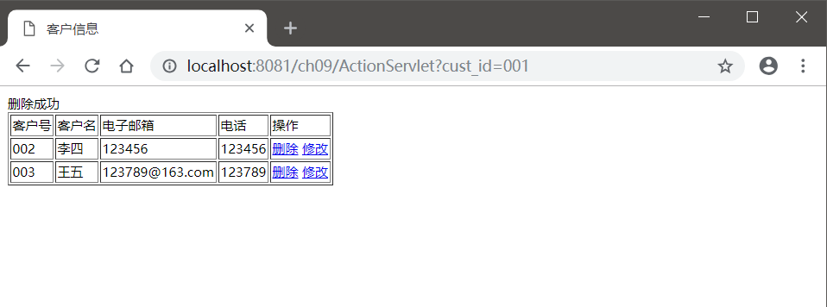
三、思考题
1. 总结并归纳传统JDBC方法访问数据库的步骤。
（1）加载驱动程序
（2）建立连接对象
（3）创建语句对象
（4）执行SQL语句并返回结果
（5）关闭建立的对象
2. 总结并归纳使用数据源访问数据库的步骤。
（1）加载JDBC驱动程序。
（2）建立连接对象。
（3）创建语句对象，语句对象有3种：Statement、PreparedStatement和CallableStatement。
（4）执行SQL语句得到结果集对象，调用ResultSet的有关方法就可以完成对数据库的操作。
（5）关闭建立的各种对象。

