BIOSTAT 721 - Project 2
Bailey Greene
2025-11-16

GitHub Link
Link to Project 2 GitHub:
https://github.com/bailey-greene/Biostat_721_Project_2

Data Cleaning Function
I created a function named clean_air_quality() that can be used on all three air quality datasets. It formats the dates and variable names, condenses duplicates dates down to a single line average, and corrects measurement error issues.

Carbon Monoxide and Ozone Plot
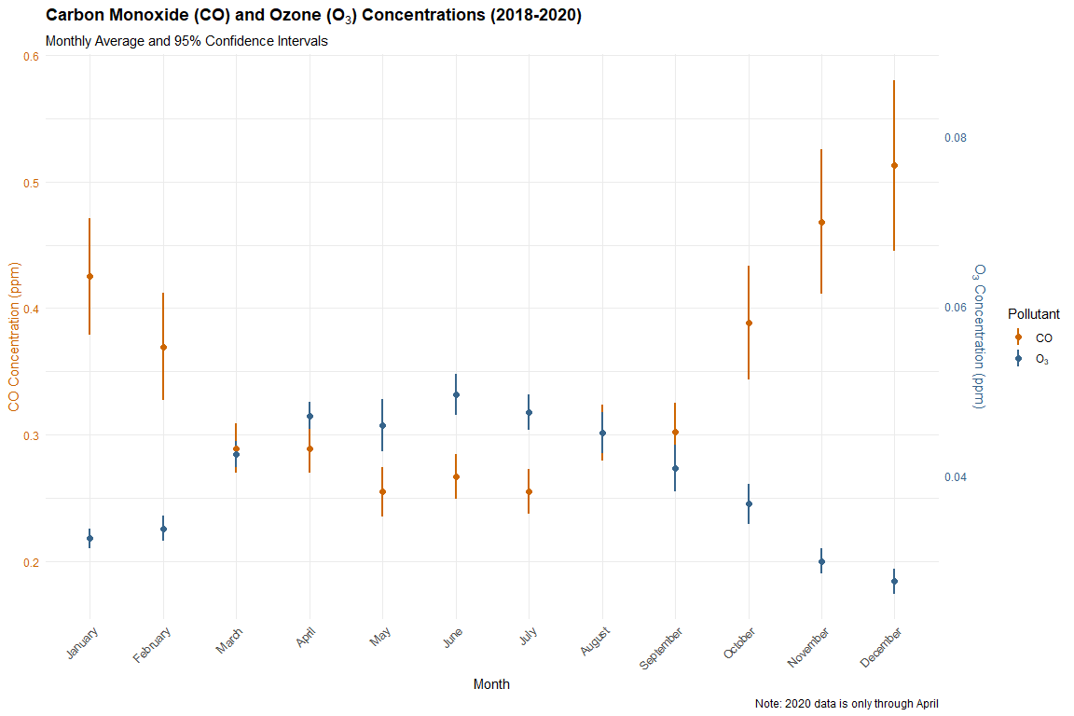

Particulate Matter Plot
