Bailey Brown
1001555076
Filter Design Project
- Introduction
Audio filters are used to boost or attenuate a range of frequencies to shape a sound. For this project, we were tasked with designing a filter out unwanted noise from an audio file. This was accomplished by designing one that would boost the speech frequencies of the audio and filter out the frequencies that just sounded like static. The analog filters we used for this project are of so-called analog Butterworth filters, which are a useful class of lowpass analog and digital filters, and a relatively simple class. Lowpass filters allow low frequencies to pass and higher ones to be filtered out. This class of filters is represented by the equation
$${\left|H_{a}\left(jΩ\right)\right|}^{2}= \frac{1}{1+{\left(\frac{jΩ}{jΩ_{c}}\right)}^{2N}}$$
where $Ω_{c}$ is the cutoff frequency and N is the order of the filter. Designing this Butterworth filter in the continuous domain, that when converted using bilinear transformation, will give us our desired digital filter characteristics.

- Audio Analysis and Filter Design
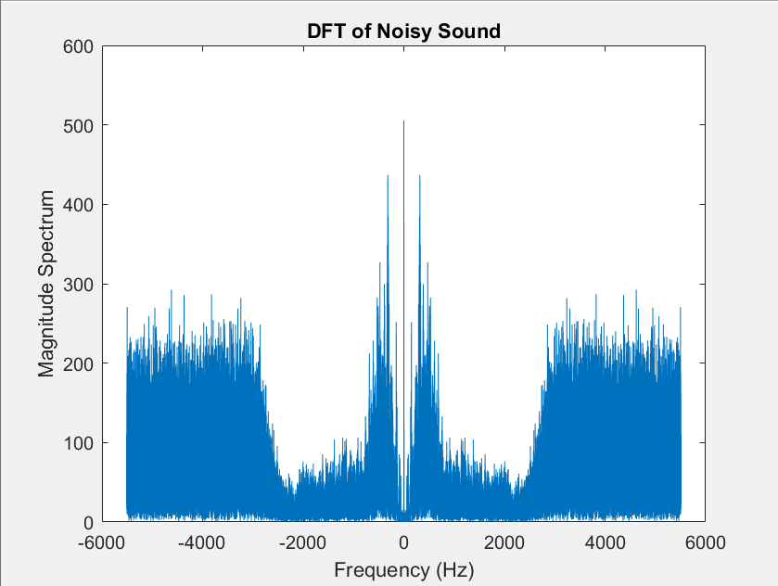
The first step was to take analyze the audio file and distinguish the noise we do and do not want from the sound. The DFT of the audio file was found, and the magnitude was plotted in Figure 1.
Figure 1

From this, we can see that there is a lot of unwanted high frequency noise that we want to filter out while still having minimal impact on the lower speech frequencies. It appears that the speech frequency starts to become disrupted around 2200 Hz, so was decided this would be the passband edge. The unwanted noise starts to become prominent around 2500 Hz, so this was decided to be the stopband edge. The above plot goes from -Fs/2 to Fs/2, where Fs is the sample rate for that data in the audio file; however, we must remember that this is in Ω. The band edges need to be chosen in a domain that is scaled to the digital domain, ω, which ranges from -π to π. This means the end of the passband, ω_{p}, would be scaled to 0.4π, and the beginning of the stopband would be scaled to 0.45π.
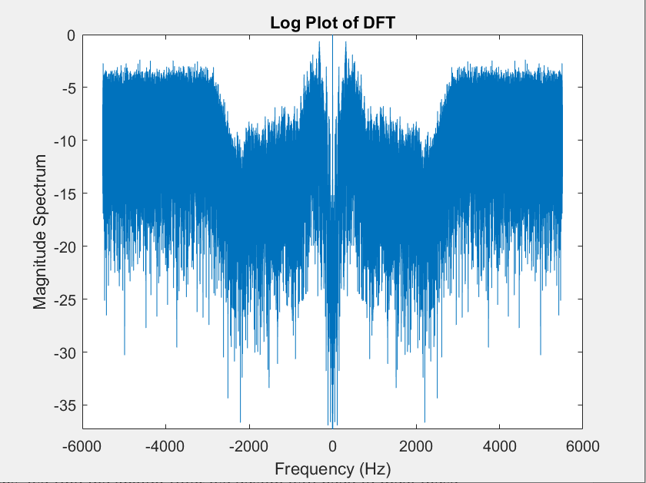
Next, we need to decide on an attenuation for each band. Per the assignment document, we will assume there is no more than 1dB attenuation for the passband. For the stopband, we need to look at the normalized log plot of the DFT to decide on an appropriate minimum attenuation.
Figure 2

From my observation of Figure 2, it appeared that the noise was reaching around -10dB and should be attenuated to approximately -30dB. Because of this, it was decided that the minimum attenuation in the stopband would be 20dB. I tested out several other different values for the attenuation in the stopband, but 20dB ultimately did end up producing the best results.

To map this analog filter design to a digital filter, we want to use Bilinear Transformation. To start, we reflect the digital frequency specifications through the bilinear warping curve
$$ω=\arctan\left(\frac{Ω}{2}\right)$$
where Ω is the band edges we chose earlier. Using this information, we now know the analog filter we are designing must meet the specifications
$$20\log_{10}\left|H_{a}\left(j2\tan{0.2π}\right)\right| ≥ -1$$
$$20\log_{10}\left|H_{a}\left(j2\tan{0.225π}\right)\right| ≤ -20$$
These two equations tell us that at the passband edge, we want the magnitude to be within 1db of unity. And at the stopband edge, we want the magnitude to be less than 20 db. Substituting in the form of the analog Butterworth filter into these expressions, we find two equations
$$1+{\left(\frac{j2\tan{0.2π}}{jΩ_{c}}\right)}^{2N}={10}^{0.1}$$
$$1+{\left(\frac{j2\tan{0.225π}}{jΩ_{c}}\right)}^{2N}={10}^{2}$$

If we solve these two equations for N, the resulting value is 18.3837 and will be rounded up to the next highest integer, 19. Choosing to round up N means we will need to choose one of the above equations to exactly satisfy and solve for Ω_{c}. Plugging N into the stopband equation will give us
$$1+{\left(\frac{j2\tan{0.225π}}{jΩ_{c}}\right)}^{2*19}={10}^{2}$$

And result in Ω_{c} being equal to 1.5136. By exactly meeting the stopband specifications, we are causing the passband specifications to be exceeded; however, because bilinear transformation does not have a problem with aliasing, we are able to be flexible and allow this to happen. Using this information, we can plot the logarithmic gain of the frequency response by plotting the equation
$$\left|H_{a}\left(s\right)\right|=20\log_{10}\left(\sqrt{\frac{1}{1+{\left(\frac{jΩ}{jΩ_{c}}\right)}^{2N}}}\right)$$
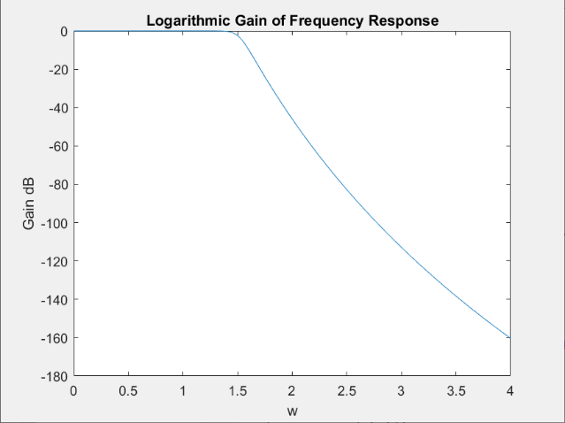
and obtaining Figure 3.
Figure 3
- Filter Implementation and Results
Finally, we need to use the information we just found to implement the filter. We start with using the MATLAB butter() command to find the numerator and denominator polynomial coefficients for a digital Butterworth lowpass filter with the final cutoff frequency, Ω_{c}, and order N we found previously. Because our cutoff frequency is specified as a percentage of Fs/2 in this command, we need to find it with the equation
$$Wn=\frac{Ω_{c}}{\frac{F_{s}}{2}}$$
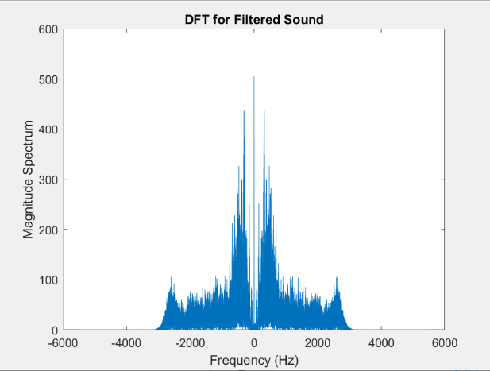
Using the coefficients found with this equation, we can use the MATLAB filter() command to create a filtered version of the original audio. The DFT of the new filtered audio was calculated and the magnitude was plotted in Figure 4.
Figure 4

As we can see, most of the unwanted noise in the higher frequencies is filtered out, and we are left with the speech frequencies being as unaltered as possible. Listening to the audio, it even sounds noticeably more clear and easier to understand.
- Conclusion
Designing and implementing a lowpass Butterworth filter required a lot of unexpected time and effort. Choosing the best values and performing the calculations presented more challenges than I was expecting, but I was able to produce audio that sounded significantly better in the end. The Butterworth lowpass filter was a useful design choice for what we were trying to accomplish, and I think produced the best result I could have.
Bonus Answer: The audio was from the 1980’s move Airplane!

