

**Your Race Pack for Stone Mad 2018!!!**

Welcome to Stone Mad! This race pack explains all the need to know information for race day – schedule, transport, and safety information etc. Please take your time to read through and if you have any questions just get in touch at [info@stonemad.com](mailto:info@stonemad.com).

Happy trails from the Stone Mad Team!

Race Day Schedule: Saturday June 16, 2018

|  |  |  |
| --- | --- | --- |
| Race | Time | Details |
| Ultra | 7:00-8:00am | Sign-in and bag drop, Carlow Town Hall |
| 8:15am | Race briefing |
| 8:30am | Ultra Race Start, Carlow Town Park |
| **Marathon** | 8:00-9:30am | Sign-in and bag drop, Carlow Town Hall |
| 9:45am | Race briefing |
| 10:00am | Marathon Race Start, Carlow Town Park |
| **Half-Marathon** | 9:30-11:00am | Sign-in and bag drop , Carlow Town Hall |
| 11.15am | Bus transfer to race start at Fenniscourt Lock |
| 12:00pm | *Half-Marathon Race Start! |
| **Finishing Schedule** | 1:00pm onwards | Scouts Hall, The Quay, Graiguenamagh, Co Kilkenny  Showers (limited facilities) and refreshments available at finish line  **Bus transfer from Graiguenamanagh back to Carlow Town Hall starting from 2pm to approx 5pm  Prizegiving |

* NOTE: Registration for the Half-Marathon is at Carlow Town Hall. You can park at Registration and you will be shuttled to the start along the River at Fenniscourt Lock, South of Bagenalstown.

**In 2018 there is no additional fee for bus transfer from the finish back to Carlow Town and seats do not need to be pre-booked

Parking

There is limited public parking at Barrow Track car park which is right beside the race registration, however there is ample parking in Carlow Town.

[Google Maps Link](https://goo.gl/maps/o6n2TWFNVg52)

Registration, Race Numbers, and Bag Drop

Race numbers can be posted prior to the event or can be picked up on the day at sign-in.

Race numbers must be visible at all times, front or back is acceptable.

You may leave a bag (clothes, towel, etc.), for collection at the finish.

Route Maps (See Appendix)

StoneMad is a self-navigating race, but it is an easy course to follow. Most of the route follows a clear trodden way.

All routes are online on www.stonemadrace.com.

Each entrant has responsibility for his or her own navigation.

Race Briefing

A mandatory race briefing will take place prior to each race start. This will cover route details, weather forecasts and other relevant updates.

Checkpoints

All checkpoints (CPs) are readily identifiable on the maps, approximately every 10 km.While you are not obliged to stop, **your Race Number must be visible at each CP.** Please note that simply passing though and expecting your details to be captured, without communicating with the officials may result in a failure to log you.

**If you need assistance or decide to drop out from the race, you must inform us through a race crew member at a checkpoint or phone the race director (contact details on the back of race number).** We will try get you back to Race HQ as soon as possible but you may wish to arrange your own transport if that is quicker.

**Please note:** If at any stage during the event, our crew deem you to be in an unfit state to continue, you may be askedto stop and recuperate. If necessary, for your safety a medical official will assess your condition.

**Supporters and spectators** may access the course along the route. Some nice places for viewing are near the checkpoints.

Cut-Off Times

We have set aside ample time to allow joggers and fast walkers to finish the course, however we will be closing down CPs at designated times**. Late arrival to any checkpoint will result in participants being retired from the race.**

|  |  |  |  |  |  |
| --- | --- | --- | --- | --- | --- |
| **Check Point Location** | **Race** | **Cut-off time** | **Ultra** | **Full** | **Half** |
| Carlow, CW | U, F | Start Ultra: 08:30  Start Full: 10:00 | **Start: 0km** | **Start: 0km** | - |
| Leighlinbridge, CW | U,F | Ultra: 10:30  Full: 12:00 | 12km | 12km | - |
| Bagnalstown, CW | U,F | Ultra: 11:30  Full: 13:00  Start Half: 12:00 | 18.3km | 18.3km | **Start: 0km**  (Fenniscourt lock) |
| Goresbridge, KK | U,F,H | Ultra: 13:00  Full: 14:30  Half: 13:30 | 27km | 27km | 6km |
| Borris, CW | U,F,H | Ultra: 14:00  Full: 15:30  Half:14:30 | 32.1km | 32.1km | 11.1km |
| Graiguenamanagh, KK | U,F,H | Ultra: 15:30  Finish Full: 17:30  Finish Half: 16:00 | 43km | **43km** | **21.1km** |
| St Mullins, CW | U | Ultra: 17:00 | 51km | - | - |
| Graiguenamanagh, KK | U | Finish Ultra: 18:30 | **60km** | - | - |

Getting Lost

The route is easily navigable however, if at any time you become lost:

Stop. Make your way back to your last known position on the course.

If you cannot find your last know position on the course, pick up your GPS from your watch or phone and contact event HQ on 086 609 0002. If you miss a CP a search will be initiated for you. It is very important that you notify us if you think you are going to miss or be late for one.

Food and Drink

CPs drinks on the day are water, squash and soft drinks. Food will consist of fruit, jellies, and other snacks.

Race Timing

The race is chip timed by PopUpRaces.com. Results will be availble shortly after the race.

Emergency Procedures & HQ Contact Number

Emergency contact details will be on the back of your race number. Please save the number to your phone.

**HQ Emergency number:** 086 609 0002

**National Emergency Number:** 112

**In an emergency,** if you have to retire in between CPs, you must contact HQ via the emergency number, and we will try to arrange collection. Please note that transport is not guaranteed to be available and in non-emergency situations, and you may still have to wait several hours before being transported. As a back-up, it is recommended that you carry some cash with you.

**Please note that failure to notify a member of crew of a retirement may result in a Search & Rescue taking place, for which you will be charged.**

Mandatory Kit - ULTRA and MARATHON only

StoneMad is a self-sufficient race. We will be enforcing the policy of: **no kit, no run**. You should be able to carry all of your mandatory kit in a modest sized waist or back pack.

* Suitable Running/Walking Footwear. Please refer to the weather when considering underfoot conditions/running shoes.
* Hydration system (bottle or pack).
* Minimum 400ml fluids and 2 energy bars or equivalent.
* Fully charged phone (water-proofed) with emergency race HQ number saved).
* Race number visible at all times.
* A lightweight, waterproof piece of warm clothing is recommended.

Please note, subject to local weather conditions and Met Eireann forecasts, we may require participants to carry additional items of clothing including; gloves, hat and long tights (waterproofed).

Post-Race Transportation

Shuttle buses will be available to bring you back to race registration in Carlow. Please book your seat before race day. **Buses will operate from 16:00hrs.** **They will leave when they are full. You may be waiting for a while after you finish, so it is strongly recommended that you send a bag to the finishing line with warm clothes in it.**

Weather & Route Change

In the unlikely event of extreme weather conditions, the Race Organisers may re-route the course to avoid potential hazards. Should this happen, it will be notified to you at race briefing and you will be provided with route maps.

Accommodation List

Below are Failte Ireland approved accommodation providers in the locality of the StoneMad event. Please let the accommodation provider know that you are an event participant when you book. You might get a discount for the referral.



Appendix - Maps

**Registration Location – ALL distances – Carlow Town Hall**

[Google Maps Link](https://www.google.ie/maps/place/Carlow+Town+Hall,+Centaur+St,+Graigue,+Carlow/@52.8376515,-6.9352176,17z/data=!3m1!4b1!4m5!3m4!1s0x485d42aca2b6f4f7:0xdae0341cec5b44e3!8m2!3d52.8376515!4d-6.9330236)

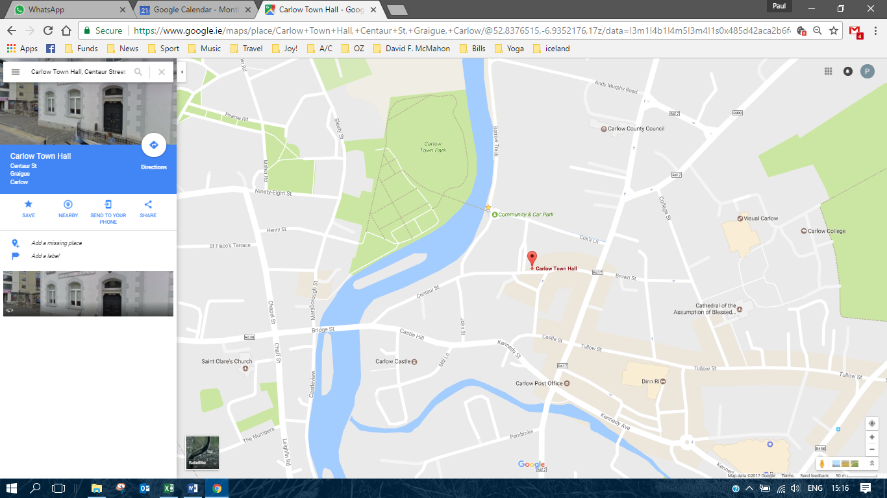

Race Maps

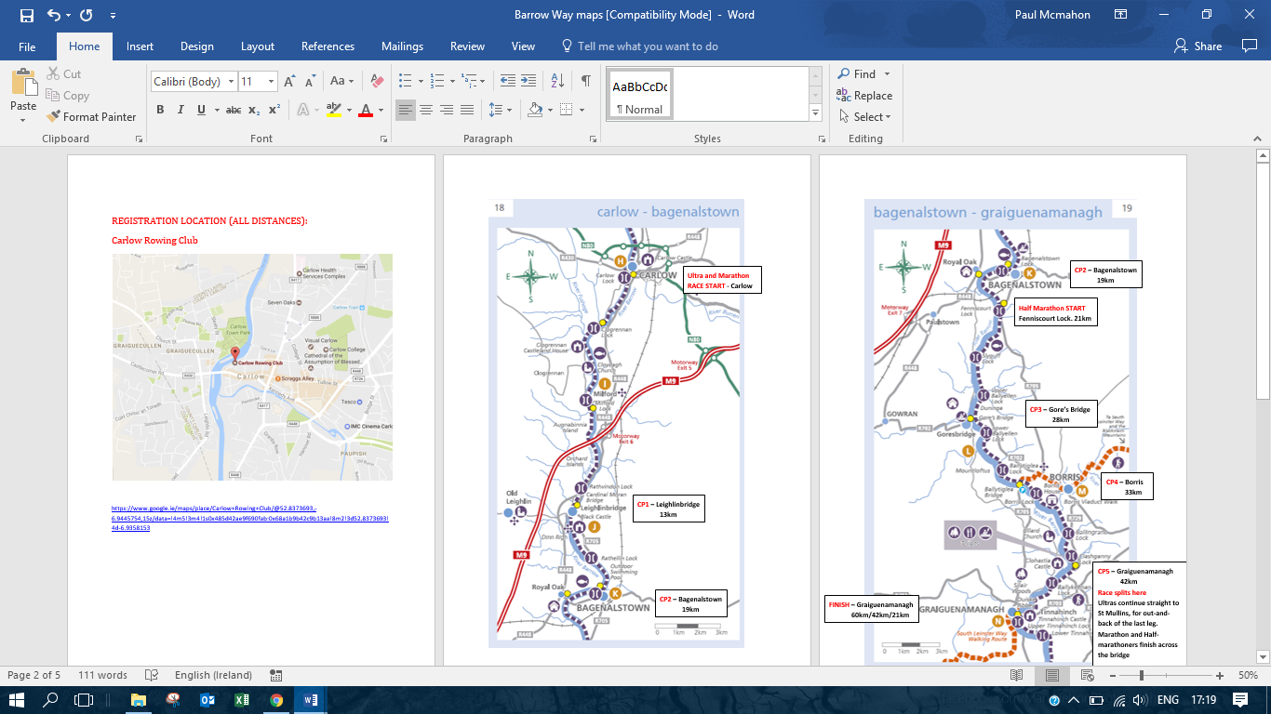

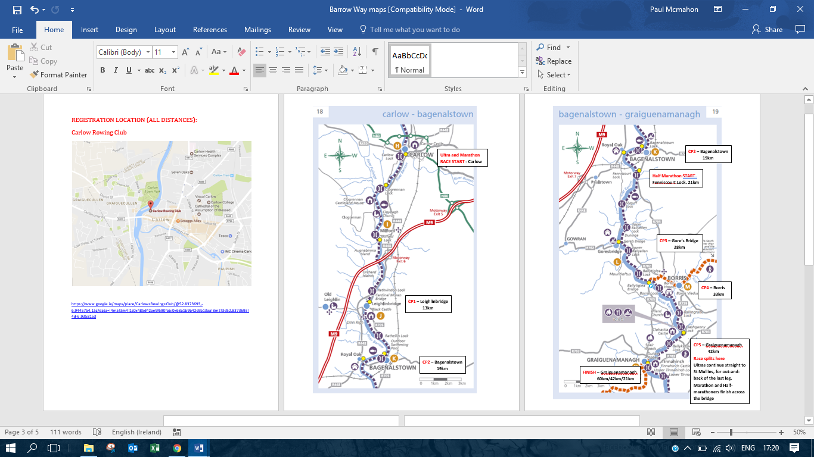

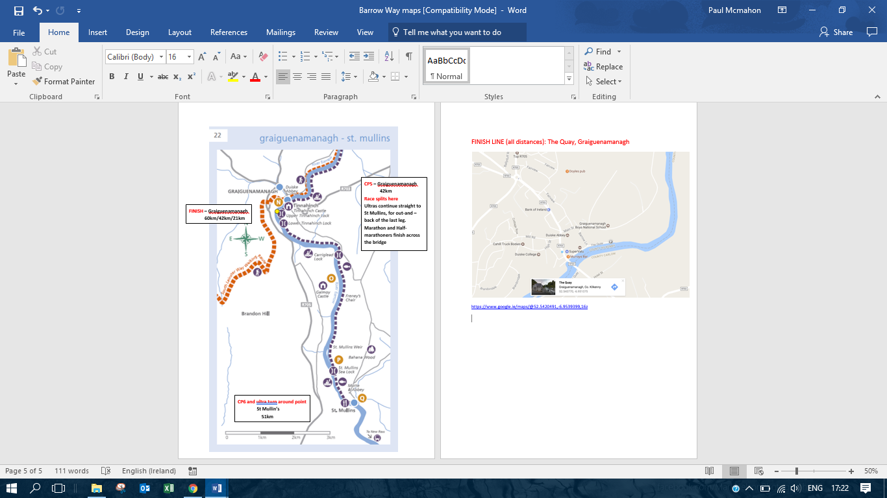

Finish Line (All Distances): The Quay, Graiguenamanagh

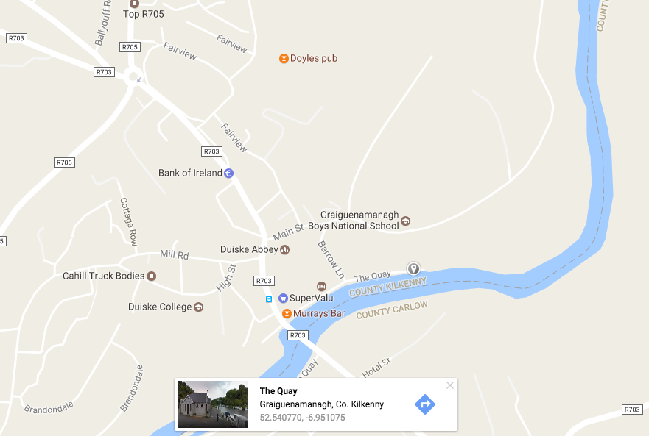

[Google Maps Link](https://www.google.ie/maps/@52.5420491,-6.9539399,16z)