Compensation Review Request
Bailey Harris · Account Manager / Account Executive · Austin, TX · October 27, 2026

Summary and request
I am requesting an increase in my base salary from $60,000 to $75,000. My base has not been adjusted since I joined in September 2023. Over that period my results have grown every year, I have met or exceeded every quarterly target set for me, the team has reduced from five people to two, and my responsibilities have expanded. This document summarizes the performance data and the reasoning behind the request.

1. Sales performance
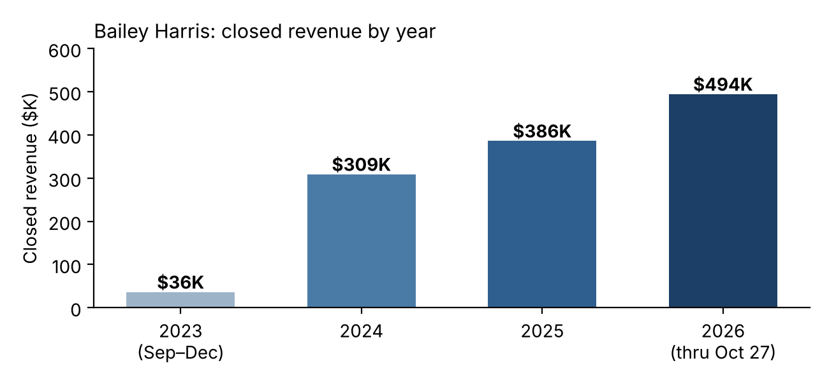
 | 2024 | 2025 | 2026 YTD (to Oct 27)
Closed revenue | $308,911 | $386,197 | $494,480
Growth vs. prior full year | n/a | +25% | +28%
Growth vs. same period prior year | n/a | +26% | +50%
Orders closed | 615 | 666 | 688
Accounts served | 414 | 442 | 490
Average order value | $502 | $580 | $719

- Ahead of last year. 2026 year-to-date revenue already exceeds my full-year 2025 total by $108K with two months remaining. Based on the November and December share of prior years (about 13%), I project roughly $565K for 2026, about +46% over 2025.
- Trailing twelve months. Revenue over the last twelve months is $550K, compared with $377K in the prior twelve months (+46%).
- Source of growth. Growth has come mainly from existing accounts (renewals, expansions and upsells), which rose from $177K (2024 YTD) to $229K (2025 YTD) to $396K (2026 YTD). New-business revenue has been steady at roughly $100K per year ($100.7K in 2025 YTD; $98.5K in 2026 YTD).

2. Performance against targets
Quarterly targets were set by management. Results against each:
Quarter | Target | Actual closed | % of target | Target basis
Q4 2025 | $74,000 | $86,023 | 116% | Q4 2024 ($62,026) + 20%
Q1 2026 | $53,000 | $82,672 | 156% | 10% growth target
Q2 2026 | $150,000 | $207,806 | 139% | Q2 2025 ($129K) + $37K transferred accounts
Q3 2026 | $155,000 | $172,687 | 111% | Q3 2025 + 5% growth target

Combined, closed revenue for these four quarters was $549K against $432K of targets (127%). Q2 included accounts transferred from a departed colleague, and the target was still exceeded.

3. Contribution to the team
Team closed revenue | 2023 | 2024 | 2025 | 2026 YTD
Team total | $643,877 | $753,240 | $933,905 | $943,490
My share | n/a | 41% | 41% | 52%

- Higher revenue with a smaller team. Team revenue has grown 47% from 2023 to 2026 YTD ($644K to $943K; about $1.09M projected for 2026) while the team reduced from five people to two. The two remaining sellers account for 99.7% of 2026 closed revenue.
- Account base. I currently manage about 490 active accounts.

4. June 2026 price increase
I planned the pricing change that took effect June 9, 2026, raising list prices about 30% on standard plans (for example, the 50-user monthly plan from $319 to $415 and the 100-user monthly plan from $349 to $454).
- Early results. Team revenue for June through October 2026 is $493K versus $455K for the same period of 2025 (+8%). My revenue in the same window rose 31% ($203K to $266K), and my order count held (310 to 327) at the higher prices.
- Estimated direct impact. Repricing only the standard list-price orders closed since June, the direct uplift is roughly $30K across the team (about $15K on my accounts) in under five months. This excludes custom, multi-month and discounted deals. The higher price points also raise the revenue baseline going forward.

5. Scope of responsibility
My role covers the full customer lifecycle: product demos, inbound inquiries, onboarding, ongoing customer support, billing, and marketing campaigns. When the team had five members these functions were shared across several roles, including project management and management. Since the team reduced to two, I have taken on a significant share of that work, in addition to planning and implementing the June 2026 pricing change.
Base salary and variable compensation serve different purposes. Commission compensates results against quota and has risen because sales have grown. Base salary reflects the scope and responsibilities of the role, which has expanded considerably without a corresponding adjustment. Commission varies with performance, whereas base is the only guaranteed component of pay.

6. Compensation context
Reaching $75,000 reflects the adjustments that would ordinarily have occurred over three years, plus a modest step for the expanded role:
 | Average merit (~3.2%/yr) | Strong performer (~6%/yr)
Current base (unchanged since Sept 2023) | $60,000 | $60,000
After three annual increases, compounded | $65,900 | $71,500
Additional step needed to reach $75,000 | +13.7% | +4.9%

- Benchmarks. Reports of employer merit budgets put average planned increases for 2027 at about 3.2% (Mercer), and 5% to 7% is generally considered a strong increase for strong performance in the same role. Average planned promotion increases for 2026 were reported at 8.7% (Mercer). The company does not currently have a promotion path for this role.
- Market. Published Austin salary data for sales account executives shows a base range of about $77K to $100K with a median near $84K (PayScale), and an average near $98K on another aggregator (Orbyt). A $75,000 base would remain below the median of both. These are aggregator estimates and vary by company size.
- Inflation. $60,000 in September 2023 has roughly the buying power of $65,500 today, based on an estimated 9% to 10% cumulative inflation; September 2026 CPI was reported at 3.7% year over year.
- Relative cost. The $15,000 increase is about 2.7% of my projected 2026 closed revenue and about 1.4% of projected team revenue.

7. Proposal
I am requesting a base salary of $75,000, effective the next pay period, with the commission structure unchanged. I would also welcome a written annual compensation review with defined criteria, so that base pay is reviewed regularly alongside performance and scope.
I am glad to walk through the data or discuss any questions at your convenience. Thank you for your consideration.

Data sources and notes
- Closed-won opportunity data from the company deal sheet (2023–2026 SF Opps Won tabs), by opportunity owner and close date. 2026 figures run through October 27, 2026.
- The 2023 data for my accounts starts in September 2023 (my start date). Full-year 2026 figures are projections based on the November and December share of 2024 and 2025 revenue.
- External benchmarks: PayScale (Austin Sales Account Executive), Orbyt (Austin Account Executive), Mercer compensation planning surveys, and the Bureau of Labor Statistics CPI as reported.

