Compensation Review: Base Salary Adjustment
Bailey Harris · Account Manager / Account Executive · Austin, TX · Prepared October 27, 2026

The ask
Increase base salary from $60,000 to $75,000 (+$15,000). My base has not changed since I started in September 2023. Over that time my role has expanded, my results have grown every year, and the team has shrunk from five people to two.

1. The headline numbers
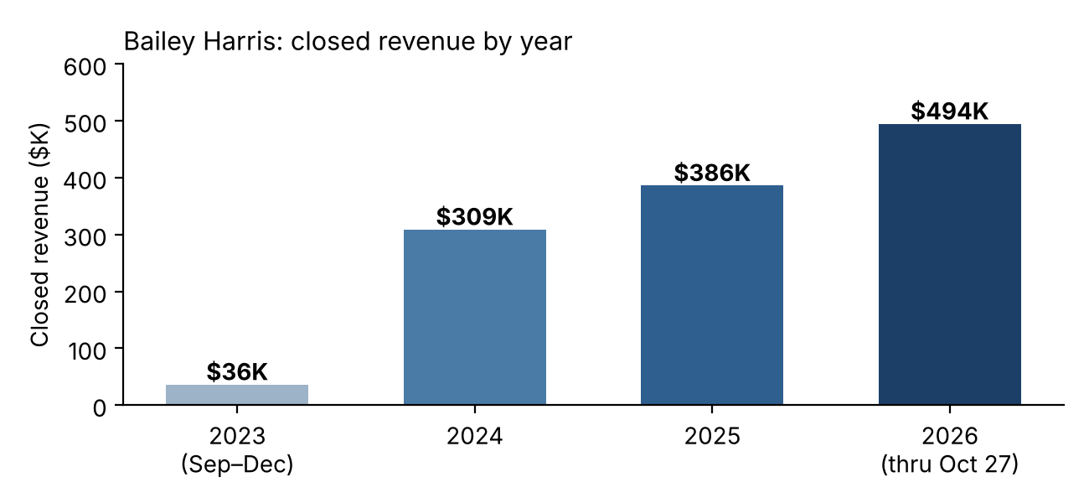
 | 2024 | 2025 | 2026 YTD (to Oct 27)
My closed revenue | $308,911 | $386,197 | $494,480
Growth vs. prior full year | n/a | +25% | +28% (already ahead of all of 2025)
Same-period growth (Jan 1 – Oct 27) | n/a | +26% | +50%
Orders closed | 615 | 666 | 688
Accounts served | 414 | 442 | 490
Average order value | $502 | $580 | $719

- Already past last year. I have already closed $108K more than all of 2025, with two months left. Using the Nov–Dec share of prior years (~13%), 2026 projects to roughly $565K, about +46% on 2025 (estimate).
- Trailing 12 months. My trailing 12 months (Oct 28, 2025 – Oct 27, 2026) is $550K versus $377K in the 12 months before: +46%.
- Two-year view. From $309K in my first full year (2024) to a projected ~$565K in 2026 is roughly +83%, with no change to my base.

2. I am now carrying most of the business
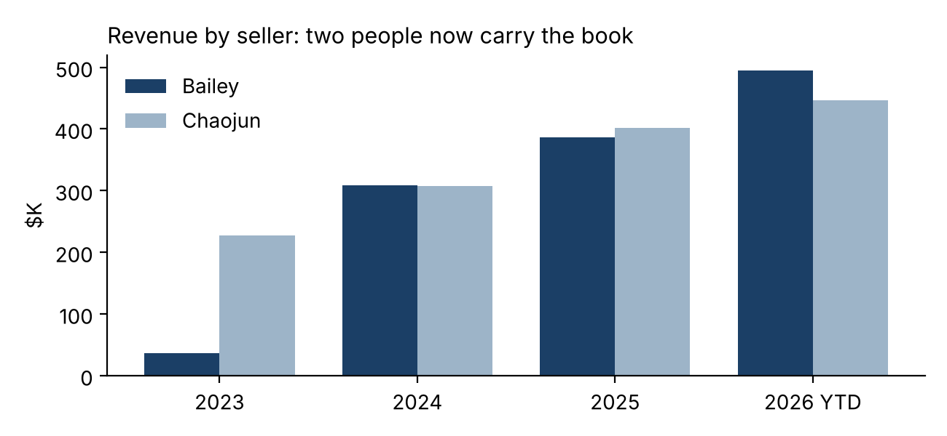
Share of team closed revenue | 2023 | 2024 | 2025 | 2026 YTD
Team total | $643,877 | $753,240 | $933,905 | $943,490
Bailey | 6% (started Sep) | 41% | 41% | 52%
Chaojun | 35% | 41% | 43% | 47%
All other owners combined | 59% | 18% | 16% | 0.3%

- More revenue, far fewer people. Team revenue is up 47% from 2023 ($644K) to 2026 YTD ($943K, ~$1.09M projected), while the team went from five people to two. Two people now close 99.7% of all 2026 revenue.
- Top producer in 2026. In 2026 I am the top revenue owner on the team ($494K vs. $446K).
- Retention and expansion. My growth is concentrated in existing-business revenue (renewals, upsells, expansions): $177K (2024 YTD) to $229K (2025 YTD) to $396K (2026 YTD). That is the account-management side of my job: support, onboarding, billing follow-up, and relationship work.

2b. I have beaten every target set for me
Since the structure change, my manager (Mike Caldwell) has set my quarterly targets in writing. I have exceeded each one:
Quarter | Target set by Mike | Actual closed | % of target | Basis Mike gave
Q4 2025 | $74,000 | $86,023 | 116% | Q4 2024 ($62,026) + 20%
Q1 2026 | $53,000 | $82,672 | 156% | 10% growth target
Q2 2026 | $150,000 | $207,806 | 139% | Q2 2025 ($129K) + accounts transferred from Xiaonan ($37K)
Q3 2026 | $155,000 | $172,687 | 111% | Q3 2025 + 5% growth target

- Consistent over-performance. Four of four quarters at 111%–156% of target, with no misses. Combined, I closed $549K against $432K of targets (127%).
- Absorbed transferred accounts and still exceeded. The Q2 target already included the $37K of accounts transferred from Xiaonan, and I beat it by $58K. Q4 2026 is under way ($31K closed in October) and I will be above the formula again if the pattern holds.
- Management's own yardstick. These are targets my manager set and confirmed by email, so they are an objective measure of expected performance. My base has stayed at $60,000 throughout.
- Ratchet effect. Each target was based on the prior year's result plus growth, so exceeding it also means my baseline for next year keeps rising.

3. The June 2026 price increase I planned
- What changed. Effective June 9, 2026, list prices rose ~30% across standard plans (50-user monthly $319 to $415; 100-user monthly $349 to $454; 200-user monthly $549 to $714).
- Result. June–Oct 2026 team revenue is $493K vs. $455K for the same months of 2025 (+8%). My own revenue in that window rose 31% ($203K to $266K), and my order count held (310 to 327) despite the higher prices.
- Direct impact. Repricing only standard list-price orders closed since June, the direct uplift is roughly $30K team-wide (~$15K on my accounts) in under five months. That excludes custom, multi-month and discounted deals, so it is conservative. It also raises the revenue base going forward.

4. Scope of role
My role covers the full customer lifecycle, not just closing: product demos, inbound inquiry response, onboarding, ongoing customer support and assistance, billing, and marketing campaigns. When the team was five people these duties were spread across several roles, including a project manager and a manager. Since the team reduced to two a year ago, I have absorbed a large share of that work at the same base pay, and I planned and executed the June 2026 pricing change on top of it.

5. Why commission does not replace a base increase
- Different purposes. Commission pays for incremental sales results; base pay is the price of the role and its responsibilities. My commission rose because I sold more, which the company has already benefited from. It does not compensate for taking on the work of three to four former teammates or for the pricing project.
- Variable vs. fixed. My monthly closings range from about $13K to $75K in 2026. Commission rises and falls with that; base is what I plan my life around.
- Inflation. $60,000 in September 2023 has roughly the buying power of ~$65,500 today (my estimate, assuming ~9–10% cumulative CPI; September 2026 CPI was reported at 3.7% year over year, per cpiinflationcalculator.com). Flat pay is a real pay cut.
- No upward mobility. There is no promotion path here, so a base adjustment is the only way the company can recognize growth in my contribution.

5b. Why $75,000 is not a "25% raise"
A routine annual raise is about 3–4%, and Mercer reports planned 2027 merit budgets averaging 3.2% and average planned promotion increases of 8.7% for 2026 (Mercer, mercer.com; figures as cited to me, not independently verified). I am not asking for one annual raise. I have had no adjustment in three years, my scope has grown, and my base is below market. Built up step by step:
Step | Basis | Base after
Today | No change since Sept 2023 | $60,000
1. Three missed annual adjustments | 3 years at ~3.2% merit (compounded, +9.9%) | $65,900
2. Scope expansion (demo, onboarding, billing, support, marketing, pricing) | Promotion-level adjustment, +8.7% | $71,700
3. Remaining gap to market | Austin SaaS AE median base ~$84K (PayScale); +4.6% to reach $75K | $75,000

- Bottom line. $75,000 is a catch-up for three skipped merit cycles, plus a promotion-sized step for a role that is much larger than the one I was hired into, plus a modest further step. It is still about 11% below the PayScale Austin median of ~$84K.
- Commission is not base. Base, target commission and quota are separate. A higher earning opportunity from more sales is not guaranteed pay. My base is the only part of my compensation that does not depend on hitting numbers, and it has not moved in three years.
- No promotion route. There is no promotion path at the company, so this raise has to cover both the missed annual adjustments and the scope change that a promotion would normally have recognized.

6. Market and cost context
- Market. PayScale lists a $77K–$100K base range with an $84K median for Sales Account Executives in Austin (payscale.com); an aggregator (orbytjobs.ai) reports an average near $98K. $75K is below both medians. These are aggregator estimates and vary by company size, so treat them as directional and check current postings before the meeting.
- Cost vs. contribution. $15,000 is about 2.7% of the ~$565K I am projected to close this year and about 1.4% of projected team revenue (~$1.09M).
- Cost of not adjusting. I manage ~490 active accounts. Replacing me would mean recruiting, training and ramping someone while that book is at risk, on a team that has already shrunk by 60%.

7. Proposed outcome
Primary ask: $75,000 base, effective the next pay period, commission structure unchanged.
If the company cannot do the full amount at once, alternatives in order of preference:
- $70,000 now and $75,000 in six months, in writing, tied to a date.
- A title change (e.g., Senior Account Executive or Account Executive Lead) reflecting the scope, plus a base increase now.
- A written annual compensation review with defined criteria so base does not stay frozen again.

Prepare for pushback
They may say | Suggested response
"Your commission went up, so you are already earning more." | Commission is payment for results; base reflects role scope. I have taken on the work of a much larger team and led the pricing change, and neither is covered by commission.
"The price increase did the work, not you." | Growth started before June: my Jan–May 2026 revenue was +79% over Jan–May 2025. The price change is an additional contribution I led, not the only driver.
"New business is flat." | True: my new-business revenue has held near $100K for two years ($98.5K 2026 YTD vs. $100.7K 2025 YTD). The growth is in existing accounts, which is what the account-management half of the role is for. Have this answer ready.
"Team orders fell after the price increase." | Team order count fell after June (636 vs. 797 in the same months last year), but revenue rose, and my own order count grew (310 to 327). Part of the team decline is the smaller team (one seller left in Jan 2026). Know your answer before walking in.
"25% is far above a normal raise." | It is not an annual raise. It is three skipped merit cycles (~$65.9K), a promotion-sized step for the expanded role (~$71.7K), and a modest step to $75K, still below the ~$84K market median. See section 5b.
"We cannot afford it right now." | Then ask for a dated plan (e.g., $70K now, $75K in six months) and written review criteria.

Data notes
- Source: the P4T Deal Sheet "2023/2024/2025/2026 SF Opps Won" tabs (closed-won opportunities by Opportunity Owner and Close Date; "Amount" field). 2026 data runs through Oct 26–27, 2026.
- The sheet shows only ~$1K of closings under my name before September 2023; that is excluded, so the 2023 figure ($36K) is Sept–Dec.
- Full-year 2026 projections use the Nov–Dec share of annual revenue in 2024–2025 and are estimates.
- The sheet lists other opportunity owners (Eric McGraw, Xiaonan Zhou, Xu Chang, Jo Saab); Richard and Yvette do not appear as opportunity owners. "All other owners" in the share table means everyone except me and Chaojun.
- Commission payouts are not in the data I was given, so total compensation is not shown. Add your actual commission figures if you want to show total pay vs. market.

