SmartOS
An Operating System Simulator

Overview
SmartOS is an Operating System simulator that was designed for my CS361 class at Concord University. It’s designed to be user friendly, and it can give the user a basic visual representation of how the operating system handles processes. It is by no means complete, but it has some basic functionality.

Commands
I tried to design SmartOS in such a way that everything is intuitive, but this isn’t something that can always be guaranteed. I have included some visual aids to help navigate the simulator.

About and User Documentation
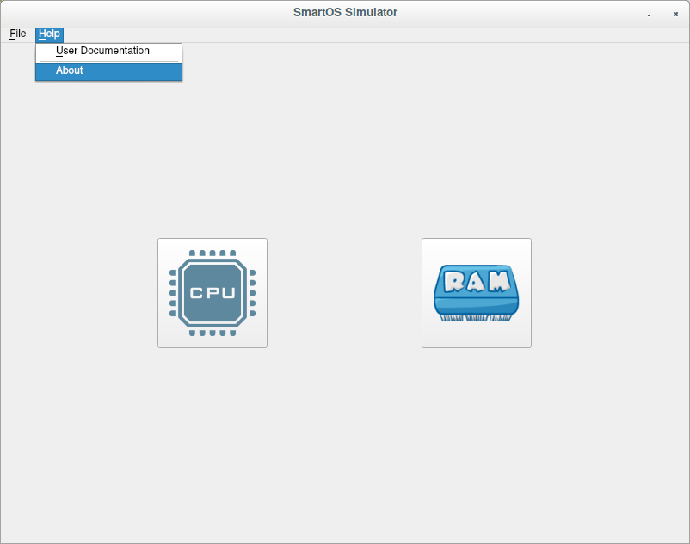
To find information about the simulator, you can look under the “Help” menu. User Documentation is located in the same menu.

Command History
If you’d like to see a list of commands that have been carried out by the simulator, take a look at File > History.
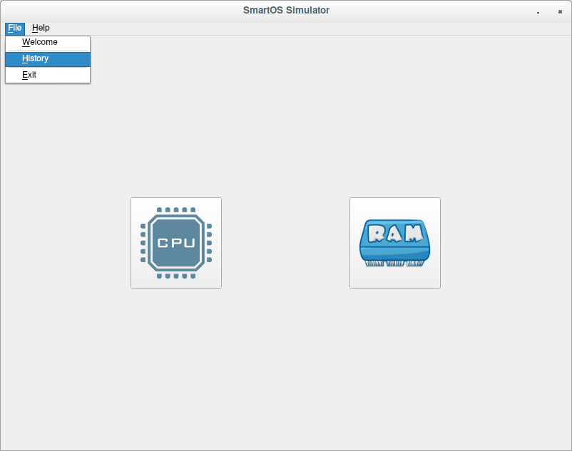

Welcome Screen
If at any point you’d like to navigate back to the Welcome Screen, just click File > Welcome.
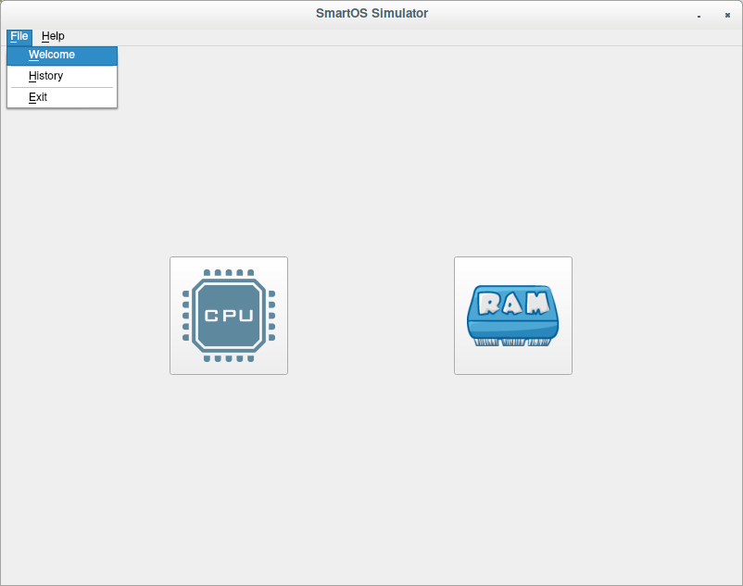

Process Scheduling
To begin running the Process Scheduling algorithms, click on the CPU button. This will cause a Process Scheduling Dialog to appear. Here you may select which algorithm you’d like to use for process scheduling.
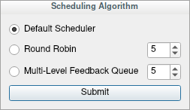

Process Scheduling Algorithms
- Default Scheduler
  - The Default Scheduler uses a very simple scheduling algorithm. It will just place the first process in the Ready Queue into the active slot of the Central Processing Unit and let it execute for one round. Repeating each cycle.
- Round Robin
  - The Round Robin scheduling algorithm requires a Time Quantum to be supplied. The Time Quantum is how many time cycles each process should stay in the Central Processing Unit. After the alotted time cycles have passed, the next process is made active.
    - If the process requires IO, it will be moved to the Blocked Queue and the current time count will be reset.
- Multi-Level Feedback Queue
  - The Multi-Level Feedback Queue is supposed to be one of the best scheduling algorithms. It gives each process a priority, starting at the maximum. Each process will be in the CPU for its ‘time slice’ (which is the value that is supplied to the Round Robin scheduler). After a total time has been used up, it will be lowered in priority. After a set period of time, all of the processes will be escalated back to maximum priority. The process chosen to be active is selected as follows:
    - If Priority(A) > Priority(B), A runs.
    - If Priority(A) = Priority(B), A and B run in Round Robin
    - When a process enters the system, it is given the maximum priority.
    - After using it’s time in the CPU it is lowered in priority
    - After a given time, all processes are returned to maximum priority.

Process Scheduler Interface
After selecting which scheduling algorithm to use, you’re presented with the Process Scheduler Interface. Here is where you can generate random Process Control Blocks or even generate your own specific ones.
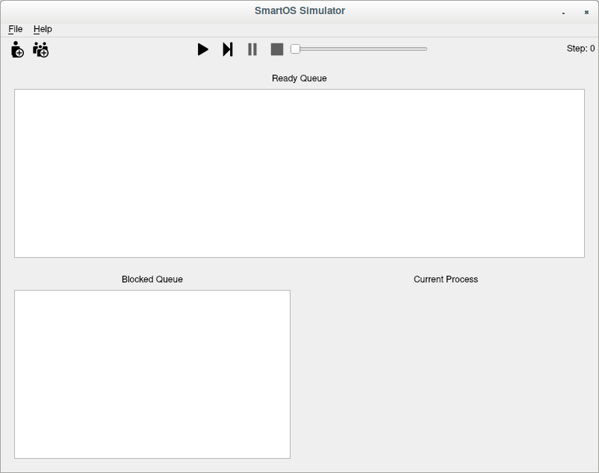
On the top of the current interface are the actions used to manipulate the simulator.
Starting from the left:

Generate Process Control Block
This button will bring up the dialog to generate a specific Process Control Block.
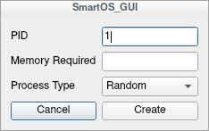

Input the Process Identification Number, the Memory Required, and the type of process before hitting create.

Bulk Process Generation
To generate a plethora of Process Control Blocks, use the next button. This will bring up an interface to determine how many processes to create. The memory required and type of process are randomly generated. The PIDs given are in sequential order.


Process Scheduler (With Processes)
After you have taken the time to generate some processes, the Process Scheduler will now have some data in it. Upon hitting play, the simulator will start to run.
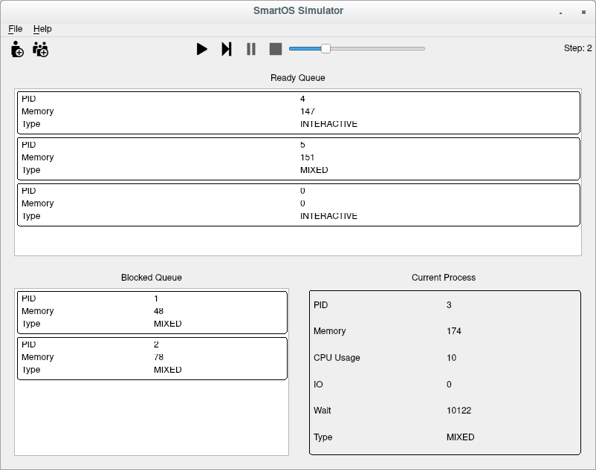
The center area of the window shows the processes that are in the Ready Queue. On the bottom left, the processes that are in the Blocked Queue are displayed. On the bottom right, the current process in the Central Processing Unit is displayed alongside information for each process.

