**Train_regression1**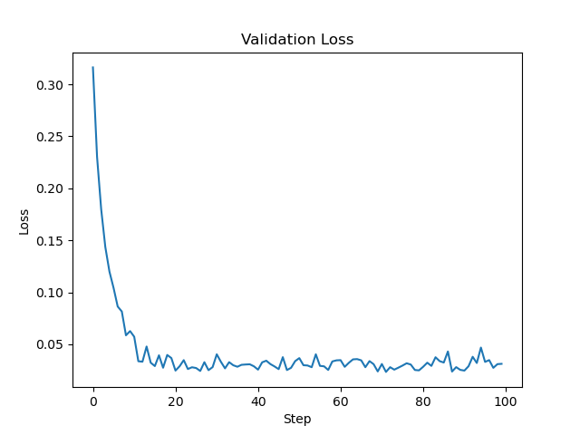

**Train_regression2**

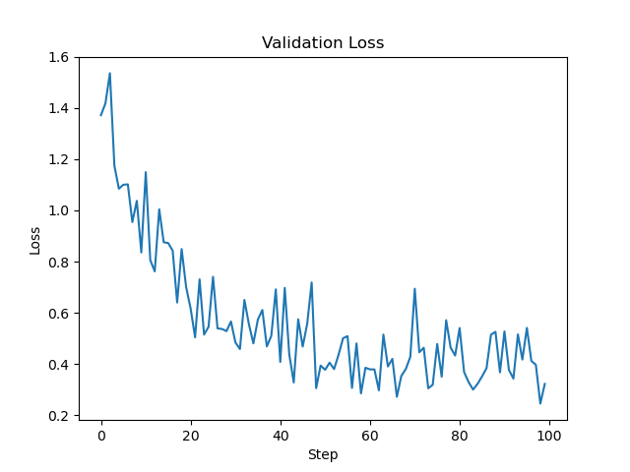

**Train_regression3**

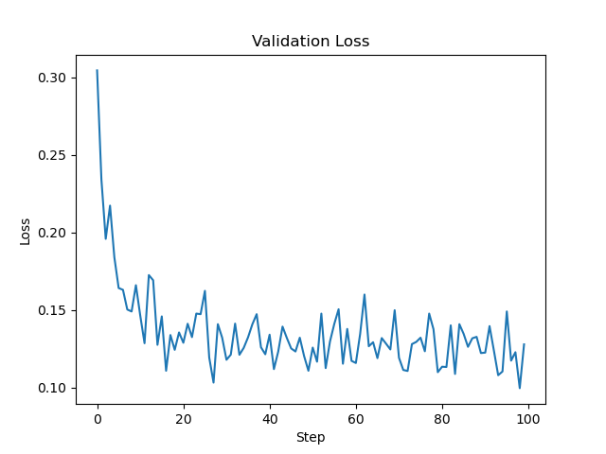**2**

**Train_regression4**

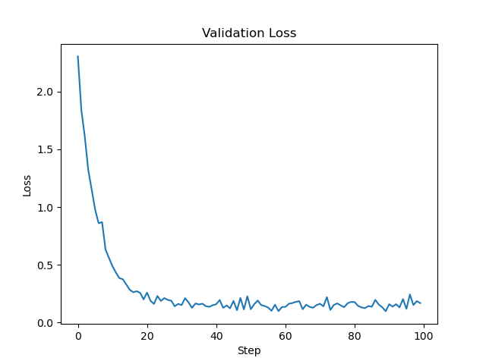

**# Linear Regression**

1. What are the pros and cons of using the normal equation to solve for the weights in linear regression as opposed to using gradient descent?

**# Logistic Regression**

1. Why is the softmax function used in multi-class logistic regression (Hint: the model itself produces logits)?