Get started with Docker Compose
2018年4月15日
19:56

坑：container hostname:需要从container 外部设置
container env: 需要在container启动时 从外部设置
openssl, openssl-dev 必须在 python3 编译之前 yum install
python3：先装 yum install zlib*, yum group install Development tools...
pip3,
pull redis
生成 docker image 要在安装 python3 之前必须安装 open-ssl open-ssl-dev, 否则 pip 无法使用

Get started with Docker Compose
Estimated reading time: 10 minutes
On this page you build a simple Python web application running on DockerCompose. The application uses the Flask framework and maintains a hit counter inRedis. While the sample uses Python, the concepts demonstrated here should beunderstandable even if you’re not familiar with it.
Prerequisites
Make sure you have already installed both Docker Engine and DockerCompose. You don’t need to install Python or Redis, as both areprovided by Docker images.
Step 1: Setup
Define the application dependencies.
- Create a directory for the project:
$ mkdir composetest
$ cd composetest
- Create a file called app.py in your project directory and paste this in:
import time
import redis
from flask import Flask
app = Flask(__name__)
cache = redis.Redis(host='redis', port=6379)
def get_hit_count():
retries = 5
while True:
try:
return cache.incr('hits')
except redis.exceptions.ConnectionError as exc:
if retries == 0:
raise exc
retries -= 1
time.sleep(0.5)
@app.route('/')
def hello():
count = get_hit_count()
return 'Hello World! I have been seen {} times.\n'.format(count)
if __name__ == "__main__":
app.run(host="0.0.0.0", debug=True)
In this example, redis is the hostname of the redis container on the application’s network. We use the default port for Redis, 6379.
X Handling transient errors
Note the way the get_hit_count function is written. This basic retryloop lets us attempt our request multiple times if the redis service isnot available. This is useful at startup while the application comesonline, but also makes our application more resilient if the Redisservice has to be restarted anytime during the app’s lifetime. In acluster, this also helps handling momentary connection drops betweennodes.
- Create another file called requirements.txt in your project directory andpaste this in:
flask
redis
Step 2: Create a Dockerfile
In this step, you write a Dockerfile that builds a Docker image. The imagecontains all the dependencies the Python application requires, including Pythonitself.
In your project directory, create a file named Dockerfile and paste thefollowing:
FROM bryan/centos7py36:v3
ADD . /code
WORKDIR /code
ENV PATH=$PATH:/usr/local/python/bin
RUN pip3 install -r requirements.txt
CMD ["python3", "app.py"]
This tells Docker to:
- Build an image starting with the Python 3.4 image.
- Add the current directory . into the path /code in the image.
- Set the working directory to /code.
- Install the Python dependencies.
- Set the default command for the container to python app.py.
For more information on how to write Dockerfiles, see the Docker userguideand the Dockerfile reference.
Step 3: Define services in a Compose file
Create a file called docker-compose.yml in your project directory and pastethe following:
version: '3'
services:
web:
build: .
ports:
- "5000:5000"
redis:
image: "redis"
This Compose file defines two services, web and redis. The web service:
- Uses an image that’s built from the Dockerfile in the current directory.
- Forwards the exposed port 5000 on the container to port 5000 on the hostmachine. We use the default port for the Flask web server, 5000.
The redis service uses a publicRedis image pulled from the DockerHub registry.
Step 4: Build and run your app with Compose
- From your project directory, start up your application by running docker-compose up.
$ docker-compose up
Creating network "composetest_default" with the default driver
Creating composetest_web_1 ...
Creating composetest_redis_1 ...
Creating composetest_web_1
Creating composetest_redis_1 ... done
Attaching to composetest_web_1, composetest_redis_1
web_1 | * Running on http://0.0.0.0:5000/ (Press CTRL+C to quit)
redis_1 | 1:C 17 Aug 22:11:10.480 # oO0OoO0OoO0Oo Redis is starting oO0OoO0OoO0Oo
redis_1 | 1:C 17 Aug 22:11:10.480 # Redis version=4.0.1, bits=64, commit=00000000, modified=0, pid=1, just started
redis_1 | 1:C 17 Aug 22:11:10.480 # Warning: no config file specified, using the default config. In order to specify a config file use redis-server /path/to/redis.conf
web_1 | * Restarting with stat
redis_1 | 1:M 17 Aug 22:11:10.483 * Running mode=standalone, port=6379.
redis_1 | 1:M 17 Aug 22:11:10.483 # WARNING: The TCP backlog setting of 511 cannot be enforced because /proc/sys/net/core/somaxconn is set to the lower value of 128.
web_1 | * Debugger is active!
redis_1 | 1:M 17 Aug 22:11:10.483 # Server initialized
redis_1 | 1:M 17 Aug 22:11:10.483 # WARNING you have Transparent Huge Pages (THP) support enabled in your kernel. This will create latency and memory usage issues with Redis. To fix this issue run the command 'echo never > /sys/kernel/mm/transparent_hugepage/enabled' as root, and add it to your /etc/rc.local in order to retain the setting after a reboot. Redis must be restarted after THP is disabled.
web_1 | * Debugger PIN: 330-787-903
redis_1 | 1:M 17 Aug 22:11:10.483 * Ready to accept connections
Compose pulls a Redis image, builds an image for your code, and starts theservices you defined. In this case, the code is statically copied into the image at build time.
- Enter http://0.0.0.0:5000/ in a browser to see the application running.
If you’re using Docker natively on Linux, Docker for Mac, or Docker forWindows, then the web app should now be listening on port 5000 on yourDocker daemon host. Point your web browser to http://localhost:5000 tofind the Hello World message. If this doesn’t resolve, you can also tryhttp://0.0.0.0:5000.
If you’re using Docker Machine on a Mac or Windows, use docker-machine ipMACHINE_VM to get the IP address of your Docker host. Then, openhttp://MACHINE_VM_IP:5000 in a browser.
You should see a message in your browser saying:
Hello World! I have been seen 1 times.
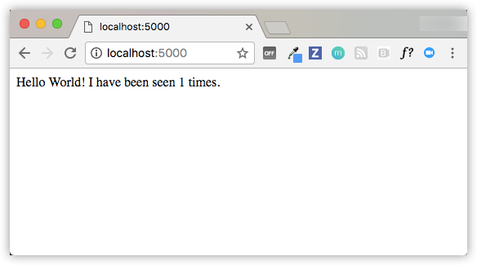
- Refresh the page.
The number should increment.
Hello World! I have been seen 2 times.
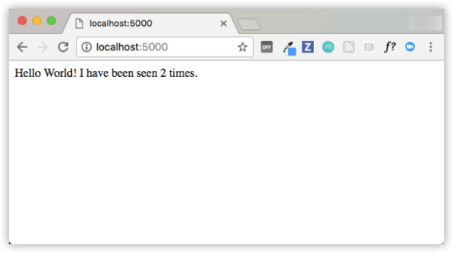
- Switch to another terminal window, and type docker image ls tolist local images.
Listing images at this point should return redis and web.
$ docker image ls
REPOSITORY TAG IMAGE ID CREATED SIZE
composetest_web latest e2c21aa48cc1 4 minutes ago 93.8MB
python 3.4-alpine 84e6077c7ab6 7 days ago 82.5MB
redis alpine 9d8fa9aa0e5b 3 weeks ago 27.5MB
You can inspect images with docker inspect <tag or id>.
- Stop the application, either by running docker-compose downfrom within your project directory in the second terminal, or byhitting CTRL+C in the original terminal where you started the app.
Step 5: Edit the Compose file to add a bind mount
Edit docker-compose.yml in your project directory to add a bind mount for the web service:
version: '3'
services:
web:
build: .
ports:
- "5000:5000"
volumes:
- .:/code
redis:
image: "redis:alpine"
The new volumes key mounts the project directory (current directory) on thehost to /code inside the container, allowing you to modify the code on thefly, without having to rebuild the image.
Step 6: Re-build and run the app with Compose
From your project directory, type docker-compose up to build the app with the updated Compose file, and run it.
$ docker-compose up
Creating network "composetest_default" with the default driver
Creating composetest_web_1 ...
Creating composetest_redis_1 ...
Creating composetest_web_1
Creating composetest_redis_1 ... done
Attaching to composetest_web_1, composetest_redis_1
web_1 | * Running on http://0.0.0.0:5000/ (Press CTRL+C to quit)
...
Check the Hello World message in a web browser again, and refresh to see thecount increment.
j Shared folders, volumes, and bind mounts
- If your project is outside of the Users directory (cd ~), then youneed to share the drive or location of the Dockerfile and volume you are using.If you get runtime errors indicating an application file is not found, a volumemount is denied, or a service cannot start, try enabling file or drive sharing.Volume mounting requires shared drives for projects that live outside ofC:\Users (Windows) or /Users (Mac), and is required for any project onDocker for Windows that uses Linuxcontainers. For more information, see Shared Driveson Docker for Windows, File sharing on Dockerfor Mac, and the general examples on how to Manage data incontainers.
- If you are using Oracle VirtualBox on an older Windows OS, you might encounter an issue with shared folders as described in this VB troubleticket. Newer Windows systems meet therequirements for Docker for Windows and do notneed VirtualBox.
Step 7: Update the application
Because the application code is now mounted into the container using a volume,you can make changes to its code and see the changes instantly, without havingto rebuild the image.
- Change the greeting in app.py and save it. For example, change the Hello World! message to Hello from Docker!:
return 'Hello from Docker! I have been seen {} times.\n'.format(count)
- Refresh the app in your browser. The greeting should be updated, and thecounter should still be incrementing.
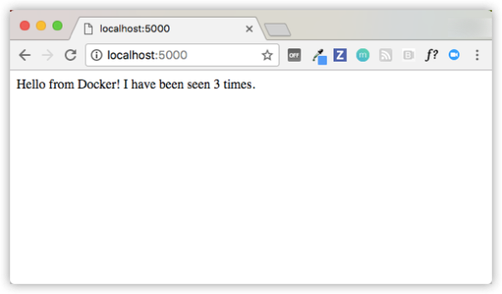
Step 8: Experiment with some other commands
If you want to run your services in the background, you can pass the -d flag(for “detached” mode) to docker-compose up and use docker-compose ps tosee what is currently running:
$ docker-compose up -d
Starting composetest_redis_1...
Starting composetest_web_1...
$ docker-compose ps
Name Command State Ports
-------------------------------------------------------------------
composetest_redis_1 /usr/local/bin/run Up
composetest_web_1 /bin/sh -c python app.py Up 5000->5000/tcp
The docker-compose run command allows you to run one-off commands for yourservices. For example, to see what environment variables are available to theweb service:
$ docker-compose run web env
See docker-compose --help to see other available commands. You can also install command completion for the bash and zsh shell, which will also show you available commands.
If you started Compose with docker-compose up -d, you’ll probably want to stopyour services once you’ve finished with them:
$ docker-compose stop
You can bring everything down, removing the containers entirely, with the downcommand. Pass --volumes to also remove the data volume used by the Rediscontainer:
$ docker-compose down --volumes
At this point, you have seen the basics of how Compose works.

