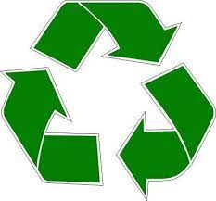Reciclaje

|  |  |  |  |  |  |  |  |
| --- | --- | --- | --- | --- | --- | --- | --- |
| material | Domingo | Lunes | Martes | Miércoles | Jueves | Viernes | Sábado |
| Aluminio |  |  |  |  |  |  |  |
| Botellas |  |  |  |  |  |  |  |
| Papeles |  |  |  |  |  |  |  |
| Vidrio |  |  |  |  |  |  |  |
| Baterias/Pilas |  |  |  |  |  |  |  |
| Abono |  |  |  |  |  |  |  |