Name:bainh alaa elden abdelfattah aboraya

Lab3 mysql

Insert new student and his score in exam in different subjects as transaction

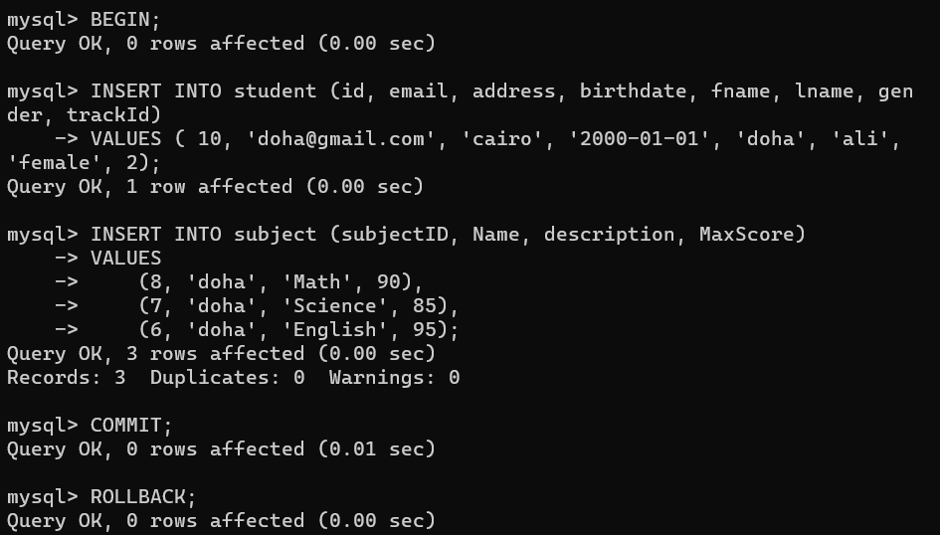

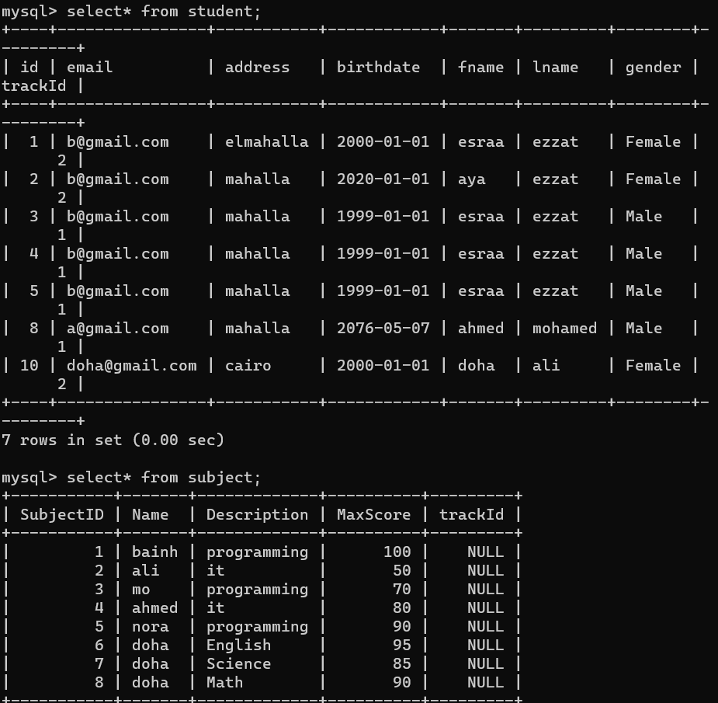

2-Display the date of exam as the following: *day 'month name' year*.

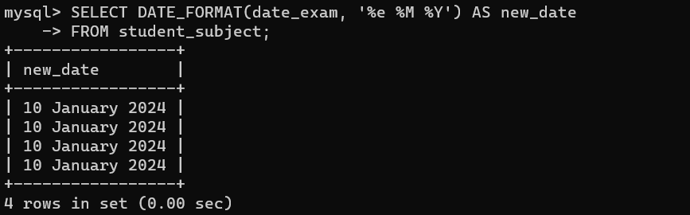

3-Display name and age of each students

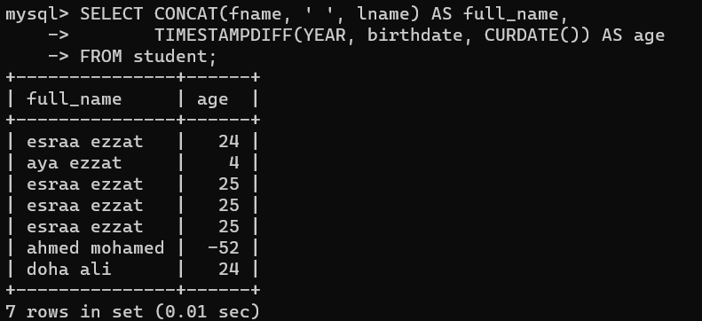

4-Display the name of students with their *Rounded* score in each Exam

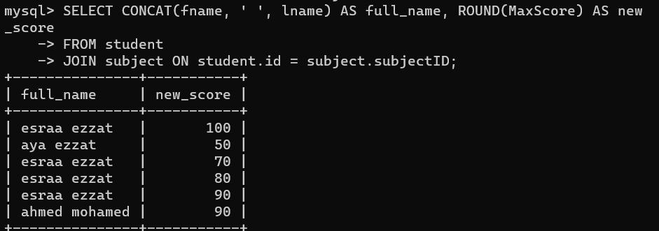

5-Display the name of students with the year of *Birthdate*

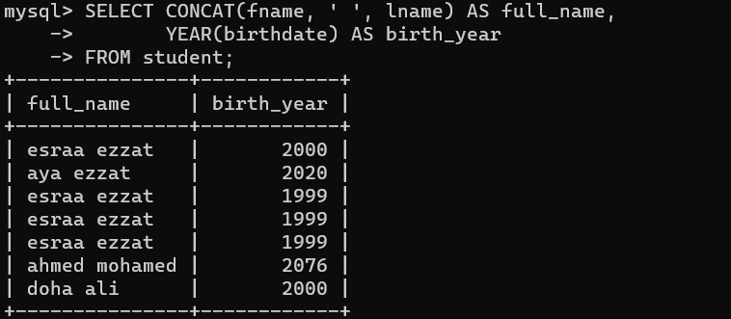

6-Add new exam result, in date column use NOW

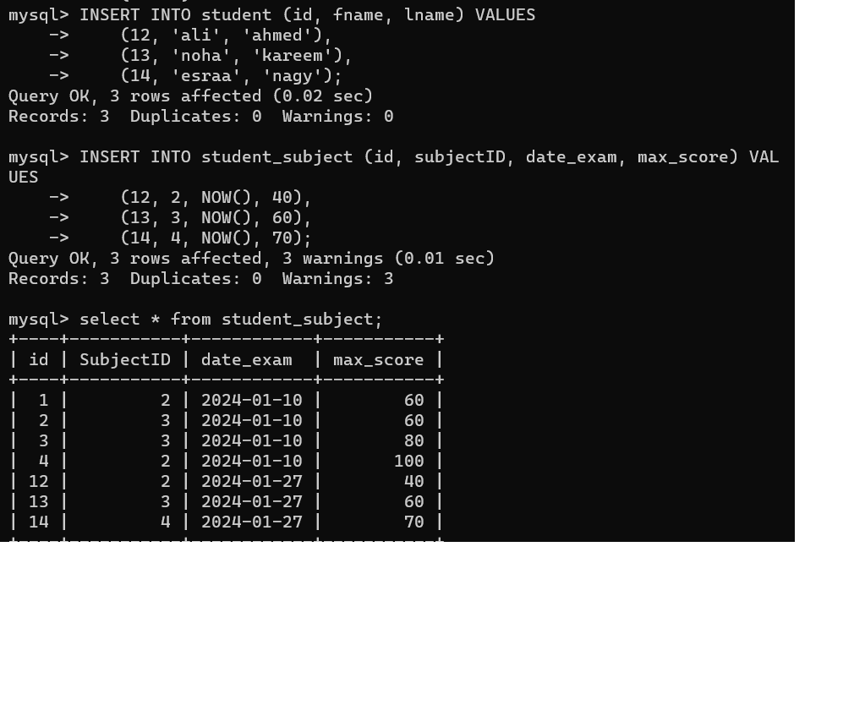

7-Create Hello world function which take username and return welcome

message to user using his name

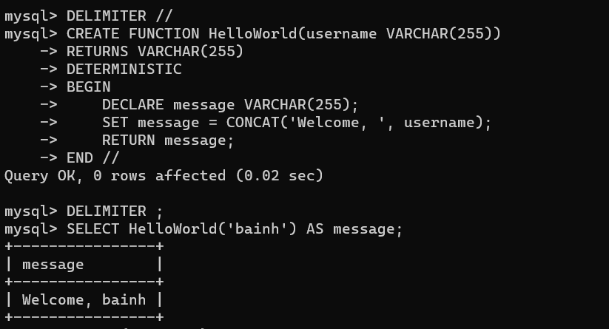

8-Create multiply function which take two number and return the multiply of

them

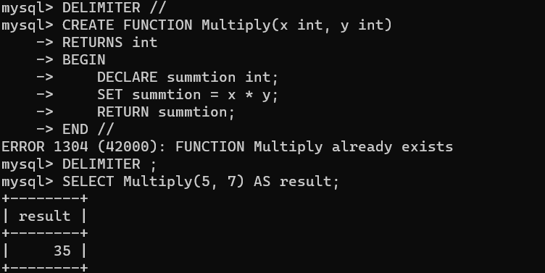

9-Create function which takes student id and Exam id and return score the

student in Exam.

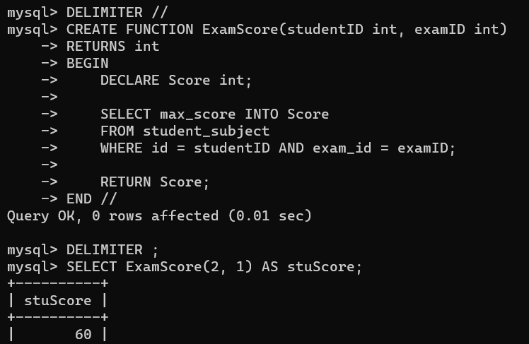

10-Create function which takes Exam id and return the number of students

who failed in a Exam (Score less than 50).

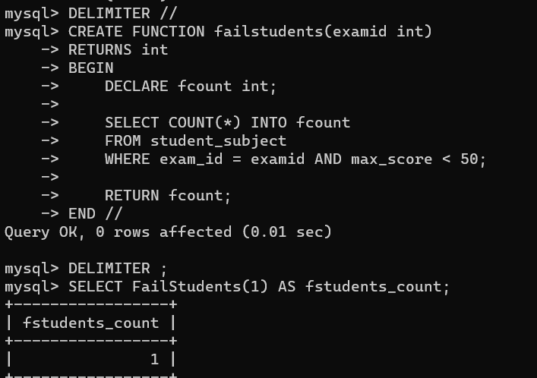

11-Create function which take subject name and return the average of max

grades for subject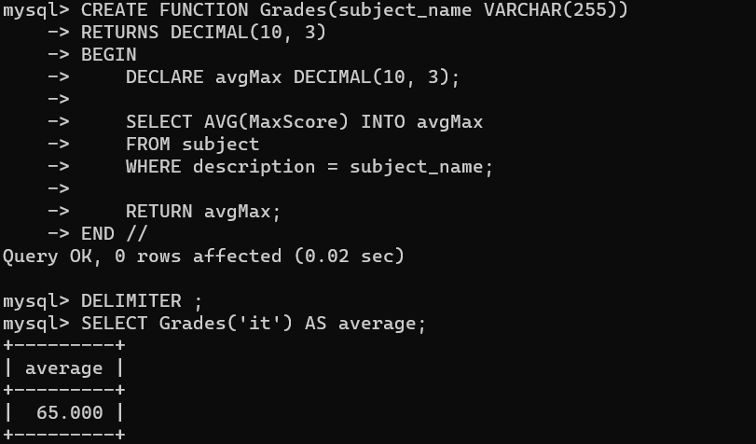

12-Create Table called Deleted_Students which will hold the deleted students

info(same columns as in student tables)

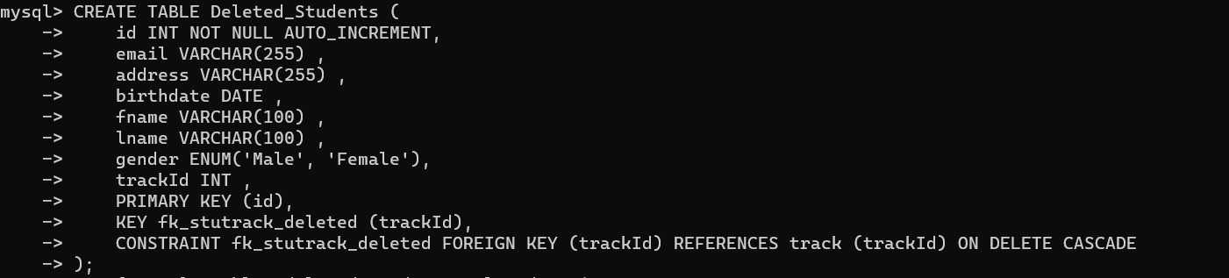

13-Create trigger to save the deleted student from Student table to

Deleted_Students

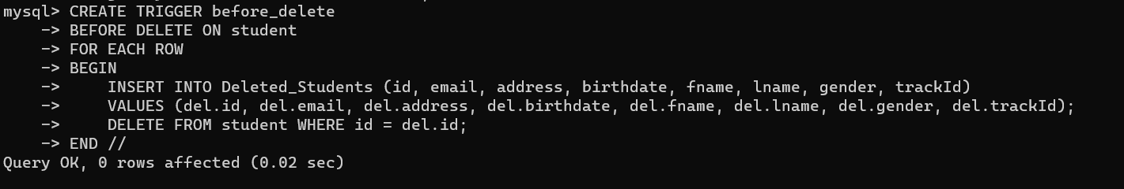

14-Create trigger to save the newly added students to Student table to

Backup_Students

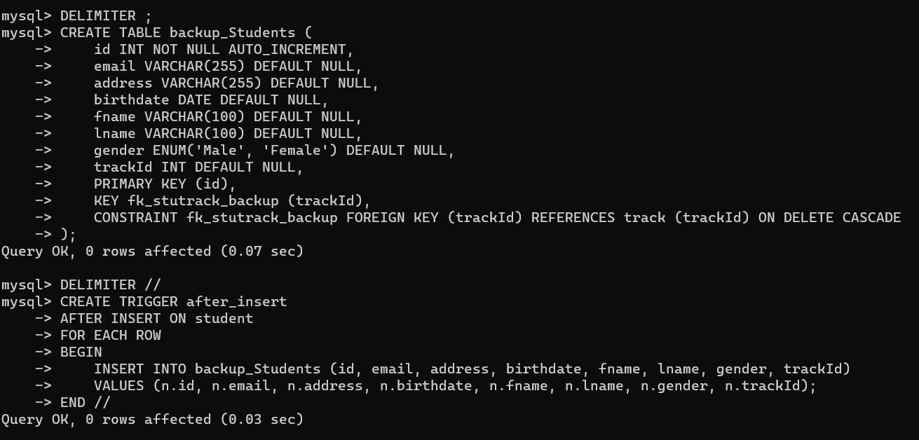

16-Dump your database (Grading Database) into SQL file.

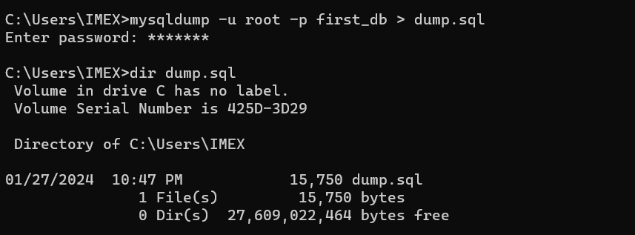

17-Dump Students table into file.

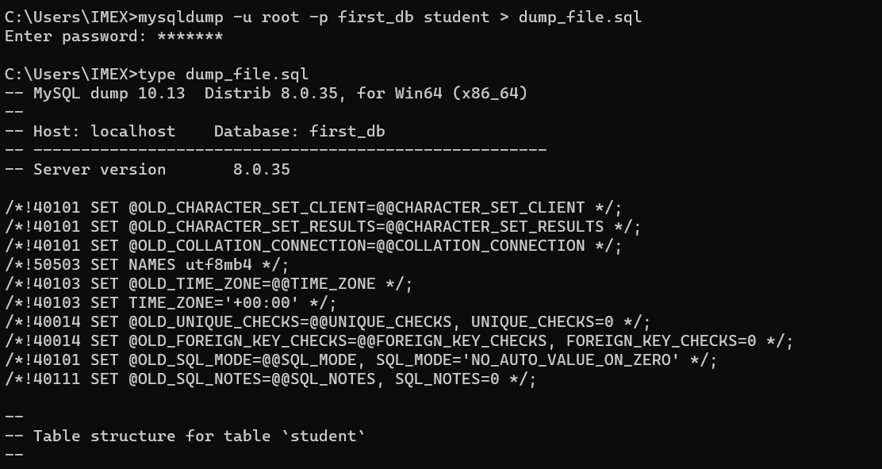

18-Import SQL file into your backup database (Grading_Backup Database)

