Name:Bainh alaa elden abdelfattah aboraya

Lab1

1. Display the lines that contain the word “lp” in /etc/passwd file.



1. Display /etc/passwd file except the third line.

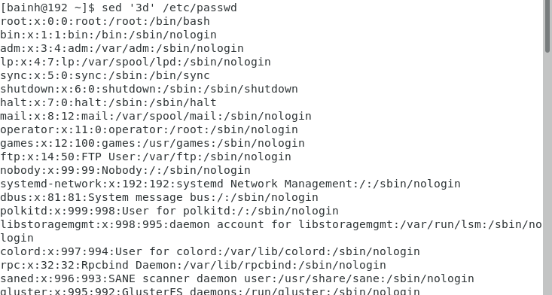

1. Display /etc/passwd file except the last line.

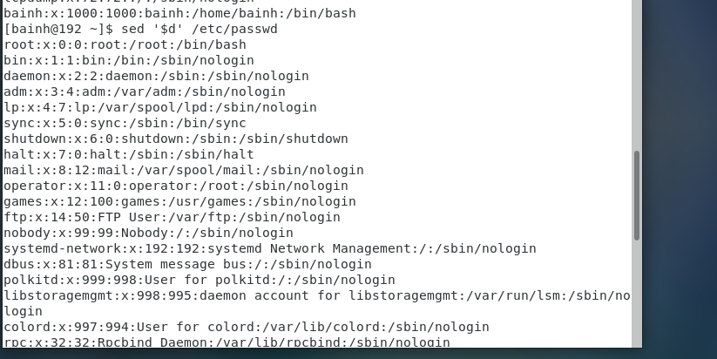

1. Display /etc/passwd file except the lines that contain the word “lp”.

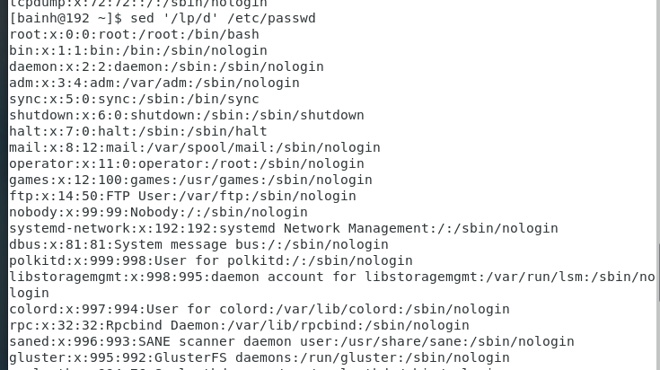

1. Substitute all the words that contain “lp” with “mylp” in /etc/passwd file.

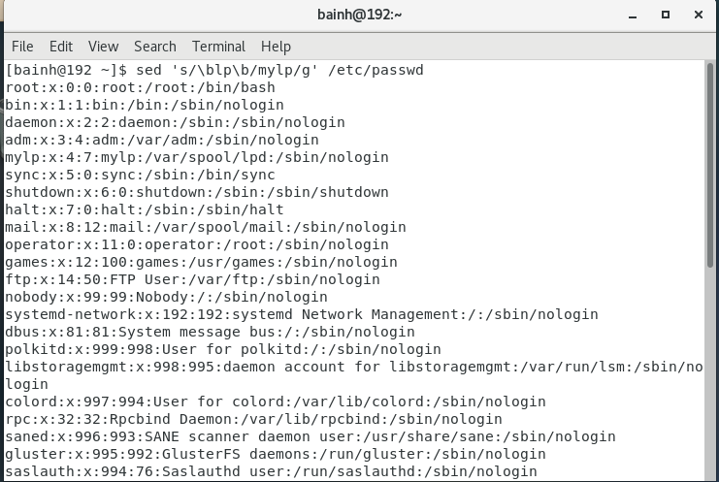

Using awk utility

1. Print full name (comment) of all users in the system.

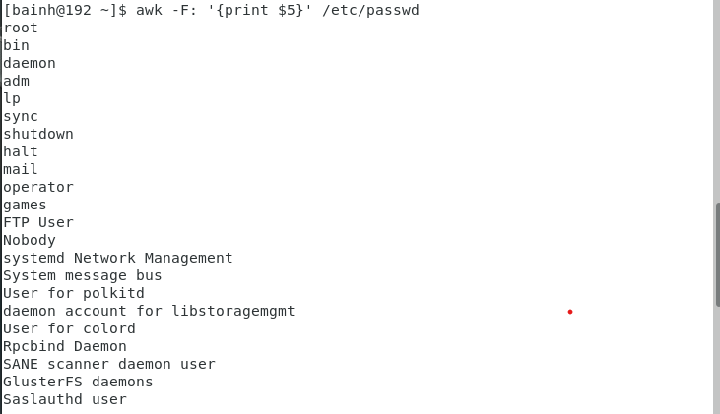

2- Print login, full name (comment) and home directory of all users.( Print each line preceded

by a line number)

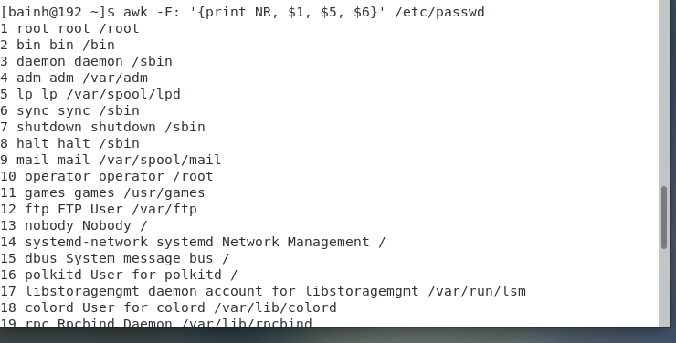

1. Print login, uid and full name (comment) of those uid is greater than 500

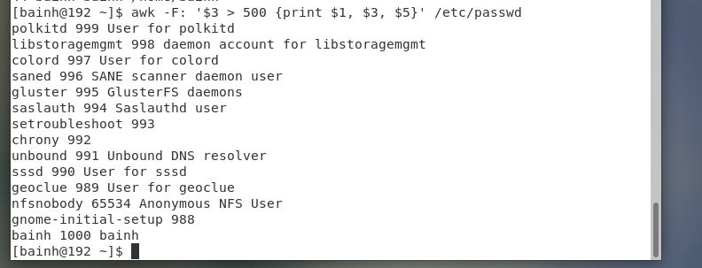

1. Print login, uid and full name (comment) of those uid is exactly 500



1. Print line from 5 to 15 from /etc/passwd

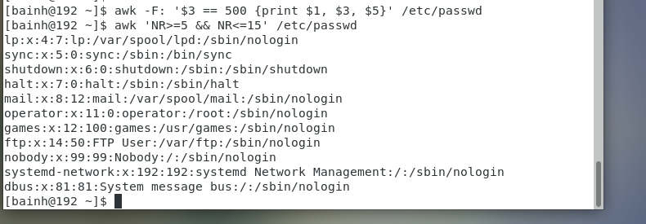

1. Change lp to mylp

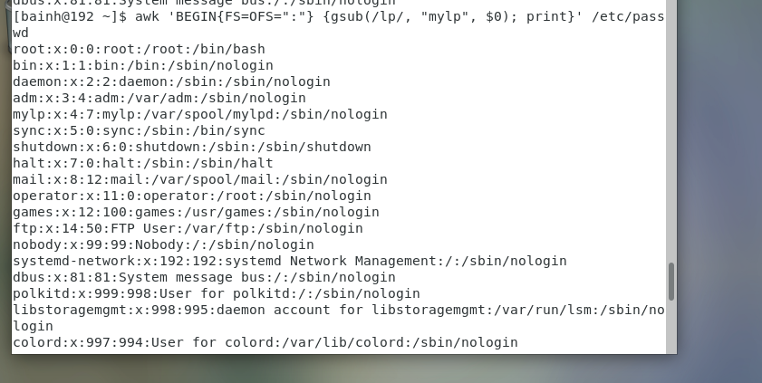

1. Print all information about greatest uid.

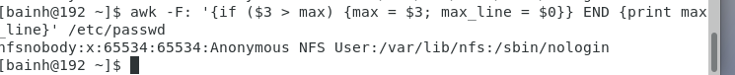

1. Get the sum of all accounts id’s.

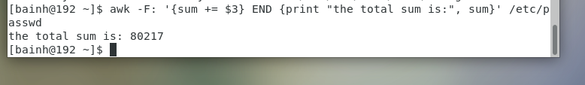

Bonus

Get the sum of accounts id’s that has the same group.

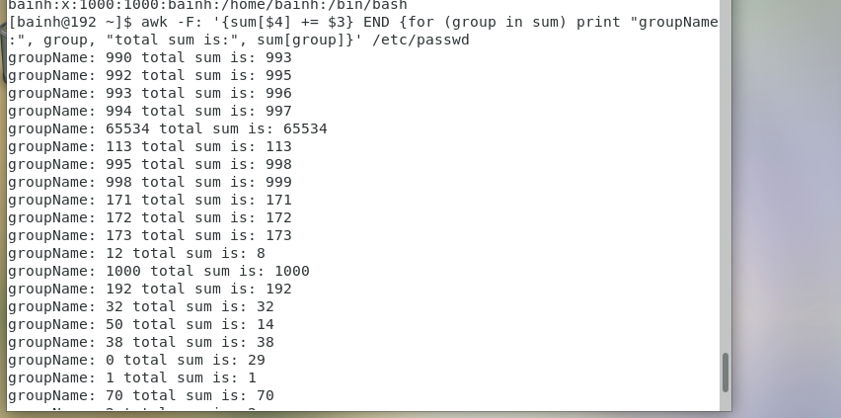

Lab2

1. Create a script that asks for user name then send a greeting to him.

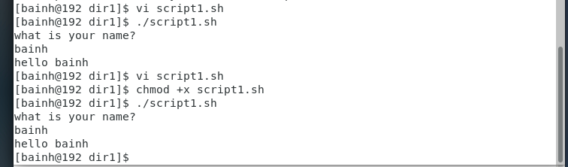

2. Create a script called s1 that calls another script s2 where:

a. In s1 there is a variable called x, it's value 5

b. Try to print the value of x in s2 by two different ways.

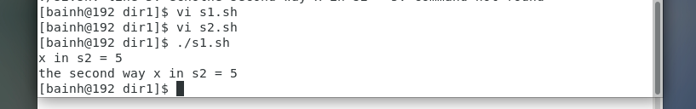

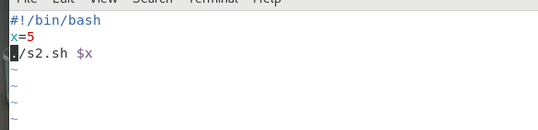

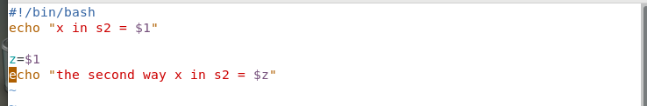

3. Create a script called mycp where:

a. It copies a file to another

b. It copies multiple files to a directory.

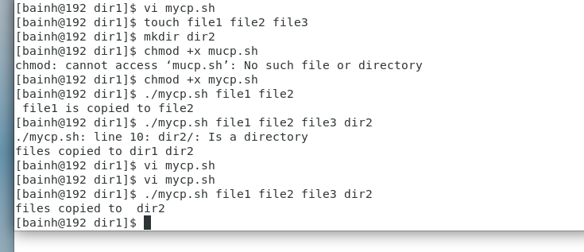

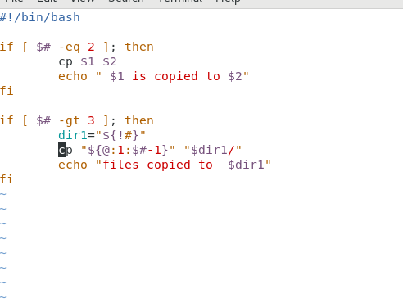

4. Create a script called mycd where:

a. It changed directory to the user home directory, if it is called without arguments.

b. Otherwise, it change directory to the given directory.

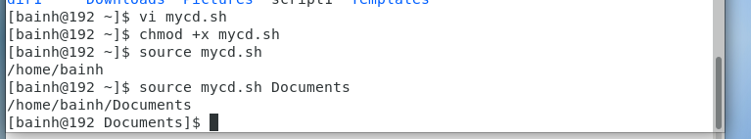

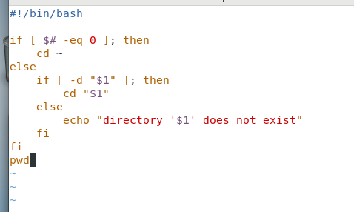

5. Create a script called myls where:

a. It lists the current directory, if it is called without arguments.

b. Otherwise, it lists the given directory.

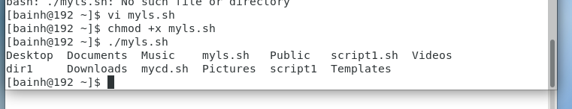

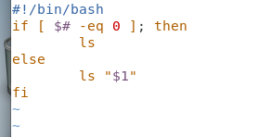

6. Enhance the above script to support the following options individually:

a. –l: list in long format

b. –a: list all entries including the hiding files.

c. –d: if an argument is a directory, list only its name

d. –i: print inode number

e. –R: recursively list subdirectories

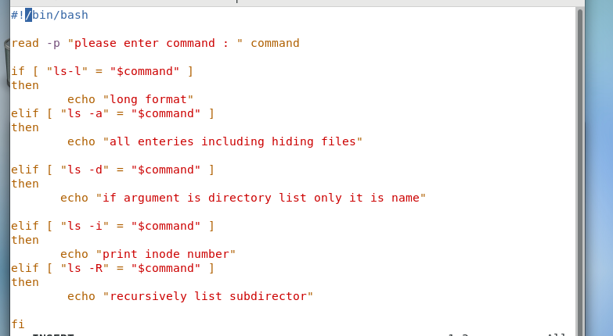

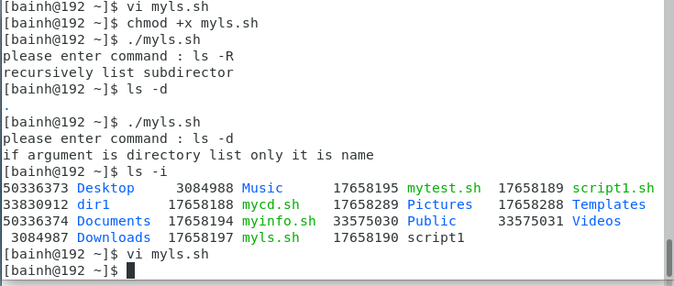

7. Create a script called mytest where:

a. It check the type of the given argument (file/directory)

b. It check the permissions of the given argument (read/write/execute)

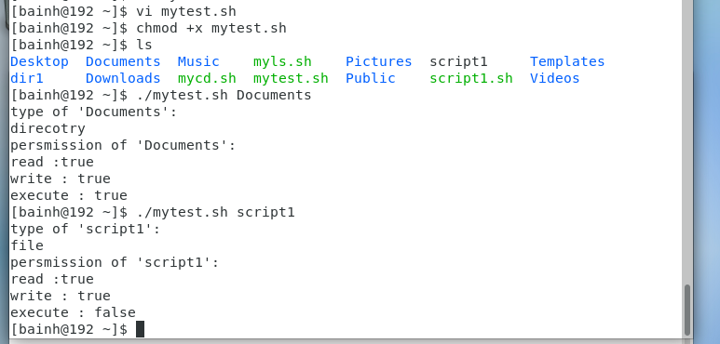

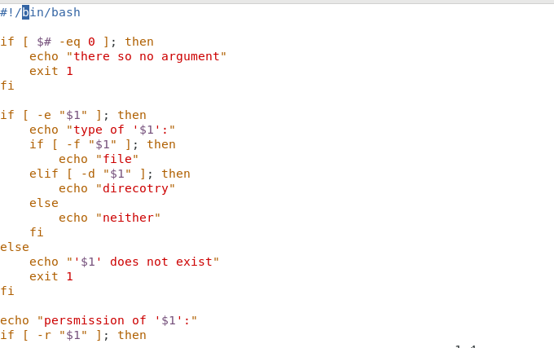

8. Create a script called myinfo where:

a. It asks the user about his/her logname.

b. It print full info about files and directories in his/her home directory

c. Copy his/her files and directories as much as you can in /tmp directory.

d. Gets his current processes status.

