Name: Bainh alaa elden abdelfattah aboraya

1. Use systemctl to view the status of all the system services

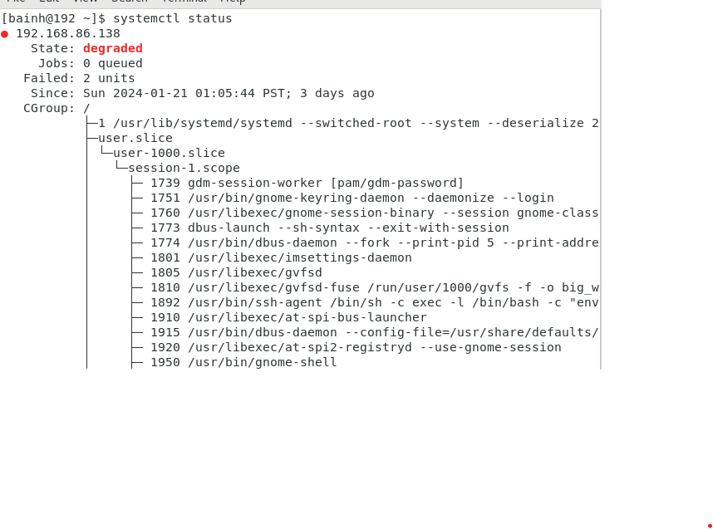

2- Change the default run level back to multi-user.target and reboot

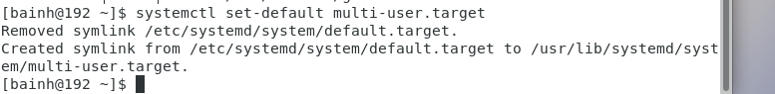

Send mail to the root user

Verify that you have received this mail

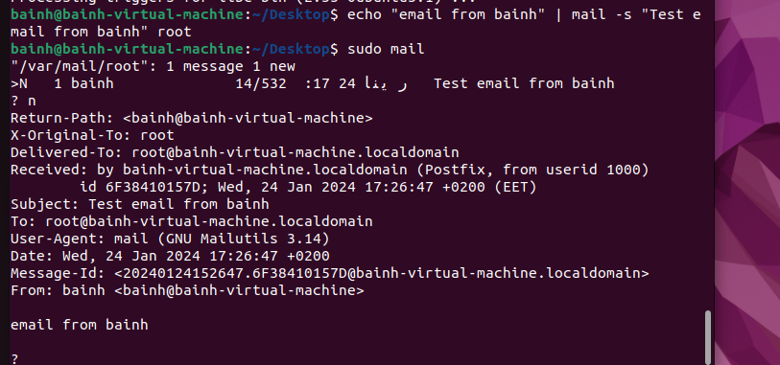

Use systemctl utility to stop postfix service

Send mail again to the root user.

Verify that you have received this mail.

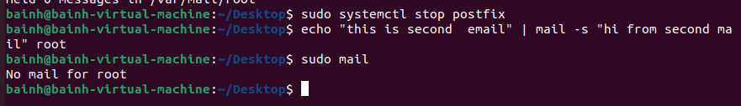

Use systemctl utility to start postfix service

Verify that you have received this mail.

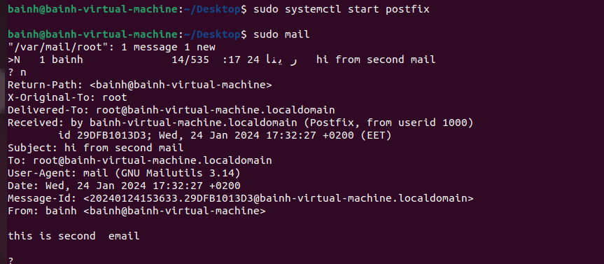

Edit in the GRUB2 configuration file and change the timeout variable equal 20 seconds.

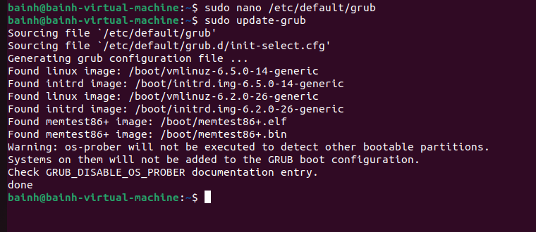



Edit in the GRUB2 configuration file and change your default operating system





1. You want to know some information about the status of the system every ten minutes today between the hours of 8:00 AM and 5:00 PM. to help investigate some performance issues you have been having. You suspect it might be memory related and want to keep an eye on those resources.
2. Use mail as the root user to check for e-mail from the cron jobs you have scheduled
3. How could you send the output from these cron jobs to another e-mail address (the manager user)?

Use mail as the manager user to check for e-mail from the cron jobs you have schedule

