What is the difference between cat and more command?

Cat-> display all data

More-> display some of the data

What is the difference between rm and rmdir using man?

Rm-> delete is full

Rmdir-> if the dir is empty

Create the following hierarchy under your home directory:

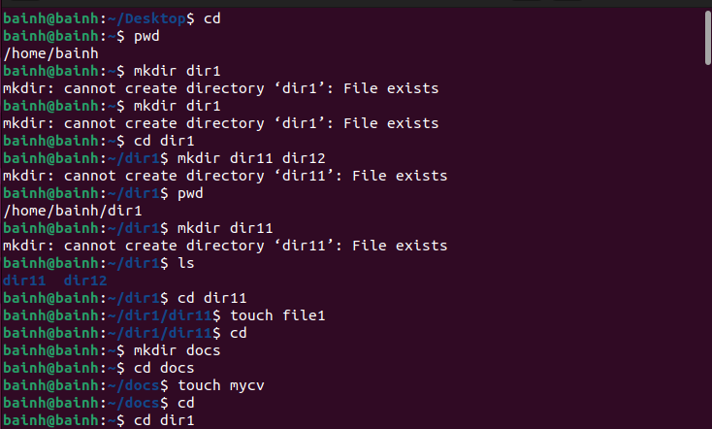

Remove dir11 in one-step. What did you notice? And how did you overcome that?



Then remove dir12 using rmdir –p command. State what happened to the hierarchy (Note: you are in your home directory).

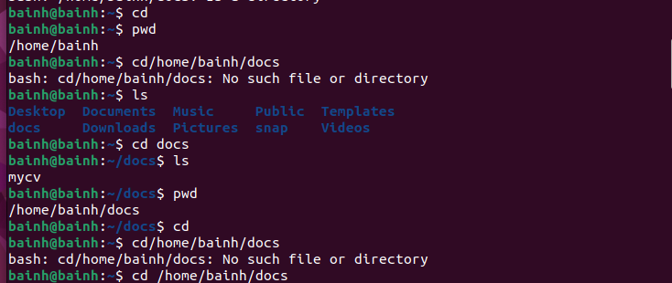

The output of the command pwd was /home/user. Write the absolute and relative path for the file mycv



Copy the /etc/passwd file to your home directory making its name is mypasswd. 6. Rename this new file to be oldpasswd.

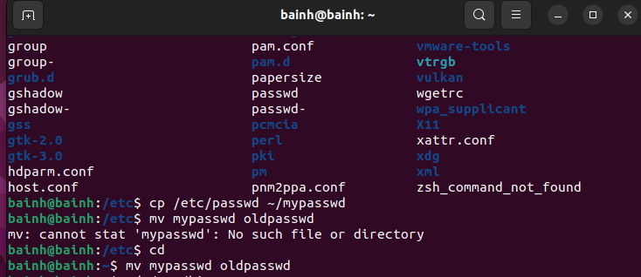

You are in /usr/bin, list four ways to go to your home directory

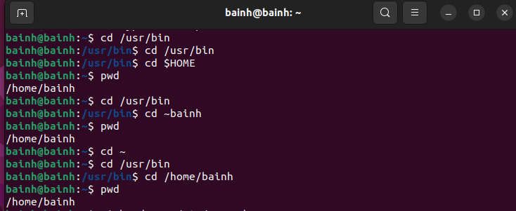

Display the first 4 lines of /etc/passwd 10.Display the last 7 lines of /etc/passwd

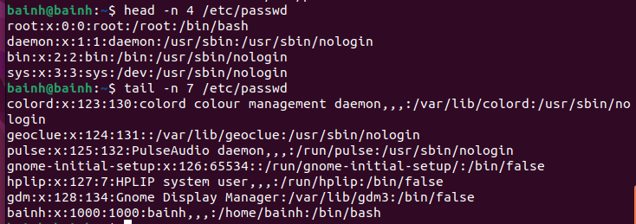

8-

List Linux commands in /usr/bin that start with letter w

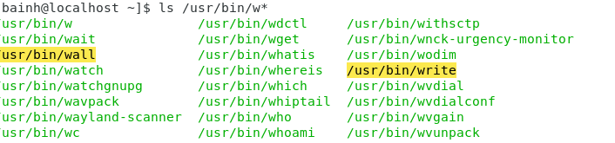

Display the man pages of passwd the command and the file sequentially in one command

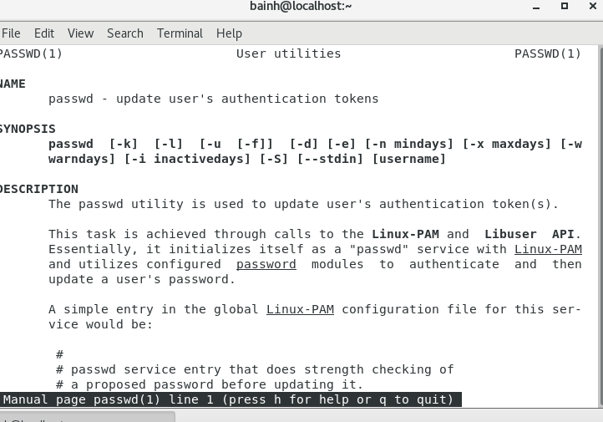

Display the man page of the passwd file.

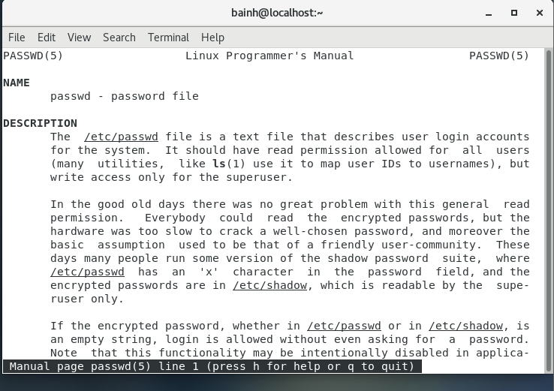

Display a list of all the commands that contain the keyword passwd in their man page.

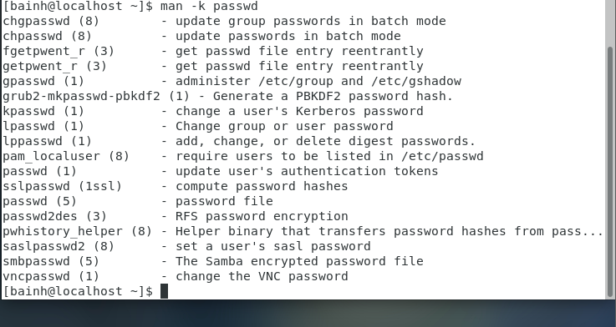

Create a user account with the following attribute

• username: islam

• Fullname/comment: Islam Askar

• Password: islam

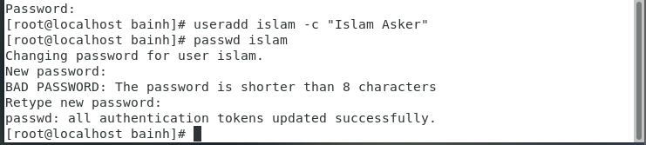

Create a user account with the following attribute

• Username: baduser

• Full name/comment: Bad User

• Password: baduser

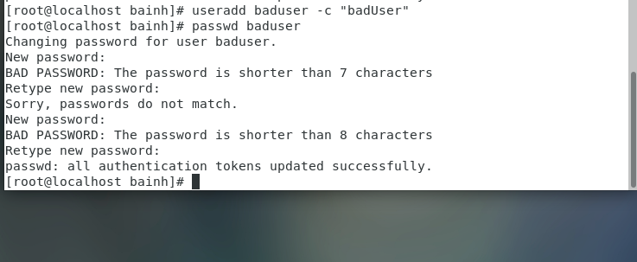

3. Create a supplementary (Secondary) group called pgroup with group ID of 30000

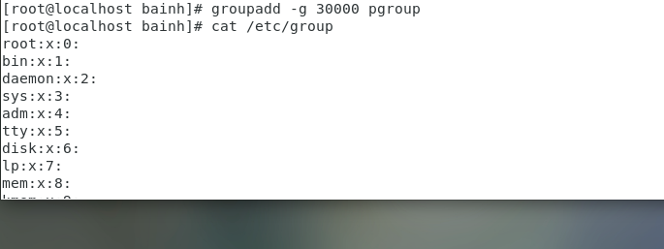

4. Create a supplementary group called badgroup

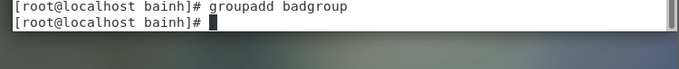

Add islam user to the pgroup group as a supplementary group

6. Modify the password of islam's account to password

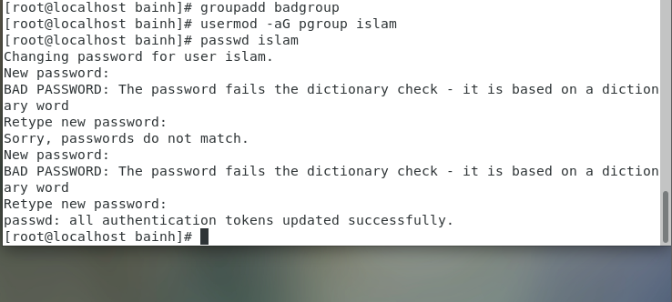

7. Modify islam's account so the password expires after 30 days

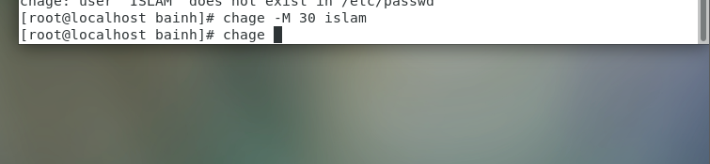

8. Lock bad user account so he can't log in

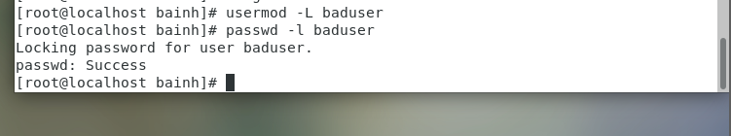

9. Delete bad user account

10. Delete the supplementary group called badgroup.

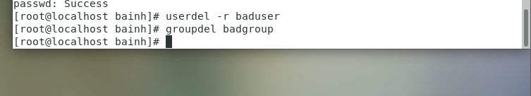

13. Create a folder called myteam in your home directory and change its permissions to read only for the owner.

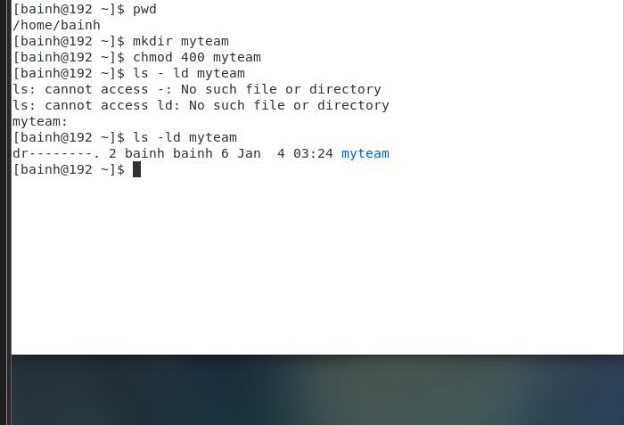

14. Log out and log in by another user

Enter exit to log out

16. Using the command Line

• Change the permissions of oldpasswd file to give owner read and write permissions and for group write and execute and execute only for the others (using chmod in 2 different ways)

• Change your default permissions to be as above.

• What is the maximum permission a file can have, by default when it is just created? And what is that for directory.

• Change your default permissions to be no permission to everyone then create a directory and a file to verify.

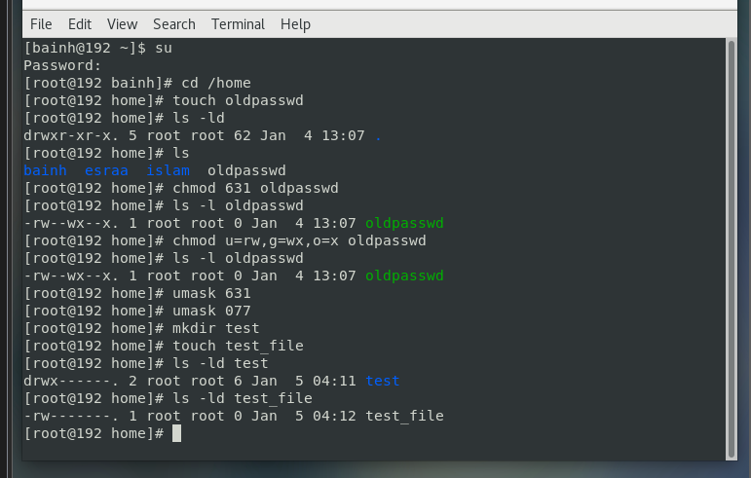

17-What are the minimum permission needed for:

• Copy a directory (permission for source directory and permissions for target parent directory)-----🡪 (r)

• Copy a file (permission for source file and and permission for target parent directory) -------🡪(r)

• Delete a file ----🡪(w)

• Change to a directory -----🡪(x)

• List a directory content (ls command) -----🡪(x)

• View a file content (more/cat command) -------🡪(r)

• Modify a file content -----🡪(w)

18. Create a file with permission 444. Try to edit in it and to remove it? Note what happened.

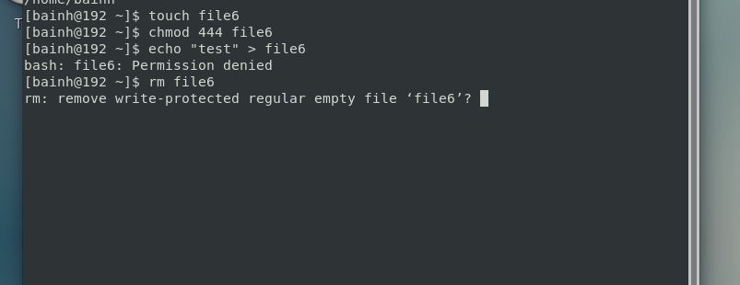

Lab3

1. Using vi write your CV in the file mycv. Your CV should include your name, age, school, college, experience

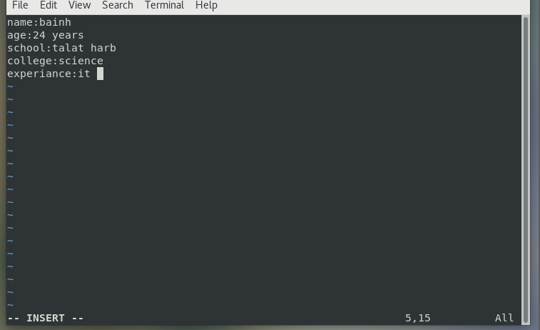

3. List the available shells in your system.

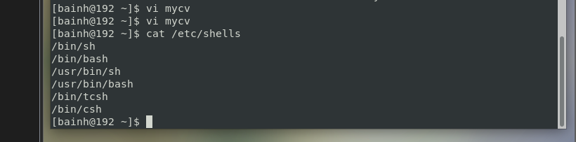

4. List the environment variables in your current shell.

5. List all of the environment variables for the bash shell.

By env or printenv

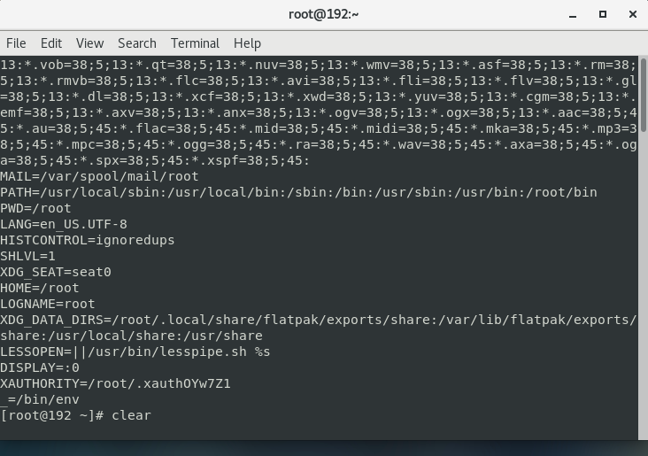

What are the commands that list the value of a specific variable?

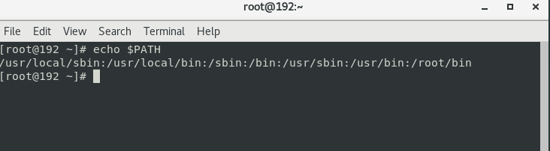

7. Display your current shell name.

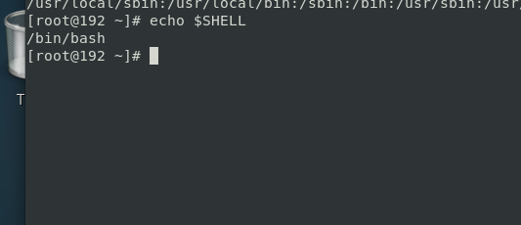

9. Edit in your profile to display date at login and change your prompt permanently.

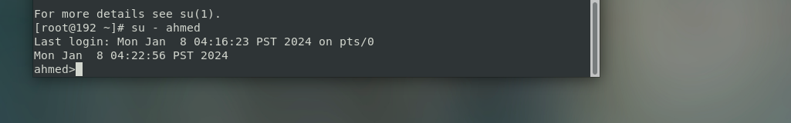

10. Execute the following command :

echo \ then press enter

What is the purpose of \ ?

Notice the prompt ”>” what is that? and how can you change it from “>” to “:”.

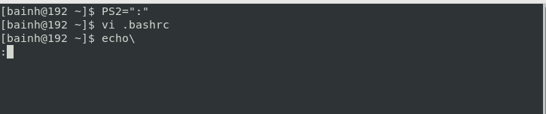

Lab 4

1. List the user commands and redirect the output to /tmp/commands.list

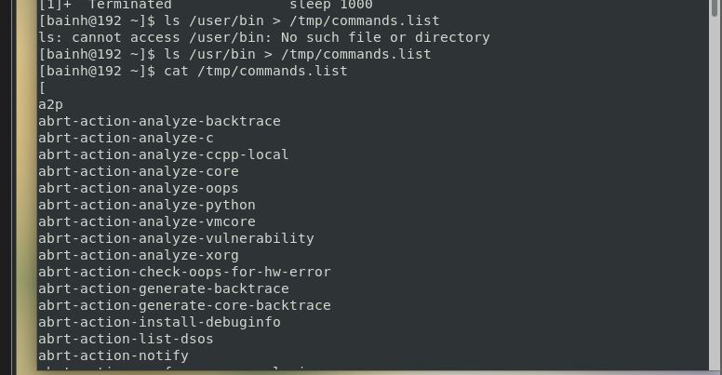

2. Count the number of user commands

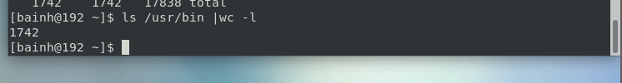

3. Get all the users names whose first character in their login is ‘g’.

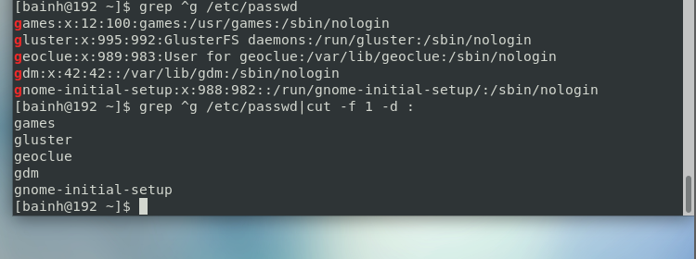

4. Get the logins name and full names (comment) of logins starts with “g”.

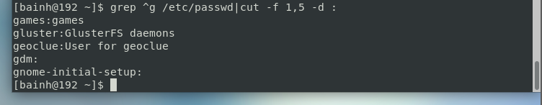

5. Save the output of the last command sorted by their full names in a file.

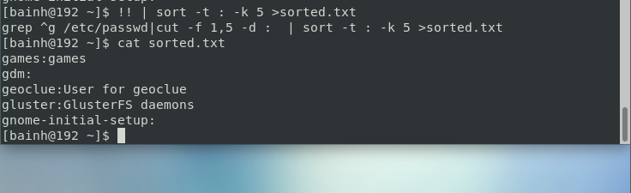

7. Display the number of users who is logged now to the system.

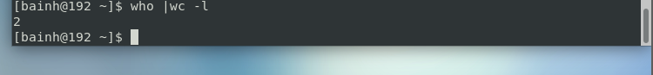

8. Display lines 7 to line 10 of /etc/passwd file

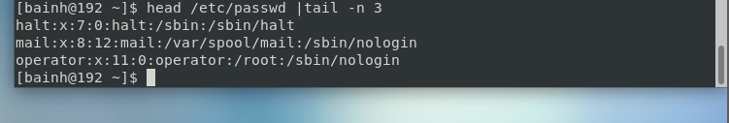

10. Issue the command sleep 100.

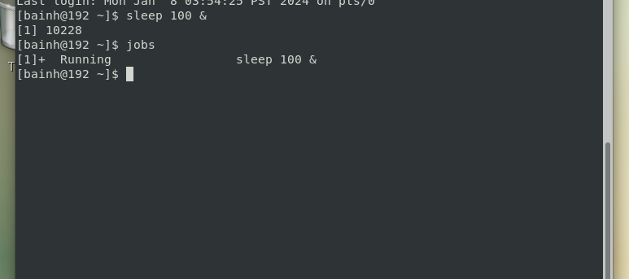

11. Stop the last command.

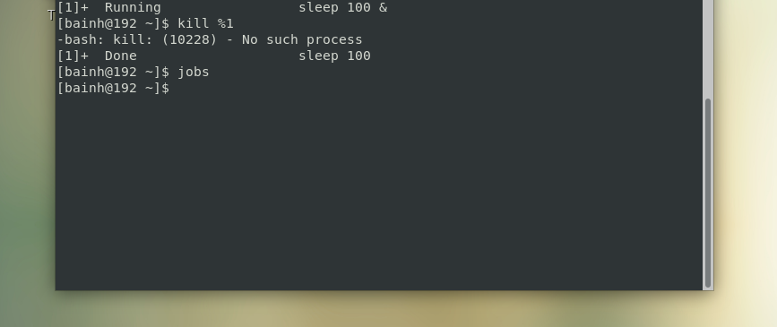

12. Resume the last command in the background

13. Issue the jobs command and see its output.

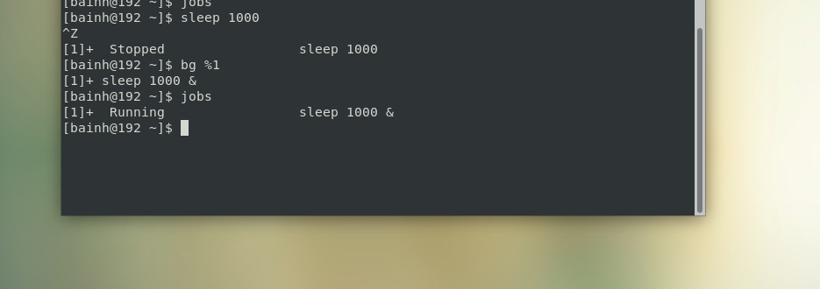

14. Send the sleep command to the foreground and send it again to the background.

 

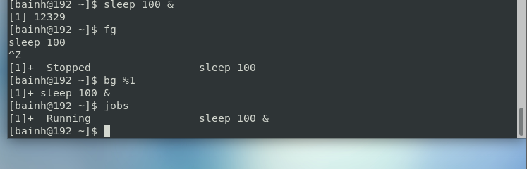

15. Kill the sleep command.

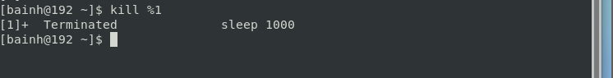

16. Display your processes only

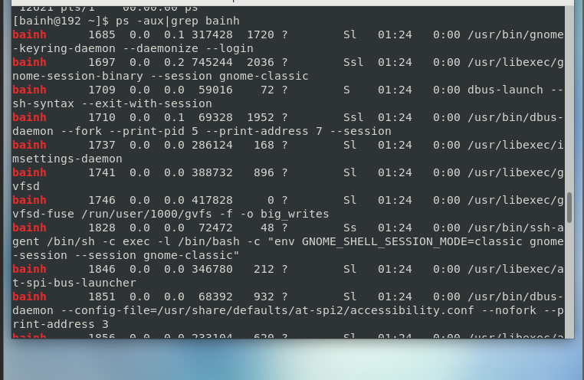

17. Display all processes except yours

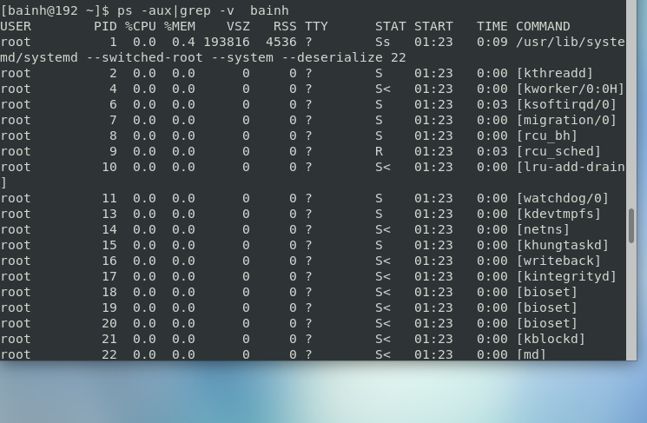

18. Use the pgrep command to list your processes only

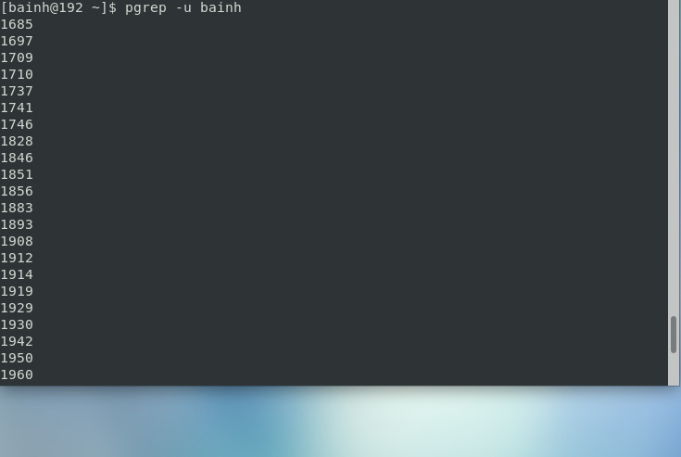

19. Kill your processes only.

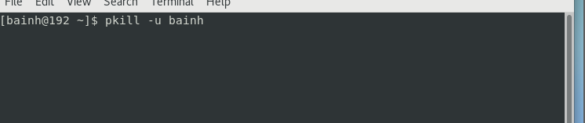

Lab5

1. Compress a file by compress, gzip, zip commands and decompress it again. State the differences between compress and gzip commands.

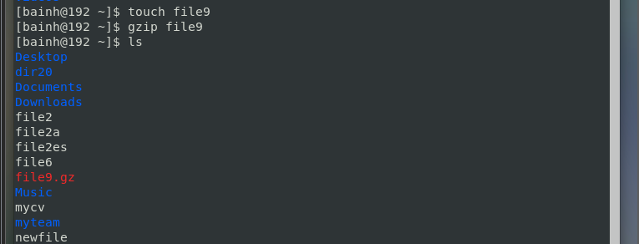



2. What is the command used to view the content of a compressed file.

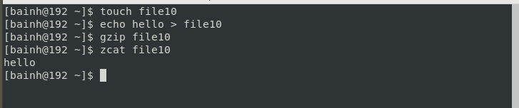

4. Starting from your home directory, find all files that were modified in the last two day.

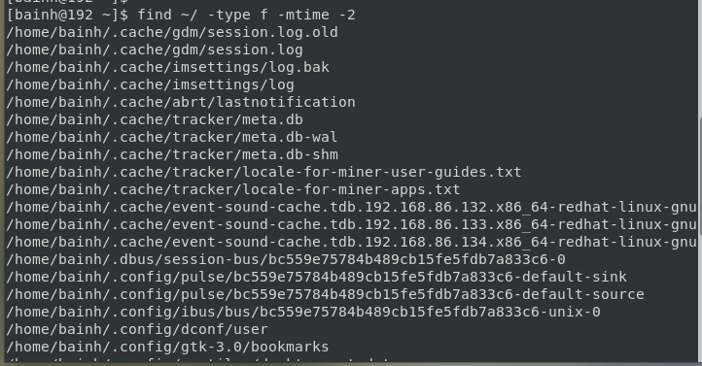

5. Starting from /etc, find files owned by root user.

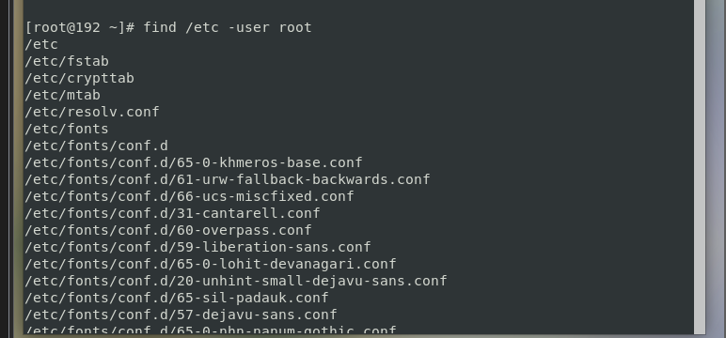

6. Find all directories in your home directory.

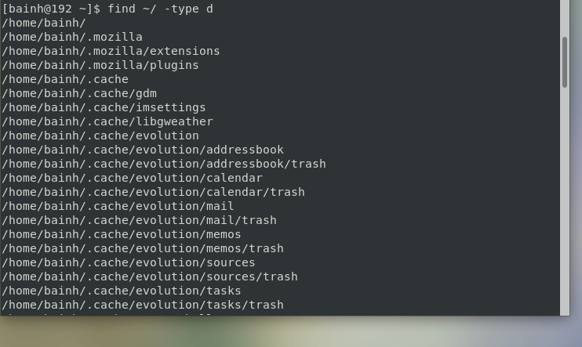

7. Write a command to search for all files on the system that, its name is “.profile”.

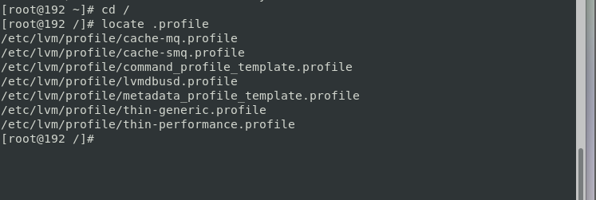

8. Identify the file types of the following: /etc/passwd, /dev/pts/0, /etc, /dev/sda

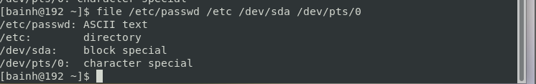

10. Copy /etc/passwd to your home directory, use the commands diff and cmp, and Edit in the file you copied, and then use these commands again, and check the output.

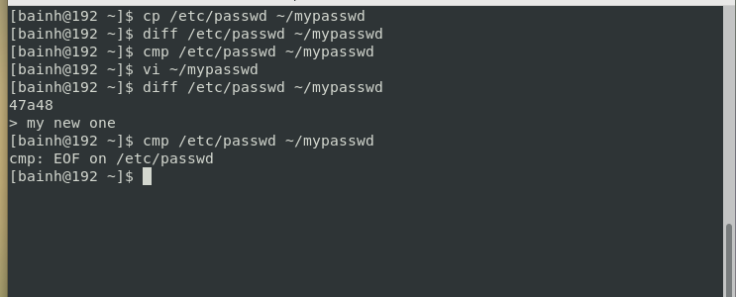

11. Create a symbolic link of /etc/passwd in /boot.

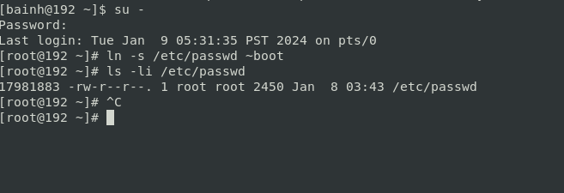

12. Create a hard link of /etc/passwd in /boot. Could you? Why?

