Lab3

1. Using vi write your CV in the file mycv. Your CV should include your name, age, school, college, experience

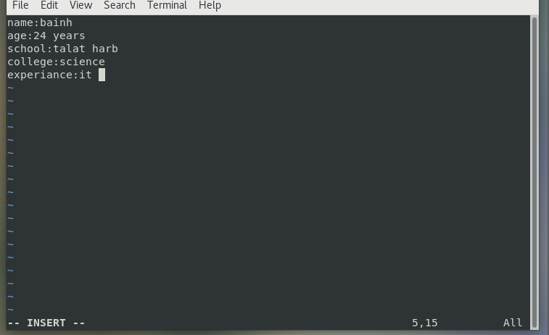

3. List the available shells in your system.

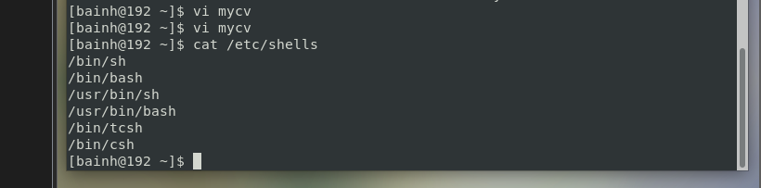

4. List the environment variables in your current shell.

5. List all of the environment variables for the bash shell.

By env or printenv

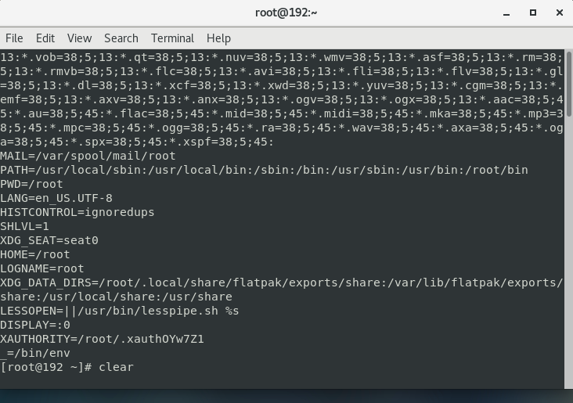

What are the commands that list the value of a specific variable?

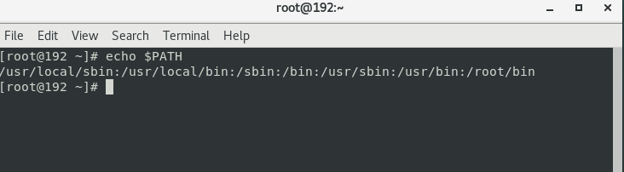

7. Display your current shell name.

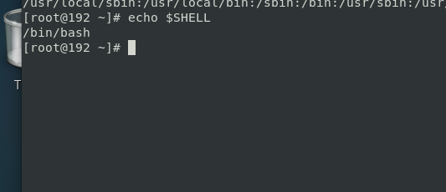

9. Edit in your profile to display date at login and change your prompt permanently.

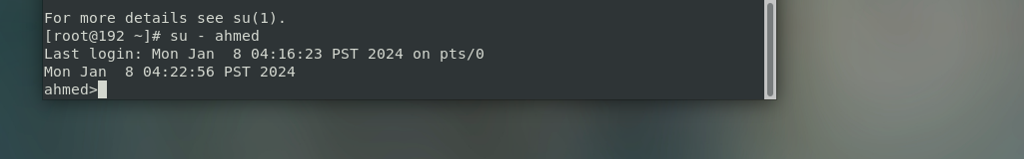

10. Execute the following command :

echo \ then press enter

What is the purpose of \ ?

Notice the prompt ”>” what is that? and how can you change it from “>” to “:”.

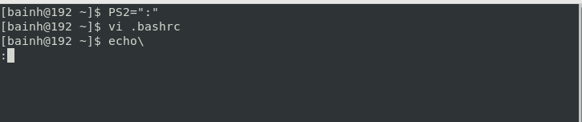

Lab 4

1-List the user commands and redirect the output to /tmp/commands.list

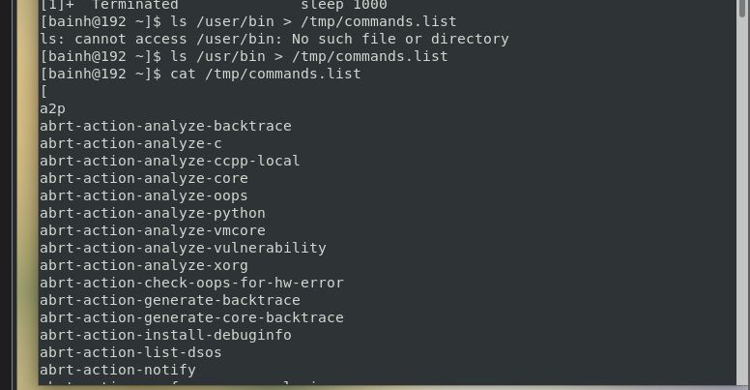

2. Count the number of user commands

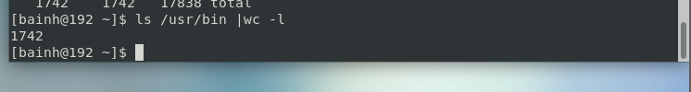

3. Get all the users names whose first character in their login is ‘g’.

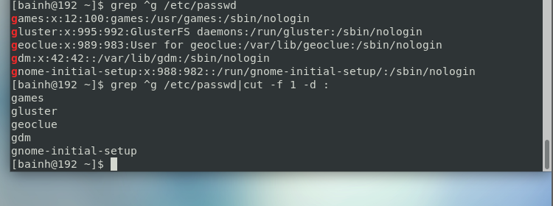

4. Get the logins name and full names (comment) of logins starts with “g”.

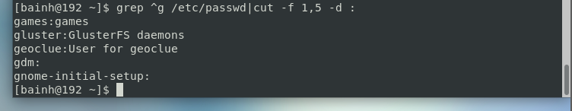

5. Save the output of the last command sorted by their full names in a file.

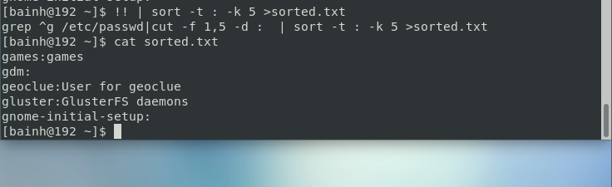

7. Display the number of users who is logged now to the system.

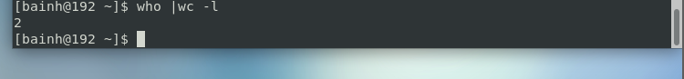

8. Display lines 7 to line 10 of /etc/passwd file

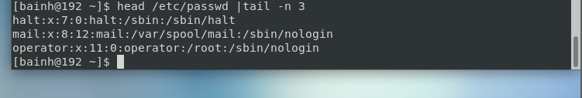

10. Issue the command sleep 100.

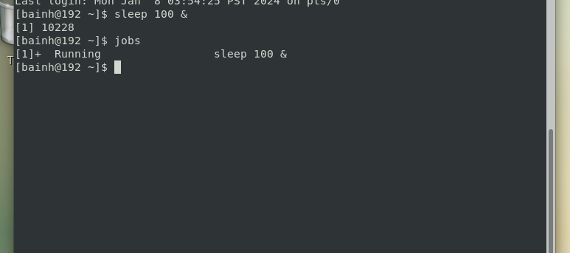

11. Stop the last command.

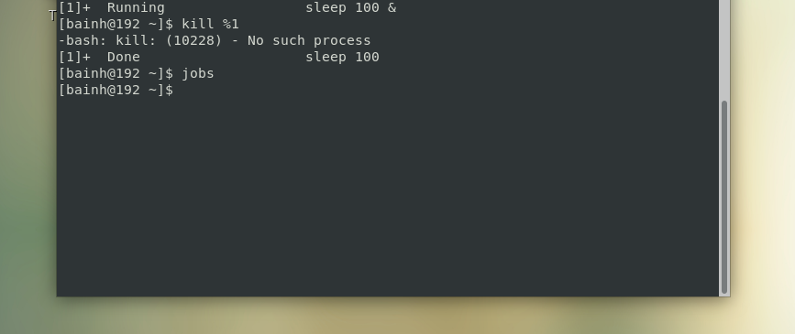

12. Resume the last command in the background

13. Issue the jobs command and see its output.

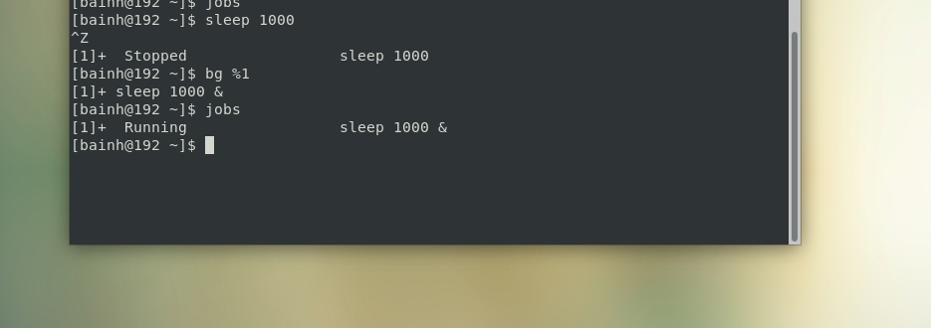

14. Send the sleep command to the foreground and send it again to the background.

 

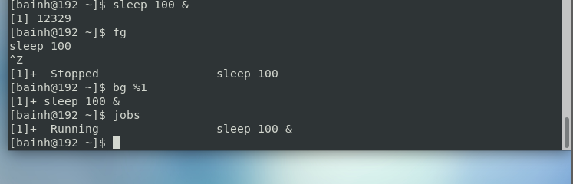

15. Kill the sleep command.

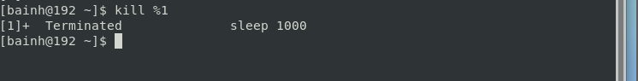

16. Display your processes only

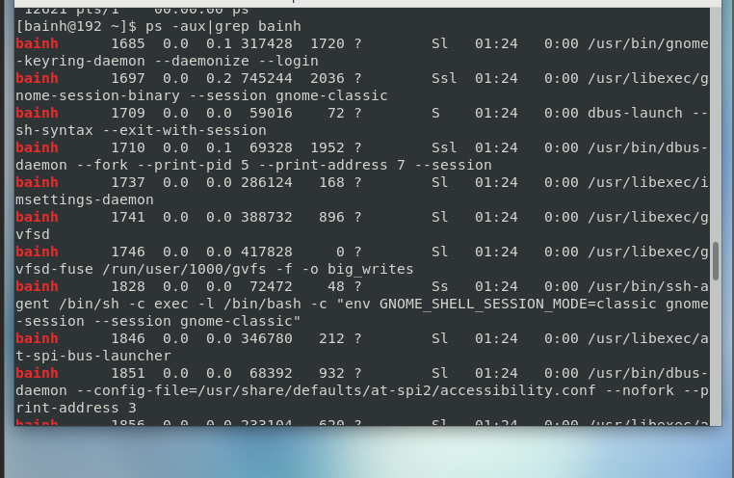

17. Display all processes except yours

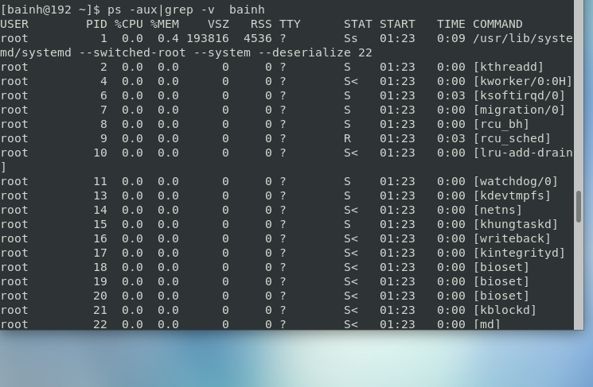

18. Use the pgrep command to list your processes only

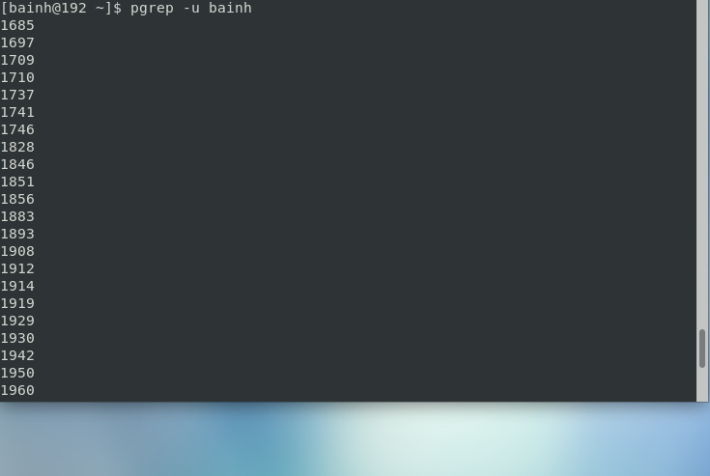

19. Kill your processes only.

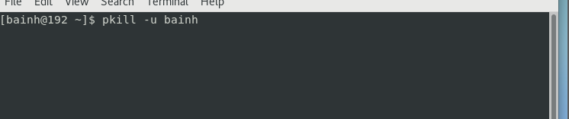

Lab5

1. Compress a file by compress, gzip, zip commands and decompress it again. State the differences between compress and gzip commands.

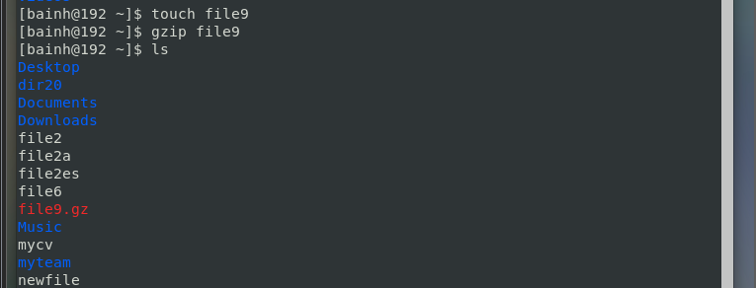

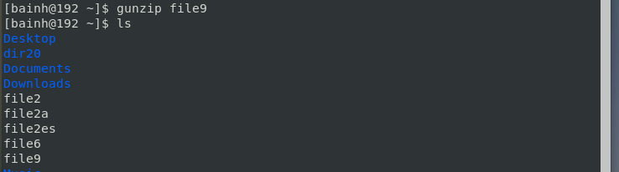

2. What is the command used to view the content of a compressed file.

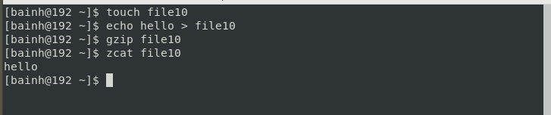

4. Starting from your home directory, find all files that were modified in the last two day.

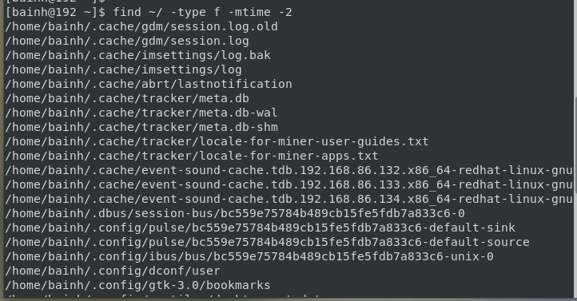

5. Starting from /etc, find files owned by root user.

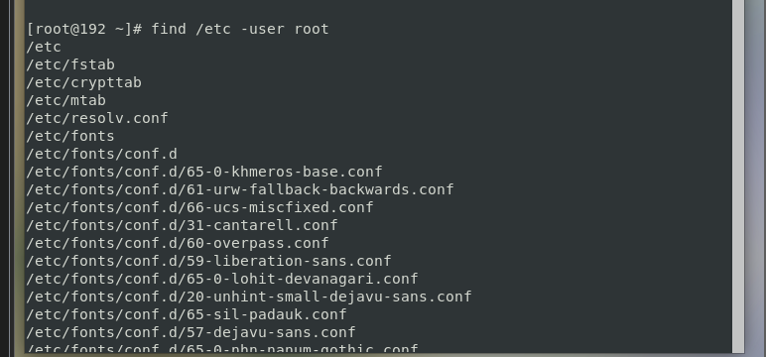

6. Find all directories in your home directory.

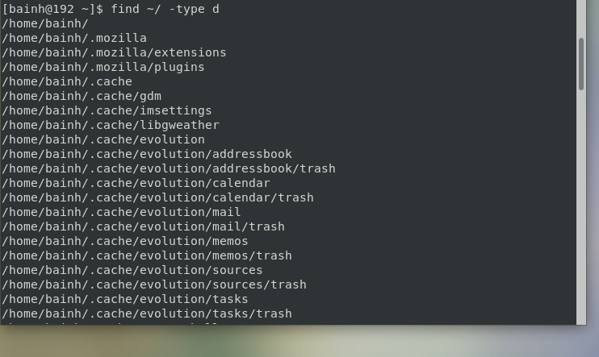

7. Write a command to search for all files on the system that, its name is “.profile”.

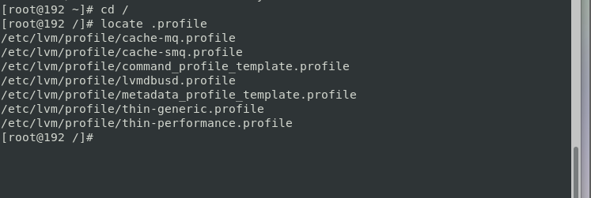

8. Identify the file types of the following: /etc/passwd, /dev/pts/0, /etc, /dev/sda

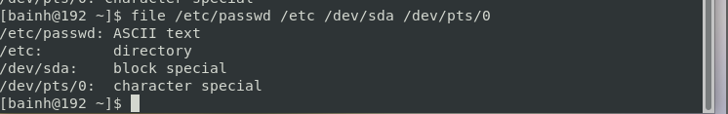

10. Copy /etc/passwd to your home directory, use the commands diff and cmp, and Edit in the file you copied, and then use these commands again, and check the output.

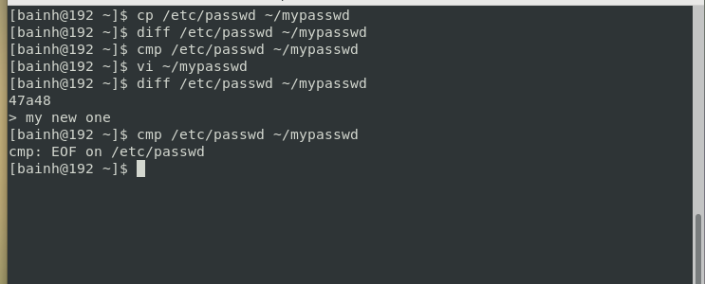

11. Create a symbolic link of /etc/passwd in /boot.

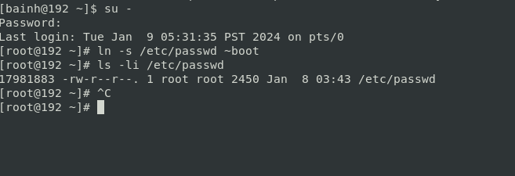

12. Create a hard link of /etc/passwd in /boot. Could you? Why?

