API library/Gem

This document should provide common API to be implemented in different languages like Rails, Php, JAVA etc so that Innowhite Conference software can be integrated into any company very easily.

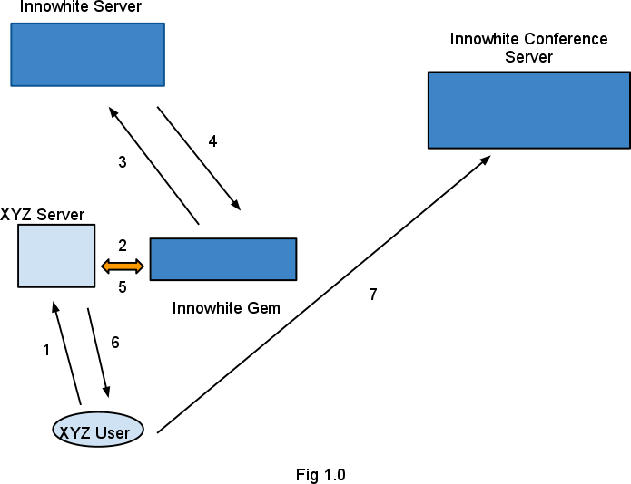

1. A call to create a new room for presenter.
Arguments :
a. moderator name (ex John)
b. orgName (optional)-- by default it is same as parentOrg.
Return value :
a. Room Id
b. URL (this URL will be passed to user so that he needs to be redirected to open in new page.)

Call flow Refer to Fig 1.0

Step 1 : A user of XYZ orgaization clicks on a button to launch a session.

Step 2 : XYZ Server calls a function provided by Innowhite API passing values userId(mandatory), orgName(optional).

Step 3 : Innowhite Gem calls Innowhite Server passing orgName and userId.

Step 4 : Innowhite server returns URL and roomID on Success else returns error code.

Step 5 : Innowhite Gem returns the values(URL , RoomId) to XYZ server.

Step 6 : XYZ server returns the values to the XYZ user.

There will be a confirmation window for the XYZ user to enter some description for the session, where the user enters some text(Mandatory) for the room and also may enter some tag(tags) (ex: English, Rails, Physics).

On clicking submit two things need to happen
a. New window is opened based on the URL from step 6.
b. A request is sent to XYZ server with information like
User Description(optional)
Tags (optional)
RoomID(Mandatory)

2. A call to Join an existing session.

List of live class rooms is displayed to users. This list can show all the live classes or based on tags.

A user clicks on any one of the links and the following needs to happen(Refer to Fig 1.0).

Step 1 : A user of XYZ orgaization clicks on a button to Join a session(sending RoomID).

Step 2 : XYZ Server calls a function provided by Innowhite API passing RoomId & userId.

Step 3 : Innowhite Gem calls Innowhite Server passing RoomId & userId.

Step 4 : Innowhite server returns URL on Success else returns error code.

Step 5 : Innowhite Gem returns the values(URL) to XYZ server.

Step 6 : XYZ server returns the URL to the XYZ user.

There will be a confirmation pop up window for the user and on click will open a new window with the above URL.

3. A call to get List of live sessions.

XYZ server will query to get list of live sesions or passing tags(one or more). Innowhite Gem will query against Innowhite server to get list of sessions.

Arguments :
a. tags (optional)
b. orgName
c. parentOrg
d. live or past.
Return :
a. RoomId
b. Room Description
c. All tags associated witht his room.
d. Room Created by.

either parentOrg or orgName is mandatory. Can have both also.

4. A call to Schedule a session.

XYZ server will query to get list of live sesions or passing tags(one or more). Innowhite Gem

Arguments :
a. tags (optional)
b. orgName
c. parentOrg
d. live or past.

Return :
a. RoomId
b. Room Description
c. All tags associated witht his room.
d. Room Created by.

5. A call to get List of past rooms.

This can be a moderator or a normal user. Can be queried with tags or userId.

Arguments :
a. tags (optional)
b. orgName
c. parentOrg
d. live or past

Return :

Should also include the link to play the video if the sesson has a video(playback) associated.

6. A call to get list of scheduled sessions.

Arguments :
a. tags (optional)
b. orgName
c. parentOrg

Security :

All the communication from XYZ user to XYZ server will be secured by XYZ Authentication mechanism.

All the communication from Innowhite Gem to Innowhite Server will be secured by SHA1 Authentication mechanism.

Every company(XYZ) who installs a gem will supply private key to the Innowhite GEM by properties.

Innowhite server will store private keys and associate them to the orgName & parentOrg.

