- STRUKTUR DATABASE
- Tabel Jabatan
CREATE TABLE jabatan (
id_jabatan SERIAL PRIMARY KEY,
nama_jabatan VARCHAR(100) NOT NULL,
gaji_pokok DECIMAL(12,2) NOT NULL
);

- Tabel Pegawai
CREATE TABLE pegawai (
id_pegawai INT GENERATED ALWAYS AS IDENTITY PRIMARY KEY,
nama VARCHAR(150) NOT NULL,
gelar VARCHAR(20) NOT NULL,
id_jabatan INT NOT NULL,
CONSTRAINT fk_pegawai_jabatan
FOREIGN KEY (id_jabatan)
REFERENCES jabatan(id_jabatan)
ON UPDATE CASCADE
ON DELETE RESTRICT
);

- Tabel Presensi
CREATE TABLE presensi (
id_presensi INT GENERATED ALWAYS AS IDENTITY PRIMARY KEY,
id_pegawai INT NOT NULL,
tanggal DATE NOT NULL,
status_hadir VARCHAR(10) NOT NULL
CHECK (status_hadir IN ('hadir', 'alpa')),
jam_masuk TIME,
jam_keluar TIME,
jam_masuk_normal TIME NOT NULL DEFAULT '09:00:00',
jam_keluar_normal TIME NOT NULL DEFAULT '17:00:00',
terlambat_menit INT NOT NULL DEFAULT 0,
lembur_menit INT NOT NULL DEFAULT 0,

CONSTRAINT fk_presensi_pegawai
FOREIGN KEY (id_pegawai)
REFERENCES pegawai(id_pegawai)
ON UPDATE CASCADE
ON DELETE CASCADE,

CONSTRAINT uq_presensi_pegawai_tanggal
UNIQUE (id_pegawai, tanggal)
);
2. SOAL TEST PROGRAMMER
- Sorting Pegawai Berdasarkan Gelar Pendidikan ( Query )

SELECT *
FROM pegawai
ORDER BY
CASE gelar
WHEN 'D3' THEN 1
WHEN 'S1' THEN 2
WHEN 'S2' THEN 3
END ASC;
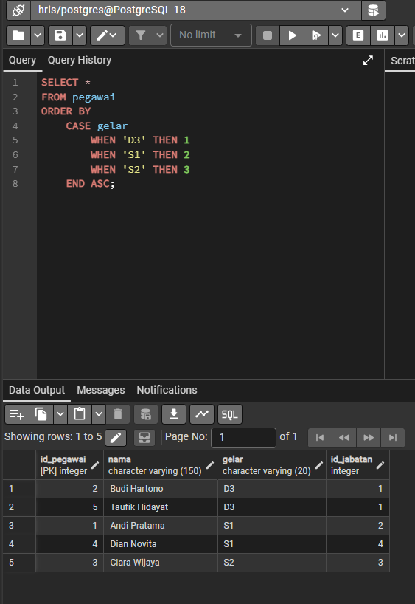

- Hitung Total Potongan Presensi Pegawai ( Query )
SELECT
p.id_pegawai,
p.nama,

SUM(
CASE
WHEN pr.status_hadir = 'alpa' THEN 100000
ELSE 0
END
) AS potongan_alpa,

COALESCE(SUM(pr.terlambat_menit), 0) * 2000 AS potongan_terlambat,

SUM(
CASE
WHEN pr.status_hadir = 'alpa' THEN 100000
ELSE 0
END
)
+
COALESCE(SUM(pr.terlambat_menit), 0) * 2000
AS total_potongan

FROM pegawai p
JOIN presensi pr
ON p.id_pegawai = pr.id_pegawai

GROUP BY
p.id_pegawai,
p.nama

ORDER BY
p.id_pegawai;
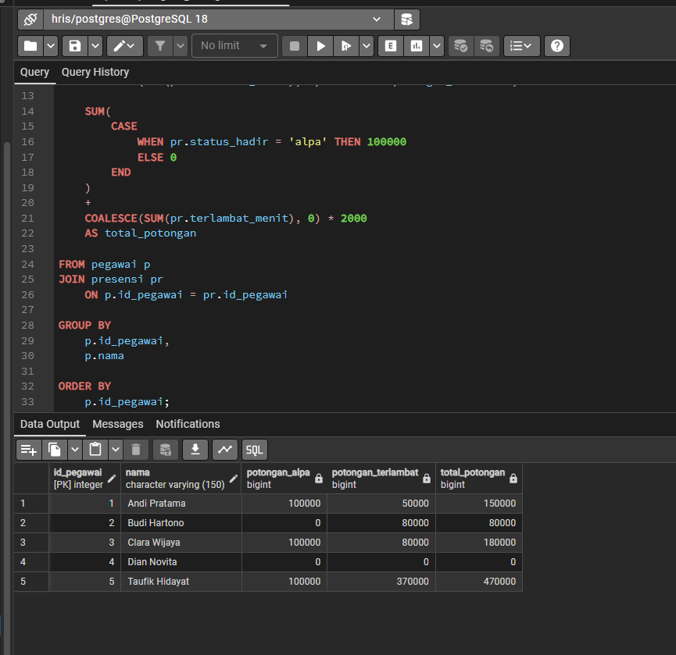

- Hitung Total Lembur Pegawai ( Query )
SELECT
p.id_pegawai,
p.nama,

COALESCE(SUM(pr.lembur_menit), 0) AS total_lembur_menit,

COALESCE(SUM(pr.lembur_menit), 0) * 1000
AS total_uang_lembur

FROM pegawai p
JOIN presensi pr
ON p.id_pegawai = pr.id_pegawai

GROUP BY
p.id_pegawai,
p.nama

ORDER BY
p.id_pegawai;
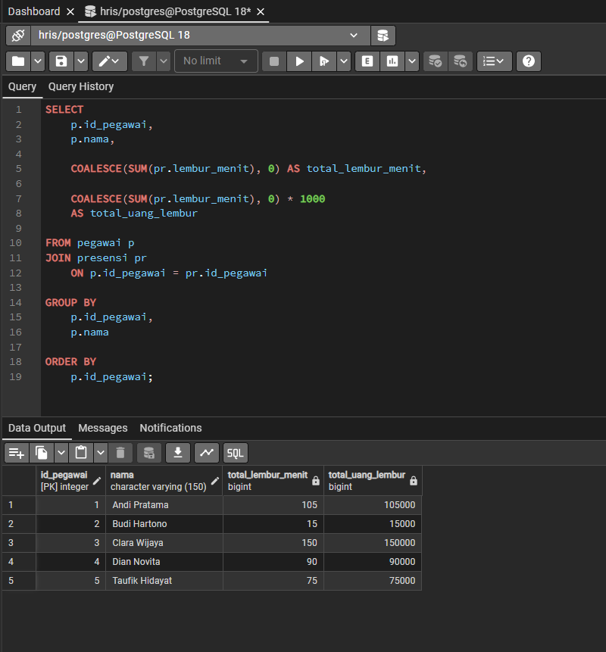

- Hitung Gaji Bersih Pegawai ( Query )

SELECT
p.nama AS pegawai,
j.nama_jabatan AS jabatan,
j.gaji_pokok,

(
SUM(
CASE
WHEN pr.status_hadir = 'alpa' THEN 100000
ELSE 0
END
)
+
COALESCE(SUM(pr.terlambat_menit), 0) * 2000
) AS total_potongan,

COALESCE(SUM(pr.lembur_menit), 0) * 1000
AS total_lembur,

(
j.gaji_pokok
-
(
SUM(
CASE
WHEN pr.status_hadir = 'alpa' THEN 100000
ELSE 0
END
)
+
COALESCE(SUM(pr.terlambat_menit), 0) * 2000
)
+
COALESCE(SUM(pr.lembur_menit), 0) * 1000
) AS gaji_bersih

FROM pegawai p
JOIN jabatan j
ON p.id_jabatan = j.id_jabatan
JOIN presensi pr
ON p.id_pegawai = pr.id_pegawai

GROUP BY
p.id_pegawai,
p.nama,
j.nama_jabatan,
j.gaji_pokok

ORDER BY
p.id_pegawai;

