UNITED STATES OF AMERICA
FEDERAL ENERGY REGULATORY COMMISSION
Northern Natural Gas Company Docket No. CP26-534-000
NOTICE OF SCOPING PERIOD REQUESTING COMMENTS ON ENVIRONMENTAL ISSUES
FOR THE PROPOSED PERMIAN BASIN EXPANSION PROJECT

(July 8, 2026)

The staff of the Federal Energy Regulatory Commission (FERC or Commission) will prepare an environmental document that will discuss the environmental impacts of the Permian Basin Expansion Project involving construction and operation of facilities by Northern Natural Gas Company (Northern) in Lea County, New Mexico and Yoakum and Gaines Counties, Texas. The Commission will use this environmental document in its decision-making process to determine whether the project is in the public convenience and necessity.

This notice announces the opening of the scoping process the Commission will use to gather input from the public and interested agencies regarding the project. As part of the National Environmental Policy Act (NEPA) review process, the Commission takes into account concerns the public may have about proposals and the environmental impacts that could result from its action whenever it considers the issuance of a Certificate of Public Convenience and Necessity. This gathering of public input is referred to as “scoping.” The main goal of the scoping process is to focus the analysis in the environmental document on the important environmental issues. Additional information about the Commission’s NEPA process is described below in the NEPA Process and Environmental Document section of this notice.

By this notice, the Commission requests public comments on the scope of issues to address in the environmental document. To ensure that your comments are timely and properly recorded, please submit your comments so that the Commission receives them in Washington, DC on or before 5:00 pm Eastern Time on August 10, 2026. Comments may be submitted in written form. Further details on how to submit comments are provided in the Public Participation section of this notice.

Your comments should focus on the potential environmental effects, reasonable alternatives, and measures to avoid or lessen environmental impacts. Your input will help the Commission staff determine what issues they need to evaluate in the environmental document. Commission staff will consider all written comments during the preparation of the environmental document.

If you submitted comments on this project to the Commission before the opening of this docket on May 28, 2026, you will need to file those comments in Docket No. CP26-534-000 to ensure they are considered as part of this proceeding.

This notice is being sent to the Commission’s current environmental mailing list for this project. State and local government representatives should notify their constituents of this proposed project and encourage them to comment on their areas of concern.

If you are a landowner receiving this notice, a pipeline company representative may contact you about the acquisition of an easement to construct, operate, and maintain the proposed facilities. The company would seek to negotiate a mutually acceptable easement agreement. You are not required to enter into an agreement. However, if the Commission approves the project, the Natural Gas Act conveys the right of eminent domain to the company. Therefore, if you and the company do not reach an easement agreement, the pipeline company could initiate condemnation proceedings in court. In such instances, compensation would be determined by a judge in accordance with state law. The Commission does not subsequently grant, exercise, or oversee the exercise of that eminent domain authority. The courts have exclusive authority to handle eminent domain cases; the Commission has no jurisdiction over these matters.

Northern provided landowners with a fact sheet prepared by the FERC entitled “An Interstate Natural Gas Facility On My Land? What Do I Need To Know?” which addresses typically asked questions, including the use of eminent domain and how to participate in the Commission’s proceedings. This fact sheet along with other landowner topics of interest are available for viewing on the FERC website (www.ferc.gov) under the Natural Gas, Landowner Topics link.

Public Participation

There are three methods you can use to submit your comments to the Commission. Please carefully follow these instructions so that your comments are properly recorded. The Commission encourages electronic filing of comments and has staff available to assist you at (866) 208-3676 or FercOnlineSupport@ferc.gov.

- You can file your comments electronically using the eComment feature, which is located on the Commission’s website (www.ferc.gov) under the link to FERC Online. Using eComment is an easy method for submitting brief, text-only comments on a project;

- You can file your comments electronically by using the eFiling feature, which is located on the Commission’s website (www.ferc.gov) under the link to FERC Online. With eFiling, you can provide comments in a variety of formats by attaching them as a file with your submission. New eFiling users must first create an account by clicking on “eRegister.” You will be asked to select the type of filing you are making; a comment on a particular project is considered a “Comment on a Filing”; or

- You can file a paper copy of your comments by mailing them to the Commission. Be sure to reference the project docket number (CP26-534-000) on your letter. Submissions sent via the U.S. Postal Service must be addressed to: Debbie-Anne A. Reese, Secretary, Federal Energy Regulatory Commission, 888 First Street NE, Room 1A, Washington, DC 20426. Submissions sent via any other carrier must be addressed to: Debbie-Anne A. Reese, Secretary, Federal Energy Regulatory Commission, 12225 Wilkins Avenue, Rockville, MD 20852.

Additionally, the Commission offers a free service called eSubscription which makes it easy to stay informed of all issuances and submittals regarding the dockets/projects to which you subscribe. These instant email notifications are the fastest way to receive notification and provide a link to the document files which can reduce the amount of time you spend researching proceedings. Go to https://www.ferc.gov/ferc-online/overview to register for eSubscription.

For public inquiries and assistance with making filings such as interventions, comments, or requests for rehearing, contact the Office of Public Participation at (202) 502-6595 or OPP@ferc.gov.

Summary of the Proposed Project

Northern proposes to construct and operate approximately 16.2 miles of interstate, natural gas transmission pipeline and associated facilities, and a new compressor station, in New Mexico and Texas. Northern also proposes to modify facilities within the fence line of the existing Plains compressor station in Yoakum County, Texas. The Permian Basin Expansion Project would provide about 361,600 dekatherms per day of firm natural gas transportation service to a new natural gas-fired generation facility located in Gaines County, Texas.

The Permian Basin Expansion Project would consist of the following facilities:

- approximately 15.1 miles of 24-inch-diameter pipeline and 1.1 miles of 16-inch-diameter pipeline;
- a new compressor station consisting of one 7,700 horsepower natural gas-fired compressor unit and two pig launchers;
- an interconnect with Transwestern Pipeline Company, LLC within the existing Phillip 66 Linam Ranch Plant;
- a new pig receiver within Northern’s existing launcher facility;
- replacing an existing recycle valve and associated equipment within Northern’s Plains Compressor Station and installing associated equipment within Northern’s expanded facility south of the Plains Compressor Station; and
- a new delivery point at the Southwestern Public Service Company Gaines County Generating Station.

The general location of the project facilities is shown in appendix 1.

Land Requirements for Construction

Construction of the proposed facilities would disturb about 355.7 acres of land for the pipeline and above-ground facilities. Following construction, Northern would maintain about 110.1 acres of land for permanent operation of the project’s facilities; the remaining acreage would be restored and revert to former uses. About six percent of the proposed pipeline route parallels existing pipeline, utility, or road rights-of-way.

NEPA Process and the Environmental Document

Any environmental document issued by the Commission will discuss impacts that could occur as a result of the construction and operation of the proposed project under the relevant general resource areas:

- geology and soils;
- water resources and wetlands;
- vegetation and wildlife;
- threatened and endangered species;
- cultural resources;
- socioeconomics;
- land use;
- air quality and noise; and
- reliability and safety.

Commission staff will also evaluate reasonable alternatives to the proposed project or portions of the project and make recommendations on how to lessen or avoid impacts on the various resource areas. Your comments will help Commission staff identify and focus on the issues that might have an effect on the human environment and potentially eliminate others from further study and discussion in the environmental document.

Following this scoping period, Commission staff will determine whether to prepare an Environmental Assessment (EA) or an Environmental Impact Statement (EIS). The EA or the EIS will present Commission staff’s independent analysis of the issues. If Commission staff prepares an EA, a Notice of Schedule for the Preparation of an Environmental Assessment will be issued. The EA may be issued for an allotted public comment period. The Commission would consider timely comments on the EA before making its decision regarding the proposed project. If Commission staff prepares an EIS, a Notice of Intent to Prepare an EIS/Notice of Schedule will be issued, which will open up an additional comment period. Staff will then prepare a draft EIS which will be issued for public comment. Commission staff will consider all timely comments received during the comment period on the draft EIS and revise the document, as necessary, before issuing a final EIS. Any EA or draft and final EIS will be available in electronic format in the public record through eLibrary and the Commission’s natural gas environmental documents webpage (https://www.ferc.gov/industries-data/natural-gas/environment/environmental-documents). If eSubscribed, you will receive instant email notification when the environmental document is issued.

With this notice, the Commission is asking agencies with jurisdiction by law and/or special expertise with respect to the environmental issues of this project to formally cooperate in the preparation of the environmental document. Agencies that would like to request cooperating agency status should follow the instructions for filing comments provided under the Public Participation section of this notice.

Consultation Under Section 106 of the National Historic Preservation Act

In accordance with the Advisory Council on Historic Preservation’s implementing regulations for section 106 of the National Historic Preservation Act, the Commission is using this notice to initiate consultation with the applicable State Historic Preservation Office(s), and to solicit their views and those of other government agencies, interested Indian tribes, and the public on the project’s potential effects on historic properties. The environmental document for this project will document findings on the impacts on historic properties and summarize the status of consultations under section 106.

Environmental Mailing List

The environmental mailing list includes federal, state, and local government representatives and agencies; elected officials; Native American Tribes; environmental and public interest groups; other interested parties; and local libraries and media outlets. This list also includes all affected landowners (as defined in the Commission’s regulations) who are potential right-of-way grantors, whose property may be used temporarily for project purposes, or who own homes within certain distances of aboveground facilities, and anyone who submits comments on the project and includes a mailing address with their comments. Commission staff will update the environmental mailing list as the analysis proceeds to ensure that Commission notices related to this environmental review are sent to all individuals, organizations, and government entities interested in and/or potentially affected by the proposed project.

If you need to make changes to your name/address, or if you would like to remove your name from the mailing list, please complete one of the following steps:

- Send an email to GasProjectAddressChange@ferc.gov stating your request. You must include the docket number CP26-534-000 in your request. If you are requesting a change to your address, please be sure to include your name and the correct address. If you are requesting to delete your address from the mailing list, please include your name and address as it appeared on this notice. This e-mail address is unable to accept comments.

OR

- Return the attached “Mailing List Update Form” (appendix 2).

Additional Information

Additional information about the project is available from the FERC website at www.ferc.gov using the eLibrary link. Click on the eLibrary link, click on “General Search” and enter the docket number in the “Docket Number” field. Be sure you have selected an appropriate date range. For assistance, please contact FERC Online Support at FercOnlineSupport@ferc.gov or (866) 208-3676, or for TTY, contact (202) 502-8659. The eLibrary link also provides access to the texts of all formal documents issued by the Commission, such as orders, notices, and rulemakings.

Public sessions or site visits will be posted on the Commission’s calendar located at https://www.ferc.gov/news-events/events along with other related information.

(Authority: 18 CFR 2.1)

Debbie-Anne A. Reese,
Secretary.

Appendix 1

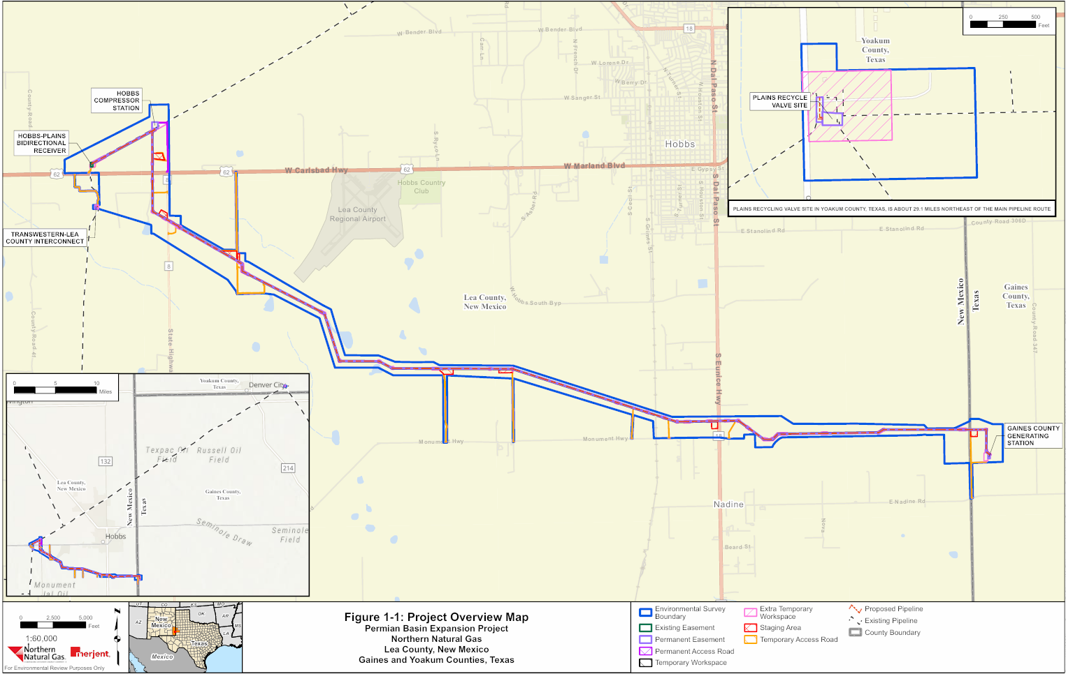

Appendix 2

MAILING LIST UPDATE FORM
Permian Basin Expansion Project

Name
Agency
Address
City State Zip Code
□ Please update the mailing list
□ Please remove my name from the mailing list

FROM

ATTN: OEP - Gas 5, PJ - 11.5
Federal Energy Regulatory Commission
888 First Street NE
Washington, DC 20426

CP26-534-000 Permian Basin Expansion Project

Staple or Tape Here

A “pig” is a tool that the pipeline company inserts into and pushes through the pipeline for cleaning the pipeline, conducting internal inspections, or other purposes.
The appendices referenced in this notice will not appear in the Federal Register. Copies of the appendices were sent to all those receiving this notice in the mail and are available at www.ferc.gov using the link called “eLibrary.” For instructions on connecting to eLibrary, refer to the last page of this notice. For assistance, contact FERC at FERCOnlineSupport@ferc.gov or call toll free, (886) 208-3676 or TTY (202) 502-8659.
For instructions on connecting to eLibrary, refer to the last page of this notice.
Cooperating agency responsibilities are addressed in Section 107(a)(3) of NEPA (42 U.S.C. § 4336(a)(3)).
The Advisory Council on Historic Preservation’s regulations are at Title 36, Code of Federal Regulations, Part 800. Those regulations define historic properties as any prehistoric or historic district, site, building, structure, or object included in or eligible for inclusion in the National Register of Historic Places.

