**Back-End**

-Java8

-Maven Version 3.6

-JPA

-Web Spring

-DevTools

**Front-End**

-Angular 6 (6.9.0)

-Angular Material

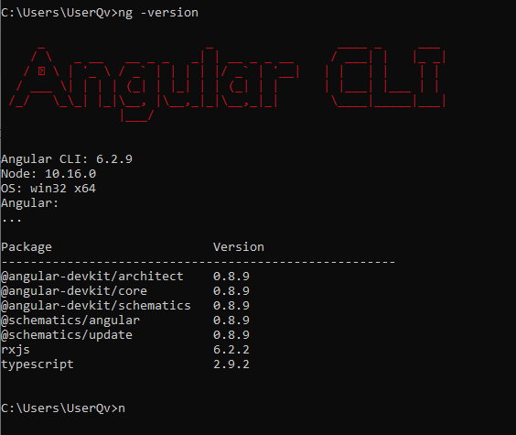

**Data-Base**

Mysql 8.0.18.0

Controlador. MySQL (5.1.46)