Factors To Consider When You Build the Solution
Use Case Understanding and Relevance - clarity and depth in terms of understanding the problem
statement
Solution Architecture – quality and feasibility of the overall architecture design, how well do the
components interact and integrate with each other
Innovation and Creativity – level of innovation and creativity in the solution, originality of ideas,
innovation .
UI and UX – usability and design of the UI, ease of navigation, visual appeal etc.
Technical Implementation and Source Code Quality – code readability, use of best practices,
documentation etc.
Model Performance and Evaluation – model accuracy/precision/recall, F1 score and other relevant
metrics
Deployment and Integration – use of CI/CD pipelines, cloud deployment strategies, integration with
APIs etc.
Presentation and Communication – clarity of communication, organization of the presentation, ability
to answer questions and justify design choices
Collaboration and Teamwork – Team dynamics, distribution of tasks and overall collaboration

Evaluation Criteria - Guideline
Post Build stage
• Use case and process flow understanding
• Proposed architecture and various alternatives
• Breadth of sample data
• Architecture consideration
• Performance
• User experience
• Integration alternatives of the solutions
• Reusable
• Ease of implementation
• Real time decisions
• Process of monitoring
• Way of presenting
- Attendance in various mentor connects

Expectation of Best Solution
Presence of
Architecture, Source code
User Interface
Documentation, PPT
Estimation of development, Roadmap
Presentation

E2  Execution | Where’s My  Truck? – Yard,  Dock Door &  Delivery Tracker | Simulated WMS feed containing  trailer ID, tracking number,  current yard location, dock-door  availability, appointment/arrival  time, load priority, and ETA.  Mapping APIs can be used for  simulated live truck movement. | Warehouse teams and customers often lack a single  real-time view of inbound/outbound truck movement,  yard location, trailer availability, and dock-door  assignments. This solution combines a customer-  facing delivery tracker with an operations dashboard  that uses WMS feeds to identify where a truck/trailer is  located, estimate arrival time, and recommend the  appropriate dock door based on availability and  planned arrival. | 1. Accept a tracking number, trailer ID, or shipment  reference.  2. Display simulated real-time truck location on a map  with updated ETA and delivery progress.  3. Receive WMS feed for yard location, trailer status,  scheduled arrival, and dock-door availability.  4. Identify the trailer that needs to be docked for each  arrival window.  5. Recommend or assign an available dock door based  on arrival time, trailer/load type, priority, and dock  availability.  6. Alert operations users when a truck is delayed, a dock  is unavailable, or reassignment is needed.  7. Output: live map tracker, yard status board, dock-door  assignment schedule, ETA alerts, and trailer-to-door  allocation summary | WM Solution with  Coding
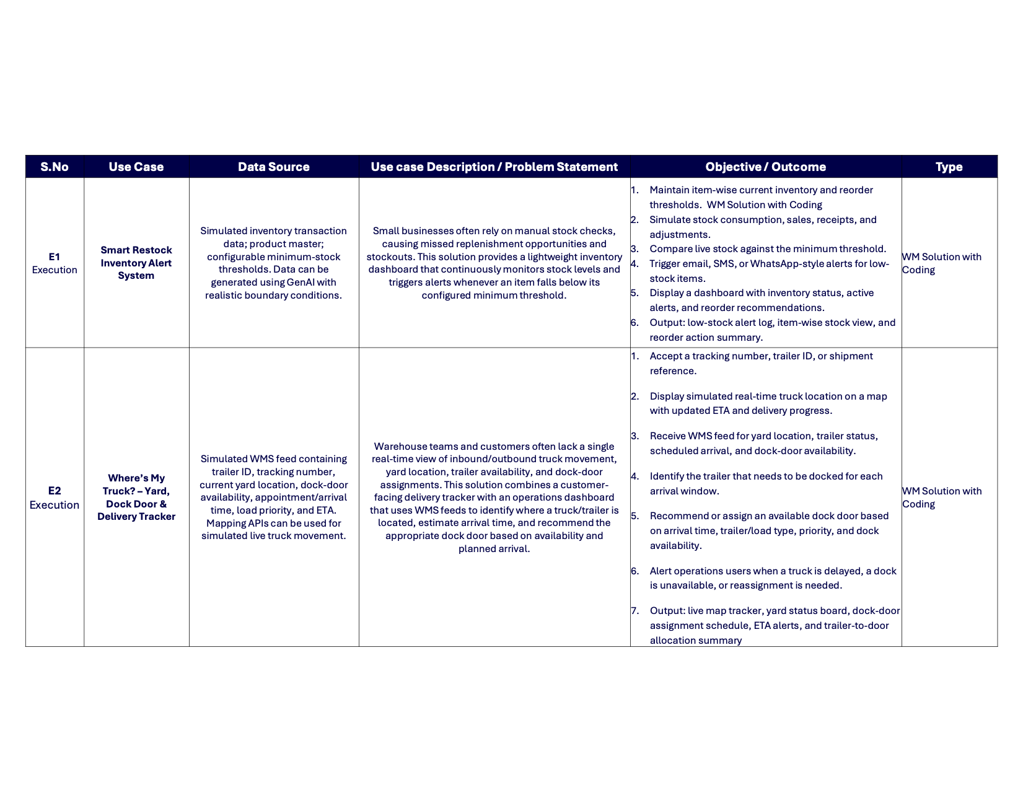

PR 2  Procurement | End-to-End  Autonomous  Procure-to-Pay  (P2P) System: A  fully autonomous,  touchless platform  designed for high-  volume enterprise  usage. | Synthetic data of:  Intelligent OCR and  conversational NLP models.  Leverage GenAI engine for data  simulation with boundary  conditions. | The solution should:  Address high-volume bottlenecks using AI  capabilities including conversational NLP,  intelligent OCR, and predictive anomaly  detection.  1. Requisition: Conversational NLP chatbot  for users to request items.  2. Sourcing & PO: AI selects best supplier  and auto-generates PO.  3. Receiving: Simulated IoT/Computer Vision  for goods receipt.  4. Invoicing: Intelligent OCR and AI for 3-way  matching (PO, Receipt, Invoice) to auto-  approve payments. | Input: Touchless inputs (user requests, enterprise  supplier catalogs, digital invoices).  Process: Conversational NLP intent extraction, rule-  based PO creation, intelligent OCR data extraction,  AI matching.  Expected Outcomes:  • Touchless invoice processing  • Automated Pos  • P2P analytics dashboard  • Demonstrate successful 3-way matching.  Clear presentation of the end-to-end automation. | Primary success criteria: Cost  reduction, operational  efficiency, and fully autonomous  operations.

