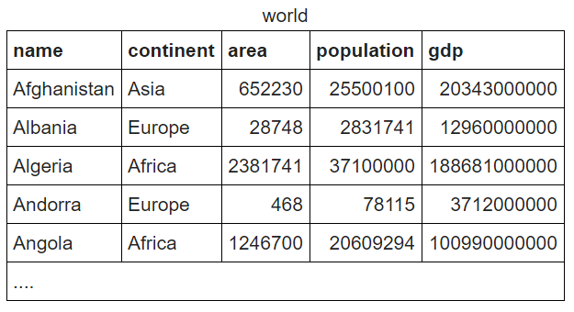

Write a SQL query to

1. Show the population of Germany

SELECT population FROM world

WHERE name = 'Germany';

1. Show the name and the population for 'Sweden', 'Norway' and 'Denmark'.

SELECT name, population

FROM world

WHERE name IN ('Sweden', 'Norway', 'Denmark');

1. Show the country and the area for countries with an area between 200,000 and 250,000.

SELECT name, area

FROM world

WHERE area BETWEEN 200000 AND 250000;