**e-shopping**

Software Construction, Testing and Maintenance

January 13, 2014

1. Kanokwan Maneerat 542115002  
2. Nontra Mahachanont 542115026  
3. Worapun Wongkium 542115055

**User Requirement Specification**

Customer

|  |  |
| --- | --- |
| **No.** | **Requirement List** |
| URS-01 | The customer can register to the system by provide the name, address, picture, username, and password. |
| URS-02 | The customer can update their information. |
| URS-03 | The customer can login to the system by using username and password. |
| URS-04 | The customer can see their picture on the top-right of the page. |
| URS-05 | The customer can browse the catalog. |
| URS-06 | The customer can search for the product name. |
| URS-07 | The customer can choose the product to shopping cart as many products as he/she wants. |
| URS-08 | The customer can see the summary of his/her shopping cart which explains what he/she chooses. |
| URS-09 | The customer can see the total price. |
| URS-10 | The customer can choose the payment option, payment option can be money transfer, credit card and PayPal. |
| URS-11 | The customer can click confirm button to finish buying process. |
| URS-12 | The customer can see the buying transaction as the shopping history in the customer’s webpage. |
| URS-13 | The customer can save the shopping card if don’t want to finish shopping yet. |

Administrator

|  |  |
| --- | --- |
| **No.** | **Requirement List** |
| URS-14 | The administrator can provide details of the product which contain product name, product description, and picture of product. |
| URS-15 | The administrator can see the shopping history of all customers in his/her page. |
| URS-16 | The administrator can login to the system by using username and password. |

**System Requirement Specification**

URS - 01

|  |  |
| --- | --- |
| **No.** | **Requirement List** |
| SRS-01 | The system provides the UI which receive the name, address, picture, username, and password for the registration. |
| SRS-02 | The system can check the length of username format which has the maximum length is twenty, and the username format can mix the character with number. |
| SRS-03 | The system can check the username format, the username format must be unique format. |
| SRS-04 | The system can check the length of the password format, the maximum length of password must be 6-20 letters. |
| SRS-05 | The system shall retrieve the existing customer information to the data from username. |
| SRS-06 | The system shall provide the successful registration page. |
| SRS-07 | The system shall display error message “This username is already exist”. |
| SRS-08 | The system shall display error message “Password length should be 4-20 letters” |

URS - 02

|  |  |
| --- | --- |
| **No.** | **Requirement List** |
| SRS-09 | The system shall update customer information to the database. |
| SRS-10 | The system shall provide the UI for customer to edit their information. |

URS - 03

|  |  |
| --- | --- |
| **No.** | **Requirement List** |
| SRS-11 | The system provides the UI which receive the username and password to login. |
| SRS-12 | The system validates the username and password. |
| SRS-13 | The system display error message “Incorrect username or password”. |

URS - 04

|  |  |
| --- | --- |
| **No.** | **Requirement List** |
| SRS-14 | The system shall display the customer’s picture on the top right in every page. |

URS - 05

|  |  |
| --- | --- |
| **No.** | **Requirement List** |
| SRS-15 | The system provides the catalog UI to display catalogs. |

URS - 06

|  |  |
| --- | --- |
| **No.** | **Requirement List** |
| SRS-16 | The system provides the search box in every page. |
| SRS-17 | The system provides the UI for showing the list of searched product. |
| SRS-18 | The system shall match the search’s keywords with product’s keywords. |
| SRS-19 | The system shall display error message “No matched product found”. |

URS - 07

|  |  |
| --- | --- |
| **No.** | **Requirement List** |
| SRS-20 | The system provides the UI to show the product name, picture, and price. |
| SRS-21 | The system can add product which customer select to the cart as a list into database. |

URS - 08

|  |  |
| --- | --- |
| **No.** | **Requirement List** |
| SRS-22 | The system shall display the list of product which customer choose. |

URS - 09

|  |  |
| --- | --- |
| **No.** | **Requirement List** |
| SRS-23 | The system shall calculate the total price of all products in shopping cart. |
| SRS-24 | The system shall display the total price of all product that customer choose. |

URS - 10

|  |  |
| --- | --- |
| **No.** | **Requirement List** |
| SRS-25 | The system shall provide the payment option UI for customer to select. |
| SRS-26 | The system shall connect to the each payment system, which consist of bank system for money transfer, credit card and PayPal. |

URS - 11

|  |  |
| --- | --- |
| **No.** | **Requirement List** |
| SRS-27 | The system shall store the buying history to database. |
| SRS-28 | The system display successful message “Your buying is successful“ |

URS - 12

|  |  |
| --- | --- |
| **No.** | **Requirement List** |
| SRS-29 | The system shall query the customer’s shopping history from database. |
| SRS-30 | The system shall display customer’s shopping history. |

URS - 13

|  |  |
| --- | --- |
| **No.** | **Requirement List** |
| SRS-31 | The system shall store the product information which customer choosing in the database. |

URS - 14

|  |  |
| --- | --- |
| **No.** | **Requirement List** |
| SRS-32 | The system shall add the product information which administrator provide into database. |
| SRS-33 | The system shall display error message “Please input product’s name”. |
| SRS-34 | The system shall display error message “Please input product’s picture”. |
| SRS-35 | The system shall display error message “Please input product’s price”. |

URS - 15

|  |  |
| --- | --- |
| **No.** | **Requirement List** |
| SRS-36 | The system shall query all shopping history from database. |
| SRS-37 | The system shall display all shopping history. |

URS - 16

|  |  |
| --- | --- |
| **No.** | **Requirement List** |
| SRS-11 | The system provides the UI which receive the username and password to login. |
| SRS-12 | The system validates the username and password. |
| SRS-13 | The system display error message “Incorrect username or password”. |

**Database**

**Product**

|  |  |  |  |  |  |  |
| --- | --- | --- | --- | --- | --- | --- |
| PID | Name | Description | Price | Picture | keyword | amount |

**Cart**

|  |  |  |  |
| --- | --- | --- | --- |
| cartID | PID | amount | price |

**Invoice**

|  |  |  |  |  |
| --- | --- | --- | --- | --- |
| invoiceID | username | cartID | TotalPrice | invoiceDate |

**Customer**

|  |  |  |  |  |  |
| --- | --- | --- | --- | --- | --- |
| Username | Name | Address | Picture | password | cartID |

**History**

|  |  |  |  |  |  |
| --- | --- | --- | --- | --- | --- |
| cartID | username | checkOutStatus | saveDate | paymentStatus | invoiceID |

**Administrator**

|  |  |
| --- | --- |
| AdminName | Password |

**ER Diagram**

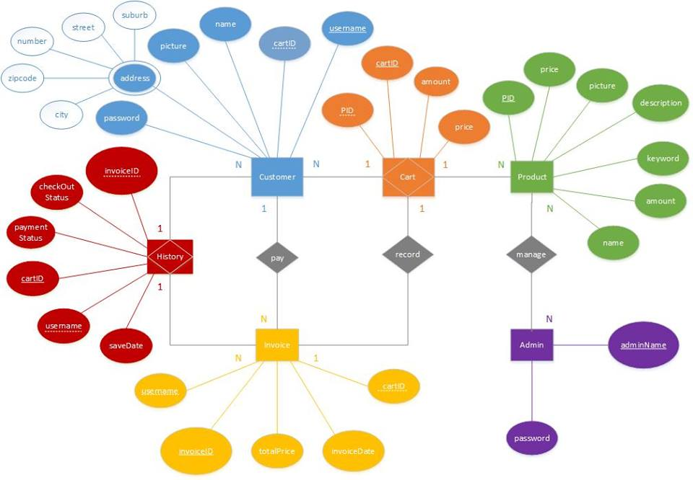

ลองอีดิทมานะ