cloudam

cd /home/cloudam/D2/pd_python

/public/software/.local/easybuild/software/Anaconda3/2020.02/envs/rdkit/bin/python simple_job_models_noslurm.py -n_it 1 -mdd /home/cloudam/dd-project/iteration_1/morgan -time 1 -protein dd-project -file_path /home/cloudam -pdfp /home/cloudam/D2/pd_python -min_last 10

cd /home/cloudam/dd-project/iteration_1/simple_job
sh simple_job_1.sh

#!/bin/bash

cd /home/cloudam/D2/pd_python
/public/software/.local/easybuild/software/Anaconda3/2020.02/envs/rdkit/bin/python
progressive_docking.py -num_units 1000 -dropout 0.7 -learn_rate 0.0001 -bin_array 2 -wt 2 -cf -9.403111690875932 -n_it 1 -t_mol 1712.731021 -os 300 -bs 256 -protein dd-project -file_path /home/cloudam-run_time 1

5.1
cd /home/cloudam/D2/pd_python
/public/software/.local/easybuild/software/Anaconda3/2020.02/envs/rdkit/bin/python hyperparameter_result_evaluation.py -n_it 1 -protein dd-project -file_path /home/cloudam -mdd /home/cloudam/dd-project/iteration_1/morgan

5.2
/public/software/.local/easybuild/software/Anaconda3/2020.02/envs/rdkit/bin/python simple_job_predictions_noslurm.py -protein dd-project -file_path /home/cloudam -n_it 1 -mdd /home/cloudam/dd-project/iteration_1/morgan -pdfp /home/cloudam/D2/pd_python

5.2.1
#!/bin/bash

cd /home/cloudam/D2/pd_python
/public/software/.local/easybuild/software/Anaconda3/2020.02/envs/rdkit/bin/python Prediction_morgan_1024.py -fn test_morgan_1024_updated.txt -protein dd-project -it 1 -mdd /home/cloudam/dd-project/iteration_1/morgan -file_path /home/cloudam

DD
iteration_no：1
number_of_cpus:8
file_path：/home/cloudam
protein ：dd-project
1
例：bash final_phase_noslurm.sh iteration_no number_of_cpus path_logs_file path_tensorflow_venv

cd /home/cloudam/D2/pd_python/
bash final_phase_noslurm.sh 1 2 /home/cloudam/dd-project/logs.txt

25行加/D2/pd_python

module add Anaconda3/2020.02
source activate
conda activate rdkit

bug
simple_job_models_noslurm.py

python simple_job_models_noslurm.py

-n_it | iteration_no | 1
-mdd | path_morgan_folder/morgan_folder | home/cloudam/dd-project/iteration_1/morgan
-time | training_time | 1
-protein | project_folder_name | dd-project
-file_path | path_to_project_folder | /home/cloudam
-pdfp | path_to_pd_python/pd_python | /home/cloudam/D2/pd_python
-tfp | path_tensorflow_venv
-min_last | minimum_molecules_at_last_iteration | 10

115行：file_path后加个 ‘ ‘
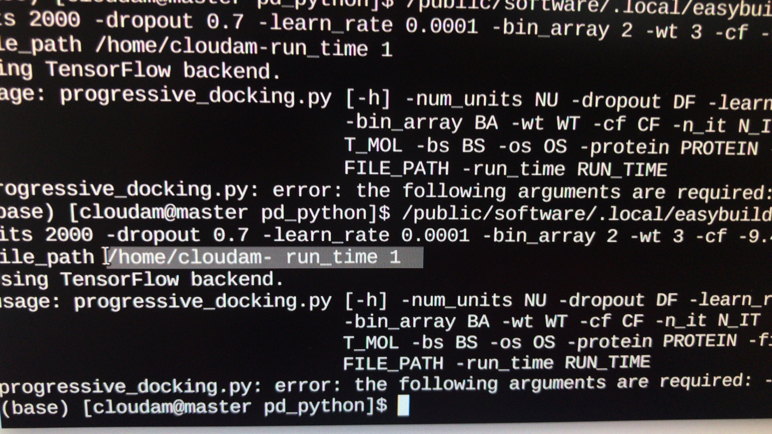
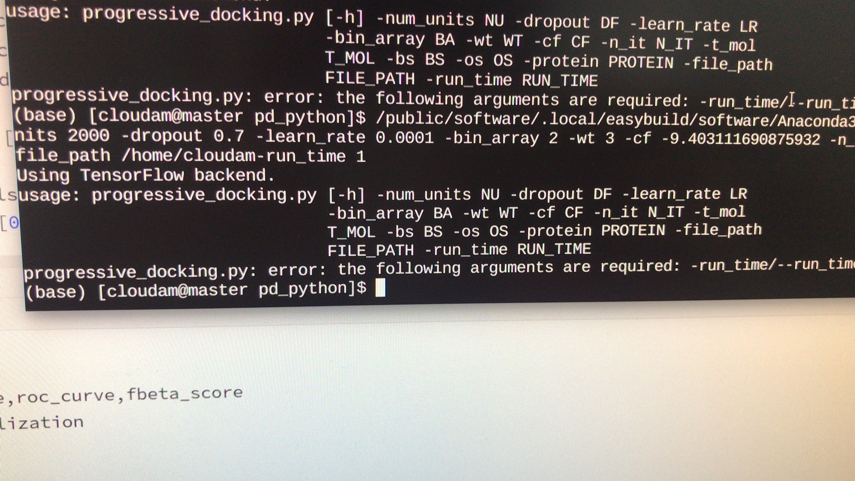

注释掉：

37行和38行加个[ ],修改完如下
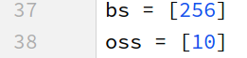

修改python路径

progressive_docking.py

注释掉15行

77行：加上dtype=’float16’
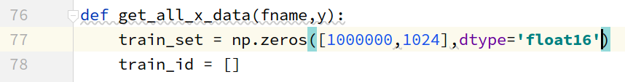

58行:io_args.os改成io_args.run_time

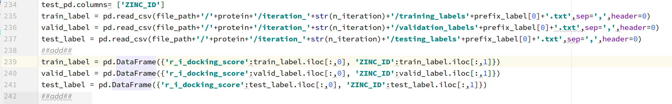
237行后加###add### ###add###中间那三段代码，加完如下：

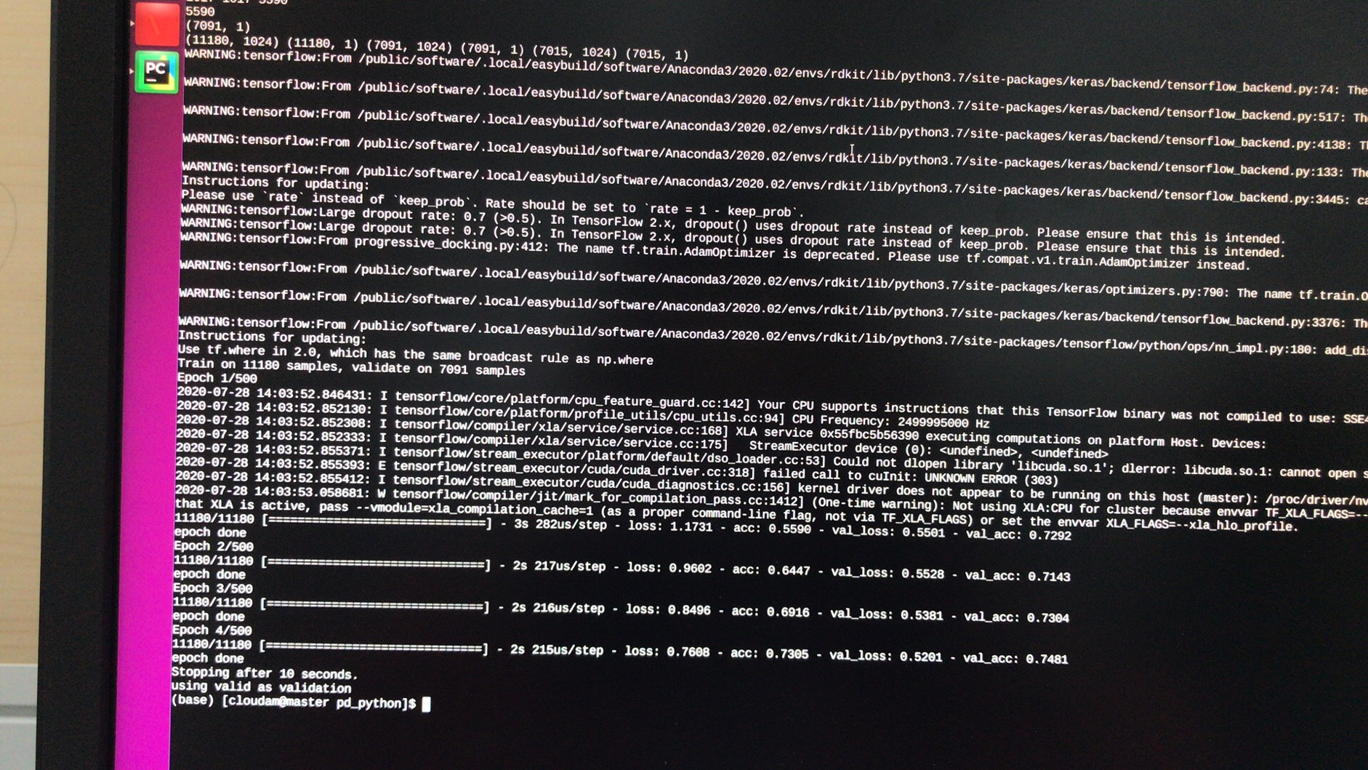
384行加上 *3600
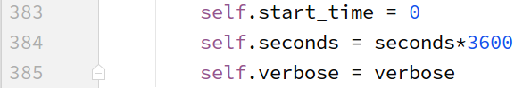

417行 EarlyStopping里的参数patience可以自己调

hyperparameter_result_evaluation.py

350行、352行、353行的protein_name换成protein

69行和87行加break
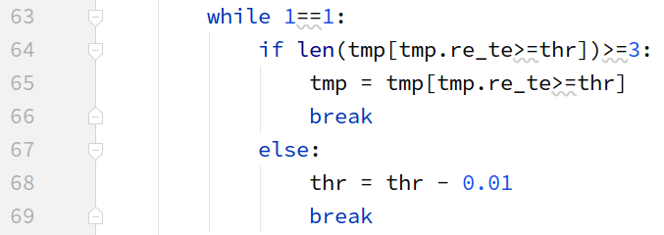

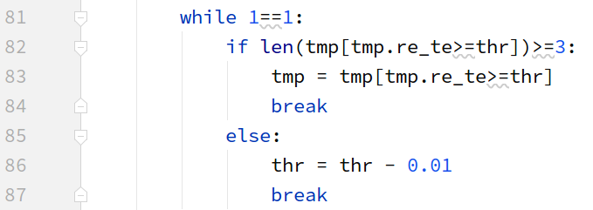

在180行和196行加上如下图代码：
180行：
test_label = pd.DataFrame({'r_i_docking_score':test_label.iloc[:,0], 'ZINC_ID':test_label.iloc[:,1]})
196行：
train_label = pd.DataFrame({'r_i_docking_score':train_label.iloc[:,0], 'ZINC_ID':train_label.iloc[:,1]})

130行：加上dtype='float16'
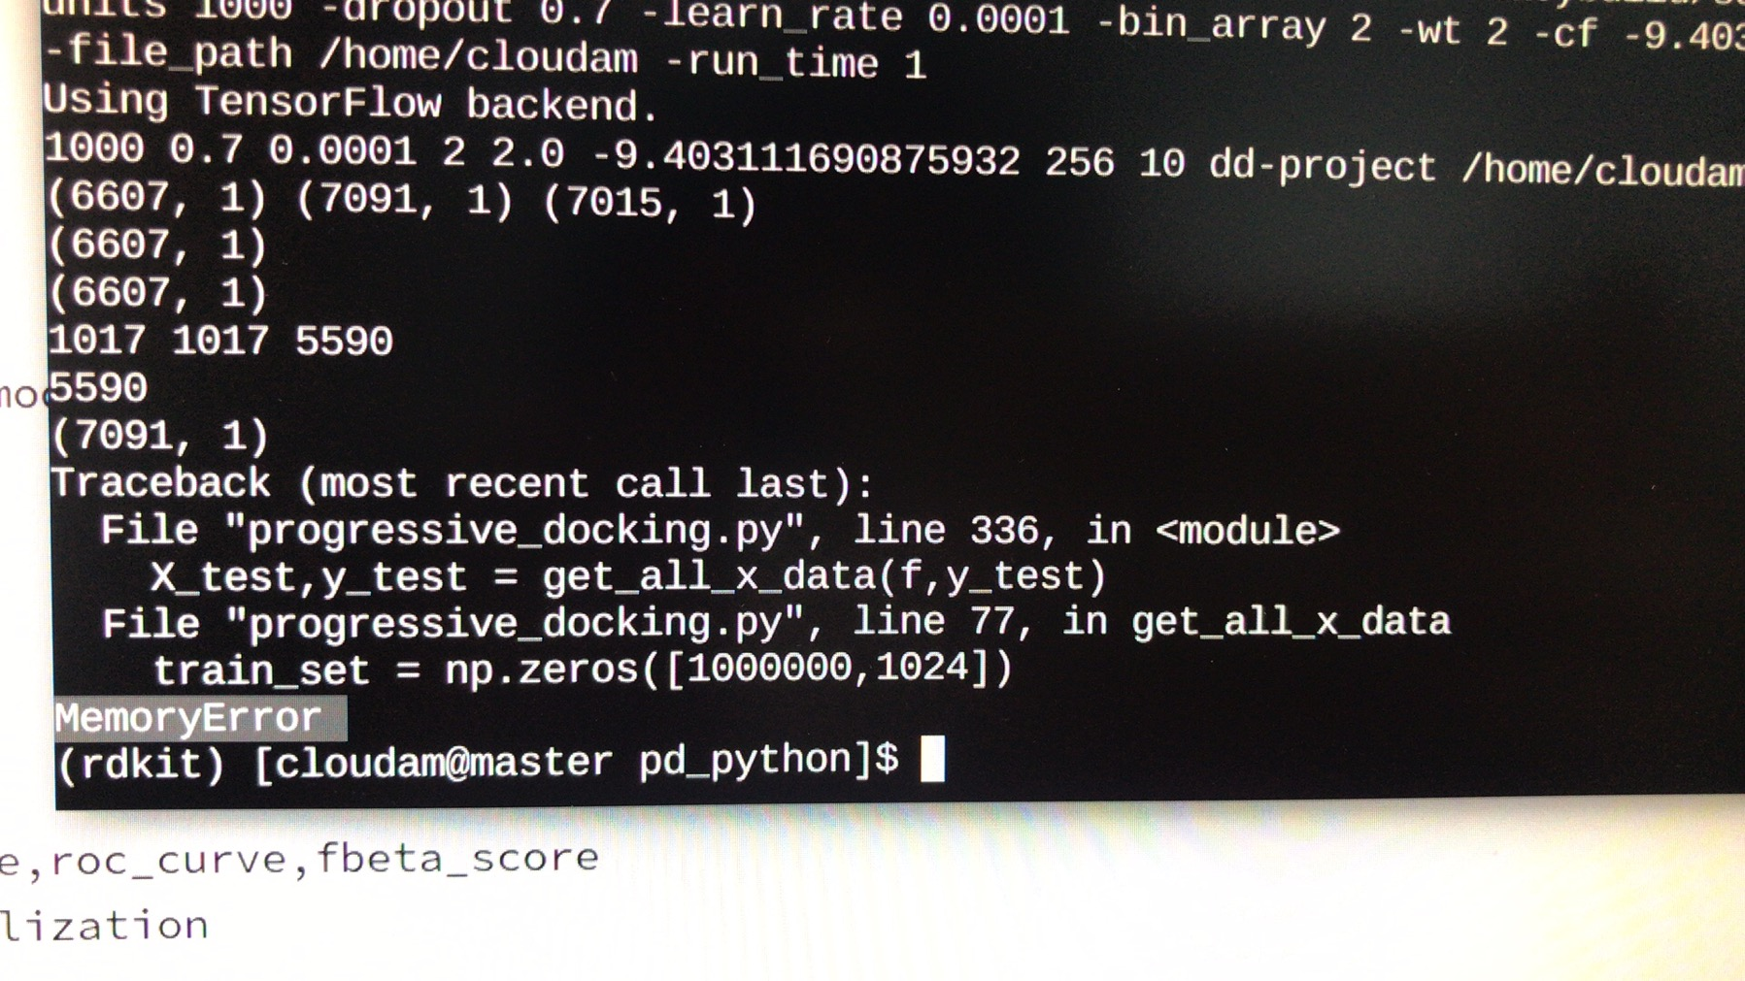
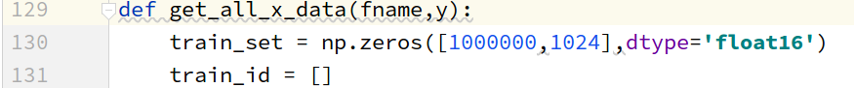

simple_job_predictions_noslurm.py
11行加上：parser.add_argument('-pdfp','--pd_folder_path',required=True)
18行加上：d_folder_path = io_args.pd_folder_path
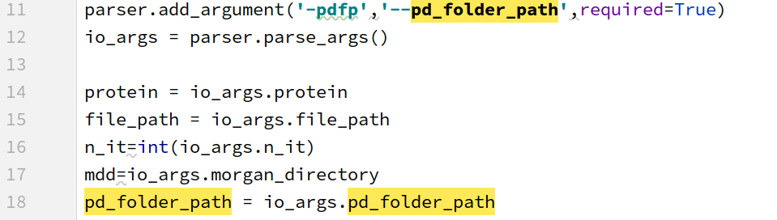
64行注释掉
65行改python路径
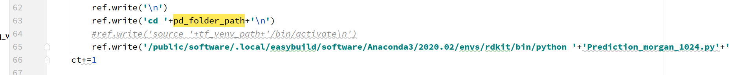

Prediction_morgan_1024.py

33行和75行：加dtype='float16'

final_phase_noslurm.sh
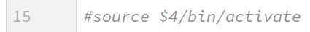
注释掉15行

17行和25行修改python路径
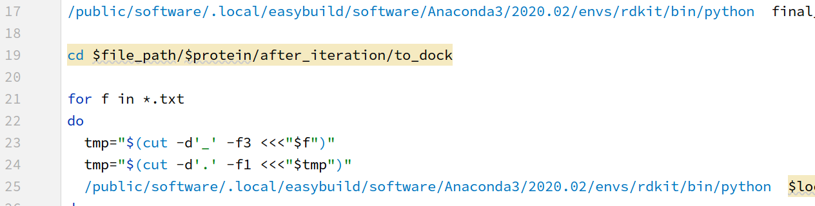
25行改local_path为file_path

logs.txt
电话号码 | 值 | 说明
1个 | path_project_folder | 项目文件夹的路径  /home/cloudam
2 | project_folder | 项目文件夹名称  dd-project
3 | path_grid_file / grid_file | 停靠网格文件的路径和名称；如果不使用网格，则写一条随机线  path_grid_file/do_not_exist
4 | path_morgan_folder / morgan_folder | 包含先前计算的QSAR描述符（摩根指纹）的文件的路径  /home/cloudam/zinc/zinc1/morgan/morgan
5 | path_smile_folder / smile_folder | 包含分子SMILES的文件的路径  /home/cloudam/zinc/zinc1/zinc1
6 | path_3dsdf_folder / 3dsdf_folder | 分子预先计算的3D sdf构象的路径；如果没有它们，写一条随机的线  path_3dsdf_folder/do_not_exist
7 | number_of_molecules_to_sample | 每次迭代采样的分子数。在第一次迭代中，此分子数量将分为三部分，以形成初始训练，验证和测试，从第二次迭代开始，它将是添加到训练集中的分子数量  10000

iteration_no：1
number_of_cpus:32
file_path：/home/cloudam
protein ：dd-project
path_to_log_file :/home/cloudam/dd-project/logs.txt

molecular_file_count_updated.py
pt:dd-project
it:1 迭代的次数
cdd:
if it = 1:/home/cloudam/zinc1/morgan/morgan
else:/home/cloudam/dd-project/iteration_it-1/morgan_1024_predictions

t_pos:cpu的个数
t_samp：每次迭代采样的分子数

progressive_docking.py
progressive_docking.py -num_units 1000 -dropout 0.7 -learn_rate 0.0001 -bin_array 2 -wt 2 -cf -11.0 -n_it 1 -t_mol 200.0 -os 10 -bs 256 -file_path /home/linjie/projects/D2 -run_time 1
-num_units | nu | 1000
-dropout | df | 0.7
-learn_rate | lr | 0.0001
-bin_array | ba | 2
-wt | wt | 2
-cf | cf | -11.0
-n_it |  | 1
-t_mol |  | 200.0
-os |  | 10
-bs |  | 256
-protein |  | dd-project
-file_path |  | /home/linjie/projects/D2
-run_time |  | 1

train_pd
train_pd = pd.read_csv(file_path + '/' + protein + '/iteration_' + str(n_it) + '/morgan/train' + prefix[0],
header=None, usecols=[0])#5120
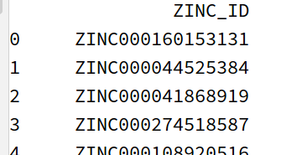

train_label
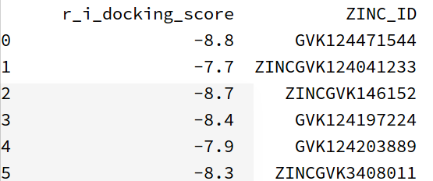

train_data
train_data = pd.merge(train_label, train_pd, how='inner', on=['ZINC_ID'])#5022

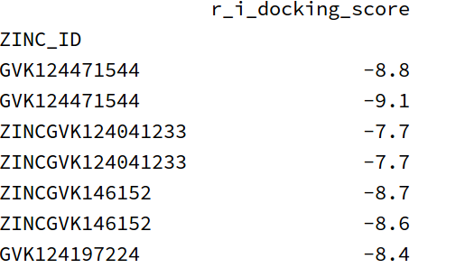

y_train

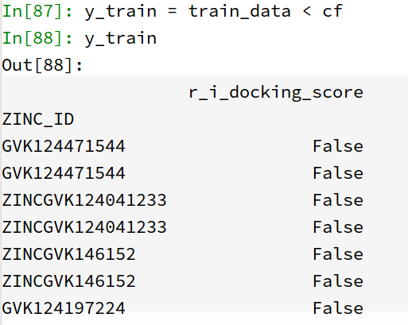

module add Anaconda3/2020.02
source activate
conda activate rdkit
# This is an anaconda3 environment.
# You can conda-install or pip-install more packages.
cd /home/cloudam/projects/pd_python
/public/software/.local/easybuild/software/Anaconda3/2020.02/envs/rdkit/bin/python download_zinc15.py
/public/software/.local/easybuild/software/Anaconda3/2020.02/envs/rdkit/bin/python smile_simplification.py
#cd /home/cloudam/dd-project/iteration_10/simple_job_predictions
#bash simple_job_1.sh

fillna.py
import pandas as pd
import numpy as np
import os
import glob
import time
from config import args
dd_project_file = args.dd_project_file
n_it = args.n_iteration
it_dir = os.path.join(dd_project_file, 'iteration_' + str(n_it))
# def fill_na(label_file,set_file):
# label = pd.read_csv(it_dir + label_file)#5126
# label = pd.DataFrame({'r_i_docking_score': label.iloc[:, 0],
# 'zinc_id': label.iloc[:, 1]})
# label.drop_duplicates(subset=['zinc_id'], keep='first', inplace=True)#5120
# setf = pd.read_csv(it_dir + set_file, header=None)#5120
# setf.columns = ['zinc_id']
# print(label_file,'label.isnull().sum()',label.isnull().sum())#103
# label.fillna(round(label['r_i_docking_score'].mean(),1),inplace=True)
# label.to_csv(it_dir + label_file, index=None)
# print(label_file, 'after fillna, label.isnull().sum()',label.isnull().sum())
# print('len(label)',len(label))
# print('fillna ok')
#
#
# if __name__ == '__main__':
# if n_it == 1:
# fill_na('/training_labels.txt','/train_set.txt')
# fill_na('/validation_labels.txt', '/valid_set.txt')
# fill_na('/testing_labels.txt', '/test_set.txt')
# else:
# fill_na('/training_labels.txt', '/train_set.txt')

DDAD

http://files.docking.org/2D/HG/HGAD.txt
http://files.docking.org/2D/ED/EDAE.txt
http://files.docking.org/2D/IF/IFAE.txt
http://files.docking.org/2D/FB/FBAD.txt
http://files.docking.org/2D/FG/FGAD.txt
http://files.docking.org/2D/CD/CDAE.txt
http://files.docking.org/2D/JG/JGAD.txt
http://files.docking.org/2D/JH/JHAD.txt
http://files.docking.org/2D/JI/JIAD.txt
http://files.docking.org/2D/CE/CEAD.txt
http://files.docking.org/2D/GE/GEAD.txt
http://files.docking.org/2D/GG/GGAD.txt
http://files.docking.org/2D/DD/DDAD.txt

