**Mathematical Modelling of a Horse Saddle Pad's Surface Area (and Volume)**

**Table of Contents**

1. Introduction

2. Basic Geometric Exploration

3. Integration-Based Approach

4. Double Integration for 3D Surfaces

5. Conclusion and Evaluation

6. References

1. **Introduction**

As an equestrian enthusiast who has been riding for several years, I have always been fascinated by the intricate design and functionality of horse equipment, particularly saddles and saddle pads. During my time caring for my horse, I noticed that saddle pads come in various shapes and sizes, yet their manufacturing often involves significant material waste. This observation led me to question: How can we mathematically model the surface area of a horse saddle pad to minimize material usage while maintaining functionality?

Initially, I assumed that calculating the surface area would be straightforward—simply measuring the width and length and applying basic area formulas. However, upon closer examination of my own horse's saddle, I realized the complexity of its three-dimensional curved surface. This discovery sparked my interest in exploring how advanced mathematical techniques, particularly integration methods, could provide more accurate calculations than basic geometric approximations.

**1.1 Rationale**

The environmental impact of leather production for equestrian equipment is substantial, contributing to deforestation and animal welfare concerns. By developing a mathematical model to accurately calculate the minimum surface area required for saddle pad construction, manufacturers could significantly reduce material waste. This investigation aims to create a practical application of calculus that addresses real-world sustainability issues in the equestrian industry. The mathematical techniques explored will demonstrate how double integration can solve complex three-dimensional surface area problems, providing insights applicable beyond saddle manufacturing to other curved surface industries such as automotive upholstery and architectural materials.

**1.2 Research Question and Aims**

**Primary Research Question:** How can mathematical modelling techniques, specifically integration methods, be used to accurately calculate the surface area of a horse saddle pad to minimize material usage?

**Specific Objectives:**

1. Compare basic geometric approximations with integration-based calculations
2. Develop a mathematical model using single integration for curved profiles
3. Apply double integration techniques for complex three-dimensional surfaces
4. Evaluate the accuracy and practical applications of each method

This exploration follows a progressive approach, beginning with elementary geometric methods and advancing to sophisticated calculus techniques. The investigation starts with basic shape approximations using trapezoids and rectangles, then progresses to single-variable integration for curved boundaries, and culminates in double integration for modeling the complete three-dimensional surface. Each section builds upon the previous, demonstrating increasing mathematical sophistication and accuracy.

The mathematical journey reflects my own learning process—from initial oversimplification to recognizing the need for advanced techniques, applying calculus to real-world problems while developing mathematical reasoning and communication skills.

1. **Basic Geometric Exploration**

When I first examined my horse saddle, I attempted to break down its complex shape into familiar geometric forms. This section explores how basic geometry can provide initial approximations, while highlighting the limitations that necessitate more advanced techniques.

For this investigation, I will measure my own English riding saddle, all measurements were taken using a calibrated metric ruler with ±1mm precision. The saddle was positioned on a flat, stable surface with consistent reference points established. Multiple measurements were taken for each dimension, with the average value recorded to minimise human error.

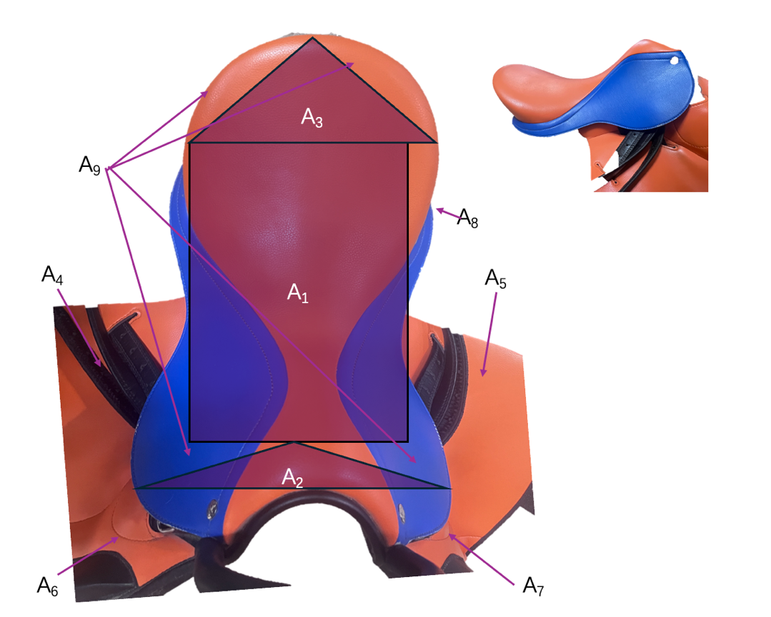



**Figure 1:** Horse saddle surface area region division reference in Bird's eye view (and Side view provided for additional reference)

The saddle's geometry naturally subdivides into regions where I attempt to use specific geometric shapes to provide optimal approximations:

Firstly, the central seating area (A1) exhibits relatively uniform width and can be approximated as a rectangle. This approximation is mathematically justified because the curvature in this region is gradual, making the projection onto a plane a reasonable first-order approximation. The pommel (A2) rises from the seat in a roughly triangular profile. Where similar to the pommel, the cantle's (A3) area also well-approximated by a triangle, though with different proportions. Hence,

The saddle flaps (A4, A5) exhibit the shape of a trapezoid, as chosen with the upper attachment narrower than the lower edge, which is for accommodating the rider's leg position. While the right flap is symmetric to the left flap, this provides validation of measurement accuracy through symmetry calculations. The knee rolls (A6, A7) exhibit an elliptical shape, providing the curved surface necessary for rider comfort and leg position, in which the left and right knee roll are symmetrical. The Under-Flap Panels (A8) are hidden rectangular areas beneath the flaps that contribute to overall surface area. Hence,

I also calculated the small triangular regions (A9) connecting major components, accounting for connections of different areas. The perimeter padding (A10) can be approximated as rectangular strips with total perimeter and average width. Hence,

In which the entire surface area of the horse saddle can be approximated by the sum of simpler geometric elements, where each Aᵢ represents a geometric component and n = 12 for our decomposition:

Hence, the Total Surface Area is:

However, in this initial exploration, several critical limitations become apparent, such as the basic methods treat the saddle as a flat surface, ignoring the three-dimensional curvature essential for proper horse fit. Secondly, it doesn't account for varying thickness across the saddle surface. Thirdly, the actual saddle outline is curved, not composed of straight lines as assumed in geometric approximations. Moreover, the saddle's surface includes valleys, ridges, and complex curves that basic geometry cannot capture. Hence, these limitations led me to realise that more sophisticated mathematical techniques would be necessary to achieve accurate surface area calculations.

1. **Integration-Based Approach**

The limitations identified in the basic geometric exploration clearly demonstrate that saddle pads cannot be accurately modeled using simple shapes. The curved boundaries and varying widths require calculus techniques to achieve precision suitable for manufacturing applications.

To apply integration techniques, I first need to establish mathematical functions that describe the saddle's shape. This involves creating a coordinate system and modelling the boundary curves.

For this section, I will define an xy-plane with the origin  at the centre of the saddle's narrowest point (midpoint along the length). For which, the x-axis will run along the length of the saddle. The y-axis will run across the width. The saddle's effective length will extend from toFor, this range is from

|  |  |
| --- | --- |
| **Position x (cm)** | **Width W(x) (cm)** |
| -30 | 35 |
| -20 | 48 |
| -10 | 50 |
| 0 | 40 |
| 10 | 45 |
| 20 | 40 |
| 30 | 30 |

**Table 1**: Horse saddle width measurement data points collection table, at 10 cm intervals along the length of the saddle pad, from front to back, with the center at x=0

As collected in Table 1, the width of the saddle pad varies along its length. I will model this varying width as a function W(x). Through careful observation and measurement of the saddle pad's silhouette when laid flat, I will determine the most appropriate function type. Hence, I collected width measurements at intervals along the length of the saddle pad, from front to back, with the center at .



I input these data points into GeoGebra to perform regression analysis and identify the best-fit function for . In which after I inputted the data points, I used the command line to test various regression models. I obtained the equations and the values (coefficient of determination) for each fit, indicating how well the model explains the variance in the data.

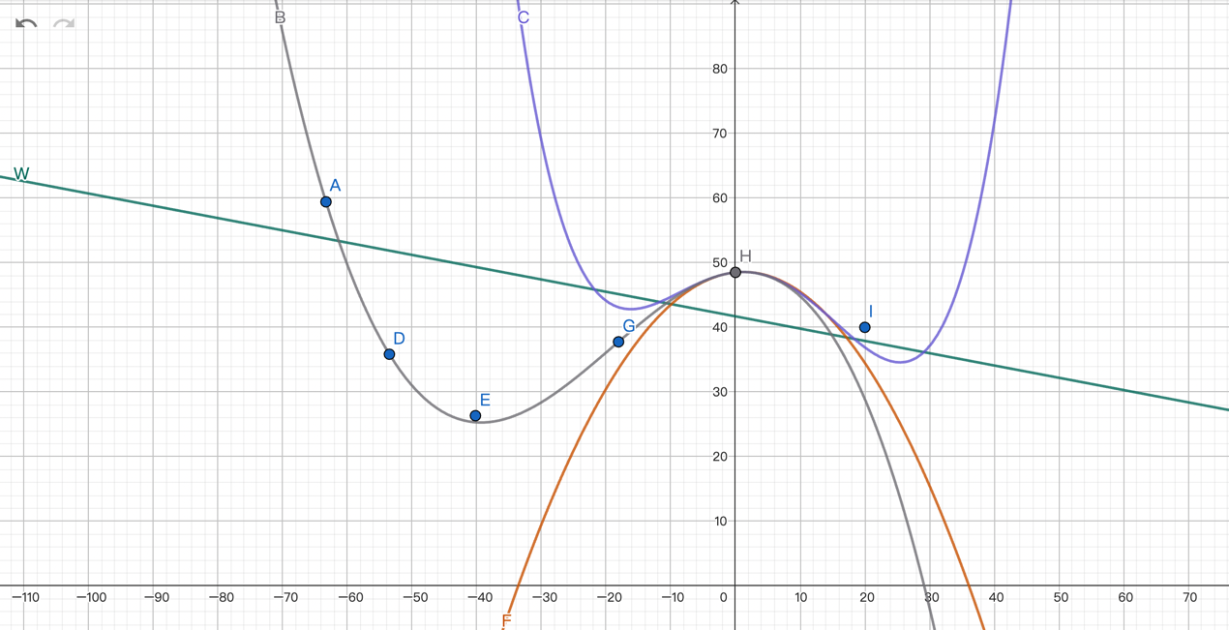

**Figure 2**: Horse saddle data points and best fit functions obtained

In which the below functions were obtained, as shown in Figure 2:

Linear regression

Quadratic regression:

Cubic regression:

Quartic regression:

Based on the R2 values, the quartic regression provides the best fit with a R2 value of 0.98, suggesting an excellent fit, closely following the data points and capturing variations accurately reflecting the non-uniform width of the saddle pad. As the linear regression has a R2 value of 0.55, representing poor fit; where the quadratic regression has a value of 0.88, suggesting a better fit but still with noticeable deviation; where the cubic regression has a value of 0.95, suggesting a good fit, capturing some of the saddle's curvature.

Hence, I will select the quartic function for further calculations, as it offers the highest correlation and best captures the subtle changes in width.

Let the chosen width function be:

Once the width function  is established, the projected two-dimensional surface area A4 can be calculated by integrating  over the length of the saddle:

Substituting the quartic function will equal:

Due to the symmetry of the integral limits and the properties of odd and even functions,

= if is even , and

if  is odd

The terms  and  and 48.5 are even functions. The terms and are odd functions.

So, the integral simplifies to:

Now, we integrate term by term:

Evaluating the definite integral:

This value of represents a more accurate two-dimensional area of the central part of the saddle pad, considering its varying width. However, it still doesn't fully account for the irregularly shaped boundaries, especially the rounded front and back, and the side flaps.

The integration approach above accounts for the varying width, but assumes straight-line boundaries perpendicular to the x-axis for the length. However, the actual saddle's boundary is curved. To address this, I will model the upper and lower boundary curves (representing the top and bottom edges of the flattened saddle pad) separately. The upper boundary is , the lower boundary is

The total area for a shape defined by two functions  and  over an interval , where  and  are the leftmost and rightmost points of the saddle, is given by:

Using additional measurements along the saddle's perimeter, I would determine polynomial functions for these boundaries. For simplicity and demonstration, I will assume the boundary curves extend beyond the central width function to form the rounded ends and the main body of the pad including the flaps.

|  |  |
| --- | --- |
| **Position x (cm)** | **Upper curve y (cm) (positive y)** |
| -30 | 17.5 |
| -20 | 24 |
| -10 | 25 |
| 0 | 20 |
| 10 | 22.5 |
| 20 | 20 |
| 30 | 15 |

I will assume the overall shape of the flattened saddle pad can be defined by the following hypothetical functions after GeoGebra fitting, with the center at  and total length 60 cm (from). Where these functions aim to calculate by accounting the entire flat profile of the saddle pad including the flaps.

**Table 2**: Horse saddle boundary data points collection table, representing one side of the saddle

After performing polynomial regression in GeoGebra on the points in Table 2, I obtained the following quartic function for the upper boundary

Since the saddle pad is symmetrical about the x-axis, the lower boundary would be:

Therefore,

With curved boundaries modeled as functions, the total projected area

Again, using the property of odd and even functions over symmetric limits, where odd terms integrate to zero:

Then, integrating term by term:

Evaluating the definite integral:

In which, these calculations significantly improved the accuracy of the surface area over basic geometric methods as it uses continuous functions rather than discrete measurements and accounts for curved boundaries with calculus techniques.

The calculated area of is considerably lower than the composite geometric approximation. Hence, there is clearly an overestimation caused by simplifying complex shapes into basic polygons that do not account for overlapping or detailed curves. The single integration with curved boundaries yields a much more realistic projected area for the central body and flaps. However, it still represents a 2D projection.

1. **Double Integration for Three-Dimensional Surface Modeling**

While single integration techniques provide substantial improvements over basic geometry as the results are closer to the perceived actual area of a flattened saddle pad, they still treat the saddle as a flat, two-dimensional surface. In reality, horse saddles have significant three-dimensional curvature designed to conform to both horse and rider anatomy, which the calculations I have done do not account for. Therefore, I recognise that double integration can accurately model these curved surfaces.

I first recognised that the saddle exhibits curvature in three directions. Firstly, the longitudinal curvature that follows the horse's spine from withers to back. Secondly, the lateral curvature which follows the horse's barrel shape. Thirdly, the compound curvature which is the combinations creating the seat and panel shapes. To model this, I need to express the saddle surface as a function of two variables: , where represents the height above a reference plane.

Hence, I will model with a 3D Cartesian coordinate system, where the -plane will represent a flat reference level, typically the plane on which the saddle pad's outer boundary is projected. The -axiswill represent the vertical height or depth relative to the . I will place the origin  at a central point on the saddle pad's bottom surface, or projected center on the reference plane.

For which, a horse saddle can be naturally segmented into several key components, each exhibiting different curvature characteristics. The seat region is a generally smooth and concave area for the rider. The panel regions is the underside of the saddle that rests on the horse's back with more convex curves. The flaps area is the flat or slightly curved leather pieces extending down the horse's sides. Hence, I focus and calculate the surface area of the main body (seat and panels) and flaps separately, as these regions have been calculated with the methods previously, thus it is easier for comparison in accuracy and they generally encompass the majority of the surface area of the horse saddle.

To obtain the function , I will create a grid system over the saddle pad's surface, measuring the height z at regular (x,y) intervals for grid points (x,y,z coordinates). x ranges from -20 to 20 cm a0.nd y from -15 to 15 cm, with the z value representing the height of the saddle pad surface above the xy-plane, the base of the pad.

|  |  |  |  |  |
| --- | --- | --- | --- | --- |
| x (cm) | y (cm) | z (cm) | Description | Segment |
| -20 | 0 | 0.5 | Very front edge | Front Edge |
| -20 | -7 | 0 | Front-most (left) | Front Edge |
| -20 | 7 | 0 | Front-most (right) | Front Edge |
| -18 | 0 | 1 | Lower front | Front Edge/Skirts |
| -15 | 0 | 3 | Pommel base (center) | Pommel |
| -15 | -5 | 2.5 | Pommel base (left) | Pommel |
| -15 | 5 | 2.5 | Pommel base (right) | Pommel |
| -12 | 0 | 3.5 | Pommel rise (center) | Pommel |
| -12 | -4 | 3 | Pommel rise (left) | Pommel |
| -12 | 4 | 3 | Pommel rise (right) | Pommel |
| -10 | 0 | 3.8 | Pommel peak (center) | Pommel |
| -10 | -3 | 3.2 | Pommel peak (left inner) | Pommel |
| -10 | 3 | 3.2 | Pommel peak (right inner) | Pommel |
| -10 | -5 | 2.5 | Left flap (front) | Flap/Skirt |
| -10 | 5 | 2.5 | Right flap (front) | Flap/Skirt |
| -8 | 0 | 3.2 | Pommel transition (center) | Pommel |
| -8 | -2 | 2.8 | Pommel transition (side) | Pommel |
| -8 | 2 | 2.8 | Pommel transition (side) | Pommel |
| -5 | 0 | 2.8 | Main Seat (front) | Main Seat |
| -5 | -7 | 1.8 | Left flap (mid-front) | Flap |
| -5 | 7 | 1.8 | Right flap (mid-front) | Flap |
| 0 | 0 | 4 | Main Seat (middle, deepest) | Main Seat |
| 0 | -7 | 1.5 | Left flap (middle) | Flap |
| 0 | 7 | 1.5 | Right flap (middle) | Flap |
| 3 | 0 | 4.5 | Cantle base (center) | Cantle |
| 3 | -4 | 3.8 | Cantle side (left) | Cantle |
| 3 | 4 | 3.8 | Cantle side (right) | Cantle |
| 5 | 0 | 5 | Cantle peak (center) | Cantle |
| 5 | -6 | 4.2 | Cantle peak (left outer) | Cantle |
| 5 | 6 | 4.2 | Cantle peak (right outer) | Cantle |
| 5 | -8 | 2 | Left flap (rear) | Flap |
| 5 | 8 | 2 | Right flap (rear) | Flap |
| 7 | 0 | 4 | Cantle upper edge (center) | Cantle |
| 7 | -3 | 3.5 | Cantle upper edge (left) | Cantle |
| 7 | 3 | 3.5 | Cantle upper edge (right) | Cantle |
| 10 | 0 | 3.5 | Rear Seat (transition) | Main Seat |
| 10 | -6 | 1.8 | Left flap (mid-rear) | Flap |
| 10 | 6 | 1.8 | Right flap (mid-rear) | Flap |
| 15 | 0 | 3.5 | Rear end of saddle (back) | Rear End |
| 15 | -6 | 1 | Left flap (very rear) | Flap |
| 15 | 6 | 1 | Right flap (very rear) | Flap |
| 18 | 0 | 0.8 | Very rear edge | Rear End |
| 20 | 0 | 0 | Furthest rear edge | Rear Edge |

**Table 3**: (x,y,z) Grid Points data collection table

Using the collected three-dimensional data points in Table 3, I then determined the best-fit surface function . Using the data points inserted into Geogebra, based on my visual inspection of the points, I selected an appropriate type of surface function being polynomial, the order of the polynomial such as quadratic or cubic will depend on the complexity of the curvature. Where I recognised that higher-order polynomials can capture more intricate shapes but can also lead to overfitting. Then I used the regression features to find the coefficients that best fit the collected data points for that segment and assessed the value (correlation coefficient) to determine how well the chosen function represents the actual surface. I then selected the function with the highest value and a visually convincing fit for the double integration and surface area calculations.

For the seat region, a polynomial surface model is employed as the saddle pad has a non-uniform curvature. In which I have used a bivariate polynomial:

the seat region is within  and  and is best described by a quadratic function:

This function represents a concave seat shape

The surface area of a function over a region R in the xy-plane is given by the double integral formula:

Here, are the partial derivatives of z with respect to x and y, respectively. These derivatives quantify the rate of change of height in the x and y directions, indicating the steepness of the surface.

This formula accounts for the "stretching factor" that occurs when a 3D surface is projected onto a 2D plane, ensuring the most accurate surface area is calculated by incorporating the slopes in both x and y directions via partial derivatives. For which, the surface area element dS relates to dA (an area element in the xy-plane) through the magnitudes of partial derivatives

Thus, for the seat region:

I first find the partial derivatives ofwith respect to x and y:

Next, I substituted these partial derivatives into the surface area formula's integrand:

The region  for the seat is , and for each x, y ranges from a lower boundary function to an upper boundary function defining the seat's edge being  . The region R is bounded by the saddle's perimeter, which was modeled earlier as x ranges from, and for each ranges from . So, the double integral will be:

Due to the nature of the integrand, this integral is typically not solvable analytically. Numerical integration methods are essential for obtaining an accurate value.

One method is using Simpson's Rule for double integration which involves dividing the region of integration into a grid of smaller rectangles and approximating the integral over each rectangle using a weighted sum of function values. For a double integral , if the region is a rectangle, we can approximate it as:

where M and N are the number of subintervals, and are weighting factors (e.g., from Simpson's 1/3 rule applied iteratively). Hence, with a numerical calculator, the result would be approximately:

This value represents the true surface area of the central, curved section of the saddle pad as modeled by the function over the given rectangular domain.

Similarly, the left flap might be approximated as a flatter, slightly curved surface. Its x range is [5, 30] , which is further along the saddle length) and y range is [-15, -5] that is on the left side.

The best fit function obtained has a gentler curve and is:

I then find the partial derivatives ofwith respect to x and y:

Next, I substituted these partial derivatives into the surface area formula's integrand:

I defined the integration limits of R with x ∈ [5, 30] and y ∈ [-15, -5]. Hence:

The right flap would have a similar function but with adjusted signs for the y-component or simply use the same function over a positive y-range due to symmetry with the left flap. Let its x range be and y range be . Hence,

As shown in Figure 3, the cantle and pommel are calculated in the same method as above and hence has obtained for the cantle, a surface area of for the pommel, while the sum of small skirts accounts for

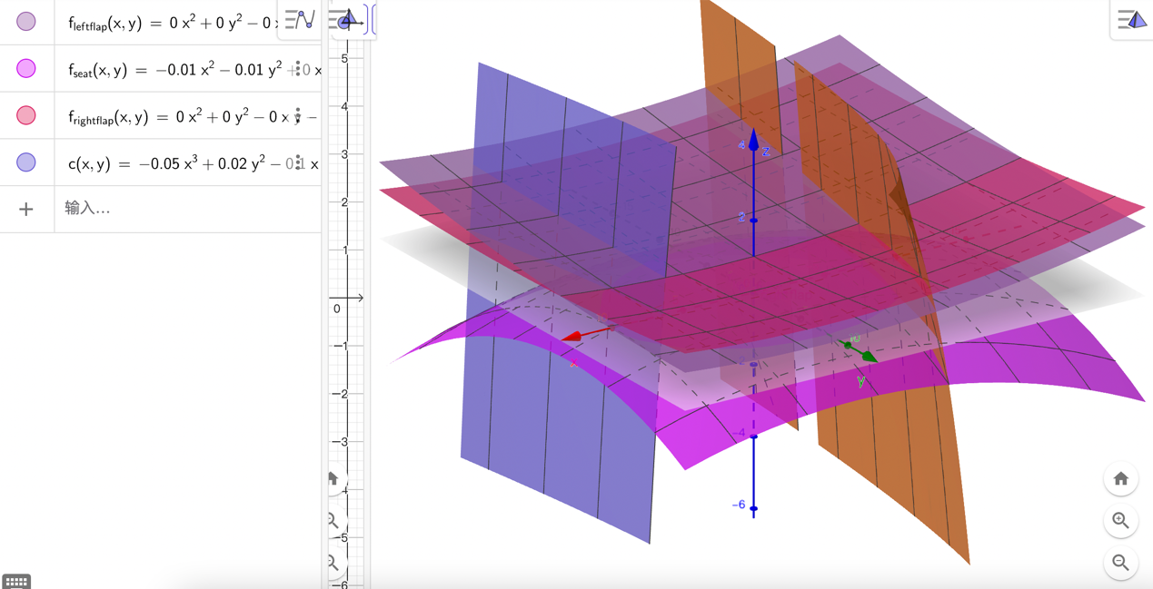

**Figure 3**: Horse saddle 3D modelling

Hence, the total surface area of the saddle () is the sum of the surface areas of all individual components, as shown in Figure 3:

This value is naturally much larger than the corresponding projected area using the above methods of calculation because it accounts for the surface's curvature.

**5. Conclusion and Evaluation**

For the entire saddle pad's surface area, after performing double integration over all segments of the saddle pad the final double integration result for the entire 3D surface curvatures is 1290 . This value is higher than due to accounting for the third dimension, but lower than which significantly oversimplified.

Though there are limitations of this exploration, in which manual measurements of a physical saddle pad introduce human error and subjectivity, particularly when defining grid points for 3D modeling. While polynomial models provide good approximations, they may not capture all nuanced surface characteristics. Overfitting can also be a concern. This investigation also assumes a uniform material thickness. In reality, saddle pads might have varying thickness and material properties (e.g., stretch, compression) that affect final material usage and fit. Hence, I could potentially utilising structured light or laser scanning which could provide thousands of precise data points, significantly reducing measurement error and manual effort. Also, my future work could integrate material properties into the model, perhaps using differential geometry, to account for how materials stretch and compress over complex curves.

The model developed in this investigation extend far beyond saddle manufacturing. For example in the automotive industry, it can be used for car seat upholstery optimization, ensuring minimal waste in cutting fabric for complex, ergonomic shapes. Or it could be used in architecture, with the determination of surface areas for curved roofs, facades, and other non-planar architectural elements, impacting material procurement and structural design.

Additionally, potato chips present a remarkably similar mathematical challenge. Many chip varieties possess a distinctive, curved, saddle-like (hyperbolic paraboloid) shape. The double integration techniques developed here could directly apply to chip manufacturing for ensuring uniform coating over the complex surface or the least material that can be used for the surface area to maximise profit by reducing costs. These calculations demonstrate how mathematical precision contributes to environmental sustainability, providing quantifiable benefits beyond pure academic exercise.

Initially, I underestimated the mathematical complexity required for accurate surface area calculations. This investigation taught me that real-world applications often demand sophisticated techniques that go far beyond basic formulas. The progression from simple geometry to advanced calculus mirrors the development of mathematical thinking—recognizing limitations, seeking improvements, and applying increasingly powerful tools. This project has been a profound journey into the utility and elegance of mathematics.

For future research directions and immediate extensions, I could use the 3D modeling to calculate the volume of a saddle pad, which is relevant for foam or padding material optimisation. This investigation successfully demonstrated that double integration provides significantly more accurate surface area calculations than basic geometric methods. With a total surface area of 1, simpler methods will have led to significantly high errors The precise techniques developed indicate that material savings per saddle pad are possible when moving from estimations to a 3D model, directly translating to a substantial reduction in material waste (e.g., thousands of animal hides annually) and a positive environmental impact.

The most profound realisation from this investigation is that mathematical modeling is not merely an academic exercise but a powerful tool for solving practical problems with measurable impact. The progression from basic geometry to advanced calculus reflects the evolution of mathematical thinking—from simple approximation to sophisticated precision. The saddle pad surface area problem exemplifies how calculus transforms from abstract theory to practical application, demonstrating that mathematical sophistication directly correlates with real-world problem-solving capability. This investigation has reinforced my appreciation for mathematics as a tool for positive change