EE 141 Project: HDD Read Header Controller Design

*EE 141 – Principles of Feedback Control*

*Spring 2015*

*University of California, Los Angeles*

Weiqian Xu 404297854

Baixiao Huang

Xingjian Yan

05/21/2015

**1.0 OBJECTIVES**

The objective of this project is to design a control system for hard disk drive read header. Knowledge of feedback control theories and skills of using Matlab are crucial in designing. The system contains a controller, a motor coil, a reader arm and a sensor forming a closed loop system.

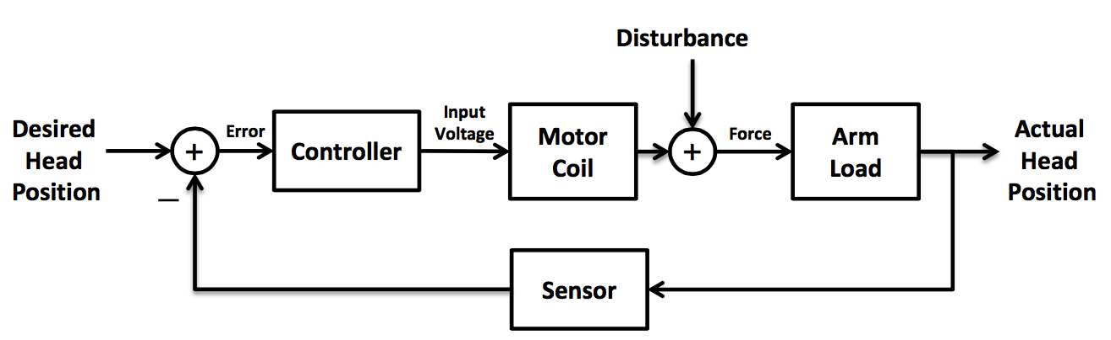

**Figure 1**

**2.0 TASKS**

2.1 Task 1

For this part, we are provided with the physical model relating the input torque to the header position with the inertia of arm and head and friction .

(1)

Simply apply Laplace transform to get the transfer function:  
 (2)

2.2 Task 2

The transfer function of the motor coil that relates the input voltage to the output torque is related by:

(3)

In this task, we are going to obtain the open-loop transfer function of the cascaded HDD head reader assembly and then use Matlab to generate the plot of the system’s step response.

(4)

The Matlab code with the constants plugged in and the plot obtained are presented below:

s = tf('s');

J = 1;

b = 20;

R = 1;

L = 0.001;

Km = 5;

G1 = Km/(L*s+R)

G2 = 1/(J*s^2+b*s)

openTF = G1*G2

t=[0:0.005:0.5];

y = step(openTF,t);

plot(t,y);

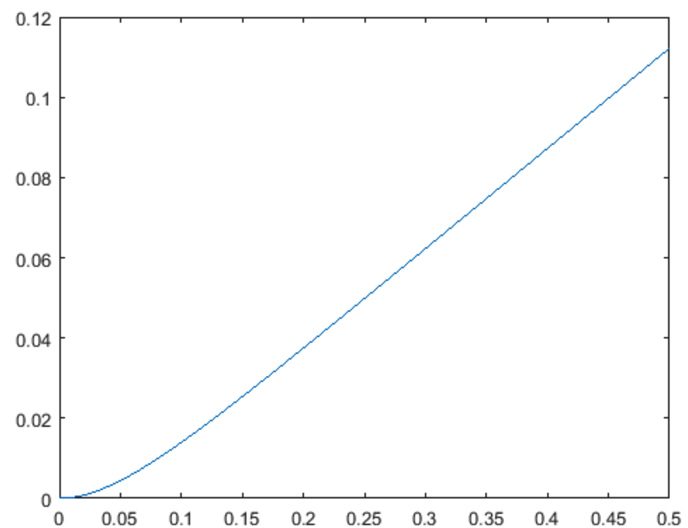

**Figure 2**

As we can see, if a constant voltage is applied, then the read head will moves with a constant speed. However, at the beginning when the voltage is applied, there is a curvature indicating the read head is accelerating.

**3.0 PROCEDURE**

3.1 Parallel RLC Circuit Response

For this part of the experiment, we start by building the circuit in Figure 1 with a 1.2k resistor, 150mH inductor, and 0.22 capacitor. Then use the function generator to generate a square wave from 1V to 0V to analyze the response of the voltage Vout. Compare the theoretical and experimental results.

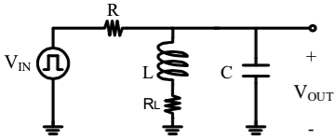

**Figure 1** – Parallel RLC circuit

3.2 Series RLC Circuit Response

Use a 3.3k resistor, 150mH, and 0.1 capacitor, build the series RLC circuit presented in Figure 2. Then as above, create a square wave with frequency of 100Hz from 1V to 0V and record the response of Vout. Use oscilloscope to view the input and output. Analyze the kind of damping involved and compare the theoretical result with the experimental one.

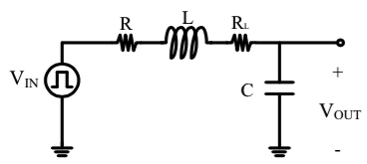

**Figure 2** – Series RLC circuit

3.3 Underdamped RLC Circuit Design

For this part we first change the value of the resistor in part 3.1 and acquire and underdamped response that over shoots the final value by approximately 0.25. Record the value of the resistor and the experimental value of the overshoot considering the internal resistance of the inductor and function generator. Then we design an underdamped system second-order circuit that has at least 4 visible peaks in oscillations. Record the experimental period and compare with the theoretical period.

3.4 Critically Damped RLC Circuit

Replaced the resistor of the circuit in Figure 1 by a 10k potentialmeter. Adjust the potentialmeter until the system is critically damped. Record the output and measure the resistance of the potentialmeter.

**4.0 DATA, DATA ANALYSIS, AND ERROR ANALYSIS**

The data for each part of the experiment is presented below:

4.1 Parallel RLC Circuit Response

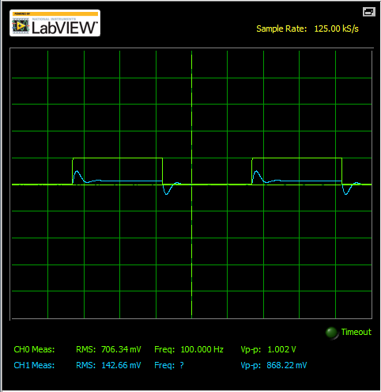

**Figure 3** – Vout of parallel RLC circuit

**Table 1**

|  |  |
| --- | --- |
| Variable | Voltage (mv) |
|  | 464.21  129.78 |

The Neper frequency and the resonant radian frequency we calculated with the theoretical values are 1894.0 rad/s and 5504.8 rad/s. Because , the system is an underdamped response with general solution of the form . Together with the initial conditions of the circuit that A and A. The coefficients are calculated as K1 = 0.119 and K2 = 0.689. As a result, the equation for Vout is: Vout = .

We can use the equation with the damping constant of to calculate the overshoot which is 0.316 for this part.

**DISCUSSION:**

The damping in this part is underdamped, same as the result we predicted.

4.2 Series RLC Circuit Response

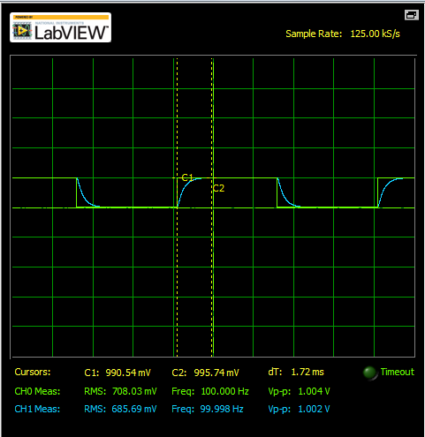

**Figure 3** – Vout of series RLC circuit

We use the same method as in 4.1 to calculate the Vout. and . Since , the circuit is overdamped. The theoretical Vout is with the initial condition that i(0+) = 0A.

**DISCUSSION:**

The damping in this part is overdamped that the prediction and the experimental result matches.

4.3 Underdamped RLC Circuit Design

In order to acquire an overshoot of 0.25, we need to be 0.40. By applying the equation below with inductor’s internal resistance of 159, we can get the value of resistance to be 803. The internal resistance of the function generator is measured to be 5.

In convenient to set the resistance, we used the potentialmeter and set it to 785. Then we are able to generate the graph as Figure 4.

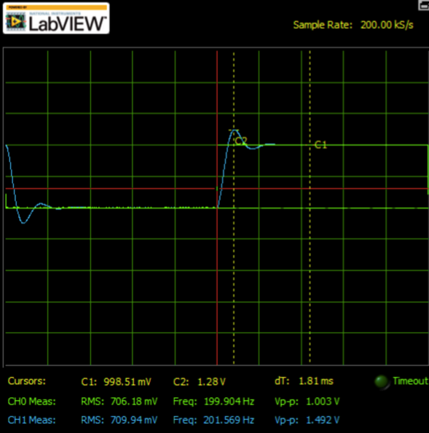

**Figure 4**

The peak voltage is 1.28V and the final voltage is 0.999V. The overshoot is then very close to 0.25.

Next, we chose a 10k resistor that and . With the initial conditions that and , we can get the voltage output to be represented by the equation . We can then calculate the period to be 1.14ms. The experimental period is measured to be 1.06ms by putting cursors on peaks.

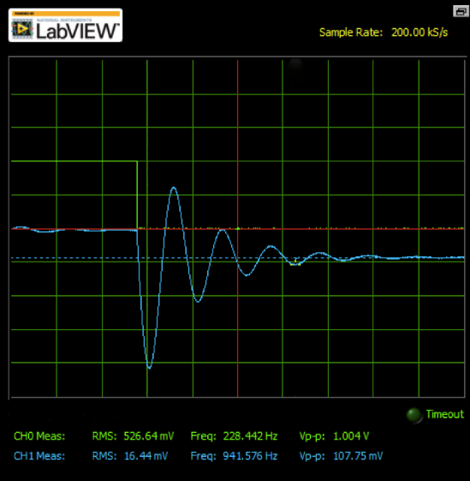

**Figure 5 –** visible peaks more than 4

**Table 2**

|  |  |  |
| --- | --- | --- |
| T theoretical (ms) | T experimental (ms) | Percentage of difference |
| 1.14 | 1.06 | 7.0% |

The percentage of difference is 7%, which can be caused by the differences between experimental and theoretical resistance, inductance and capacitance. This part of the experiment is successful.

Next, we removed the resistor and the circuit is supposed to be undamped. However，due to the internal resistance of the inductor, the response is still damped as shown in figure 6.

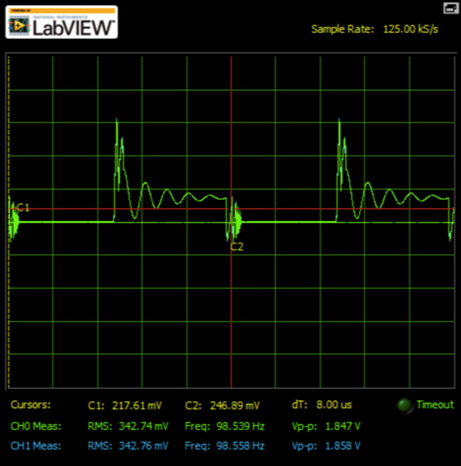

**Figure 6**

**DISCUSSION:**

1. The theoretical and experimental values have differences, which can be caused by the differences between real and expected resistance, inductance and capacitance.

2. A damped response caused by internal resistance of the inductor.

4.4 Critically Damped RLC Circuit

In this part of the experiment, when a circuit is critically damped, . The theoretical resistance for the circuit to be critically damped is approximately 448. The experimental value is 435. The percentage of difference is 2.9%. The minor difference indicates the validity of this part.

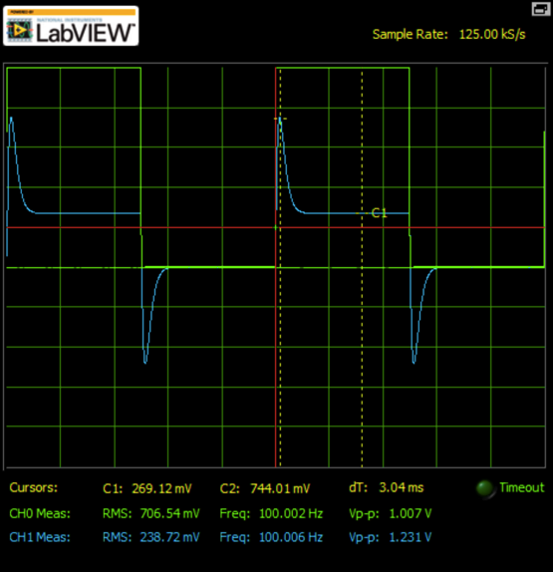

Figure 8 – Critically damped

**DISCUSSION:**

1. The experimental value and the theoretical value has a minor differences of 2.9% and this part of the experiment is successful.

2. If the resistance decreases, there will be oscillation since the circuit is underdamped. If the resistance increases, the response decays slower.

**5.0 CONCLUSION**

In this experiment, we build and study the RLC circuits in parallel and series. The underdamped, overdamped and critically damped circuits are built successfully that can show responses of the RLC circuit clearly. However, the internal resistance of the inductor cannot be ignored that it affects the precision of the experiment significantly. Also, the sample rate of myDAQ is low that it can causes errors. In general, this experimental is successful.

Lab Signature:

