#HW-1,4110056009陳柏硯

(1)allocate_map()

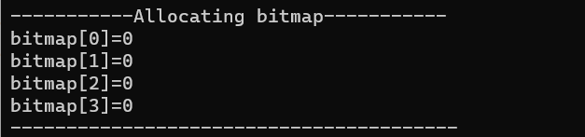

(2)allocate_pid

一般Allocate

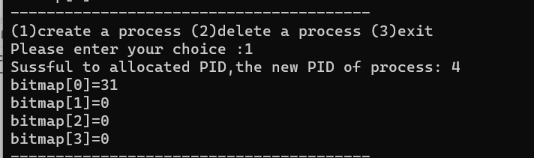

Full of bit map

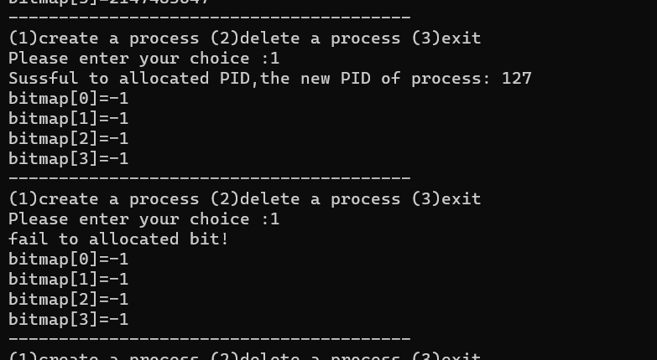

(3) release_pid()

If PID is not allocated

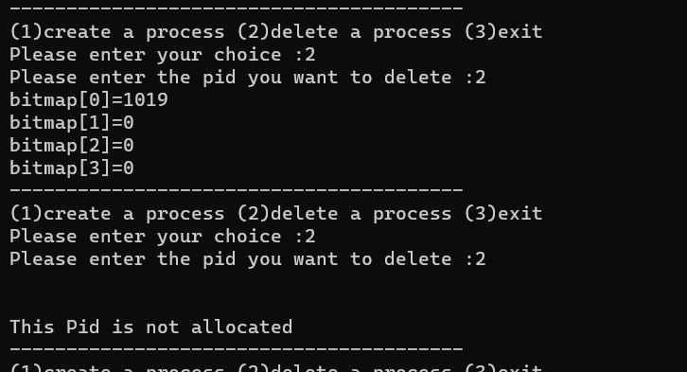

(4)exit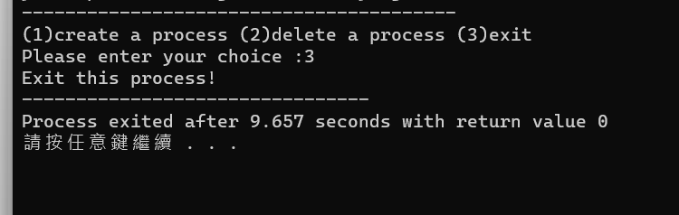

(5)out of choice

