Intent Dynamics: From Flow-of-Thought Capture to Simulated Intelligence
Geometric measurement and dynamical modeling of human–AI thought differences
Author: Baitao Wang | August 2026

Current flagship result (v0.75) — complete empirical chain: measurement (flow-of-thought capture) → dissection (64-dimension atlas) → intervention (inference-time spectrum) → conception (Intent Dynamics Engine). Full empirical archive: *Multi-level Semantic Fingerprint System* (historical comprehensive version, in Chinese).
【Machine Intent Dynamics — positioning】 The multi-level semantic fingerprint system built in this study embodies the prototype of "Machine Intent Dynamics." For the first time, it transforms "root intent" from an abstract cognitive concept into a computable geometric gravity field, and reveals the dynamical features (waves, turns, coupling) that distinguish human thought-flow from AI's probabilistic gliding. Although current validation is limited to small models and the textual domain, this framework provides an empirical path beyond the autoregressive paradigm: using an explicit intent-state space to guide models from "local-probability token continuation" toward "goal-driven reasoning around a core intent." If validated at larger parameter scales and in multimodal settings, this mechanism could lay the cognitive and engineering foundation for a new generation of AI architectures with intrinsic self-drive, interpretable thought trajectories, and extremely low inference energy.
Abstract
Autoregressive models have a single driver — local probability maximization — and no persistent state of "why write this sentence." Starting from engineering practice, this study builds a geometric representation of intent state from the discriminator's middle-layer 64-dimensional fingerprint, and captures systematic differences between human and AI thought-flow at clause granularity: Humans = breathing waves (inter-clause dimensional jump d=+2.16, turn peak/valley steepness d=+2.09, long-range memory Hurst 0.62, topic–reference coupling 0.52, low-determinism information flow), AI = flat lines (small jumps, shallow turns, goldfish memory Hurst 0.46, mechanical dictionary-like flow, higher transfer entropy). The 64-dimension dissection further shows that the deep signals learned by the discriminator (the unexplained-11 dimensions) are precisely the strongest human–AI difference group (median d=0.53 vs 0.32 for explained dimensions) — among them dim48 is triple-evidenced (composite traceback + dual-model agreement + causal control of reference density −0.42) as the reference-chain/cohesion dimension, and dim10 as the topic-organization dimension. The inference-time intervention spectrum (201 runs / 22 conditions) proves intent state is intervenable (peak 117% oracle; recommended form vt_gate_beam 103% with 67% cost reduction — virtual-token channel + Kalman gating — minimal-intervention principle). From these phenomena, this paper derives the three-layer Intent Dynamics Engine (Root Intent Field / Intent Trajectory Planner / Intent Steering Executor) — five empirical laws — moving from "predicting the next word" to "free thinking around a root intent": AI's first possession of an internal "why."
1. Introduction: From "Resembling Humans" to "How Thought Flows"
1.1 Origin
This research began with an engineering pain point in a narrative-writing system: AI-generated text remained machine-identifiable even after prompt engineering and local lexical substitution. The first-generation research (v0.60–v0.66) answered: the difference lies in the organization of local clauses — humans organize language around an intent core (clause projection 0.96 vs AI 0.79–0.84), AI is local-optimum stitching. This is static "resemblance."
The v0.74 flow-of-thought capture advanced the question: the deepest human–AI difference is not "whether a moment resembles" but "how thought flows" — human thought trajectories are waves fluctuating freely around a core (with undulation, memory, loops); AI trajectories are flat lines (no undulation, goldfish memory, mechanical flow). This paper's core contribution turns "intent" from philosophical metaphor into a measurable dynamical system, and derives an architecture from the measurements.
1.2 Structure
§2 Capture tools → §3 Flow-of-thought capture (core) → §4 Intent-state dissection → §5 Intent intervenability → §6 Intent Dynamics Engine → §7 Boundaries & decoupling → §8 Conclusion.
2. Capture Tools: Geometric Representation of Intent State
2.1 Discriminator and Fingerprint
ParaDiscNN (bge-small-zh-v1.5 encoding → 512→256→64→1 MLP, trained to discriminate AI/human paragraphs). The middle-layer 64-dim activation (net[0:3]+relu+net[3]+relu — skipping LN(64)) is the style fingerprint:
f(x) = relu(W₂·relu(LN₁(W₁x+b₁)) + b₂) # f ∈ R^64 — W₁=net[0].weight (256×512) — W₂=net[3].weight (64×256)
Geometric property (v0.66): discriminative power comes from projection onto the core (in-segment mean fingerprint direction — human 0.972 vs AI 0.807), not pairwise cosine (AUC 0.55 meaningless) — "the fingerprint points at the shaping core."
2.2 Trajectory Metric System (v0.74 — the capture toolbox)
Slice text at a granularity (segment/clause/word) → extract per-slice dimensional activations → connect into a trajectory — this line is the intent-flow trajectory.
Metric | Definition | Thought property captured
Jump | mean \ | Δactivation\
Turn type | local peak/valley steepness/depth | Topic opening/closing sharpness
Hurst | R/S analysis (long-range autocorrelation) | Memory (does earlier text influence later? looping ability)
Transfer entropy | symbolic conditional entropy (X past→Y future) | Information-flow freedom (mechanical vs free)
Coupling | sliding-window dimX×dimY correlation | Inter-dimension tension (topic–reference bonded?)
Dimension activation | per-dim value/variance/sign | Coordinates of intent state
Why clause-level is the best observation granularity (v0.74-4): word-level trajectories have the weakest discriminative power (dim10 jump human 0.309 vs AI 0.295 — word fingerprints are highly continuous); segment-level loses undulation (dim10 jump d=+1.24); clause-level (509–1029 points per human text) carries full undulation with the strongest discrimination (d=+2.16).
3. Flow-of-Thought Capture: Human vs AI Thought-Dynamics Portrait (Core)
3.1 Data and Procedure
Corpus: bilingual zh 30 texts (10 human, 96–160 segments / 509–1029 clauses each — Dragon Clan/Zhu Xian/Tianxingjian continuous segments; 20 AI, 23–98 segments — DS/Qwen continuous generation) + same-theme ultra-long (Tianxingjian ch.1–6, 899 segments human vs archives, 146 segments AI imitation)
Fingerprint matrix: 26,734 clauses × 64-dim fingerprints archived (fp_matrix.npz — three regression validations ALL PASS: document-level sent_proj 30/30 Δ≤0.0005; 6 dims 3618/3618 Δ≤0.0001; disc 603/603 — fingerprints verified authentic)
Analysis: per-text clause-level dim10 (topic)/dim48 (reference) activations → trajectory → five metrics (jump/turn/Hurst/TE/coupling) → human vs AI group tests (Mann-Whitney U + Cohen's d)
3.2 Finding 1: Humans are Waves, AI is a Flat Line (Jump)
Data (clause-level):
Metric | Human (median) | AI (median) | d | p
dim10 jump | 0.310 | 0.257 | +2.16 | <0.001
dim48 jump | 0.368 | 0.339 | +1.07 | 0.009
(segment-level dim10) | 0.155 | 0.115 | +1.24 | 0.010
Derivation: human thought trajectories fluctuate freely around the core — dim10 (topic) rises when opening a new topic, holds during development, falls during transitions — forming waves. AI trajectories are significantly flatter (d=+2.16) — AI is not "randomly jagged" but "wave-less" — lacking topic opening/closing structure. For humans, undulation is the breathing of thought; for AI, flatness is the standstill of thought.
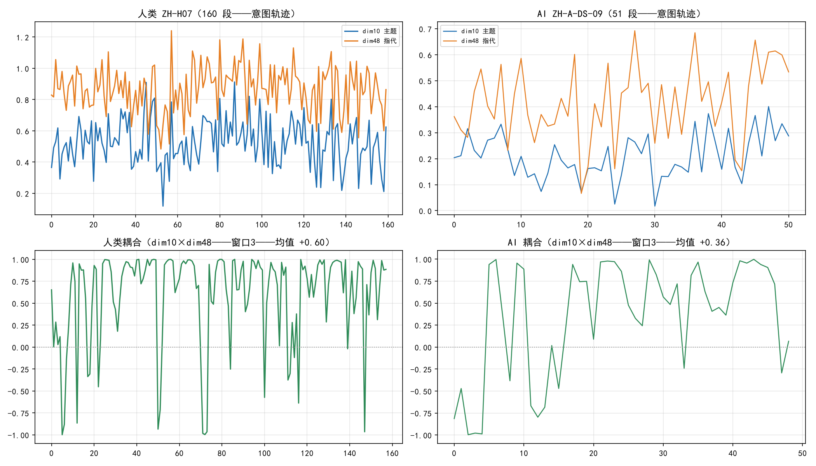
Intent flow trajectory (human waves vs AI flat)
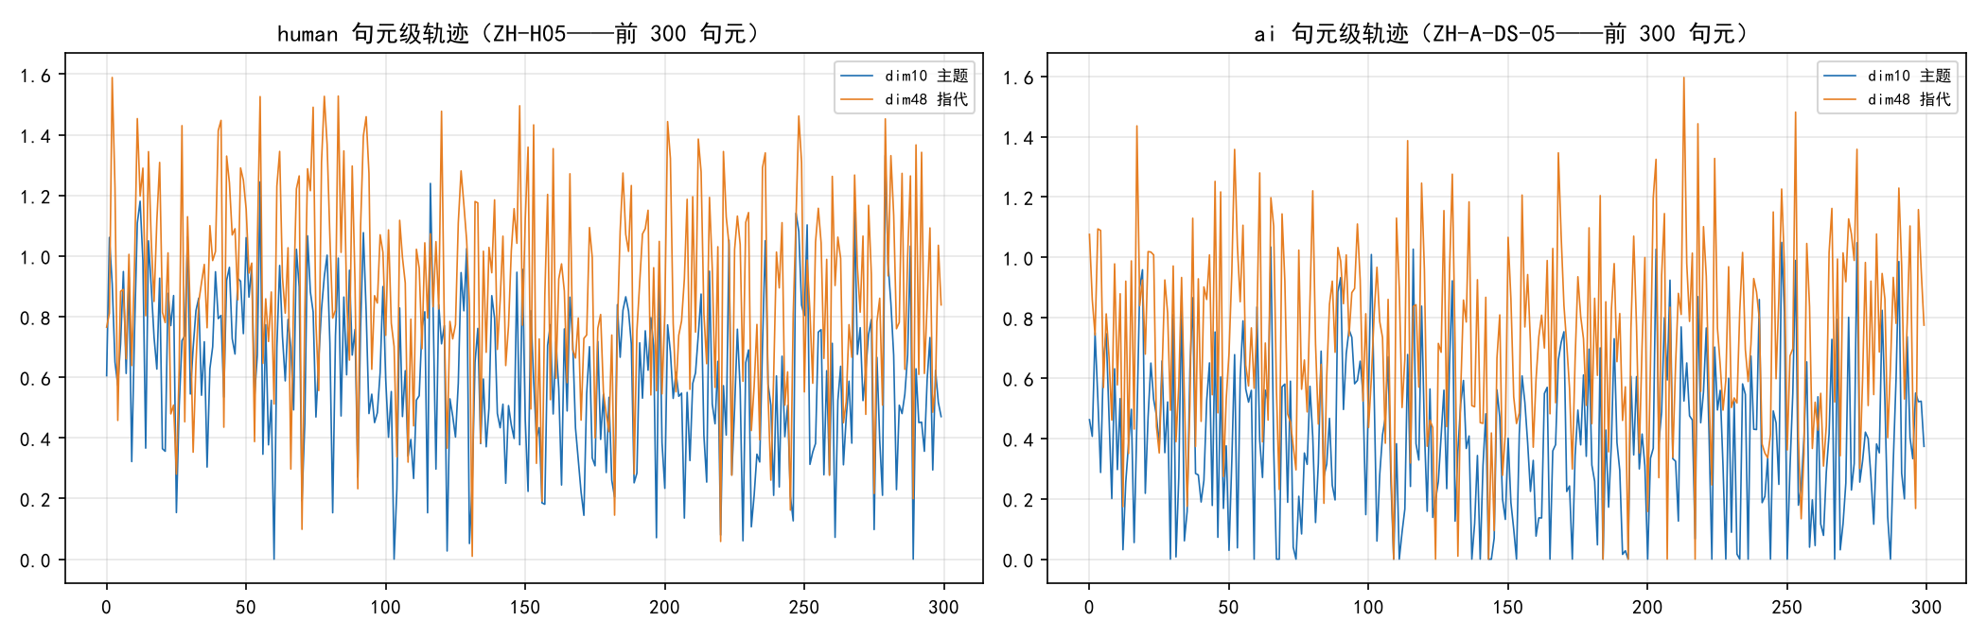
Clause-level intent trajectory (human steep vs AI flat)
3.3 Finding 2: Deeper Human Turns, Shallow AI Turns (Turn Type)
Data (turn "type" not "count"):
Metric | Human | AI | d | p
dim10 peak steepness | 0.468 | 0.381 | +2.09 | <0.001
dim10 valley depth | 0.468 | 0.391 | +2.14 | <0.001
dim48 peak steepness | 0.556 | 0.520 | +0.90 | 0.033
dim48 valley depth | 0.550 | 0.523 | +0.93 | 0.026
(Control: turn count / break density show no difference — 0.175 vs 0.170 — "count" metrics are ineffective; "type" metrics are effective.)
Derivation: turn steepness/depth (not count) separates humans and AI — human topic opening/closing is distinct (sharp peaks/valleys — the "cadence" of thought), AI turns are shallow (smooth gliding). Counts equal, amplitudes differ sharply — both have similar numbers of turns, but human turns are "meaningful pivots," AI turns are "directionless slides."
3.4 Finding 3: Human Long-Range Memory, AI Goldfish Memory (Hurst)
Data (same-theme ultra-long trajectories):
Trajectory | Segments | dim10 Hurst | dim48 Hurst
Tianxingjian ch.1–6 (human) | 899 | 0.621 (>0.5 — long-range memory) | 0.638
archives (AI imitation) | 146 | 0.457 (<0.5 — anti-persistent / near random walk) | 0.592
Derivation: human writing has memory — earlier content influences later organization across distance (loops, echoes, foreshadowing — Hurst>0.5) — the ability for "the original intent to periodically resurface." AI's dim10 Hurst below 0.5 (anti-persistent) — inter-segment topic-memory breaks — goldfish memory — AI cannot "remember its original intent." This is the dynamical explanation of "AI long-text digression" (not semantic forgetting — organizational-memory fracture; consistent with long-range semantic retention 0.94+ showing no difference: semantics remembered, organization forgotten).
3.5 Finding 4: AI's Information Flow is Mechanical, Human's is Free (Transfer Entropy)
Data (clause-level):
Direction | Human | AI | d | p
TE(dim10→dim48) | 0.0124 | 0.0194 | -0.79 | 0.075 (marginal)
TE(dim48→dim10) | 0.0123 | 0.0160 | -0.55 | 0.244
Derivation: transfer entropy measures the predictability gain of Y's future given X's past — AI's higher topic→reference flow = more mechanically determined "topic-word→reference-pronoun" transitions (dictionary-like association: a topic word is predictably followed by a reference — predictable) — human's lower flow = more complex, less predictable topic–reference relations (free organization) — an information-theoretic quantification of "human freedom vs AI mechanism."
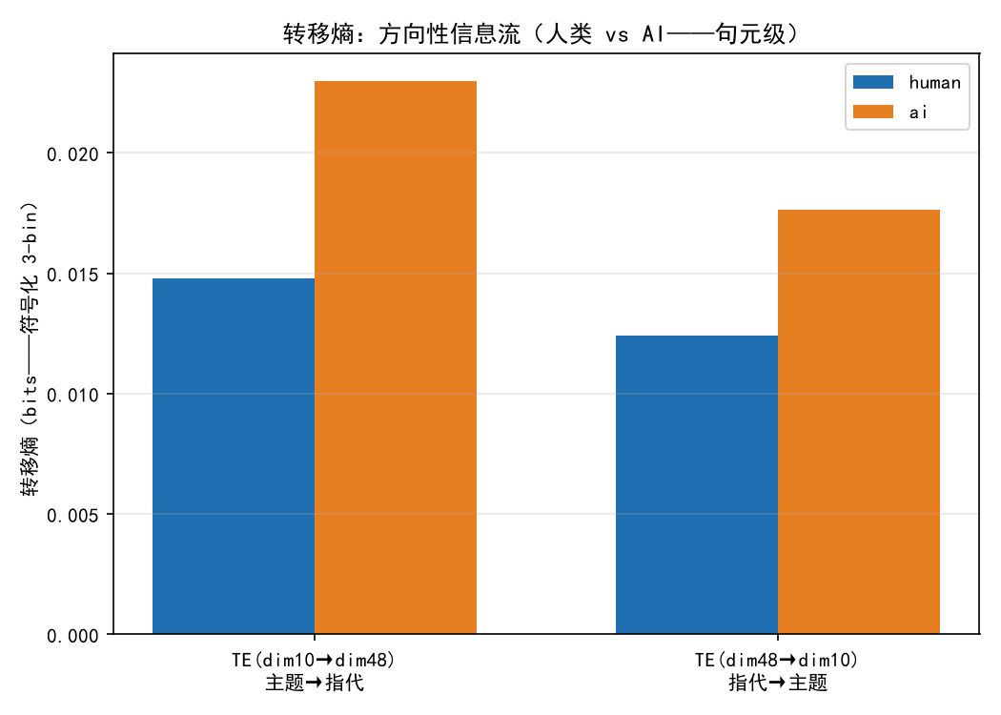
Transfer entropy (AI mechanical flow higher)
3.6 Finding 5: Human Topic–Reference "Bonded," AI "Disconnected" (Coupling)
Data (3-segment sliding window dim10×dim48 correlation): human coupling mean +0.517 vs AI +0.432 (p=0.118 — directional).
Derivation: in human writing, reference chains naturally follow topics (mention topic → "this/it/that" follows — co-fluctuation) — high coupling. AI's lower coupling — a segment may repeat topic words (dim10 surging) while using no references (dim48 low) — the mathematical explanation of "circular repetition": dictionary repetition replaces logical reference — the two threads of thought (topic and cohesion) are "disconnected" in AI.
3.7 Synthesis: Human vs AI Thought-Dynamics Portrait
Dimension | Human | AI
Undulation | Waves (jump d=+2.16) | Flat (no waves)
Turns | Deep (steepness d=+2.09) | Shallow
Memory | Long-range (Hurst 0.62) | Goldfish (Hurst 0.46)
Information flow | Free (low TE) | Mechanical (high TE)
Coupling | Bonded (+0.52) | Disconnected (+0.43)
In one sentence: human writing is free fluctuation within a root-intent gravity field (memorable loops, deep turns, free flow); AI writing is field-less flat gliding (no undulation, no memory, mechanical flow) — "thought with a gravity field" vs "thought without a field" — the observational basis of the Intent Dynamics Engine.
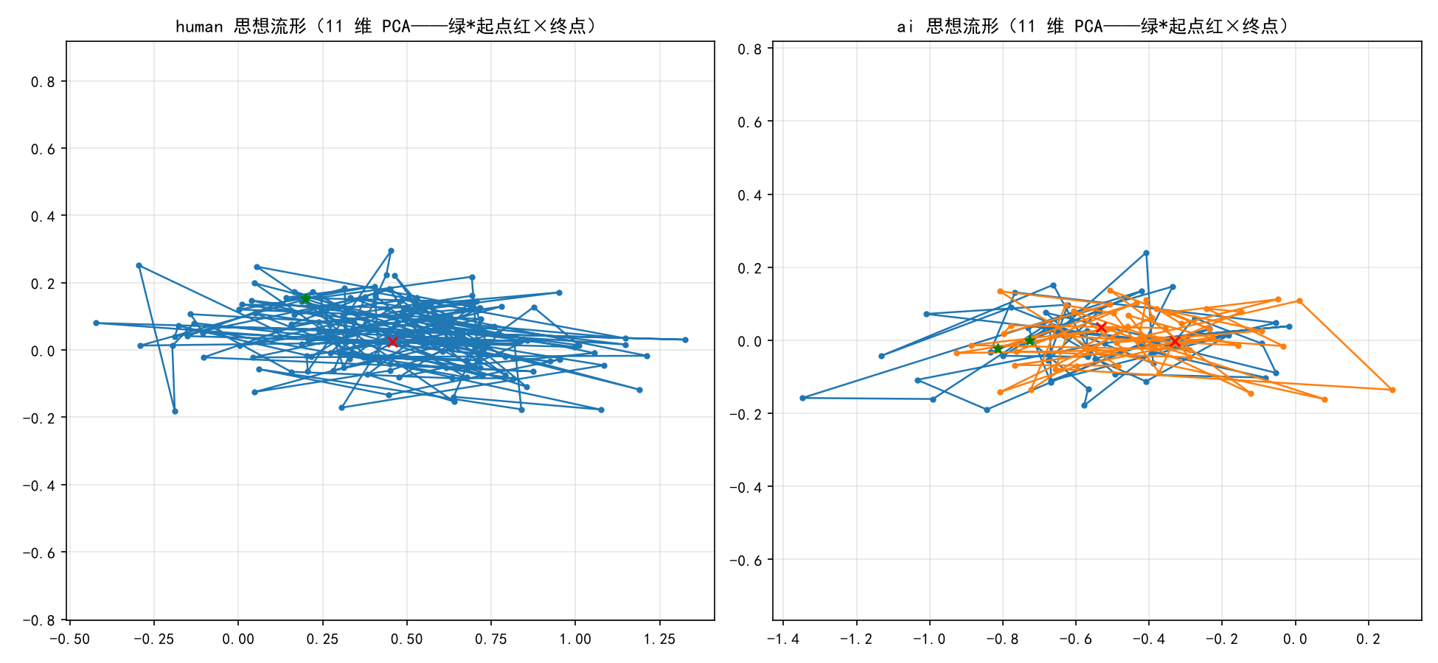
Thought manifold (human concentrated vs AI dispersed)
4. Intent-State Dissection: 64-Dimension Atlas (v0.74)
4.1 Dimension Function Localization (Causal Intervention — 144 runs)
Dimension perturbation (replace μ_h / scale 1.5 / 0.5 / noise control) → virtual-token channel injection → language-feature changes in generated text:
Dimension | Perturbation effect | Function
dim48 | reference density −0.42 / conjunction −0.20 | reference-chain/cohesion dimension
dim10 | topic density +0.12~+0.23 / reference density +0.13~+0.15 | topic-organization dimension
dim46 | sent_proj scale0.5 significant (+0.021 p=0.04) | projection-adjustment candidate
dim34/22/43 | weak directional | discriminative signal
(Note: sent_proj-level effects are weak — 2/18 significant — attenuated by the MLP 64→896 mapping — dimension control must be measured at the language-feature level)
4.2 Interpretability × Discrimination Inverse Relation (64-Dimension Panorama)
Group | Median \ | human-AI d\ |  | Significant
Explained (42 — surface features) | 0.32 | 23
Other unexplained (11) | 0.35 | 7
Unexplained-11 | 0.53 | 9/11
Derivation: the deep signals the discriminator learned are precisely the dimensions not linearly explainable by surface features — unexplained-11 = discriminative-signal proper (top-10 strongest includes 5 unexplained: dim58 +0.69/dim55 +0.67/dim59 +0.65/dim34/dim46) — "unexplainable" ≠ "useless" — it is the most concentrated discriminative information — the core coordinates of intent state lie on these deep dimensions.
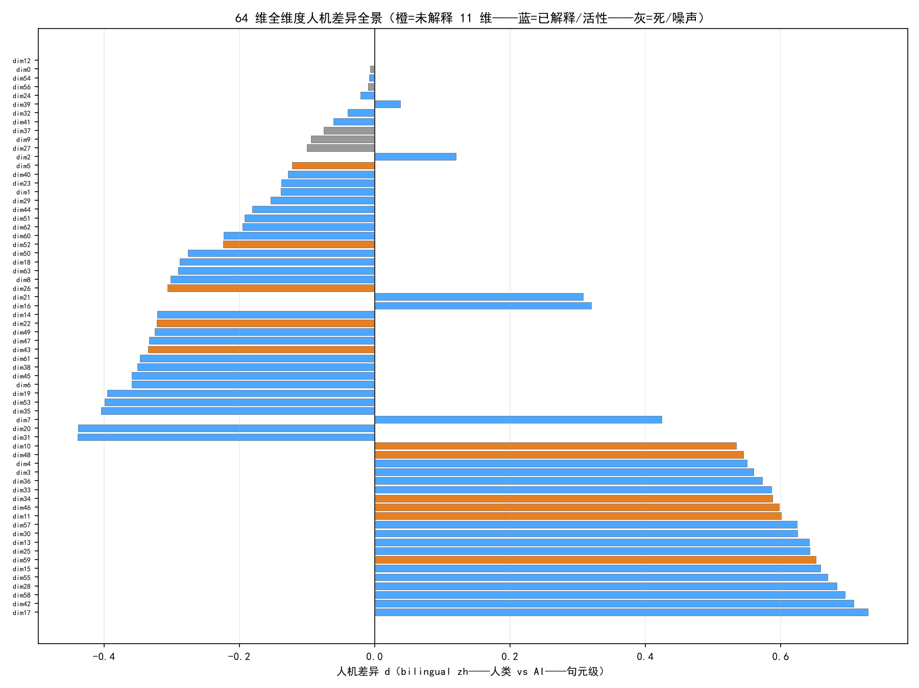
64-dim human-AI difference panorama (orange=unexplained-11)
4.3 Polarity Grouping (basis of Law 3)
Unexplained-11 splits into two groups (consistent with internal correlation 38/55): Human-organization group (dim10/11/34/46/48/59 — positive human-AI d + positive jump — human-high-activation + human-waves) vs AI-feature group (dim22/26/43/52/5 — negative + negative — AI-high-activation + AI-fluctuation) — human waves appear on human-high-activation dimensions; AI fluctuations on AI-high-activation dimensions — intervention must distinguish polarity (Law 3).
5. Intent Intervenability: Inference-Time Spectrum and Causal Control
5.1 Intervention Spectrum (201 runs / 22 conditions — oracle = Δ÷0.09×100)
Probability 17-25% → logits 40% → beam 51% → seed+beam 82% → virtual-token channel (vt_ext 49% — +16 points over the logits carrier) → three-layer stacking vt_seed_beam 117% → Kalman-gated vt_gate_beam 103% (67% cost reduction — 0.37 s/oracle-point — recommended form). No-beam tests: seed effect depends on beam (pure seed −1%) — beam's net contribution 36 points irreplaceable — gating 46% is the no-beam optimum — "when to inject" matters more than "what to inject" (minimal-intervention principle).
5.2 Kalman Repair (Prediction-Accuracy Path)
S2 r=0.15's root cause: Kalman implementation (segment start read stale x_pred) — after fixing the `predict()` semantics, r=0.389 (2.6–3×) — adaptive strategy (free segments skip beam — efficiency) — intent state is predictable (segment-level r≈0.68 — lag structure) — prediction-driven resource allocation = quality-cost optimum.
5.3 Causal-Control Loop
dim48/dim10 perturbations change reference/topic organization of generated text — dimensions are not merely correlated but causally intervenable — providing "knobs" for the engine's steering executor.
6. Intent Dynamics Engine: The Inference Chain from Phenomena to Architecture
6.1 Derivation of the Five Laws (phenomenon → law)
Law 1 (Subconscious before surface control) — Phenomenon: human clause jump d=+2.16 — human thought fluctuates freely around the core, not glued to it. Derivation: if intent were a per-sentence hard constraint (existing "core-clinging" interventions), fluctuation would be suppressed — making AI flatter and more mechanical (opposite of the goal) — root intent must exist as a background field — surface intent flows freely — pull-back only when deviating beyond a safety boundary.
Law 2 (Flow features are more fundamental than static features) — Phenomenon: clause-level jump-significant dimensions 56/64 vs static human-AI 39/64; turn steepness d=+2.09. Derivation: single-point projections tell whether "this clause clings"; flow rhythm/turn depth/coupling dynamics tell "how thought progresses" — the higher-information discriminative and target signals live in flow features — the engine's objective should be trajectory-morphology-based, not point-based.
Law 3 (Dimension polarity must be treated separately) — Phenomenon: 64 dims are non-uniform — human waves on human-high-activation dims (dim10/34/46 etc.), AI fluctuation on AI-high-activation dims (dim22/26/43). Derivation: intervention cannot be one-size-fits-all — positive (human-organization) group should encourage wave-like undulation (wide fluctuation band); negative (AI-feature) group should suppress mechanical swinging (narrow band).
Law 4 (Interpretability and discriminative power are inversely related) — Phenomenon: explained d=0.32 vs unexplained-11 d=0.53. Derivation: the discriminator's deep signals are the unexplainable dimensions — the core coordinates of intent state lie on deep dimensions — the engine's state representation should use all 64 dims (or the 11-dim core subspace), not only explainable ones — explainable dims provide the "translation layer," deep dims the "discriminative power."
Law 5 (Information-flow freedom is a new axis) — Phenomenon: TE AI 0.019 vs human 0.012 — AI's topic→reference transitions are mechanically determined. Derivation: human freedom vs AI mechanism is an axis independent of "core-clinging" — the engine must not only "cling to the core" (projection) but also "flow freely" (low-determinism flow) — the target distribution should include an information-flow-freedom constraint.
6.2 Three-Layer Architecture
Layer 1: Root Intent Field — root intent = fixed vector R in the 64-dim (or 11-dim core subspace) space — the gravity-field minimum — close = comfortable, far = high potential — correction triggered only when potential exceeds a threshold (Law 1) — verified components: document-core/external-core anchors (document-core d 2.04–2.09; vt_ext 49% / vt_oracle 55% — the field's anchor is verified).
Layer 2: Intent Trajectory Planner — learns human fluctuation patterns (§3.2–3.6 target distributions: allowed fluctuation range / target jump / target coupling / target Hurst) — input: current intent state + history → output: next-clause target-state distribution — wide band for positive dims, narrow for negative dims (Law 3) — verified components: Kalman gating (predict-assign — r=0.389 — intent state predictable) — fluctuation-pattern learning is the core to be implemented.
Layer 3: Intent Steering Executor — target state → real-time LLM sampling guidance — options: magnetic guidance (logits bias) / intent mask (token subset) / virtual-token injection — gating: enabled only on coupling drop / abnormal jump / trajectory deviation (Law 1 — "when to inject" > "what to inject") — verified components: vt channel (injection 117%/103% — +16 points over logits), Kalman gating (no-beam 46%).
6.3 Essential Difference from the Existing Paradigm
Dimension | Traditional autoregressive | Intent Dynamics Engine
Driver | Local probability | Root-intent field + local probability
State | No persistent intent state | Measurable intent-state vector (64-dim fingerprint)
Trajectory | Flat or random drift | Human-like waves and loops (target-distribution constrained)
Intervention | None | Field-boundary trigger + trajectory planning + gated execution
Interpretability | Black box | Dimension atlas + polarity grouping
Cost | Full-vocabulary compute | Optional intent mask (output-layer load reduction)
6.4 Implementation Path (from verified components to end-to-end)
Fluctuation-pattern learning (planner core — to be implemented): learn target jump/turn-steepness/coupling distributions for dim10/dim48 (and all 64) from human corpora — as generation target states
Field end-to-end: root intent (document/external core) → deviation detection (trajectory–field distance, clause-level) → above-threshold triggers vt-channel pull-back — "free fluctuation + field pull-back" generation loop
Polarity steering: positive dims encourage waves (wide target band); negative dims suppress swinging (narrow band) — implemented via the dim_perturb channel
Training-time: dim48/dim10 as loss terms (φ jointly optimized with LM — eliminating OOD injection)
Verification: end-to-end generation → five flow metrics (jump/turn/Hurst/TE/coupling) should approach the human portrait — the engine's acceptance criterion
7. Boundaries and Decoupling (Engine Positioning)
The engine is confined to the organizational layer (focus/undulation/cohesion/memory — flow metrics). Three decoupling findings:
Reasoning zero transfer (v0.70 + v0.73-5): intent anchoring / strongest intervention forms give zero reasoning-accuracy gain (none 39% vs vt 31% — organizational optimization does not convert to semantic correctness — "organized ≠ correct")
Long-range semantics zero difference (v0.71): 0.94+ both high — "AI digression" is not semantic forgetting but organizational-memory fracture (Hurst 0.46)
Semantic layer needs training time: the engine's organizational guidance does not touch semantics — semantic ability (reasoning/facts) still depends on model capacity and training
Boundary statement: the engine does not claim to "improve reasoning" — it claims to "make generation trajectories exhibit human-like organizational dynamics" (waves/memory/coupling/free flow) — semantic correctness is the model's responsibility; intent dynamics is the organization's responsibility.
8. Conclusion
This paper advances from "static resemblance" to "dynamic thought-flow":
Intent flow is capturable (§3): all five clause-level metrics capture systematic human–AI differences — humans = breathing waves (free fluctuation/deep turns/long memory/free flow/bonded coupling), AI = flat lines (no waves/shallow/goldfish/mechanical/disconnected);
Intent state is dissectable (§4): 64-dim atlas — unexplained-11 = deep discriminative-signal proper (interpretability × discrimination inverse) — dim48 = reference chain (triple-evidenced) — dim10 = topic organization — polarity grouping;
Intent is intervenable (§5): spectrum to 117%/103% — minimal-intervention principle — causal control (dim48/dim10 knobs);
Intent is conceivable (§6): five laws derived from phenomena — three-layer architecture — explicit implementation path (fluctuation learning → field end-to-end → polarity steering → training-time regularization → five-metric acceptance).
Final proposition: the essential human–AI writing difference lies not in vocabulary but in the organization of intent state — humans fluctuate freely in a root-intent gravity field (memorable loops, deep turns, free flow); AI glides flat without a field. The Intent Dynamics Engine aims to move AI from "passive prediction" to "proactive thinking around its original intent" — AI's first possession of an internal "why."
Appendix: Reproduction Guide (per-conclusion paths)
Environment: Python 3.13 + torch/transformers/sentence-transformers/scipy/jieba/sklearn — offline analysis pure CPU (minutes) — generation needs GPU (MX570 2GB verified) — local models Qwen2.5-0.5B / bge-small-zh (HF_HUB_OFFLINE=1 cache). Repository: IntentDynamics (GitHub-ready — scripts/data/models/papers bundled).
Bundled assets (no regeneration needed)
Asset | Path | Validation
Clause fingerprint matrix | data/dim_analysis/fp_matrix.npz (26,734×64 + h1 256) | three regression validations PASS
Clause metadata | data/dim_analysis/rows.json | row-aligned
Discriminator weights | data/para_discriminator_v2.pt | fingerprint pipeline
Mapping MLP | data/intent_prior_model/mlp_checkpoint.pt | vt injection
Intervention spectrum | data/training_intervention/manifest.json + texts/ (201 runs full texts) | reproduces paper numbers
Probe corpus | data/independent_test/ (dim_probe/language_mechanism/manifest) | 11-dim list reproduction
Conclusion→command mapping
Paper conclusion | Script | Command | Output
§3.2 waves vs flat (d=+2.16) | dim_flow_sent.py | `python stage3/dim_flow_sent.py` | flow_sent_analysis.json (dim10_jump)
§3.3 turn steepness (d=+2.09) | dim_flow_sent.py | same | turn10_peak_steep_mean
§3.4 Hurst | dim_flow.py | `python stage3/dim_flow.py` (corpus-optional) | flow_analysis.json
§3.5 transfer entropy | dim_flow_sent.py | same | te_10_to_48
§3.6 coupling | dim_flow.py | same | coupling
§4.1 dim48/dim10 causal | dim_intervene.py (GPU) | `python stage3/dim_intervene.py` | intervene_manifest.json
§4.2 inverse relation | dim_64_full.py | `python stage3/dim_64_full.py` | dim64_full.json
§5.1 spectrum | gen_theme_guidance.py (GPU) | `--conditions vt_ext,vt_seed_beam,vt_gate_beam --seeds 0,1` | manifest append
11-dim list | dim_activity.py | `python stage3/dim_activity.py` | activity.json
Full pipeline
python stage3/dim_activity.py # activity
python stage3/dim_probe_deep.py # probe + traceback
python stage3/dim_cross_validate.py # dual-model
python stage3/dim_64_full.py # 64-dim panorama
python stage3/dim_flow.py # segment + Hurst
python stage3/dim_flow_sent.py # clause + TE
python stage3/dim_flow_word.py # word + 11-dim panorama
python stage3/gen_theme_guidance.py --conditions vt_ext --seeds 0,1 # GPU
python stage3/md_to_docx.py "论文/意图动力学：从意图流转捕捉到模拟智能的架构构想.md"
Reproduction verification (2026-08-14 — all PASSED)
dim_activity (11-dim list ✓) → dim_64_full (dim59 d=+0.65 ✓) → dim_flow_sent (d=+2.16 / TE 0.0124 vs 0.0194 ✓) → dim_probe_deep (dim48: 21 sig-pairs/8-8 ✓) → gen_theme_guidance smoke (vt_ext 0.9602 ✓) → md_to_docx (✓) — all numbers match the paper.

