Supplement

Spectral Data Sample Preparation and Cytometer Analysis

Peripheral blood was obtained from healthy, non-pregnant adult donors. All human samples used for this research were de-identified, with discarded clinical material and no patient or clinical information available for analysis. Whole blood from each donor was diluted 1:1 in 1x PBS to a final volume of 50 mL and 25 mL aliquots were layered on 12 mL Ficoll gradient. After gradient centrifugation (20 min, 2000 rpm), lymphocytes were isolated from the Ficoll interface and washed once in RPMI containing pen/strep and 10% FBS and directly stained for analysis on a 5-laser Cytek Aurora spectral flow cytometer.

Antibodies and isotype controls used for flow cytometric analysis are listed in Table S1. For surface staining, cells were stained for 30 min in RPMI containing pen/strep and 10% FBS. For intracellular staining, cells were fixed and permeabilized using the eBiosciences FOXP3 kit (eBiosciences). Analysis was performed on a Cytek Aurora. All flow cytometric data were acquired using equipment maintained by the Research Flow Cytometry Facility in the Division of Rheumatology at Cincinnati Children’s Hospital Medical Center (RRID:SCR_022635).

Binary Classification

Binary classification was used to assess the performance of the Part 1 algorithm. Positive and negative marker designations were each considered their own condition, while null marker designations were only considered when a ground truth positive marker designation or a ground truth negative marker designation was labeled as null. Null values were only judged in this manner for a few reasons. One reason was that cases of actual nulls corresponding to predicted nulls could inflate accuracy numbers since there are many nulls that are in both the ground truth and are predicted as such. Additionally, instances where benchmark nulls were predicted as being either positive or negative were not considered since the Kimmey marker definitions and the Samusik and spectral manual gating data did not contain comprehensive cell type marker definitions but rather focused on the most ‘important’ or defining markers. In other words, some so-called nulls could really be positive or negative markers that remained unlabeled as such in those datasets even though the underlaying expression values indicated those patterns. This ambiguity about which designation is considered ‘true’ led to their removal from the classification assessment.

Creation of the Marker Standardization Workflow
The primary approach to standardizing marker names was to directly query the Protein Ontology. For these queries, the specified species was used to return both species-specific matches and matches that were unlinked to any species. When querying PRO, the inputted name was compared to the listed PRO term, PRO name, exact synonym, broad synonym, related synonym, and narrow synonym. Based on the quality of matches, ‘primary’ matches were considered inputs that connected to PRO terms, PRO names, and exact synonyms. ‘Secondary’ matches were the inputs that matched to broad, related, and narrow synonyms. If an input matched to both a primary and secondary term per species (with ‘no species’ considered a species type), only the primary matched term was returned. If an input only matched to the secondary term per species, then that term was outputted.

Due to the general lack of standardization of marker names used in the cytometry field, direct queries to PRO sometimes fail. As a result, other resources were added to the workflow to encompass more marker synonyms. It was observed that in many cases protein complexes (i.e. MHCII or TCRab) were not listed as PRO terms but rather GO terms. Because querying the GO directly could result in inaccurate GO term matches for the other protein markers, a list was created with all the GO complex terms used in the CL. This list was used in the workflow to automatically revert these protein complexes to GO terms. Additionally, a list of cluster of differentiation (CD) synonyms was used to automatically connect to additional marker synonyms¹. If marker names were linked through this list, the algorithm would then query those names in PRO. Wikidata, which encompasses protein information from UniProt, InterPro, and the Protein Data Bank, was used as another reference^{2–6}. SPARQL was used for these queries and if any synonyms were found then PRO would once again be queried.

When user-inputted marker names were not able to be automatically matched to a PRO term, the cause was often that the names were not specific enough. Automatically reverting to standardized marker names in this case may be making incorrect assumptions about the user’s intentions. Instead, a list of suggestions was created by manually examining all the inputted marker names from the developmental dataset that failed. Some suggestions were taken from the list of CD synonyms, created by the Human Cell Differentiation Molecules organization, which was also used for the synonyms search¹. This list was modified to include the broad CD identifiers that did not match and the more specific forms as suggestions. For example, an input of ‘CD11’ was too broad, so this list will suggest to the user they indicate if it is ‘CD11a’, ‘CD11b’, ‘CD11c’, or ‘CD11d’. Other non-CD marker suggestions were added based on the development markers and how they were specified in PRO.

In addition to marker inputs not being specific enough, marker inputs often were in a format that made it impossible to provide an accurate match. For example, users frequently combined multiple markers together in their panel or referred to multiple markers as a non-protein term (i.e. ‘lineage’). Additionally, user inputs sometimes included punctuation markers used in disparate ways, meaning they could not be removed or split universally (i.e. ‘CD16a/b’ and ‘CD194/CCR4’). In these cases, the solution was to include suggestions to rewrite inputs when certain characters are used (commas, brackets, parentheses, and slashes). Lists of non-protein words that were commonly used were also created to tag inputs that either were not marker names at all (i.e. ‘dead’ or ‘lineage’) or still contained the metal or fluorochrome used in the experiment. The general ‘non-protein’ word list was created based off names found in the developmental set, with additional words added based off observed patterns (i.e. cytometry instrumentation names were added since it was observed they are sometimes connected to protein names). The ‘fluorochrome’ list was created based off fluorochromes listed in the ‘reported_name’ column of the downloaded ‘reagent’ file from ImmPort. Similarly, the ‘metal tag’ list was created based off metal ions listed in the ‘reported_name’ column of the same file. All curated suggestion lists are available on GitHub.

Since the commonly used markers CD3e, CD8a, and TCR are part of larger complexes, the workflow was created to include automatic matching to those complexes. Specifically, an input of CD3e matches to CD3e, TCR, TCRab, and TCRgd, while TCR matches to TCRab and TCRgd. CD8a matches to CD8a and CD8ab. If the more specific marker is also included in the query (TCRab, TCRgd, or CD8ab), this automatic matching will not occur.

The order of the workflow was determined based on maximizing the number of PRO or GO matches in the least amount of time. The final step of the workflow allows the user to incorporate any suggestions into renaming their unmatched markers.

Figures

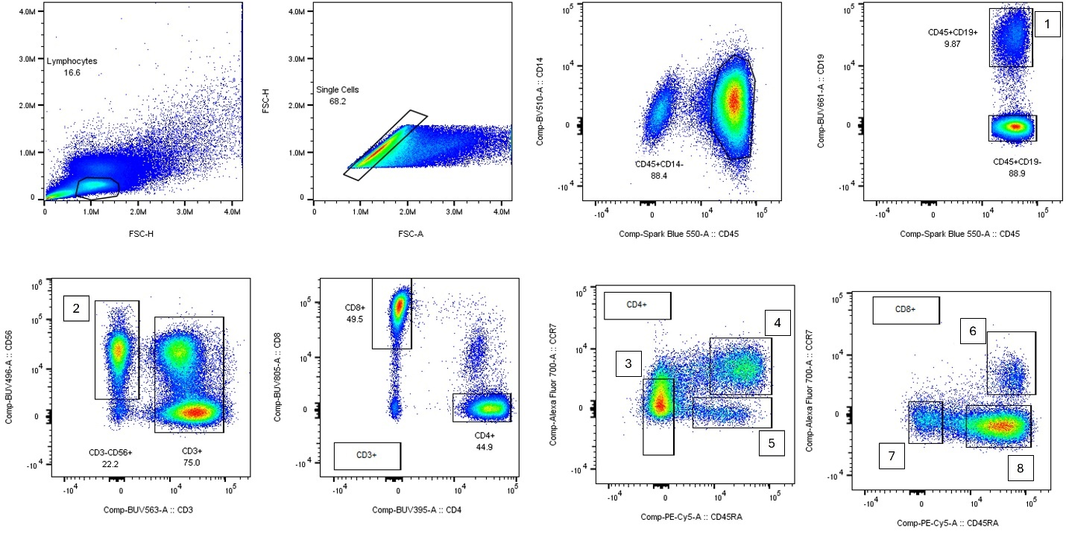
Figure S1. Manual gating scheme for the spectral flow cytometry dataset that was used for benchmarking the tool. The numbers indicate the populations and correspond to the following cell type names: 1) B cells, 2) Natural killer cells, 3) Effector memory CD4⁺ T cells, 4) Naïve CD4⁺ T cells, 5) TEMRA CD4⁺ T cells, 6) Naïve CD8⁺ T cells, 7) Effector memory CD8⁺ T cells, and 8) TEMRA CD8⁺ T cells.

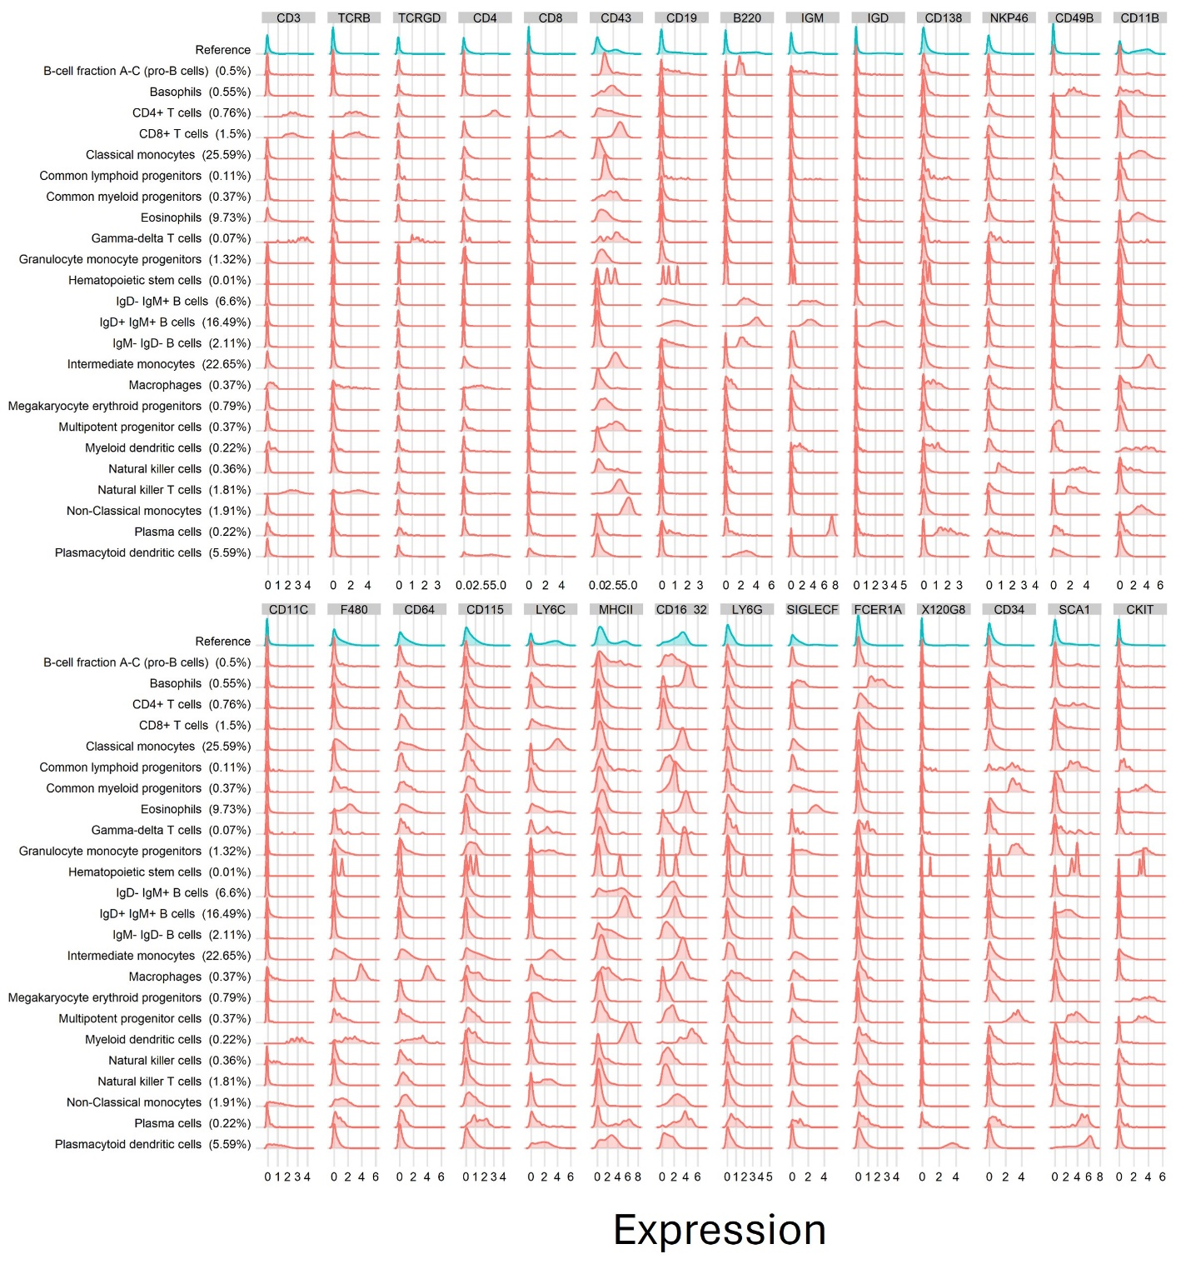
Figure S2. Histogram plots showing the expression distribution (arcsinh transformed) per cluster from the Samusik dataset⁷. Only markers used in the manual gating scheme are included. The percentage of live cells per cluster are shown in parentheses.

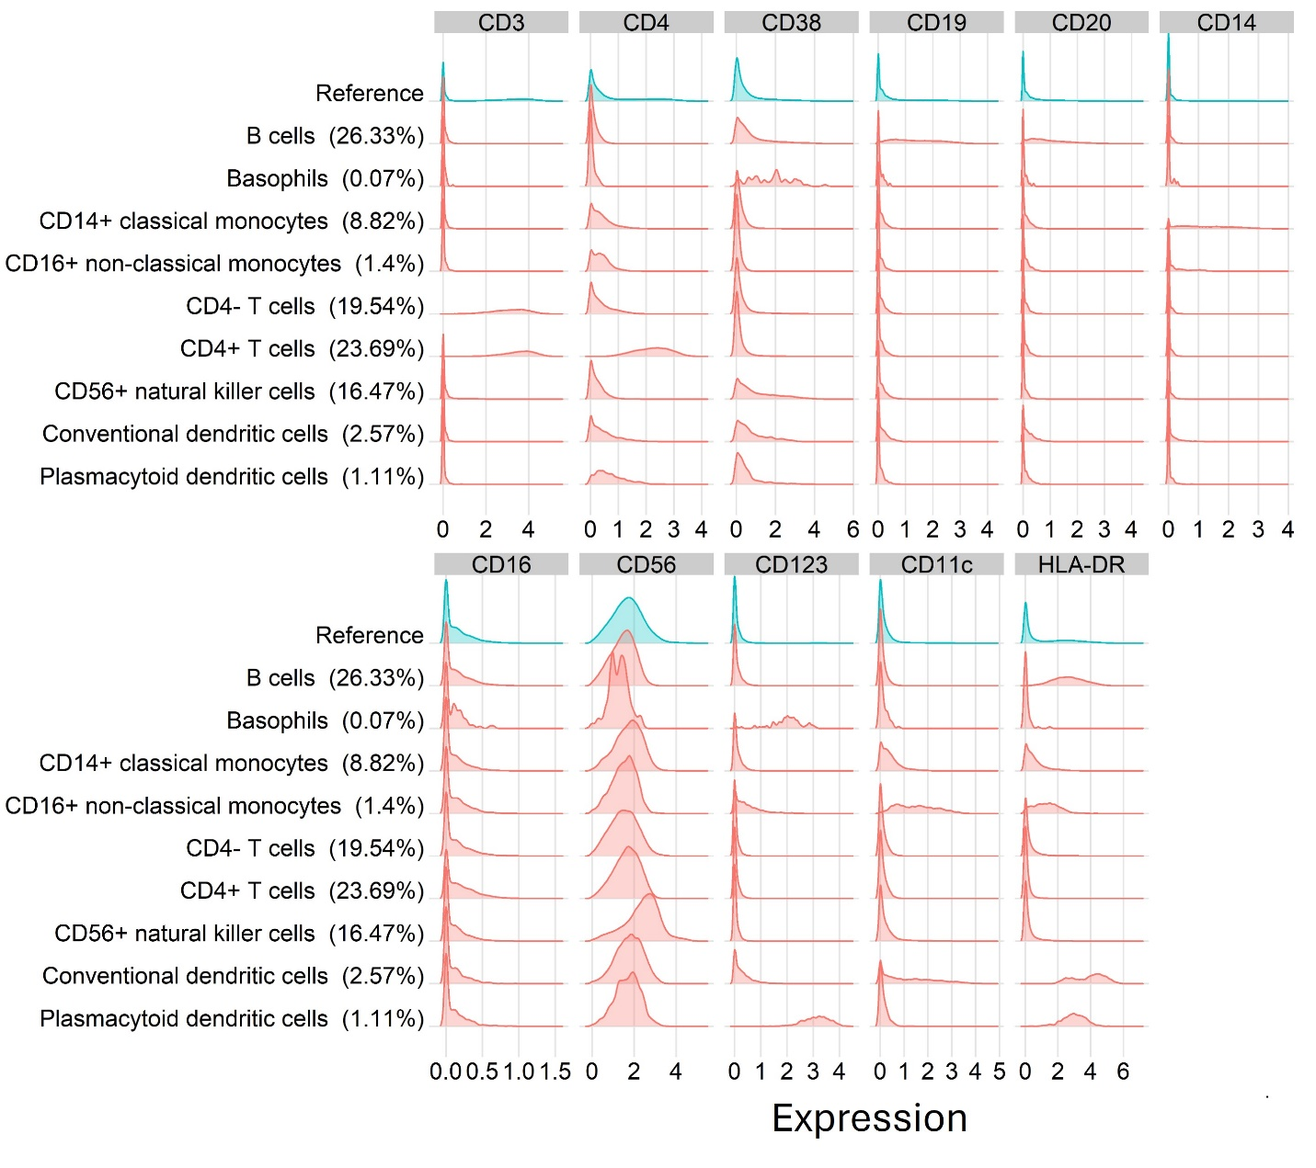
Figure S3. Histogram plots showing the expression distribution (arcsinh transformed) per cluster from the Kimmey dataset⁸. Only markers used in the cell type marker definitions are included. The percentage of live cells per cluster are shown in parentheses.

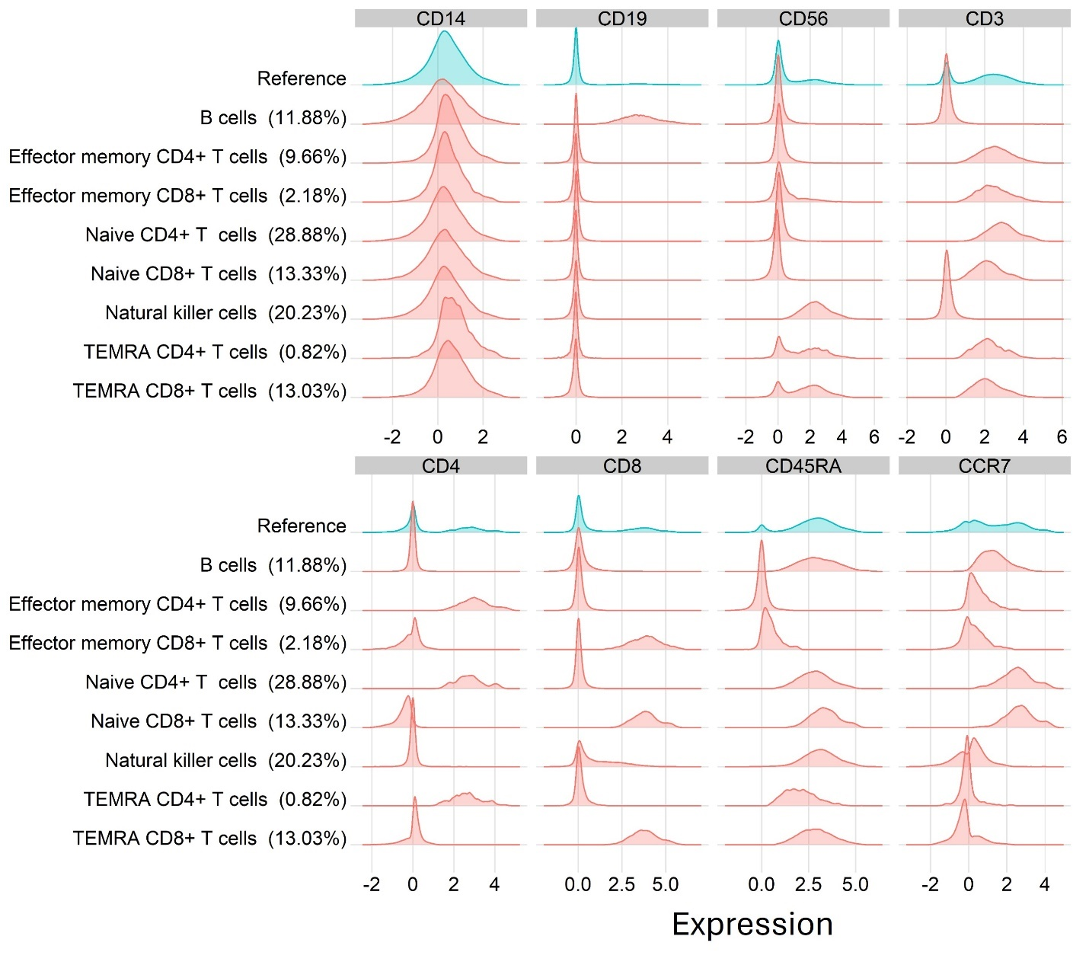
Figure S4. Histogram plots showing the expression distribution (arcsinh transformed) per cluster from the spectral dataset. Only markers used in the manual gating scheme are included. The percentage of live cells per cluster are shown in parentheses.

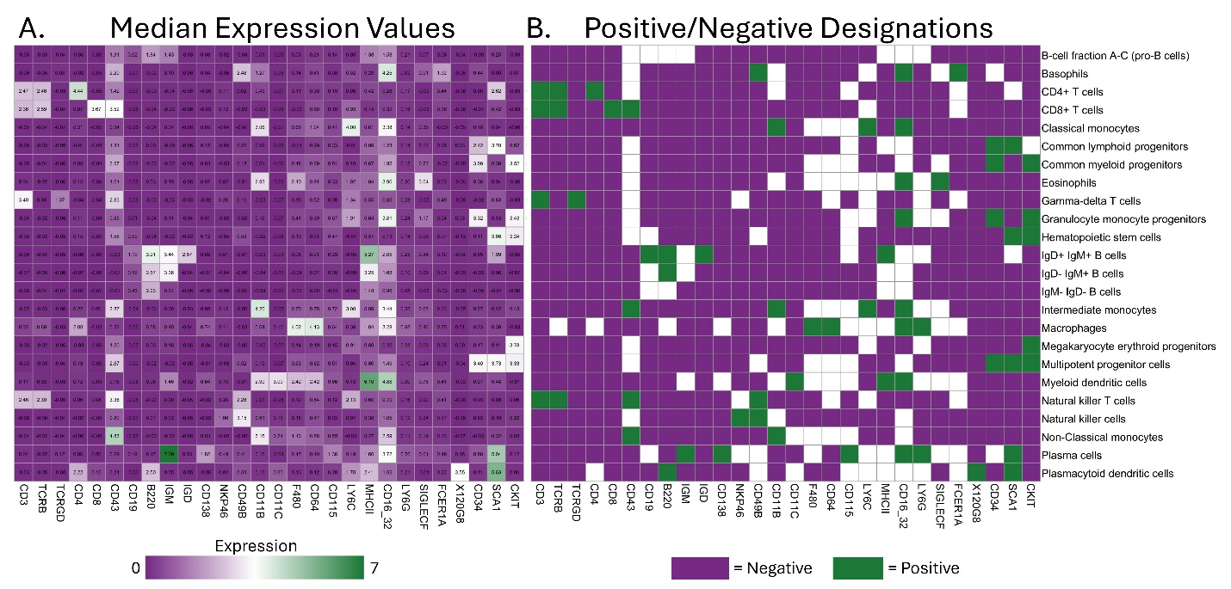
Figure S5. Heatmaps depicting the markers and cell type names that were delineated via manual gating analysis from Samusik et al⁷. Specifically, A) shows median expression values and B) shows results of the tool’s marker designation algorithm (Part 1).

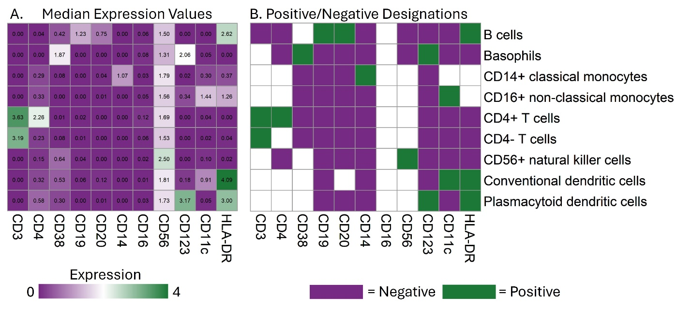
Figure S6. Heatmaps depicting the markers and cell type names that were delineated via clustering analysis from Kimmey et al⁸. Specifically, A) shows median expression values and B) shows results of the tool’s marker designation algorithm (Part 1).

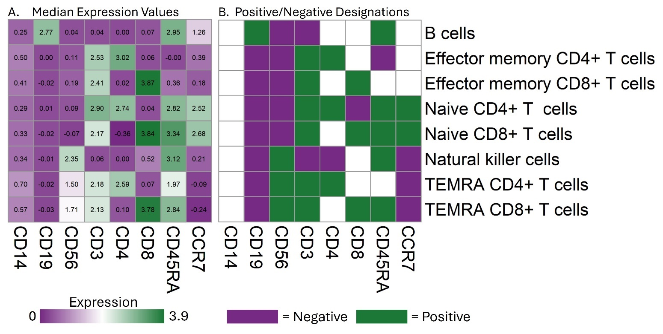
Figure S7. Heatmaps depicting the markers and cell type names that were delineated via manual gating analysis for the spectral flow cytometry data. Specifically, A) shows median expression values and B) shows results of the tool’s marker designation algorithm (Part 1).

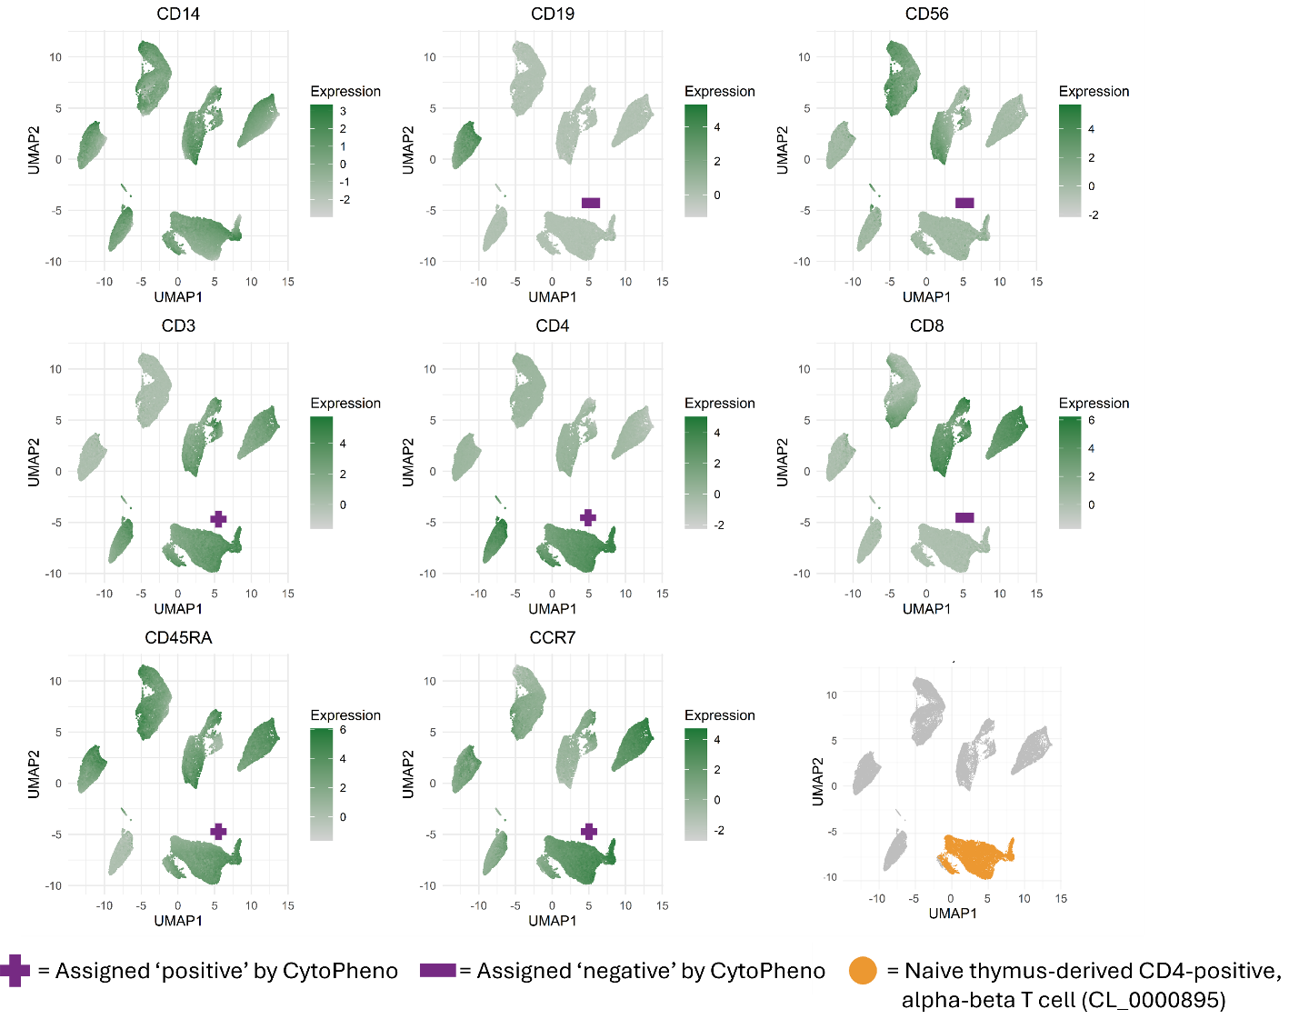
Figure S8. UMAPs showing a randomly down sampled (50,000 cells) subset of the spectral dataset. One cluster, naïve thymus-derived CD4⁺ alpha-beta T cells (CL_0000895), is highlighted (bottom right corner in orange). All other UMAPs are overlaid with the expression values per marker, colored with a grey to green gradient. The purple ‘+’ and ‘-’ symbols indicate the marker designation for the highlighted cluster, as assigned by CytoPheno.

Tables

Table S1. Antibody panel used for the seven sample spectral cytometry dataset. Note that the fluorophores for CCR7 and HELIOS were switched for analysis of donors five through seven.
Antigen | Fluorophore | Clone | Company
CD4 | BUV395 | M-T477 | BD Biosciences
CD56 | BUV496 | NCAM16.2 | BD Biosciences
CD3 | BUV563 | UCHT1 | BD Biosciences
CD19 | BUV661 | SJJJ25C1 | BD Biosciences
CD8 | BUV805 | RPA-T8 | BD Biosciences
CD103 | BV421 | Ber-ACT8 | Biolegend
FOXP3 | Pacific Blue | 259D | Biolegend
CD14 | BV510 | 63D3 | Biolegend
CD69 | BV605 | FN50 | Biolegend
CCR6 | BV650 | A019D5 | Biolegend
Perforin | BV711 | dG9 | Biolegend
CCR7 | AlexaFluor 488 (donors 5-7) | G043H7 | Biolegend
CCR7 | AlexaFluor 700 (donors 1-4) | G043H7 | Biolegend
HELIOS | AlexaFluor 488 (donors 1-4) | 22F6 | Biolegend
HELIOS | AlexaFluor 700 (donors 5-7) | 22F6 | Biolegend
CD45 | Spark Blue 550 | 2D1 | Biolegend
TIGIT | PerCP/eFluor710 | MBSA43 | eBiosciences
CD25 | PE | 2A3 | BD Biosciences
CD39 | PE/Dazzle594 | A1 | Biolegend
CD45RA | PE/Cy5 | HI100 | Biolegend
PD1 | PE/Cy7 | EH12.1 | BD Biosciences
CCR4 | APC | DT5D3 | Miltenyl Biotec
GZMB/GranzymeB | APC/Fire750 | QA16A02 | Biolegend

Table S2. Summary of cell type names and marker definitions that were included in the bone marrow study published by Samusik et al. and used for benchmarking in this study⁷. All cell types that were listed by name in Supplementary Figure 5 from the original manuscript were included (N=24). The marker descriptions were taken from the manual gating strategy included in that supplemental figure. The equivalent CL name and term was manually determined for each original cell type based on the original name and the marker definition. Cell types that could not be matched to a CL term and were subsequently excluded from cell type matching tests are indicated.

Original cell type name | Original marker definitions | CL cell type name | CL term
B-cell fraction A-C (pro-B cells) | CD43⁺, B220⁺, 120g8⁻ | No equivalent CL term - too broad
Basophils | FceR1a⁺, NKp46⁻, CD3⁻, CD49b⁺, B220⁻, 120g8⁻ | Basophil | CL_0000767
CD4⁺ T cells | CD4⁺, CD8⁻, TCRb⁺, TCRgd⁻, CD3⁺, CD49b⁻, B220⁻, 120g8⁻ | CD4-positive, alpha-beta T cell | CL_0000624
CD8⁺ T cells | CD8⁺, CD4⁻, TCRb⁺, TCRgd⁻, CD3⁺, CD49b⁻, B220⁻, 120g8⁻ | CD8-positive, alpha-beta T cell | CL_0000625
Classical monocytes | Ly6C⁺, CD43⁻, CD11b⁺, CD3⁻, CD49b⁻, B220⁻, 120g8⁻ | Gr1-high classical monocyte | CL_0002395
Common lymphoid progenitors | CD43⁺, B220⁻, Sca1⁺, cKit⁺, CD115⁻, CD11b⁻, CD3⁻, CD49b⁻, B220⁻, 120g8⁻ | Kit-positive, Sca1-positive common lymphoid progenitor | CL_0001025
Common myeloid progenitors | CD34⁺, CD16_32⁻, cKit⁺, Sca1⁻, CD115⁻, CD11b⁻, CD3⁻, CD49b⁻, B220⁻, 120g8⁻ | Kit-positive, CD34-positive common myeloid progenitor | CL_0001023
Eosinophils | SiglecF⁺, CD11b⁺ | Eosinophil | CL_0000771
Gamma-delta T cells | TCRgd⁺, TCRb⁻, CD3⁺, CD49b⁻, B220⁻, 120g8⁻ | Gamma-delta T cell | CL_0000798
Granulocyte monocyte progenitors | CD16_32⁺, CD34⁺, cKit⁺, Sca1⁻, CD115⁻, CD11b⁻, CD3⁻, CD49b⁻, B220⁻, 120g8⁻ | Kit-positive granulocyte monocyte progenitor | CL_0002002
Hematopoietic stem cells | CD34⁻, cKit⁺, Sca1⁺, CD115⁻, CD11b⁻, CD3⁻, CD49b⁻, B220⁻, 120g8⁻ | Kit and Sca1-positive hematopoietic stem cell | CL_0001008
IgD⁻ IgM⁺ B cells | IgD⁻, IgM⁺, CD43⁻, B220⁺, 120g8⁻ | Fraction E immature B cell | CL_0002054
IgD⁺ IgM⁺ B cells | IgD⁺, IgM⁺, CD43⁻, B220⁺, 120g8⁻ | Fraction F mature B cell | CL_0002056
IgM⁻ IgD⁻ B cells | IgD⁻, IgM⁻, CD43⁻, B220⁺, 120g8⁻ | Fraction D precursor B cell | CL_0002052
Intermediate monocytes | Ly6C⁺, CD43⁺, CD11b⁺, CD3⁻, CD49b⁻, B220⁻, 120g8⁻ | Gr1-positive, CD43-positive monocyte | CL_0002398
Macrophages | F480⁺, CD64⁺, CD3⁻, CD49b⁻, B220⁻, 120g8⁻ | Bone marrow macrophage | CL_0002476
Megakaryocyte erythroid progenitors | CD34⁻, CD16_32⁻, cKit⁺, Sca1⁺, CD115⁻, CD11b⁻, CD3⁻, CD49b⁻, B220⁻, 120g8⁻ | Kit-positive, CD34-negative megakaryocyte erythroid progenitor cell | CL_0002006
Multipotent progenitor cells | CD34⁺, DNA2⁺, cKit⁺, Sca1⁺, CD115⁻, CD11b⁻, CD3⁻, CD49b⁻, B220⁻, 120g8⁻ | Slamf1-positive multipotent progenitor cell | CL_0002036
Multipotent progenitor cells |  | Slamf1-negative multipotent progenitor cell | CL_0002035
Myeloid dendritic cells | MHCII⁺, CD11c⁺, CD3⁻, CD49b⁻, B220⁻, 120g8⁻ | Mature CD16-positive myeloid dendritic cell | CL_0002534
Natural killer cells | FceR1a⁻, NKp46⁺, CD3⁻, CD49b⁺, B220⁻, 120g8⁻ | Natural killer cell | CL_0000623
Natural killer T cells | CD3⁺, CD49b⁺, B220⁻, 120g8⁻ | Mature NK T cell | CL_0000814
Natural killer T cells | CD3⁺, CD49b⁺, B220⁻, 120g8⁻ | Immature NK T cell stage IV | CL_0002042
Non-Classical monocytes | Ly6C⁻, CD43⁺, CD11b⁺, CD3⁻, CD49b⁻, B220⁻, 120g8⁻ | Gr1-low non-classical monocyte | CL_0002058
Plasma cells | IgM⁺, CD138⁺ | Plasma cell | CL_0000786
Plasmacytoid dendritic cells | 120g8⁺, B220⁺ | CD8_alpha-negative plasmacytoid dendritic cell | CL_0002455

Table S3. Summary of cell type names and marker definitions that were included in the PBMC study published by Kimmey et al. and used for benchmarking in this study⁸. All groups that were listed in Supplementary Table 3 from the original manuscript and were not used for in silico mononuclear cell purification (N=9) were included. Both the cell type names and marker descriptions were taken directly from that supplemental table. The equivalent CL name and term was manually determined for each original cell type based on the original name and the marker definition. Cell types that could not be matched to a CL term and were subsequently excluded from cell type matching tests are indicated. Markers that were designated as ‘het’ were excluded from analysis.

Original cell type name | Original marker definitions | CL cell type name | CL term
B cells | CD20⁺, CD19⁺, HLADR⁺ | No equivalent CL term - too broad
Basophils | CD38⁺, CD123⁺, CD19⁻, HLADR⁻ | Basophil | CL_0000767
CD14⁺ classical monocytes | CD14⁺, CD16^{neg} | CD14-positive, CD16-negative classical monocyte | CL_0002057
CD16⁺ non-classical monocytes | CD14^{low}, CD16⁺ | CD14-low, CD16-positive monocyte | CL_0002396
CD4⁺ T cells | CD3⁺, CD4⁺, CD19⁻, HLADR⁻ | CD4-positive, alpha-beta T cell | CL_0000624
CD4- T cells | CD3⁺, CD4⁻, CD19⁻, HLADR⁻ | No equivalent CL term - too broad
CD56⁺ natural killer cells | CD56⁺⁺, CD38^{het}, CD16^{het}, CD14⁻, CD19⁻, CD20⁻ | CD16-negative, CD56-bright natural killer cell, human | CL_0000938
Conventional dendritic cells | CD11c⁺, HLADR⁺, CD14- | Immature conventional dendritic cell | CL_0000840
Conventional dendritic cells | CD11c⁺, HLADR⁺, CD14- | Mature conventional dendritic cell | CL_0000841
Plasmacytoid dendritic cells | CD123⁺, HLADR⁺, CD14⁻ | Immature CD11c-negative plasmacytoid dendritic cell | CL_0000994

Table S4. Summary of cell type names and marker definitions that were included in the unpublished spectral cytometry PBMC study and used for benchmarking in this study. All cell types (N=8) that were numbered in the manual gating scheme were included. Marker descriptions were taken from the manual gating strategy. The equivalent CL name and term was manually determined for each original cell type based on the original name and the marker definition. Cell types that could not be matched to a CL term and were subsequently excluded from cell type matching tests are indicated.

Original cell type name | Original marker definitions | CL cell type name | CL term
B cells | CD14⁻, CD19⁺ | B cell, CD19-positive | CL_0001201
Effector memory CD4⁺ T cells | CD14⁻, CD19⁻, CD3⁺, CD4⁺, CD8⁻, CD45RA⁻, CCR7⁻ | Effector memory CD4-positive, alpha-beta T cell | CL_0000905
Effector memory CD8⁺ T cells | CD14⁻, CD19⁻, CD3⁺, CD4⁻, CD8⁺, CD45RA⁻, CCR7⁻ | Effector memory CD8-positive, alpha-beta T cell | CL_0000913
Naive CD4⁺ T cells | CD14⁻, CD19⁻, CD3⁺, CD4⁺, CD8⁻, CD45RA⁺, CCR7⁺ | Naive thymus-derived CD4-positive, alpha-beta T cell | CL_0000895
Naive CD8⁺ T cells | CD14⁻, CD19⁻, CD3⁺, CD4⁻, CD8⁺, CD45RA⁺, CCR7⁺ | Naive thymus-derived CD8-positive, alpha-beta T cell | CL_0000900
Natural killer cells | CD14⁻, CD19⁻,  CD3⁻, CD56⁺ | CD16-negative, CD56-bright natural killer cell, human | CL_0000938
Natural killer cells | CD14⁻, CD19⁻,  CD3⁻, CD56⁺ | CD16-positive, CD56-dim natural killer cell, human | CL_0000939
TEMRA CD4⁺ T cells | CD14⁻, CD19⁻, CD3⁺, CD4⁺, CD8⁻, CD45RA⁺, CCR7⁻ | Effector memory CD4-positive, alpha-beta T cell, terminally differentiated | CL_0001087
TEMRA CD8⁺ T cells | CD14⁻, CD19⁻, CD3⁺, CD4⁻, CD8⁺, CD45RA⁺, CCR7⁻ | Effector memory CD8-positive, alpha-beta T cell, terminally differentiated | CL_0001062

Table S5. Summary of cell type names and marker definitions that were included in OMIP 54 and used for benchmarking (Part 3) in this study⁹. All cell types that were numbered (N=9) in the original manuscript were included, while cell subtypes that represented activation states were excluded. Markers were defined through a combination of OMIP textual descriptions and from the manual gating strategy. The equivalent CL name and term was manually determined for each original cell type based on the original OMIP name and the marker definition. Cell types that could not be matched to a CL term and were subsequently excluded in testing are indicated.

Original cell type name | Original marker definitions | CL cell type name | CL term
Dendritic cells (CD11c^{high}) | CD11c^{high} | Conventional dendritic cell | CL_0000990
CD45⁻ cells | CD45⁻ | No equivalent CL term - too broad
CD8 T cells | CD11b⁻, CD3⁺, TCRb⁺, CD8⁺, CD4⁻ | CD8-positive, alpha-beta T cell | CL_0000625
CD4 T cells | CD11b⁻, CD3⁺, TCRb⁺, CD8⁻, CD4⁺ | CD4-positive, alpha-beta T cell | CL_0000624
Tregs | CD11b⁻, CD3⁺, TCRb⁺, CD8⁻, CD4⁺, FoxP3⁺ | CD4-positive, CD25-positive, alpha-beta regulatory T cell | CL_0000792
Microglia | CD11b⁺, CD44⁻, CD49d⁻ | Microglial cell | CL_0000129
Granulocytes | CD11b⁺, Ly6G⁺ | Granulocyte | CL_0000094
Monocytes | CD11b⁺, Ly6G⁻, Ly6C^{high}, CCR2^{high}, CD49d⁺ | Gr1-high classical monocyte | CL_0002395
Macrophages | CD11b⁺, Ly6G⁻ | Macrophage | CL_0000235

Table S6. Summary of cell type names and marker definitions that were included in OMIP 63 and used for benchmarking (Part 3) in this study¹⁰. All cell types that were listed in Table 3 (N=28) from the original manuscript were included. Markers were defined through a combination of OMIP textual descriptions and from the manual gating strategy. The equivalent CL name and term was manually determined for each original cell type based on the original OMIP name and the marker definition. Cell types that could not be matched to a CL term and were subsequently excluded in testing are indicated. Markers that were designated as ‘⁺/⁻’ and ‘low/⁻’ were excluded from analysis.

Original cell type name | Original marker definitions | CL cell type name | CL term
T cell | CD3⁺, CD20⁻ | No equivalent CL term - too broad
CD8⁺ T cell | CD3⁺, CD20⁻, CD8⁺, CD4⁻ | CD8-positive, alpha-beta T cell | CL_0000625
Naïve CD8⁺ T cell | CD3⁺, CD20⁻, CD8⁺, CD4⁻, CCR7⁺, CD45RA⁺ | Naive thymus-derived CD8-positive, alpha-beta T cell | CL_0000900
Central memory CD8⁺ T cell | CD3⁺, CD20⁻, CD8⁺, CD4⁻, CCR7⁺, CD45RA⁻ | Central memory CD8-positive, alpha-beta T cell | CL_0000907
Effector memory CD8⁺ T cell | CD3⁺, CD20⁻, CD8⁺, CD4⁻, CCR7⁻, CD45RA⁻ | Effector memory CD8-positive, alpha-beta T cell | CL_0000913
Effector memory revertant CD8⁺ T cell | CD3⁺, CD20⁻, CD8⁺, CD4⁻, CCR7⁻, CD45RA⁺ | Effector memory CD8-positive, alpha-beta T cell, terminally differentiated | CL_0001062
CD4⁺ T cell | CD3⁺, CD20⁻, CD8⁻, CD4⁺ | CD4-positive, alpha-beta T cell | CL_0000624
CD4⁺ regulatory T cell | CD3⁺, CD20⁻, CD8⁻, CD4⁺, CD25^{high}, CD127^{low} | CD4-positive, CD25-positive, alpha-beta regulatory T cell | CL_0000792
Naïve CD4⁺ T cell | CD3⁺, CD20⁻, CD8⁻, CD4⁺, CCR7⁺, CD45RA⁺ | Naive thymus-derived CD4-positive, alpha-beta T cell | CL_0000895
Central memory CD4⁺ T cell | CD3⁺, CD20⁻, CD8⁻, CD4⁺, CCR7⁺, CD45RA⁻ | Central memory CD4-positive, alpha-beta T cell | CL_0000904
Effector memory CD4⁺ T cell | CD3⁺, CD20⁻, CD8⁻, CD4⁺, CCR7⁻, CD45RA⁻ | Effector memory CD4-positive, alpha-beta T cell | CL_0000905
T follicular helper cell | CD3⁺, CD20⁻, CD8⁻, CD4⁺, CD25^{low/-}, CD127^{+/-}, CXCR5⁺, CD45RA⁻ | T follicular helper cell | CL_0002038
T helper 1 cell | CD3⁺, CD20⁻, CD8⁻, CD4⁺, CD25^{low/-}, CD127^{+/-}, CXCR5⁻, CD45RA⁻, CXCR3⁺, CCR6⁻ | T-helper 1 cell | CL_0000545
T helper 17 cell | CD3⁺, CD20⁻, CD8⁻, CD4⁺, CD25^{low/-}, CD127^{+/-}, CXCR5⁻, CD45RA⁻, CXCR3⁻, CCR6⁺ | T-helper 17 cell | CL_0000899
Other T helper cells | CD3⁺, CD20⁻, CD8⁻, CD4⁺, CD25^{low/-}, CD127^{+/-}, CXCR5⁻, CD45RA⁻, CXCR3⁻, CCR6⁻ | No equivalent CL term - too broad
B cell | CD20⁺, CD3⁻ | No equivalent CL term - too broad
Transitional B cell | CD20⁺, CD3⁻, CD10⁺, CD27⁻ | Transitional stage B cell | CL_0000818
Naïve B cell | CD20⁺, CD3⁻, CD10⁻, CD27⁻ | Naive B cell | CL_0000788
Memory B cell | CD20⁺, CD3⁻, CD10⁻, CD27⁺ | Memory B cell | CL_0000787
Atypical or aged memory B cell | CD20⁺, CD3⁻, CD19^{high}, CD21^{low} | No equivalent CL term - not in CL
IgM⁺ memory B cell | CD10⁻, CD27⁺, IgM⁺, IgG⁻, IgA⁻ | IgM memory B cell | CL_0000971
IgG⁺ switched memory B cell | CD10⁻, CD27⁺, IgM⁻, IgG⁺, IgA⁻ | IgG memory B cell | CL_0000979
IgA⁺ switched memory B cell | CD10⁻, CD27⁺, IgM⁻, IgG⁻, IgA⁺ | IgA memory B cell | CL_0000973
Natural killer cell | CD3⁻, CD56⁺ | Natural killer cell | CL_0000623
Unconventional T cells (CD3⁺CD20⁻) | CD20⁻, CD3⁺ | No equivalent CL term - too broad
Natural killer T cell | CD20⁻, CD3⁺,  TCR Vα24JαQ⁺ | Mature NK T cell | CL_0000814
Mucosal-associated invariant T cell | CD20⁻, CD3⁺, CD161⁺, TCR Vα7.2⁺ | Mucosal invariant T cell | CL_0000940
Gamma-delta T cell | CD20⁻, CD3⁺,  TCR Vab⁻, TCR Vgd⁺ | Gamma-delta T cell | CL_0000798

Table S7. Summary of cell type names and marker definitions that were included in OMIP 78 and used for benchmarking (Part 3) in this study¹¹. All cell types that were numbered (N=25) in the original manuscript were included. Markers were defined through a combination of OMIP textual descriptions and from the manual gating strategy. The equivalent CL name and term was manually determined for each original cell type based on the original OMIP name and the marker definition. Cell types that could not be matched to a CL term and were subsequently excluded in testing are indicated.

Original cell type name | Original marker definitions | CL cell type name | CL term
Naïve CD4⁺ T cell | CD45⁺, CD19⁻, CD14⁻, CD56⁻, CD16⁻, CD133⁻, CD3⁺, CD4⁺, CD8⁻, CD27⁺, CD45RO⁻ | Naive thymus-derived CD4-positive, alpha-beta T cell | CL_0000895
Effector/effector memory CD4⁺ T cell | CD45⁺, CD19⁻, CD14⁻, CD56⁻, CD16⁻, CD133⁻, CD3⁺, CD4⁺, CD8⁻, CD27⁻ | Effector CD4-positive, alpha-beta T cell | CL_0001044
Effector/effector memory CD4⁺ T cell |  | Effector memory CD4-positive, alpha-beta T cell | CL_0000905
Central memory CD4⁺ T cell | CD45⁺, CD19⁻, CD14⁻, CD56⁻, CD16⁻, CD133⁻, CD3⁺, CD4⁺, CD8⁻, CD27⁺, CD45RO⁺ | Central memory CD4-positive, alpha-beta T cell | CL_0000904
Naïve CD8⁺ T cell | CD45⁺, CD19⁻, CD14⁻, CD56⁻, CD16⁻, CD133⁻, CD3⁺, CD4⁻, CD8⁺, CD27⁺, CD45RO⁻ | Naive thymus-derived CD8-positive, alpha-beta T cell | CL_0000900
Effector/effector memory CD8⁺ T cell | CD45⁺, CD19⁻, CD14⁻, CD56⁻, CD16⁻, CD133⁻, CD3⁺, CD4⁻, CD8⁺, CD27⁻ | Effector CD8-positive, alpha-beta T cell | CL_0001050
Effector/effector memory CD8⁺ T cell |  | Effector memory CD8-positive, alpha-beta T cell | CL_0000913
Central memory CD8⁺ T cell | CD45⁺, CD19⁻, CD14⁻, CD56⁻, CD16⁻, CD133⁻, CD3⁺, CD4⁻, CD8⁺, CD27⁺, CD45RO⁺ | Central memory CD8-positive, alpha-beta T cell | CL_0000907
Natural killer T cell | CD45⁺, CD19⁻, CD14⁻, CD56⁺, CD3⁺ | Mature NK T cell | CL_0000814
CD16⁻ CD56⁺ natural killer cell | CD45⁺, CD19⁻, CD14⁻, CD3⁻, CD16⁻, CD56⁺ | CD16-negative, CD56-bright natural killer cell, human | CL_0000938
CD16⁺ CD56^{low} natural killer cell | CD45⁺, CD19⁻, CD14⁻, CD3⁻, CD16⁺, CD56^{low} | CD16-positive, CD56-dim natural killer cell, human | CL_0000939
CD16^{low} CD56⁺ natural killer cell | CD45⁺, CD19⁻, CD14⁻, CD3⁻, CD16^{low}, CD56⁺ | No equivalent CL term - not in CL
CD16⁺ CD56⁻ natural killer cell | CD45⁺, CD19⁻, CD14⁻, CD3⁻, CD16⁺, CD56⁻ | No equivalent CL term - not in CL
Hematopoietic progenitor cell | CD45⁺, CD19⁻, CD14⁻, CD56⁻, CD3⁻, CD11b⁻, HLA-DR⁻, CD34⁺ | Hematopoietic multipotent progenitor cell | CL_0000837
Naive B cell | CD45⁺, CD14⁻, CD56⁻, CD3⁻, CD19⁺, CD27⁻, IgD⁺ | Naive B cell | CL_0000788
Unswitched memory B cell | CD45⁺, CD14⁻, CD56⁻, CD3⁻, CD19⁺, CD27⁺, IgD⁺ | Unswitched memory B cell | CL_0000970
Memory B cell | CD45⁺, CD14⁻, CD56⁻, CD3⁻, CD19⁺, CD27⁺, IgD⁻ | IgD-negative memory B cell | CL_0001053
IgG⁺ memory B cell | CD45⁺, CD14⁻, CD56⁻, CD3⁻, CD19⁺, CD27⁺, IgD⁻, IgM⁻, IgG⁺ | IgG memory B cell | CL_0000979
Plasma cell | CD45⁺, CD14⁻, CD56⁻, CD3⁻, CD19⁺, CD27⁺, IgD⁻, IgM⁻, CD38⁺, CD138⁻ | Plasma cell | CL_0000786
Plasmablast | CD45⁺, CD14⁻, CD56⁻, CD3⁻, CD19⁺, CD27⁺, IgD⁻, IgM⁻, CD38⁺, CD138⁺ | Plasmablast | CL_0000980
Transitional stage B cell | CD45⁺, CD14⁻, CD56⁻, CD3⁻, CD19⁺, CD27⁻, CD38⁺, CD24⁺ | Transitional stage B cell | CL_0000818
Plasmacytoid dendritic cell | CD45⁺, CD14⁻, CD3⁻, CD19⁻, CD56⁻, CD11b⁻, HLA-DR⁺, CD11c⁻, CD123⁺, CD303⁺ | Plasmacytoid dendritic cell, human | CL_0001058
CD141⁺ conventional dendritic cell | CD45⁺, CD14⁻, CD3⁻, CD19⁻, CD56⁻, CD11b⁻, HLA-DR⁺, CD11c⁺, CD1c⁻, CD141⁺ | CD141-positive myeloid dendritic cell | CL_0002394
CD1c⁺ conventional dendritic cell | CD45⁺, CD14⁻, CD3⁻, CD19⁻, CD56⁻, CD11b⁻, HLA-DR⁺, CD11c⁺, CD1c⁺, CD141⁻ | CD1c-positive myeloid dendritic cell | CL_0002399
Classical monocyte | CD45⁺, CD3⁻, CD19⁻, CD56⁻, CD8⁻, CD34⁻, HLA-DR⁺, CD14⁺, CD16⁻ | CD14-positive, CD16-negative classical monocyte | CL_0002057
Intermediate monocyte | CD45⁺, CD3⁻, CD19⁻, CD56⁻, CD8⁻, CD34⁻, HLA-DR⁺, CD14⁺, CD16⁺ | CD14-positive, CD16-low monocyte | CL_0001055
Non-classical monocyte | CD45⁺, CD3⁻, CD19⁻, CD56⁻, CD8⁻, CD34⁻, HLA-DR⁺, CD14⁻, CD16⁺ | Non-classical monocyte | CL_0000875

Table S8. Studies from FlowRepository and the ImmPort repository that were used to extract user-inputted marker names for the benchmarking of the marker standardization workflow (Part 2). The ImmPort or FlowRepository study accession number, the listed study name, and the species used in the study are shown.

ImmPort (SDY) or FlowRepository (FR) Study Accession | Listed title | Species
SDY1530 | ZIKV ex vivo PBMCs study | Homo sapiens
SDY1733 | Single-Cell immune signature for detecting early-stage HCC and early assessing PD-1 immunotherapy efficacy | Homo sapiens
SDY1393 | Toll-like Receptors in Older Adults and Response to Vaccination - Year2 | Homo sapiens
SDY1396 | Systems Immune Profiling of Divergent Responses to Infection | Homo sapiens
SDY1397 | Systems Immune Profiling of Divergent Responses to Infection - Year2 | Homo sapiens
SDY1394 | Blood and tissue studies of Tick-borne diseases in adults. Blood and tissue studies of Tick-borne diseases in children. Year1 | Homo sapiens
SDY1395 | Blood and tissue studies of Tick-borne diseases in adults. Blood and tissue studies of Tick-borne diseases in children. Year2 | Homo sapiens
SDY1998 | Stereotactic Body Radiation Therapy in Treating Patients With Metastatic Kidney Cancer Undergoing Surgery | Homo sapiens
SDY1538 | Systems Biology to Identify Biomarkers of Neonatal Vaccine Immunogenicity | Homo sapiens
SDY2011 | A shift in lung macrophage composition is associated with COVID-19 severity and recovery | Homo sapiens
SDY2107 | Tissue adaptation and clonal segregation of human memory T cells in barrier sites | Homo sapiens
SDY2075 | Deficiency of PD-L1⁺ Non-Immune Cells in Preterm Labor | Homo sapiens
SDY2159 | Cytotoxic T cells targeting spike glycoprotein are associated with hybrid immunity to SARS-CoV-2 | Homo sapiens
SDY2060 | Immune memory to COVID-19 vaccines | Homo sapiens
SDY2365 | Interactions between Siglec-8 and endogenous sialylated cis ligands restrain cell death induction in human eosinophils and mast cells | Homo sapiens
FR-FCM-Z6J8 | in vivo chemotherapy mediated cancer dormancy escape and its prevention | Mus musculus
FR-FCM-Z64U | MYC induced AML model | Mus musculus
FR-FCM-Z63E | OMIP-0XX: 40-Color Spectral Flow Cytometry Delineates All Major Leukocyte Populations in Murine Lymphoid Tissues | Mus musculus
FR-FCM-Z4GN | Tissue resident lymphocyte landscape of murine lungs post recovery from pneumococcal pneumonia | Mus musculus
FR-FCM-Z4TE | Fetal liver autofluorescence | Mus musculus
FR-FCM-Z56F | Development and characterization of a mass cytometry panel for detecting the effect of acute doxorubicin exposure on murine cardiac non-myocytes | Mus musculus
FR-FCM-Z4LQ | Surface phenotypes of naïve and memory B cells in murine tissues | Mus musculus
FR-FCM-Z4Q2 | 27-color murine lung immunophenotyping (unmixed data) | Mus musculus
FR-FCM-Z4NB | A 33-color panel for phenotypic analysis of murine organ specific immune cells | Mus musculus
FR-FCM-Z3MY | Tumor infiltrating lymphocyes from Arid5a KO or WT murine tumors | Mus musculus

Table S9. Contingency table depicting the binary classifier used to assess the results of the median difference equation (Part 1). The rows correspond to actual values and the columns correspond to classified/predicted values.

 |  | Predicted condition
 |  | Predicted Positive | Predicted Negative
Actual condition | Positive | Positive markers to positive markers | Positive markers to null markers and positive markers to negative markers
Actual condition | Negative | Negative markers to null markers and negative markers to positive markers | Negative markers to negative markers

Table S10. Studies from the ImmPort repository that were used to extract user-inputted marker names for the development of the marker standardization workflow (Part 2). The ImmPort study accession number, the ImmPort listed study name, and the species used in the study are shown.

ImmPort Study Accession | Listed title | Species
SDY1468 | B-cell Immunity to Influenza (SLVP017) 2010 | Homo sapiens
SDY1471 | B-cell Immunity to Influenza (SLVP017) 2013 | Homo sapiens
SDY1466 | Monozygotic and Dizygotic Twin Pair T-Cell Responses to Influenza Vaccination SLVP018 2013 | Homo sapiens
SDY1469 | B-cell Immunity to Influenza (SLVP017) 2011 | Homo sapiens
SDY1464 | T cell responses to H1N1v and a longitudinal study of seasonal influenza vaccination SLVP015 2014 | Homo sapiens
SDY311 | T cell responses to H1N1v and a longitudinal study of seasonal influenza vaccination (TIV) SLVP015 2010 (See companion studies SDY315 2012 / SDY312 2009 / SDY314 2008 / SDY112 2011) | Homo sapiens
SDY112 | T cell responses to H1N1v and a longitudinal study of seasonal influenza vaccination (TIV) SLVP015 2011 (See companion studies SDY311 2010 / SDY312 2009 / SDY314 2008 / SDY315 2012) | Homo sapiens
SDY515 | Monozygotic and Dizygotic Twin Pair T-Cell Responses to Influenza Vaccination SLVP018 2010 | Homo sapiens
SDY519 | Monozygotic and Dizygotic Twin Pair T-Cell Responses to Influenza Vaccination SLVP018 2011 | Homo sapiens
SDY113 | Plasmablast response to inactivated and live attenuated influenza vaccines (TIV3/TIV3 ID/LAIV) SLVP021 2011 | Homo sapiens
SDY312 | T cell responses to H1N1v and a longitudinal study of seasonal influenza vaccination (TIV) SLVP015 2009 (See companion studies SDY315 2012 / SDY314 2008 / SDY311 2010 / SDY112 2011) | Homo sapiens
SDY314 | T cell responses to H1N1v and a longitudinal study of seasonal influenza vaccination (TIV) SLVP015 2008 (See companion studies SDY315 2012 / SDY312 2009 / SDY311 2010 / SDY112 2011) | Homo sapiens
SDY364 | Systems Biology Approach to Study Influenza Vaccine 2012-13 in Healthy Children (see companion studies SDY144, SDY368, SDY387, SDY522) | Homo sapiens
SDY368 | Systems Biology Approach to Study Influenza Vaccine 2013-14 in Healthy Children (see companion studies SDY364, SDY144, SDY387, SDY522) | Homo sapiens
SDY369 | Systems Biology Approach to Study Influenza Vaccine in Children with Autoimmunity (Juvenile Dermatomyositis JDM) 2011/2012 Cohort (see companion studies SDY376, SDY372, SDY645) | Homo sapiens
SDY144 | Systems Biology Approach to Study Influenza Vaccine 2011-12 in Healthy Children (see companion studies SDY364, SDY368, SDY387, SDY522) | Homo sapiens
SDY372 | Systems Biology Approach to Study Influenza Vaccine in Children with Autoimmunity (Juvenile Dermatomyositis JDM) 2012/2013 Cohort (see companion studies (SDY369, SDY376, SDY645) | Homo sapiens
SDY376 | Systems Biology Approach to Study Influenza Vaccine in Children with Autoimmunity (Juvenile Dermatomyositis JDM) 2013/2014 Cohort (see companion studies SDY369, SDY372, SDY645) | Homo sapiens
SDY387 | Systems Biology Approach to Study Influenza Vaccine 2010-11 in Healthy Children (see companion studies SDY144, SDY368, SDY387, SDY522) | Homo sapiens
SDY416 | Study to measure the immune response to the influenza vaccine in patients with chronic plaque psoriasis | Homo sapiens
SDY396 | Immune Responses to Seasonal LAIV 2011-2012 Influenza Vaccination in Humans (see companion study SDY224,SDY564) | Homo sapiens
SDY315 | T cell responses to H1N1v and a longitudinal study of seasonal influenza vaccination (TIV) SLVP015 2012 (See companion studies SDY311 2010 / SDY312 2009 / SDY314 2008 / SDY112 2011) | Homo sapiens
SDY461 | Monitoring of tissue-specific immune responses in man to naturally occurring pathogens using mass cytometric monitoring | Homo sapiens
SDY305 | Plasmablast response to inactivated and live attenuated influenza vaccines (TIV3/TIV3 ID) SLVP021 2012 | Homo sapiens
SDY472 | Plasmablast response to inactivated and live attenuated influenza vaccines (TIV3/TIV3 ID) in SLVP021 2013 | Homo sapiens
SDY475 | Characterization of the human maternal immune response 6 months or greater post delivery via cytometry Time-of-Flight(CyTOF). | Homo sapiens
SDY202 | Heterovariant cross-reactive B-cell responses induced by the 2009 pandemic influenza virus A subtype H1N1 vaccine SLVP021 | Homo sapiens
SDY984 | Zoster vaccine in young and elderly | Homo sapiens
SDY56 | Systems Biology of 2010 trivalent Influenza vaccine (TIV) in young and elderly (see companion study SDY61 2007, SDY270 2009, SDY119 2011) | Homo sapiens
SDY478 | T cell responses to H1N1v and a longitudinal study of seasonal influenza vaccination SLVP015 2013 | Homo sapiens
SDY506 | CD107 CTL assay | Homo sapiens
SDY58 | Defining signatures for immune responsiveness by functional systems immunology | Homo sapiens
SDY517 | Natural Killer cells in resistance to infection with West Nile virus | Homo sapiens
SDY404 | Immunologic and genomic signatures of influenza vaccine response - 2011 (see companion studies SDY63, SDY400, SDY520) | Homo sapiens
SDY67 | Bioinformatics Approach to 2010-2011 TIV Influenza A/H1N1 Vaccine Immune Profiling | Homo sapiens
SDY420 | Immunobiology of Aging | Homo sapiens
SDY565 | IL2-RAPA ITN018AI: Proleukin and Rapamune in Type 1 Diabetes Mellitus | Homo sapiens
SDY622 | Humoral responses to Influenza vaccination in aged populations - Year 2 2012 (See companion studies SDY272 2011, SDY648 2013, SDY739 2014, SDY819 2015) | Homo sapiens
SDY645 | Systems Biology Approach to Study Influenza Vaccine in Children with Autoimmunity (Juvenile Dermatomyositis JDM) 2014/2015 Cohort (see companion studies SDY369, SDY376, SDY372) | Homo sapiens
SDY80 | Cellular and molecular characterization of the immune response in healthy NIH employees at baseline and after immunization with the H1N1 or seasonal influenza vaccines | Homo sapiens
SDY564 | Immune Responses to Seasonal TIV 2012-2013 Influenza Vaccination in Humans (see companion study SDY396,SDY224) | Homo sapiens
SDY89 | Systems Biology Analysis of the response to Licensed Hepatitis B Vaccine (Engerix-B) (see companion study SDY690) | Homo sapiens
SDY702 | Human T Cell Profile | Homo sapiens
SDY1097 | Early-life compartmentalization of human T cells | Homo sapiens
SDY1041 | CMV CD8 T Cells | Homo sapiens
SDY736 | Human Aging and CMV | Homo sapiens
SDY720 | Age-related alterations in innate immune responses (See companion study SDY736) | Homo sapiens
SDY788 | Immune Profiles to Predict Response to Desensitization Therapy in Highly HLA-Sensitized Kidney Transplant Candidates | Homo sapiens
SDY648 | Humoral responses to Influenza vaccination in aged populations - Year 3 2013 (See companion studies SDY272 2011, SDY622 2012, SDY739 2014, SDY819 2015) | Homo sapiens
SDY887 | Defective signaling in aging, influenza vaccination 2007 SLVP015 | Homo sapiens
SDY739 | Humoral responses to Influenza vaccination in aged populations - Year 4 2014 (See companion studies SDY272 2011, SDY622 2012, SDY648 2013, SDY819 2015) | Homo sapiens
SDY820 | Human Immune Signature of Mycobacterium Tuberculosis infection. (See SDY1324 for sorted cell gene expression data) | Homo sapiens
SDY1324 | Transcriptomic Analysis of CD4⁺ T Cells Reveals Novel Immune Signatures of Latent Tuberculosis. (See SDY820 for corresponding PBMC results.) | Homo sapiens
SDY888 | Human Immune Signature of Dengue virus infection- Gene Expression of CD4 subsets | Homo sapiens
SDY997 | AMP Lupus Network Project: Molecular Characterization of Lupus Nephritis and Correlation with Response to Therapy | Homo sapiens
SDY998 | AMP Rheumatoid Arthritis Phase 1 | Homo sapiens
SDY194 | Innate Immune Pathways in Elderly and Immunosuppressed Populations 2011 | Homo sapiens
SDY819 | Humoral responses to Influenza vaccination in aged populations - Year 5 2015 (See companion studies SDY272 2011, SDY622 2012, SDY648 2013, SDY739 2014) | Homo sapiens
SDY901 | Activation of the PD-1 Pathway Contributes to Immune Escape in EGFR-Driven Lung Tumors | Homo sapiens
SDY824 | Anti-TNF Agents in RA (ARA06) | Homo sapiens
SDY1100 | Project 3 - Optimization experiments DCs DV2 and DV4 - CyTOF | Homo sapiens
SDY1486 | Development of a Comprehensive Antibody Staining Database using a Standardized Analytics Pipeline | Homo sapiens
SDY1594 | Modified CyTOF Helios Injector Can Improve Data Quality | Homo sapiens
SDY1115 | Comparative analysis of neonatal and adult immune responses after in vitro rhinovirus stimulation | Homo sapiens
SDY1157 | Immune response throughout human pregnancy | Homo sapiens
SDY1290 | Dendritic Cell Maturation Dynamics | Homo sapiens
SDY1302 | Prematurity, Respiratory outcomes, Immune System, and Microbiome Study (PRISM) | Homo sapiens
SDY1256 | Small Sample- Big Data: The Gambia | Homo sapiens
SDY1288 | Chikungunya virus infection immunoprofiling in pediatric cohort | Homo sapiens
SDY903 | Human Immune Signature of Zika virus infection | Homo sapiens
SDY1369 | Immune signatures of responses to infection with Dengue and Zika virus | Homo sapiens
SDY1371 | Profiling of NK cell ligands on monocytes infected with Influenza A virus | Homo sapiens
SDY1634 | Charge-Altering Releasable Transporters Enable Specific Phenotypic Manipulation Of Resting Primary Natural Killer Cells | Homo sapiens
SDY1385 | IFN-g-independent immune markers of Mycobacterium tuberculosis exposure | Homo sapiens
SDY1335 | Immune Profiling Assay Development for Pertussis vaccines | Homo sapiens
SDY1389 | Lymph node reservoirs for long-lived memory T cells | Homo sapiens
SDY1086 | Responses to Inactivated Influenza Vaccine (IIV) in adults with or without antibiotics | Homo sapiens
SDY1535 | TIGIT is upregulated by HIV-1 infection and marks a highly functional adaptive and mature subset of natural killer cells | Homo sapiens
SDY1555 | Allele-specific expression changes dynamically during T cell activation in HLA and other autoimmune loci | Homo sapiens
SDY1597 | Immune Cell Repertoires in Breast Cancer Patients after Adjuvant Chemotherapy | Homo sapiens
SDY1603 | Investigating the natural killer cell response to acute dengue infection. | Homo sapiens
SDY1620 | Treated HIV infection induces alterations in phenotype but not HIV-specific function of peripheral blood natural killer cells | Homo sapiens
SDY1625 | Double Expressor Assessment | Homo sapiens
SDY1630 | Effects of tissue localization on Natural Killer (NK) cell phenotypic and functional diversity | Homo sapiens
SDY1658 | A comparative CyTOF analysis of resected-tumor samples from human GBM patients and mouse GBM-tumors (see companion study SDY1637) | Homo sapiens
SDY1655 | Longitudinal Analyses Reveal Immunological Misfiring in Severe COVID-19 (Companion study to SDY1648) | Homo sapiens
SDY1886 | Multiscale PHATE identifies multimodal signatures of COVID-19 | Homo sapiens
SDY1666 | KSHV tropism in B lymphocytes | Homo sapiens
SDY1667 | Cross-reactive SARS-CoV-2 T cell epitopes in unexposed humans | Homo sapiens
SDY1640 | T and B cell responses to SARS-CoV-2 coronavirus | Homo sapiens
SDY1680 | Comorbid illnesses are associated with altered adaptive immune responses to SARS-CoV-2 | Homo sapiens
SDY1647 | CD16 is upregulated in HIV-exposed seronegative women and may mediate enhanced antibody-dependent cytotoxicity | Homo sapiens
SDY1734 | Controlled malaria infection in Europeans and Africans | Homo sapiens
SDY1600 | Mapping Immune Responses to CMV in Renal Transplantation | Homo sapiens
SDY1708 | Broad dysregulation of innate immunity and hematopoiesis distinguishes mild from severe COVID-19 | Homo sapiens
SDY1743 | Antigen-Specific Adaptive Immunity to SARS-CoV-2 in Acute COVID-19 | Homo sapiens
SDY1773 | Human plasmacytoid dendritic cells mount a distinct antiviral response to virus-infected cells | Homo sapiens
SDY1767 | Longitudinal profiling of respiratory and systemic immune responses in severe COVID-19 | Homo sapiens
SDY1844 | Natural killer cell repertoire and function in HIV-1 persistence | Homo sapiens
SDY1870 | Kinetics of immunological memory to SARS-CoV-2 | Homo sapiens
SDY1885 | Heterogeneity of human anti-viral immunity shaped by virus, tissue, age, and sex | Homo sapiens
SDY1944 | Flow cytometer data for investigation into an integrated microfluidic system for basophil isolation from whole blood | Homo sapiens
SDY1669 | Mild and severe COVID-19 | Homo sapiens
SDY1961 | Age-related signs of immunosenescence correlate with 3 poor outcome of mRNA COVID-19 vaccination in older 4 adults | Homo sapiens
SDY165 | Characterization of in vitro Stimulated B Cells from Human Subjects | Homo sapiens
SDY217 | Orchestration of CD4 T cell epitope preferences after multi-peptide immunization | Mus musculus
SDY579 | Assessing the role of NLRX1 during mucosal immune responses to H. pylori in mice | Mus musculus
SDY598 | HP45 | Mus musculus
SDY601 | HP47 | Mus musculus
SDY583 | Immune Responses to Seasonal Influenza Vaccination in Mouse model | Mus musculus
SDY585 | 2013 Murine Vaccine with Adjuvant Study | Mus musculus
SDY827 | An Interactive Reference Framework for Modeling a Dynamic Immune System | Mus musculus
SDY901 | Activation of the PD-1 Pathway Contributes to Immune Escape in EGFR-Driven Lung Tumors | Mus musculus
SDY1108 | Systemic Immunity for Cancer Immunotherapy | Mus musculus
SDY1176 | Extensive homeostatic T cell phenotypic variation within the Collaborative Cross | Mus musculus
SDY1502 | Platelets attach to lung ILC2 expressing PSGL-1 and influence ILC2 function | Mus musculus
SDY1595 | MDR1 expression in hematopeotic cells | Mus musculus
SDY1536 | Unconventional ST2- and CD127-negative lung ILC2 populations are induced by the fungal allergen Alternaria | Mus musculus
SDY1618 | Superior mouse eosinophil depletion in vivo targeting transgenic Siglec-8 instead of endogenous Siglec-F: mechanisms and pitfalls | Mus musculus
SDY1631 | The roles of CD103 and CD49a in adherence and motility of CD8 T cells | Mus musculus
SDY1637 | Immune phenotyping of diverse syngeneic murine brain tumors identifies immunologically distinct types (see companion study SDY1658) | Mus musculus
SDY1774 | Tumor Immune Microenvironment of mIDH1 and wtIDH1 Glioma GEMMs | Mus musculus
SDY139 | The peptide specificity of the endogenous T follicular helper cell repertoire generated after protein immunization | Mus musculus
SDY1424 | MaHPIC: Host Aotus nancymaae infected with P. vivax Brazil VII | Aotus nancymaae
SDY1015 | MaHPIC: Host M. mulatta infected with P. cynomolgi | Macaca mulatta
SDY1409 | MaHPIC: Host M. mulatta infected with homologous and heterologous strains of P. cynomolgi | Macaca mulatta
SDY1411 | MaHPIC: Host M. mulatta infected with P. coatneyi | Macaca mulatta

Table S11. Summary of the inputted and matched marker names from the bone marrow study published by Samusik et al⁷. ‘Inputted’ refers to the marker name as described by the study, while ‘matched’ refers to the marker name after standardization and automatic matching within the Part 2 workflow. The matched PRO or GO terms were used for cell type matching in the CL. Only PRO or GO terms that were included in the CL at the time of analysis are included.
Inputted Marker  Name | Matched Marker Name | Matched PRO/GO Term
B220 | B220 | http://purl.obolibrary.org/obo/PR_000001014
CD115 | CD115 | http://purl.obolibrary.org/obo/PR_000002062
CD11B | CD11B | http://purl.obolibrary.org/obo/PR_000001012
CD11C | CD11C | http://purl.obolibrary.org/obo/PR_000001013
CD138 | CD138 | http://purl.obolibrary.org/obo/PR_000001935
CD16_32 | CD16  CD32 | http://purl.obolibrary.org/obo/PR_000001483  http://purl.obolibrary.org/obo/PR_000001479  http://purl.obolibrary.org/obo/PR_000001481
CD19 | CD19 | http://purl.obolibrary.org/obo/PR_000001002
CD34 | CD34 | http://purl.obolibrary.org/obo/PR_000001003
CD3 | CD3E | http://purl.obolibrary.org/obo/PR_000001020
CD4 | CD4 | http://purl.obolibrary.org/obo/PR_000001004
CD43 | CD43 | http://purl.obolibrary.org/obo/PR_000001879
CD49B | CD49B | http://purl.obolibrary.org/obo/PR_000001008
CD64 | CD64 | http://purl.obolibrary.org/obo/PR_000001465
CD8 | CD8A  CD8ALPHABETA | http://purl.obolibrary.org/obo/PR_000001084  http://purl.obolibrary.org/obo/PR_000025402
CKIT | CKIT | http://purl.obolibrary.org/obo/PR_000002065
F480 | EMR1 | http://purl.obolibrary.org/obo/PR_000001813
FCER1A | FCER1A | http://purl.obolibrary.org/obo/PR_000007431
IGD | IGD | http://purl.obolibrary.org/obo/GO_0071738
IGM | IGM | http://purl.obolibrary.org/obo/GO_0071753
LY6C | LY6C | http://purl.obolibrary.org/obo/PR_000002980
LY6G | LY6G | http://purl.obolibrary.org/obo/PR_000002978
MHCII | MHCII | http://purl.obolibrary.org/obo/GO_0042613
NKP46 | NKP46 | http://purl.obolibrary.org/obo/PR_000001893
SCA1 | SCA1 | http://purl.obolibrary.org/obo/PR_000002979
SIGLECF | SIGLECF | http://purl.obolibrary.org/obo/PR_000001927
TCRB | TCRAB | http://purl.obolibrary.org/obo/GO_0042105
TCRGD | TCRGD | http://purl.obolibrary.org/obo/GO_0042106
120G8 | Not matched

Table S12. Summary of the inputted and matched marker names from the PBMC study published by Kimmey et al⁸. ‘Inputted’ refers to the marker name as described by the study, while ‘matched’ refers to the marker name after standardization and automatic matching within the Part 2 workflow. The matched PRO or GO terms were used for cell type matching in the CL. Only PRO or GO terms that were included in the CL at the time of analysis are included.
Inputted Marker  Name | Matched Marker Name | Matched PRO/GO Term
CD11C | CD11C | http://purl.obolibrary.org/obo/PR_000001013
CD123 | CD123 | http://purl.obolibrary.org/obo/PR_000001865
CD14 | CD14 | http://purl.obolibrary.org/obo/PR_000001889
CD19 | CD19 | http://purl.obolibrary.org/obo/PR_000001002
CD20 | CD20 | http://purl.obolibrary.org/obo/PR_000001289
CD3 | TCR  TCRAB  TCRGD  CD3E | http://purl.obolibrary.org/obo/GO_0042101 http://purl.obolibrary.org/obo/GO_0042105 http://purl.obolibrary.org/obo/GO_0042106 http://purl.obolibrary.org/obo/PR_000001020
CD38 | CD38 | http://purl.obolibrary.org/obo/PR_000001408
CD4 | CD4 | http://purl.obolibrary.org/obo/PR_000001004
CD56 | CD56 | http://purl.obolibrary.org/obo/PR_000001024
HLADR | HLADR | http://purl.obolibrary.org/obo/GO_0042613
CD16 | Not included due to ‘null’ assignment in Part 1

Table S13. Summary of the inputted and matched marker names from the unpublished spectral cytometry PBMC study. ‘Inputted’ refers to the marker name as described by the study, while ‘matched’ refers to the marker name after standardization and automatic matching within the Part 2 workflow. The matched PRO or GO terms were used for cell type matching in the CL. Only PRO or GO terms that were included in the CL at the time of analysis are included.
Inputted Marker  Name | Matched Marker Name | Matched PRO/GO Term
CCR7 | CCR7 | http://purl.obolibrary.org/obo/PR_000001203
CD19 | CD19 | http://purl.obolibrary.org/obo/PR_000001002
CD3 | TCR  TCRAB  TCRGD  CD3E | http://purl.obolibrary.org/obo/GO_0042101 http://purl.obolibrary.org/obo/GO_0042105 http://purl.obolibrary.org/obo/GO_0042106 http://purl.obolibrary.org/obo/PR_000001020
CD4 | CD4 | http://purl.obolibrary.org/obo/PR_000001004
CD45RA | CD45RA | http://purl.obolibrary.org/obo/PR_000001015
CD56 | CD56 | http://purl.obolibrary.org/obo/PR_000001024
CD8 | CD8A  CD8ALPHABETA | http://purl.obolibrary.org/obo/PR_000001084  http://purl.obolibrary.org/obo/PR_000025402
CD14 | Not included due to ‘null’ assignment in Part 1

Table S14. Summary of the inputted and matched marker names from OMIP 54⁹. ‘Inputted’ refers to the marker name as described by the study, while ‘matched’ refers to the marker name after standardization and automatic matching within the Part 2 workflow. The matched PRO or GO terms were used for cell type matching in the CL. Only PRO or GO terms that were included in the CL at the time of analysis are included.
Inputted Marker  Name | Matched Marker Name | Matched PRO/GO Term
CCR2 | CCR2 | http://purl.obolibrary.org/obo/PR_000001199
CD11B | CD11B | http://purl.obolibrary.org/obo/PR_000001012
CD11C | CD11C | http://purl.obolibrary.org/obo/PR_000001013
CD3 | TCR  TCRAB  TCRGD  CD3E | http://purl.obolibrary.org/obo/GO_0042101 http://purl.obolibrary.org/obo/GO_0042105 http://purl.obolibrary.org/obo/GO_0042106 http://purl.obolibrary.org/obo/PR_000001020
CD4 | CD4 | http://purl.obolibrary.org/obo/PR_000001004
CD44 | CD44 | http://purl.obolibrary.org/obo/PR_000001307
CD49D | CD49D | http://purl.obolibrary.org/obo/PR_000009129
CD8 | CD8A  CD8ALPHABETA | http://purl.obolibrary.org/obo/PR_000001084  http://purl.obolibrary.org/obo/PR_000025402
FOXP3 | FOXP3 | http://purl.obolibrary.org/obo/PR_000001350
LY6C | LY6C | http://purl.obolibrary.org/obo/PR_000002980
LY6G | LY6G | http://purl.obolibrary.org/obo/PR_000002978
TCRB | TCRAB | http://purl.obolibrary.org/obo/GO_0042105

Table S15. Summary of the inputted and matched marker names from OMIP 63¹⁰. ‘Inputted’ refers to the marker name as described by the study, while ‘matched’ refers to the marker name after standardization and automatic matching within the Part 2 workflow. The matched PRO or GO terms were used for cell type matching in the CL. Only PRO or GO terms that were included in the CL at the time of analysis are included. Note that there was no exact equivalent to TCR Vα24JαQ or TCR Vα7.2 within PRO, so the more general TCR marker was used instead.
Inputted Marker  Name | Matched Marker Name | Matched PRO/GO Term
CCR6 | CCR6 | http://purl.obolibrary.org/obo/PR_000001202
CCR7 | CCR7 | http://purl.obolibrary.org/obo/PR_000001203
CD10 | CD10 | http://purl.obolibrary.org/obo/PR_000001898
CD127 | CD127 | http://purl.obolibrary.org/obo/PR_000001869
CD161 | CD161 | http://purl.obolibrary.org/obo/PR_000025670
CD20 | CD20 | http://purl.obolibrary.org/obo/PR_000001289
CD25 | CD25 | http://purl.obolibrary.org/obo/PR_000001380
CD27 | CD27 | http://purl.obolibrary.org/obo/PR_000001963
CD3E | CD3E | http://purl.obolibrary.org/obo/PR_000001020
CD4 | CD4 | http://purl.obolibrary.org/obo/PR_000001004
CD45RA | CD45RA | http://purl.obolibrary.org/obo/PR_000001015
CD56 | CD56 | http://purl.obolibrary.org/obo/PR_000001024
CD8 | CD8A  CD8ALPHABETA | http://purl.obolibrary.org/obo/PR_000001084  http://purl.obolibrary.org/obo/PR_000025402
CXCR3 | CXCR3 | http://purl.obolibrary.org/obo/PR_000001207
CXCR5 | CXCR5 | http://purl.obolibrary.org/obo/PR_000001209
IGA | IGA | http://purl.obolibrary.org/obo/GO_0071745
IGG | IGG | http://purl.obolibrary.org/obo/GO_0071735
IGM | IGM | http://purl.obolibrary.org/obo/GO_0071753
TCR VAB | TCRAB | http://purl.obolibrary.org/obo/GO_0042105
TCR VGD | TCRGD | http://purl.obolibrary.org/obo/GO_0042106
TCR Vα24JαQ | TCR | http://purl.obolibrary.org/obo/GO_0042101
TCR Vα7.2 | TCR | http://purl.obolibrary.org/obo/GO_0042101
CD161 | Matched to PRO term, but not in the CL

Table S16. Summary of the inputted and matched marker names from OMIP 78¹¹. ‘Inputted’ refers to the marker name as described by the study, while ‘matched’ refers to the marker name after standardization and automatic matching within the Part 2 workflow. The matched PRO or GO terms were used for cell type matching in the CL. Only PRO or GO terms that were included in the CL at the time of analysis are included.
Inputted Marker  Name | Matched Marker Name | Matched PRO/GO Term
CD11B | CD11B | http://purl.obolibrary.org/obo/PR_000001012
CD11C | CD11C | http://purl.obolibrary.org/obo/PR_000001013
CD123 | CD123 | http://purl.obolibrary.org/obo/PR_000001865
CD133 | CD133 | http://purl.obolibrary.org/obo/PR_000001786
CD138 | CD138 | http://purl.obolibrary.org/obo/PR_000001935
CD14 | CD14 | http://purl.obolibrary.org/obo/PR_000001889
CD141 | CD141 | http://purl.obolibrary.org/obo/PR_000002105
CD16 | CD16 | http://purl.obolibrary.org/obo/PR_000001483
CD19 | CD19 | http://purl.obolibrary.org/obo/PR_000001002
CD1C | CD1C | http://purl.obolibrary.org/obo/PR_000002027
CD24 | CD24 | http://purl.obolibrary.org/obo/PR_000001932
CD27 | CD27 | http://purl.obolibrary.org/obo/PR_000001963
CD3 | TCR  TCRAB  TCRGD  CD3E | http://purl.obolibrary.org/obo/GO_0042101 http://purl.obolibrary.org/obo/GO_0042105 http://purl.obolibrary.org/obo/GO_0042106 http://purl.obolibrary.org/obo/PR_000001020
CD303 | CD303 | http://purl.obolibrary.org/obo/PR_000001292
CD34 | CD34 | http://purl.obolibrary.org/obo/PR_000001003  http://purl.obolibrary.org/obo/PR_P28906
CD38 | CD38 | http://purl.obolibrary.org/obo/PR_000001408
CD4 | CD4 | http://purl.obolibrary.org/obo/PR_000001004
CD45RO | CD45RO | http://purl.obolibrary.org/obo/PR_000001017
CD56 | CD56 | http://purl.obolibrary.org/obo/PR_000001024
CD8 | CD8A  CD8ALPHABETA | http://purl.obolibrary.org/obo/PR_000001084  http://purl.obolibrary.org/obo/PR_000025402
HLADR | HLADR | http://purl.obolibrary.org/obo/GO_0042613
IGD | IGD | http://purl.obolibrary.org/obo/GO_0071738
IGG | IGG | http://purl.obolibrary.org/obo/GO_0071735
IGM | IGM | http://purl.obolibrary.org/obo/GO_0071753

References

1. Engel, P. et al. CD Nomenclature 2015: Human Leukocyte Differentiation Antigen Workshops as a Driving Force in Immunology. J. Immunol. 195, 4555–4563 (2015).
2. Vrandečić, D. & Krötzsch, M. Wikidata: a free collaborative knowledgebase. Commun. ACM 57, 78–85 (2014).
3. Waagmeester, A. et al. Wikidata as a knowledge graph for the life sciences. eLife 9, e52614 (2020).
4. The UniProt Consortium et al. UniProt: the Universal Protein Knowledgebase in 2023. Nucleic Acids Res. 51, D523–D531 (2023).
5. Paysan-Lafosse, T. et al. InterPro in 2022. Nucleic Acids Res. 51, D418–D427 (2023).
6. Berman, H. M. The Protein Data Bank. Nucleic Acids Res. 28, 235–242 (2000).
7. Samusik, N., Good, Z., Spitzer, M. H., Davis, K. L. & Nolan, G. P. Automated mapping of phenotype space with single-cell data. Nat. Methods 13, 493–496 (2016).
8. Kimmey, S. C., Borges, L., Baskar, R. & Bendall, S. C. Parallel analysis of tri-molecular biosynthesis with cell identity and function in single cells. Nat. Commun. 10, 1185 (2019).
9. Dusoswa, S. A., Verhoeff, J. & Garcia‐Vallejo, J. J. OMIP‐054: Broad Immune Phenotyping of Innate and Adaptive Leukocytes in the Brain, Spleen, and Bone Marrow of an Orthotopic Murine Glioblastoma Model by Mass Cytometry. Cytometry A 95, 422–426 (2019).
10. Payne, K., Li, W., Salomon, R. & Ma, C. S. OMIP-063 : 28‐Color Flow Cytometry Panel for Broad Human Immunophenotyping. Cytometry A 97, 777–781 (2020).
11. Nogimori, T. et al. OMIP 078: A 31‐parameter panel for comprehensive immunophenotyping of multiple immune cells in human peripheral blood mononuclear cells. Cytometry A 99, 893–898 (2021).

