Portfolio Monitor program

This program takes your investment goals, your current assets, and information about yourself to determine how well you are on track to reach your goals by the time you expect to retire.

All user input information is stored as plain text CSV files.

This program requires 3 pieces of user input:

Investment goals or Glide Path

Your glide path is the percentage of each asset you want to have at each age, from 1 to 100. It can be as simple or complex as you like. Two examples are shown in Figure 1. The left example is a 50/50 portfolio your entire life. The right example is from Vanguard’s Target Retirement funds at each age.
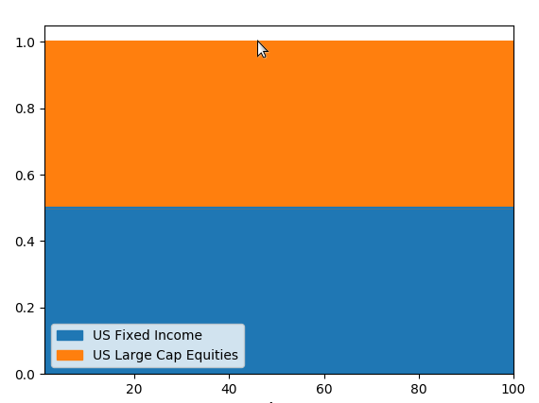
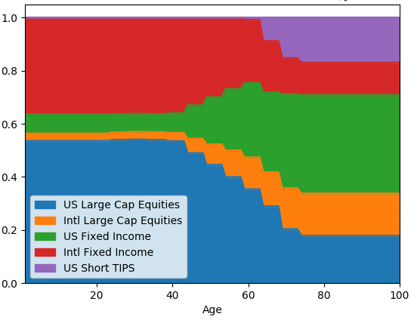

Figure 1. Two sample glide paths

The glide path file format consists of a header row and data rows. The header row has the following fields:

Age,Asset1,Asset2,….,AssetN

where Asset1 through AssetN are the asset classes that you wish to invest in over the course of your life.

The data rows have the data in each column that match the header row, where age is an integer and each asset class is expressed as a fraction of a whole. The sum of all asset class fractions should sum to unity.

This file is kept in the data/glide_path directory and can be named <anything>.csv. Example files are in the directory.

Assets

Your assets are simply a listing of the investment assets you wish to track. The software uses the yfinance module to update the asset values. This file file format consists of a header row and data rows. The header row has the following fields:

asset_class,symbol,quantity,price,price_update_date,user_roi,roi,roi_update_date,description,\multi,multi_update_date

The data rows have the following values:
asset_class matches one of the Asset Classes defined in your glide path file, unless it’s a multi-asset asset. If the asset is a multi-asset, put multi in this field.
symbol is the symbol the asset trades under. If it is unlisted, put unlisted in this field
quantity is how much of the asset you own
price is the value of the asset, an unlisted asset will prompt you to enter the value when updating.
price_update_date is the date the value was updated it must be in this format adjust with caution
user_roi is an estimated return on investment (ROI) provided by the user.
roi is the calculated ROI, calculated as the difference between the last and first closing prices / first closing price in the yahoo finance database where the first closing price is the adjusted closing price, based on the dividends and splits.
roi_update_date is the date the value was updated it must be in this format adjust with caution
description a description of the asset, especially helpful for a multi-asset asset.
multi if the asset is a normal asset, this field is blank. Otherwise it is a quoted dictionary made up of Asset Classes and percentages of each:

“{'US Fixed Income': 0.50, 'US Large Cap Equities’: 0.50}”

multi_update_date is the date the value was updated it must be in this format adjust with caution

This file is kept in the data/assets directory and can be named <anything>.csv. Example files are in the directory.

User Information

Your information has several pieces of information that is used to calculate where you are on your glide path. Each piece of information is pretty self-explanatory.

The expected_annual_expenses are how much you expect to spend each year when you retire. A good estimate is what you spend now.
The months_add_money is how often do you contribute to this savings goal.
The monthly_savings_amt is how much do you contribute. No fancy estimate of returns are made using these two numbers, it is simply amount * time to get a total annual saving.
The retire_age is how old do you plan to be when you retire. This is when you plan to meet the goal of having enough assets to create an income that matches your expected annual expenses.
The target_tolerance is the percentage error in how close to the glide path your savings can be before it issues a warning.
The birthday is your birthday, so you know where you are on the glide path.

This file is kept in the data/users directory and can be named <anything>.csv. Example files are in the directory.
Using the program

Once you have your user input saved, launch the program via the ./rebal script in the bin directory.
Then pick your Glide Path, Asset, and User files and click “Monitor Portfolio”.

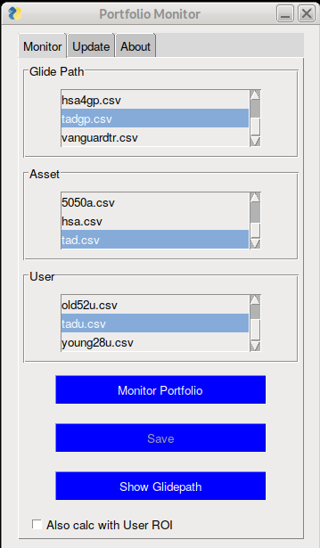

This will update the assets and ROIs, and do all the calculations. It will display the results in a browser as an html file. Clicking “Save” will save the file in the data/output directory. Checking the “Also calc with User ROI” will generate an alternate html file using the ROI found in the User file.

The html file shows the Assets and their current value, the target percentage, the actual percentage, the difference between these percentages, what action to take if the difference is outside of the tolerance, and the amount to sell or buy to reach 100% rebalanced.

It shows the differences summed in quadrature as well as calculated as the root-mean-square.

It also shows the goals. The end asset value goal with an estimated ROI that would be needed to provide the estimated expenses.

It shows the Years to Goal, based on the savings age. The savings age is where you are on the glide path. If your savings age is less than your real age, then a warning is shown saying you need to save more.

An example calculation result is shown on the next page.
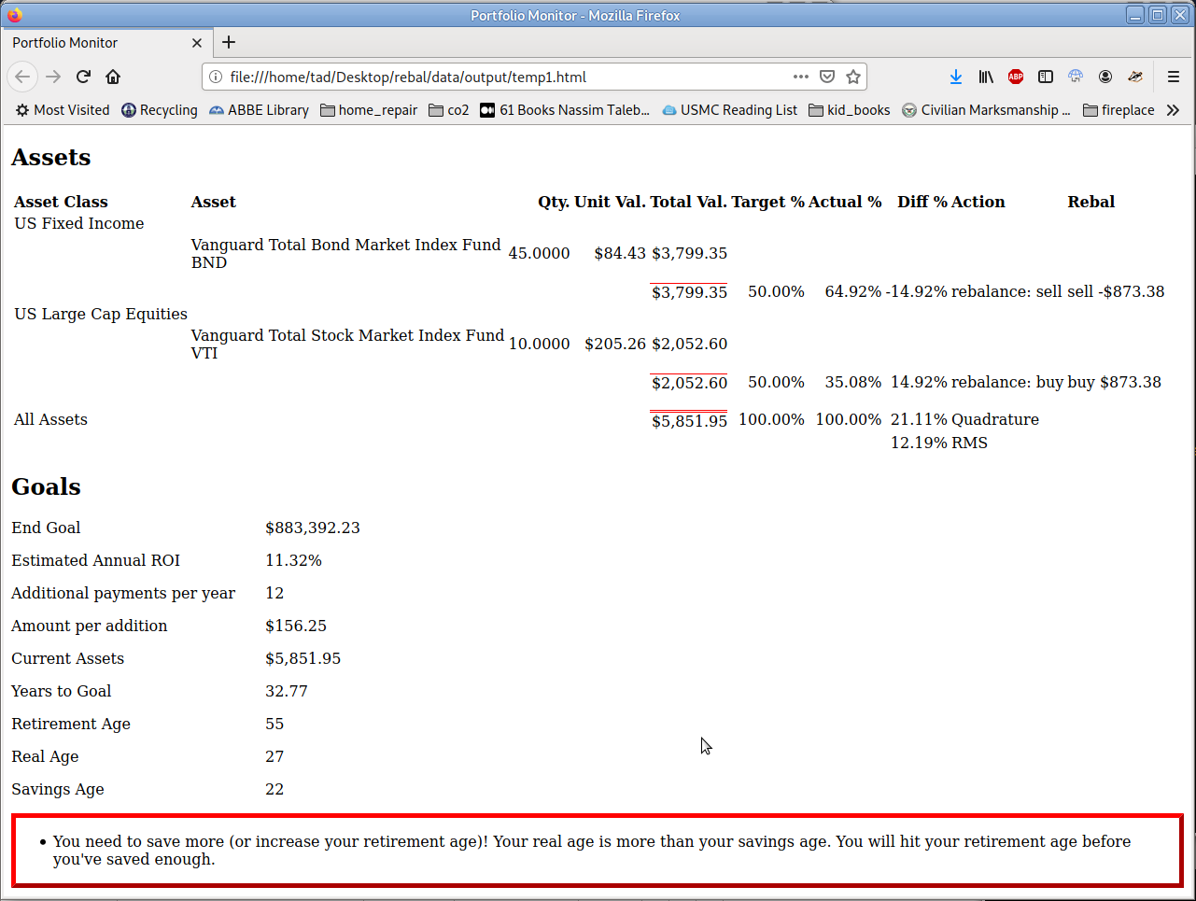

Manual Update

The Update Tab has three buttons to allow you to update the information whenever you want, versus the predefined times set in the program. These values are daily for price, monthly for roi, and quarterly for multi assets assets, they can be edited in the settings.ini file.

