**A Project Report On**

Wal-Mart Management System

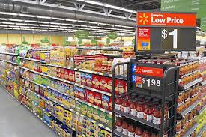



Name : RAHUL BAJAJ

Class : XII B

Roll No. :

C E R T I F I C A T E

This is to certify that **RAHUL BAJAJ** of Class XII B has prepared the report on the project entitled “**WALMART MANAGMENT SYSTEM**”. The report is the result of his efforts & endeavours. He successfully completed the research on the below mentioned project under the guidance of **Mrs. SONY DEVATWAL** ( **COMPUTER SCIENCE** ) during the year 2014-15 The report is found worthy of acceptance as final project report for the subject Computer Science of Class XII. He has prepared the report under my guidance.

**Signature of External Examiner Signature of Teacher**

A C K N O W L E D G E N T

I would like to express a deep sense of thanks & gratitude to my project guide **Mrs**. **SONY DEVATWAL** for guiding me immensely through the course of the project. She always evinced keen interest in my work. Her constructive advice & constant motivation have been responsible for the successful completion of this project.

I also thanks to my parents for their motivation & support. I must thanks to my classmates for their timely help & support for compilation of this project.

Last but not the least, I would like to thank all those who had helped directly or indirectly towards the completion of this project**.**

RAHUL BAJAJ

Class: XII B

CONTENTS



1. HEADER FILES AND CLASS USED. . . . . . .
2. WORKING DESCRIPTION. . . . . . . . . . . . .
3. CODING. . . . . . . . . .. . . . . . . . . . . . . . . . .
4. OUTPUT SCREENS. . . . . . . . . . . . . . . . . . .

1. BIBLIOGRAPHY. . . . . . . . . . . . . . . . . . . . .

**HEADER FILES AND CLASS USED**



**FSTREAM.H :** For File Handling, Cin &

Cout

**PROCESS.H**  **:** For Exit ( ) function

**STDIO.H :** For Standard I/O Operations

**CONIO.H** **:** For Clrscr ( ) & getch( )

Functions

**CLASS PRODUCT** IS CREATED FOR DECLARING DATA MEMBERS AND MEMBER FUNCTION TO BE REFFERED UNDER ONE NAME.

**DATA MEMEBERS** : PNO(PRODUCT NUMBER), PRICE,QTY(QUANTITY),DIS(DISCOUNT).

**MEMBER FUNCTIONS**: CREATE_PRODUCT,SHOW_PRODUCT,RETPNO,

RETPRICE,RETNAME,RETDIS.

WORKING DESCRIPTION



This program is designed to place an order and then generating the bill according to the purchase in a walmart store .This program consists of three options as follows :-

* CUSTOMER
* ADMINISTRATOR
* TO EXIT

In customer section you can place order and bill will be generated accordingly.

In administrator section where we can create a product, display a product list, modify the database of product, delete a specific product.

Query where in you can get details of the product and a product menu where we can get all the product list.

**CODING**



**//WALMART MANAGMENT SYSTEM- //SUBMITTED BY RAHUL BAJAJ**

**//HEADER FILE USED IN THIS PROJECT**

**#include<conio.h>**

**#include<stdio.h>**

**#include<process.h>**

**#include<fstream.h>**

**//CLASS USED IN THIS PROJECT**

**class product**

**{**

**int pno;**

**char name[50];**

**float price,qty,dis;**

**public:**

**void create_product();**

**void show_product();**

**int retpno()**

**{return pno;}**

**float retprice()**

**{return price;}**

**char* retname()**

**{return name;}**

**int retdis()**

**{return dis;}**

**};**

**void product::create_product()**

**{**

**cout<<"\nPlease Enter The Product No. of The Product ";**

**cin>>pno;**

**cout<<"\n\nPlease Enter The Name of The Product ";**

**gets(name);**

**cout<<"\nPlease Enter The Price of The Product ";**

**cin>>price;**

**cout<<"\nPlease Enter The Discount (%) ";**

**cin>>dis;**

**}**

**void product::show_product()**

**{**

**cout<<"\nThe Product No. of The Product : "<<pno;**

**cout<<"\nThe Name of The Product : ";**

**puts(name);**

**cout<<"\nThe Price of The Product : "<<price;**

**cout<<"\nDiscount : "<<dis;**

**}**

**//GLOBAL DECLARATION FOR STREAM OBJECT**

**fstream fp;**

**product pr;**

**//FUNCTION TO WRITE IN THE FILE**

**void write_product()**

**{**

**fp.open("Shop.dat",ios::out|ios::app);**

**pr.create_product();**

**fp.write((char*)&pr,sizeof(product));**

**fp.close();**

**cout<<"\n\nThe Product Has Been Created ";**

**getch();**

**}**

**//function to read all records from file**

**void display_all()**

**{**

**clrscr();**

**cout<<"\n\n\n\t\tDISPLAY ALL RECORD !!!\n\n";**

**fp.open("Shop.dat",ios::in);**

**while(fp.read((char*)&pr,sizeof(product)))**

**{**

**pr.show_product();**

**cout<<"\n\n====================================\n";**

**getch();**

**}**

**fp.close();**

**getch();**

**}**

**//FUNTION TO READ SPECIFIC RECORD FROM FILE**

**void display_sp(int n)**

**{**

**int flag=0;**

**fp.open("Shop.dat",ios::in);**

**while(fp.read((char*)&pr,sizeof(product)))**

**{**

**if(pr.retpno()==n)**

**{**

**clrscr();**

**pr.show_product();**

**flag=1;**

**}**

**}**

**fp.close();**

**if(flag==0)**

**cout<<"\n\nrecord not exist";**

**getch();**

**}**

**//FUNCTION TO MODIFY RECORD OF FILE**

**void modify_product()**

**{**

**int no,found=0;**

**clrscr();**

**cout<<"\n\n\tTo Modify ";**

**cout<<"\n\n\tPlease Enter The Product No. of The Product";**

**cin>>no;**

**fp.open("Shop.dat",ios::in|ios::out);**

**while(fp.read((char*)&pr,sizeof(product)) && found==0)**

**{**

**if(pr.retpno()==no)**

**{**

**pr.show_product();**

**cout<<"\nPlease Enter The New Details of Product"<<endl;**

**pr.create_product();**

**int pos=-1*sizeof(pr);**

**fp.seekp(pos,ios::cur);**

**fp.write((char*)&pr,sizeof(product));**

**cout<<"\n\n\t Record Updated";**

**found=1;**

**}**

**}**

**fp.close();**

**if(found==0)**

**cout<<"\n\n Record Not Found ";**

**getch();**

**}**

**//FUNCTION TO DELETE RECORD FROM FILE**

**void delete_product()**

**{**

**int no;**

**clrscr();**

**cout<<"\n\n\n\tDelete Record";**

**cout<<"\n\nPlease Enter The product no. of The Product You Want To Delete";**

**cin>>no;**

**fp.open("Shop.dat",ios::in|ios::out);**

**fstream fp2;**

**fp2.open("Temp.dat",ios::out);**

**fp.seekg(0,ios::beg);**

**while(fp.read((char*)&pr,sizeof(product)))**

**{**

**if(pr.retpno()!=no)**

**{**

**fp2.write((char*)&pr,sizeof(product));**

**}**

**}**

**fp2.close();**

**fp.close();**

**remove("Shop.dat");**

**rename("Temp.dat","Shop.dat");**

**cout<<"\n\n\tRecord Deleted ..";**

**getch();**

**}**

**//FUNCTION TO DISPLAY ALL PRODUCT PRICE LIST**

**void menu()**

**{**

**clrscr();**

**fp.open("Shop.dat",ios::in);**

**if(!fp)**

**{**

**cout<<"ERROR!!! FILE COULD NOT BE OPEN\n\n\n Go To Admin Menu to create File";**

**cout<<"\n\n\n Program is closing ....";**

**getch();**

**exit(0);**

**}**

**cout<<"\n\n\t\tProduct MENU\n\n";**

**cout<<"====================================================\n";**

**cout<<"P.NO.\t\tNAME\t\tPRICE\n";**

**cout<<"====================================================\n";**

**while(fp.read((char*)&pr,sizeof(product)))**

**{**

**cout<<pr.retpno()<<"\t\t"<<pr.retname()<<"\t\t"<<pr.retprice()<<endl;**

**}**

**fp.close();**

**}**

**//FUNCTION TO PLACE ORDER AND GENERATING BILL**

**void place_order()**

**{**

**int order_arr[50],quan[50],c=0;**

**float amt,damt,total=0;**

**char ch='Y';**

**menu();**

**cout<<"\n============================";**

**cout<<"\n PLACE YOUR ORDER";**

**cout<<"\n============================\n";**

**do{**

**cout<<"\n\nEnter The Product No. Of The Product : ";**

**cin>>order_arr[c];**

**cout<<"\nQuantity in number : ";**

**cin>>quan[c];**

**c++;**

**cout<<"\nDo You Want To Order Another Product ? (y/n)";**

**cin>>ch;**

**}while(ch=='y' ||ch=='Y');**

**cout<<"\n\nThank You For Placing The Order";getch();clrscr();**

**cout<<"\n\n********************************INVOICE************************\n";**

**cout<<"\nPr No.\tPr Name\tQuantity \tPrice \tAmount \tAmount after discount\n";**

**for(int x=0;x<=c;x++)**

**{**

**fp.open("Shop.dat",ios::in);**

**fp.read((char*)&pr,sizeof(product));**

**while(!fp.eof())**

**{**

**if(pr.retpno()==order_arr[x])**

**{**

**amt=pr.retprice()*quan[x];**

**damt=amt-(amt*pr.retdis()/100);**

**cout<<"\n"<<order_arr[x]<<"\t"<<pr.retname()**

**<<"\t"<<quan[x]<<"\t\t"<<pr.retprice()<<"\t"<<amt<<"\t\t"<<damt;**

**total+=damt;**

**}**

**fp.read((char*)&pr,sizeof(product));**

**}**

**fp.close();**

**}**

**cout<<"\n\n\t\t\t\t\tTOTAL = "<<total;**

**getch();**

**}**

**//INTRODUCTION FUNCTION**

**void intro()**

**{**

**clrscr();**

**gotoxy(35,11);**

**cout<<"WALMART";**

**gotoxy(35,14);**

**cout<<"MANAGMENT ";**

**gotoxy(35,17);**

**cout<<"SYSTEM";**

**cout<<"\n\nMADE BY : RAHUL BAJAJ ";**

**cout<<"\n\nSCHOOL : BAL BHARATI PUBLIC SCHOOL";**

**getch();**

**}**

**//ADMINSTRATOR MENU FUNCTION**

**void admin_menu()**

**{**

**clrscr();**

**char ch2;**

**cout<<"\n\n\n\tADMIN MENU";**

**cout<<"\n\n\t1.CREATE PRODUCT";**

**cout<<"\n\n\t2.DISPLAY ALL PRODUCTS";**

**cout<<"\n\n\t3.QUERY ";**

**cout<<"\n\n\t4.MODIFY PRODUCT";**

**cout<<"\n\n\t5.DELETE PRODUCT";**

**cout<<"\n\n\t6.VIEW PRODUCT MENU";**

**cout<<"\n\n\t7.BACK TO MAIN MENU";**

**cout<<"\n\n\tPlease Enter Your Choice (1-7) ";**

**ch2=getche();**

**switch(ch2)**

**{**

**case '1': clrscr();**

**write_product();**

**break;**

**case '2': display_all();**

**break;**

**case '3':**

**int num;**

**clrscr();**

**cout<<"\n\n\tPlease Enter The Product No. ";**

**cin>>num;**

**display_sp(num);**

**break;**

**case '4': modify_product();**

**break;**

**case '5': delete_product();**

**break;**

**case '6': menu();**

**getch();**

**case '7': break;**

**default:cout<<"\a";admin_menu();**

**}**

**}**

**void main()**

**{**

**char ch;**

**textcolor(110);**

**textbackground(114);**

**intro();**

**do**

**{**

**clrscr();**

**cout<<"\n\n\n\tMAIN MENU";**

**cout<<"\n\n\t01. CUSTOMER";**

**cout<<"\n\n\t02. ADMINISTRATOR";**

**cout<<"\n\n\t03. EXIT";**

**cout<<"\n\n\tPlease Select Your Option (1-3) ";**

**ch=getche();**

**switch(ch)**

**{**

**case '1': clrscr();**

**place_order();**

**getch();**

**break;**

**case '2': admin_menu();**

**break;**

**case '3':exit(0);**

**default :cout<<"\a";**

**}**

**}while(ch!='3');**

**}**

OUTPUT SCREENS

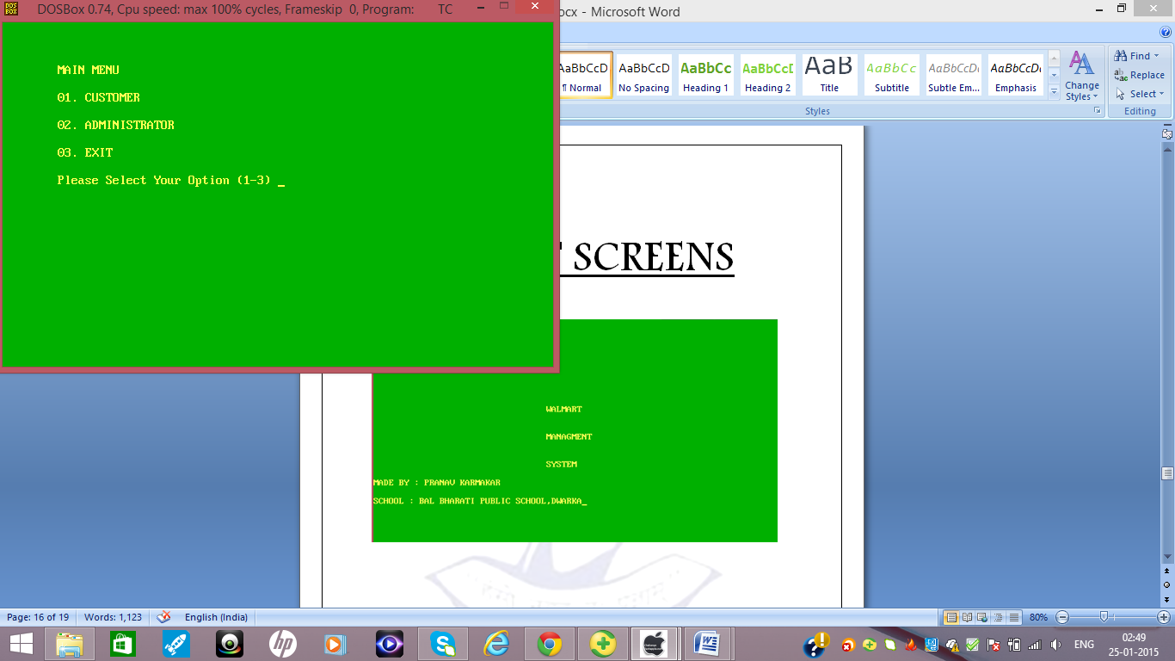

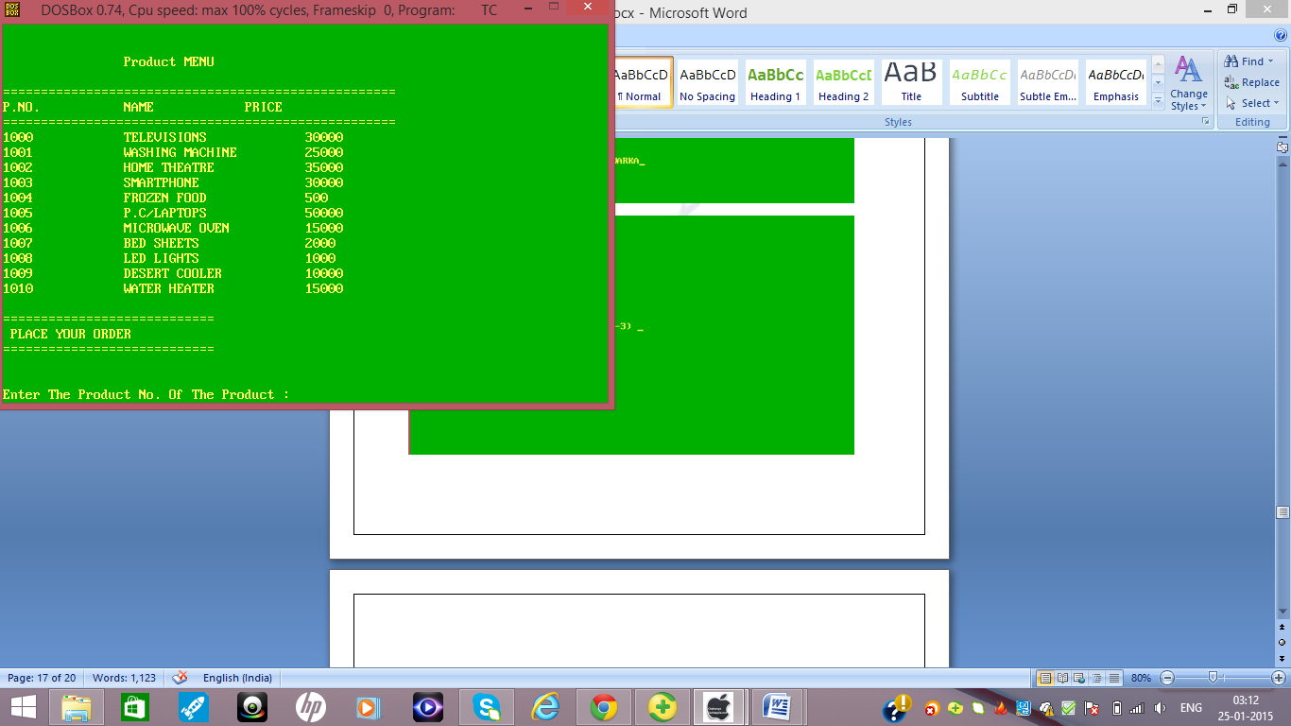

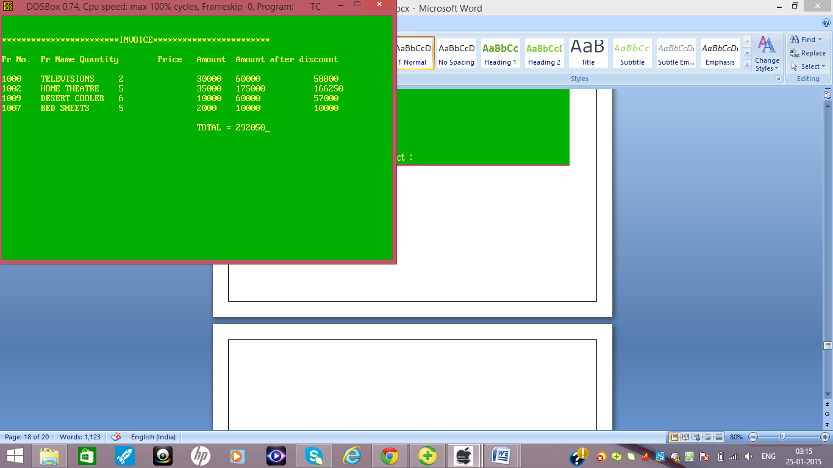

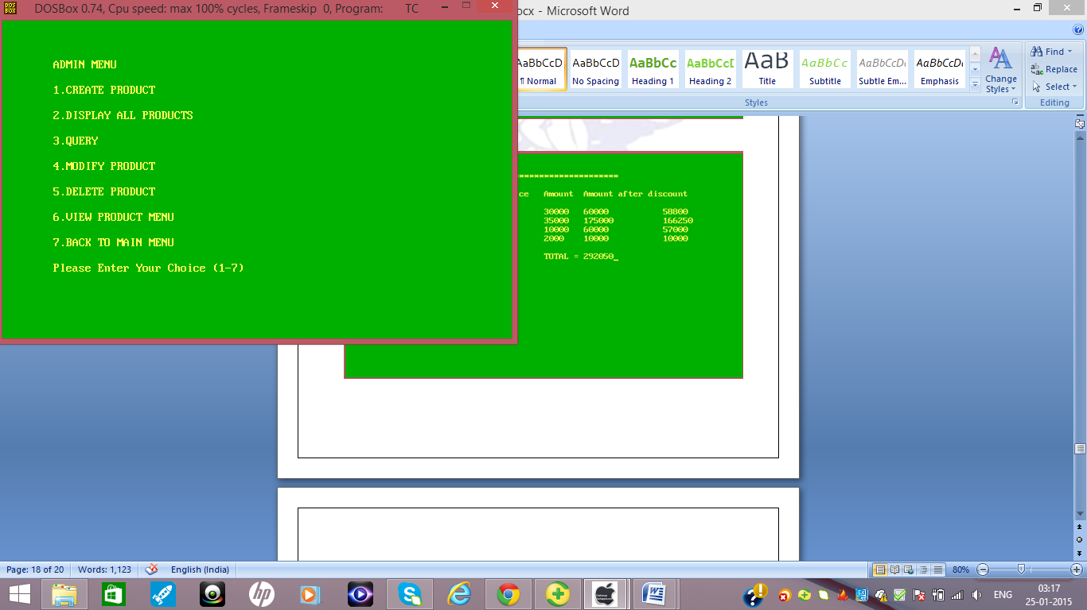

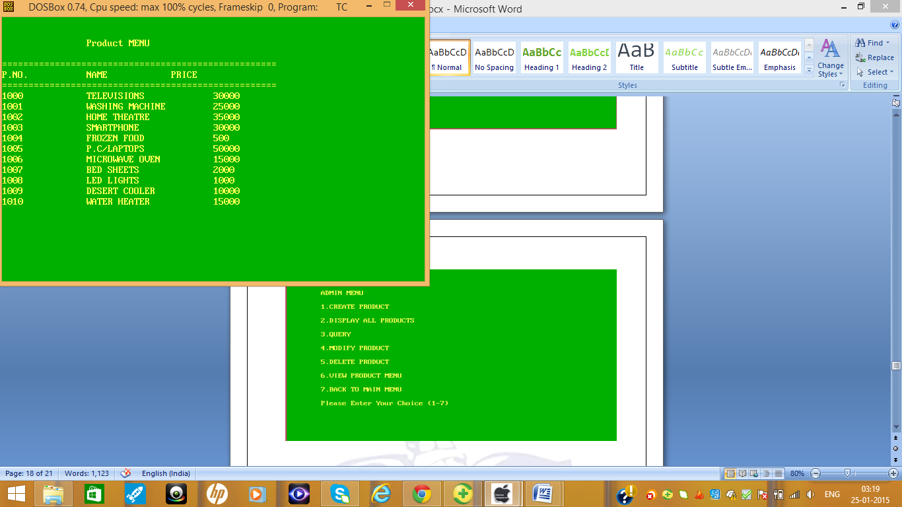

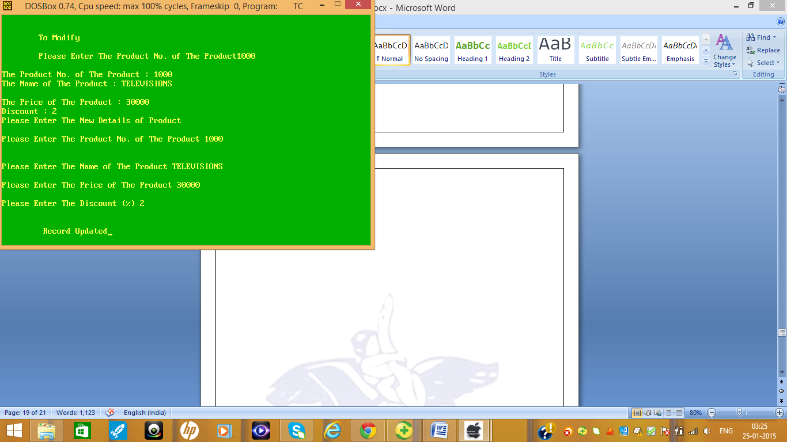  
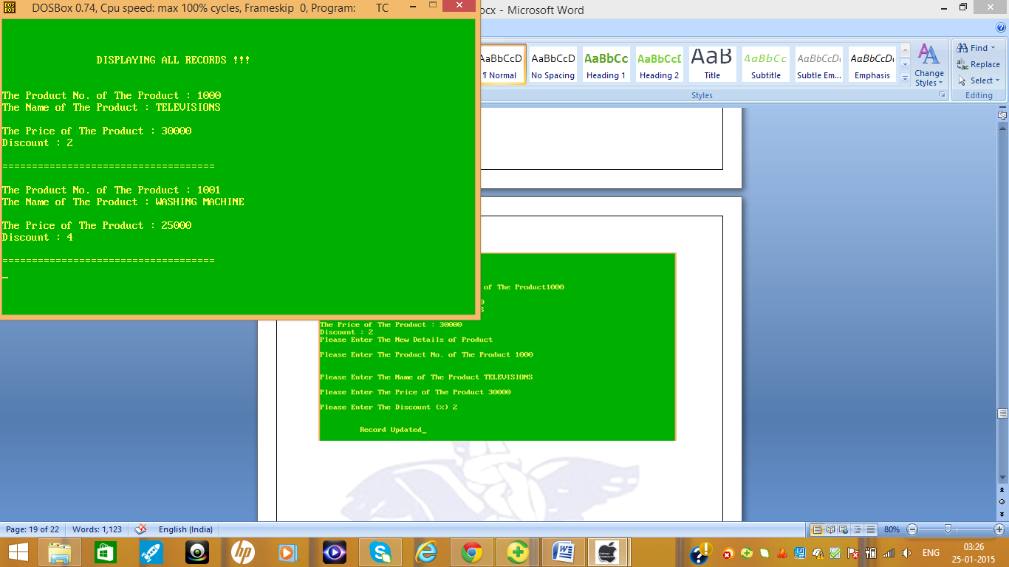

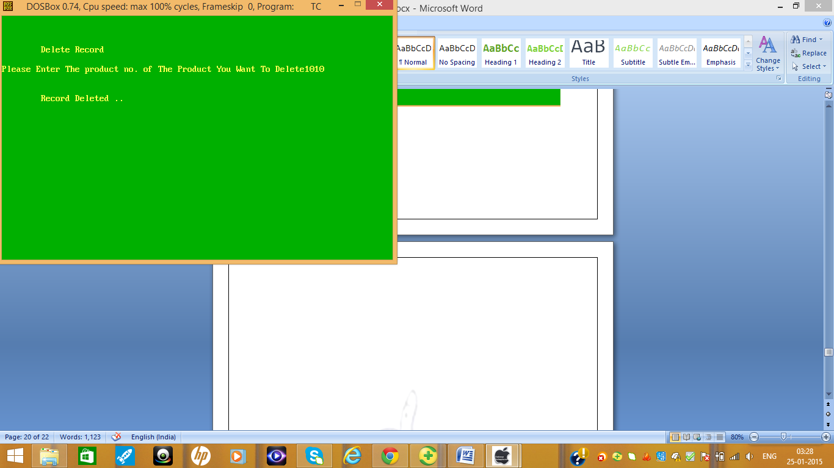

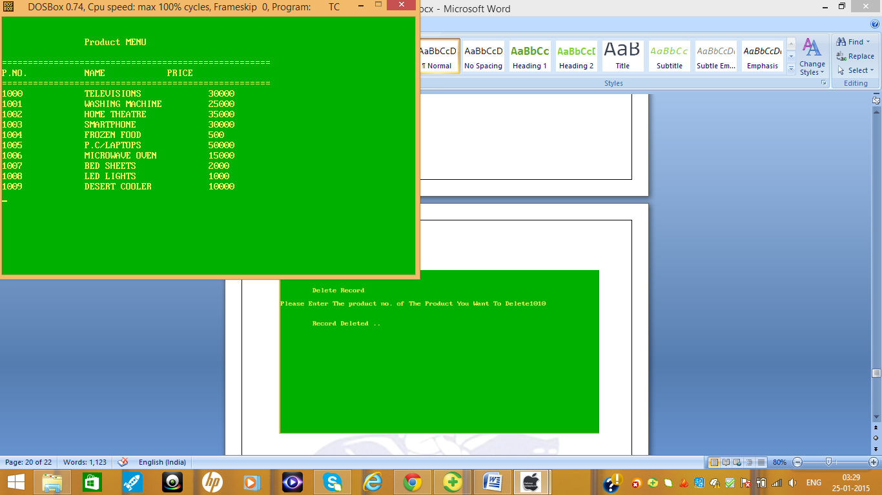

**BIBLIOGRAPHY**



* [**http://www.google.com**](http://www.google.com/)**/**
* [**http://en.wikipedia.or**](http://en.wikipedia.org/)**g**
* **Computer Science with C++ by**

**Sumita Arora**

