**Personal Assistance For Independent**

**Senior Citizens**

**Introduction:**

With this project, you will be able to assist the senior citizens from home or office using iot. In these days senior citizens are forgetting to take the medicines and which medicine to take at that point of time. This project will be useful to help them by iot. IoT devices can be used to monitor and control them regularly.

**Purpose:**

By this project one can monitor the person to take the medicine regularly and in case of any emergency alerts will be sent to the family members and doctors. By this user can track patient’s medicine intake and their condition through web app or mobile app.

**Literature survey:**

**Existing problem:**

In our home we have a senior citizen who lives independently for them no one will be there to take care about them when to take medicines or which medicine to take. And in case of any emergency there will be nobody to take to the hospital.

**Proposed solution:**

By using iot we can able to develop the application which helps to the senior citizens who lives independently by this we can give the alerts to them by voice command about the medicine intake. We can send the notifications to the doctor and family members by using voice command which it converts into text and compared with predefined messages with keywords provided.

**Block diagram:**

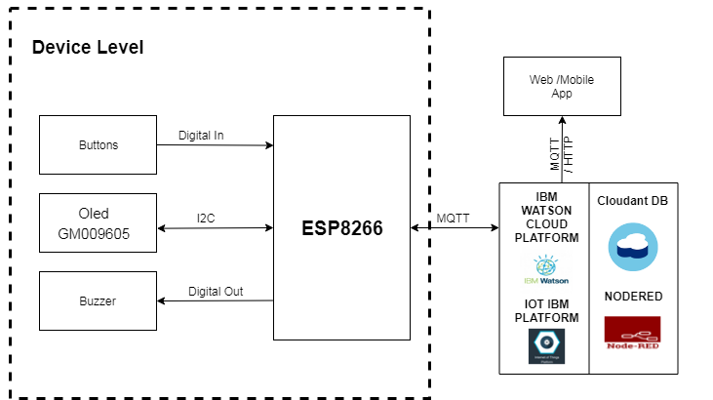

Figure 1: Block diagram

**Software/hardware designing:**

The hardware part of the project involves the ESP8266 model. The buttons, OLED (GM009605) and buzzer are connected to the ESP8266.

The software part of the project involves cloudant DB, Nodered, IBM Watson cloud Platform, iot IBM platform and Web/Mobile app.

**Experimental investigations:**

There are several IoT authentication challenges and issues that need to be understood before employing the right security solution that can dynamically vary with the situation based on certain critical situations such as IOT health applications, frequent authorization and authentication are necessary and cloud dynamically vary, potentially resulting in changes to the authorization of iot devices. To address these issues, automated mutual authentication without user intervention is required in supporting users from remembering passwords for a large number of devices.

**Flowchart:**

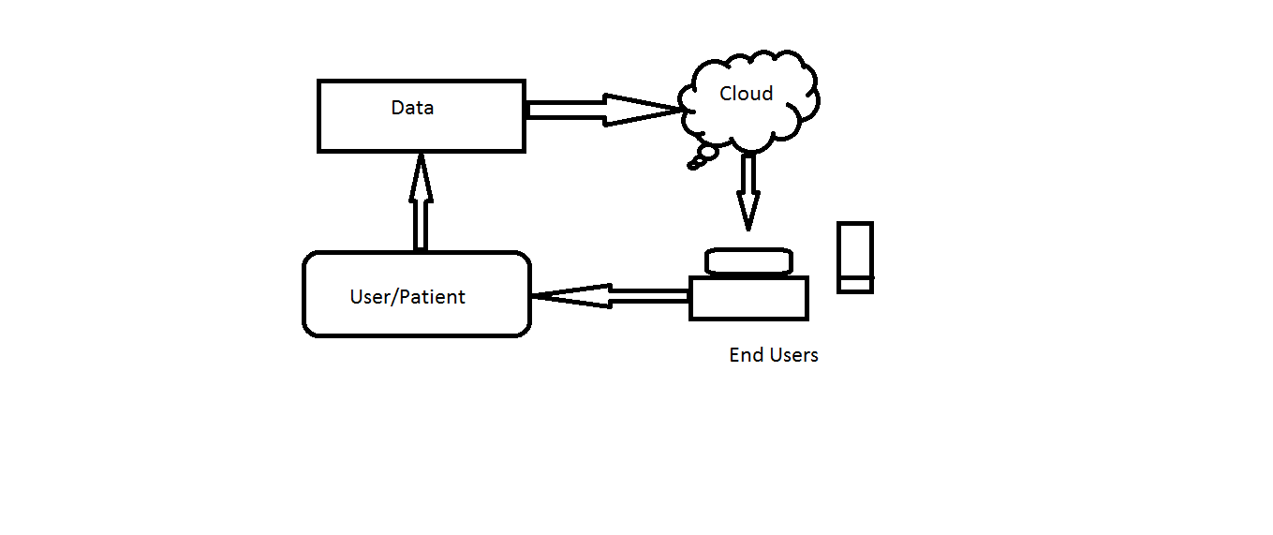

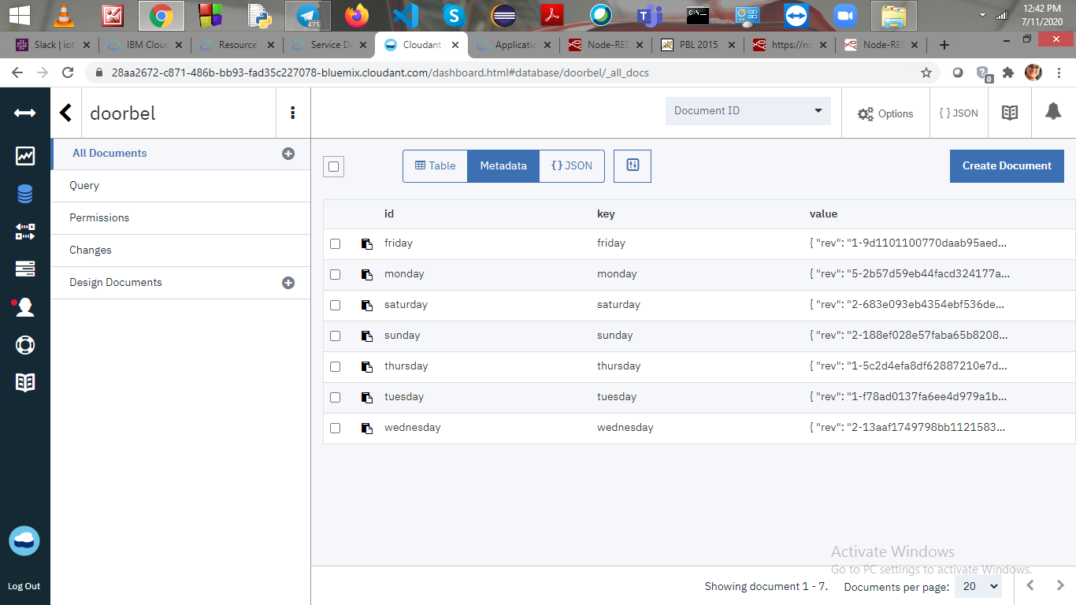

Figure 2: Database Screenshot

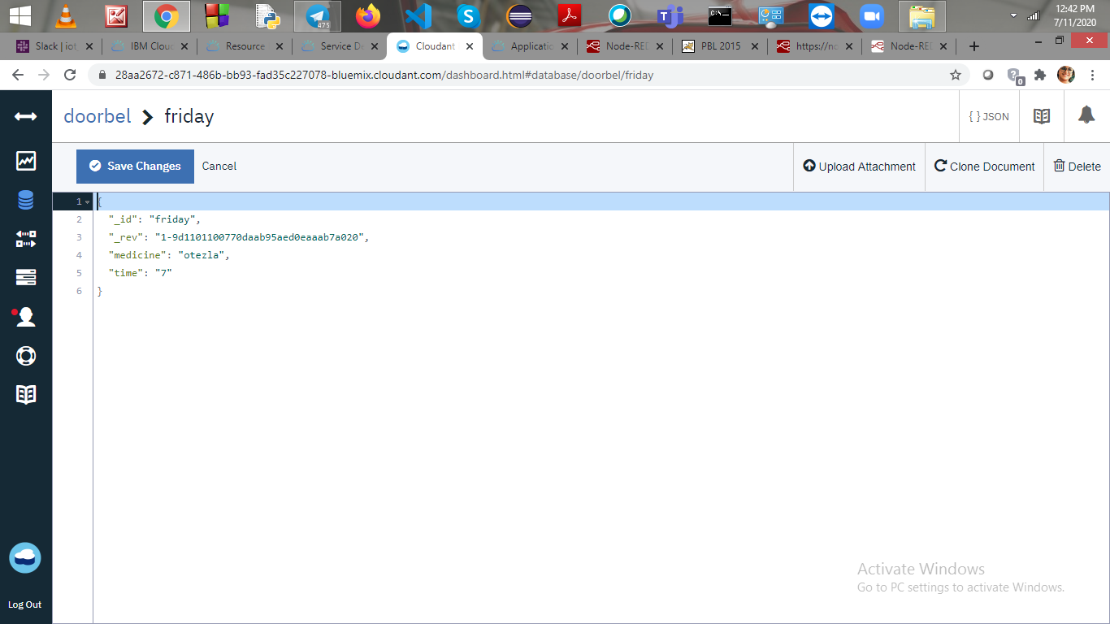

Figure 3:Sample Database Document Screenshot

**Advantages & Disadvantages:**

**Advantages of IOT in Personal Assistance:**

* Advantages of personal assistance we can track the patient health whether they are taking medicines regularly or not.
* It is helpful at emergency situations with voice command control.
* It records by voice and converted into text and it sends notification to doctor and family members.
* It send the alerts at medicine intake time arrives it sounds with buzzer or voice.

**Disadvantages of IOT in Personal Assistance:**

* Device requires Continuous Wi-Fi connectivity.
* Wearable Device requires charging.
* Manual data entry required for alerts.

**Applications:**

* Medicine intake.
* Emergency alerts to doctors.
* Emergency alerts to family members.

**Output Screenshots:**

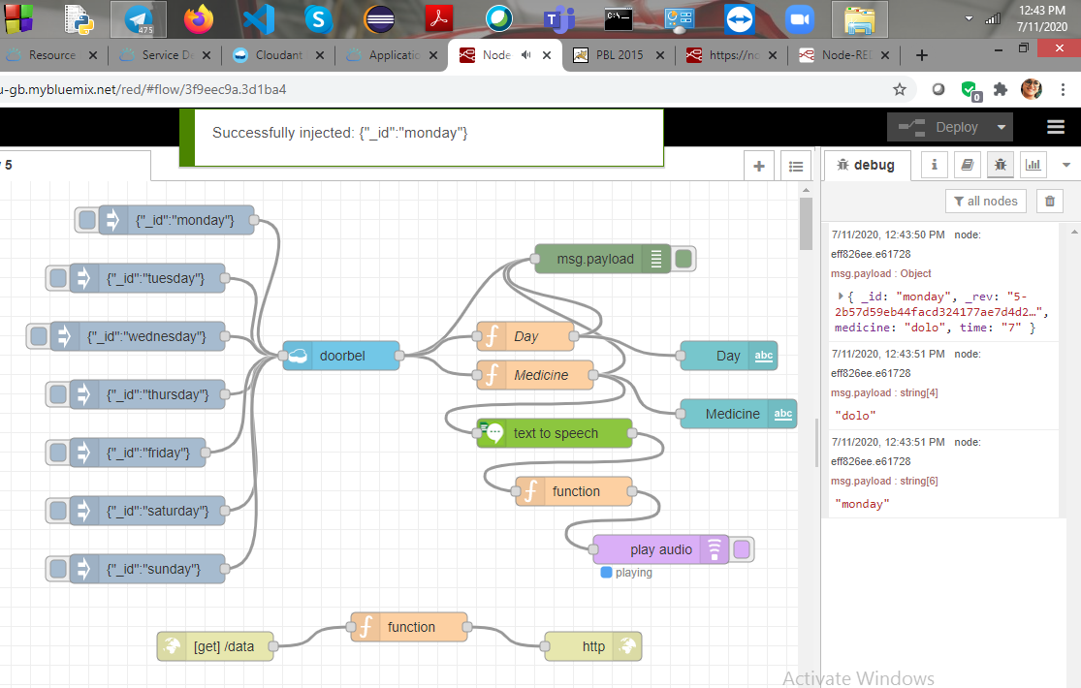

Figure 4:NodeRed flow and out on the Debug Screen

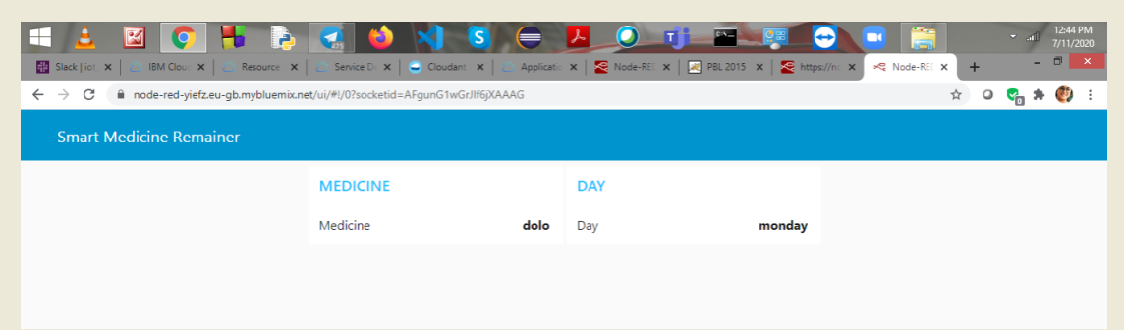

Figure 5:out put on User Interface

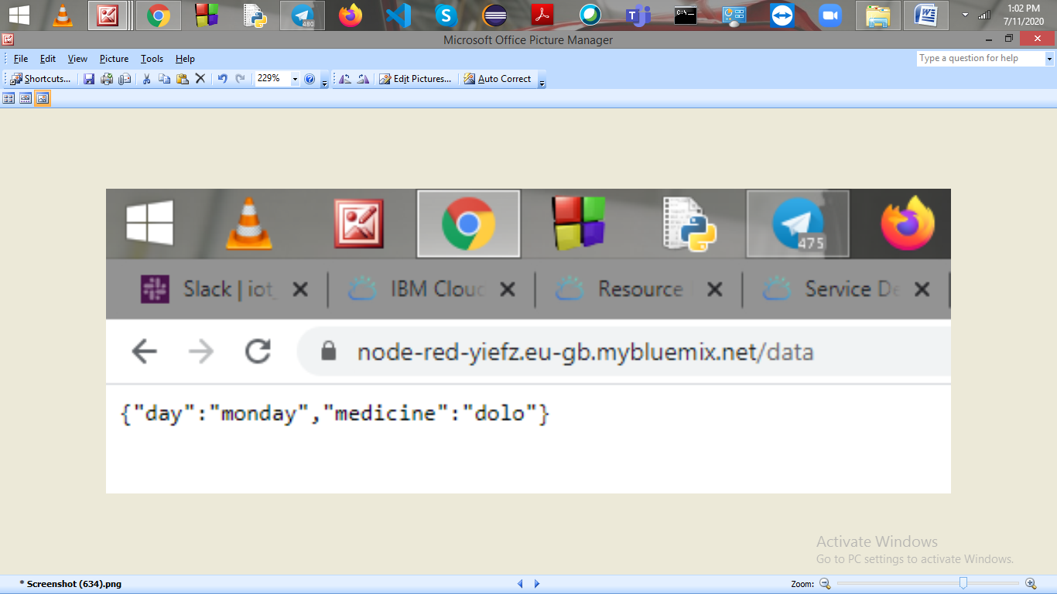

Figure 6:out put on web

**Conclusion:**

The conclusion for the project is to give personal assistance for independent senior citizens it give alerts at medicine intake time and it notifies at emergency situations.

**Future Scope:**

It increases more applications and different problems and it increases opportunities and decreases problems.