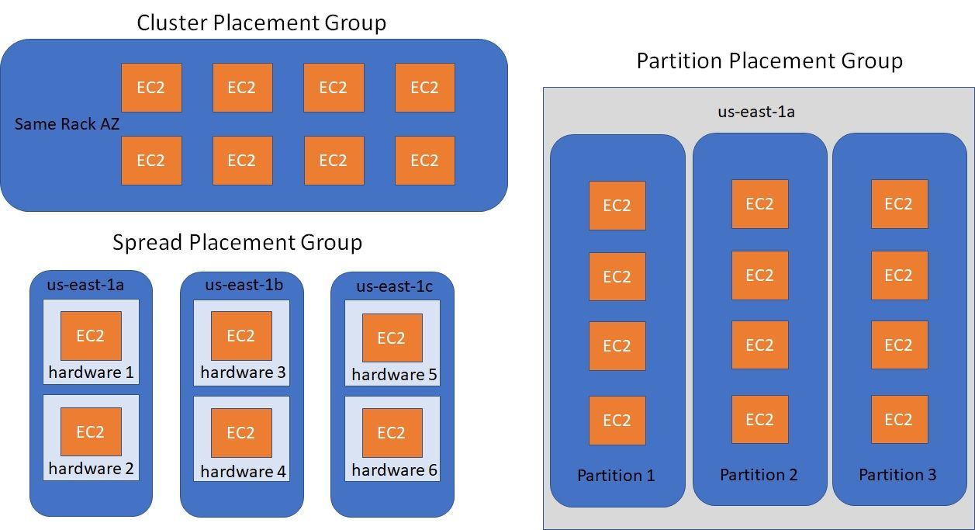

Cluster
- Same rack and same availability zone
- Great network, low latency (10Gbps bandwidth between instances)
- Cons: if rack fails then all the EC2 instances will fail at the same time
- Usage: Big data job that needs to complete fast, Application with low latency and high throughput

Spread
- All EC2 instance will be located on different hardware
- Span across multiple AZ
- Reduced risk of simultaneous failure
- Limit of 7 instances per AZ per placement group
- Usage: Application that needs maximize HA , Critical Applications that needs to be isolated from failure from each other

Partition
- Upto 7 partitions per AZ with 100s of EC2 instances
- The instances of 1 partition do not share racks with instances of other partitions
- A partition failure can affect many EC2 instances from same partition but it won't affect other EC2 instances on other partitions
- EC2 instances can get access to the partition information using metadata
- Usage: HDFS, HBase, Cassandra, Kafka

