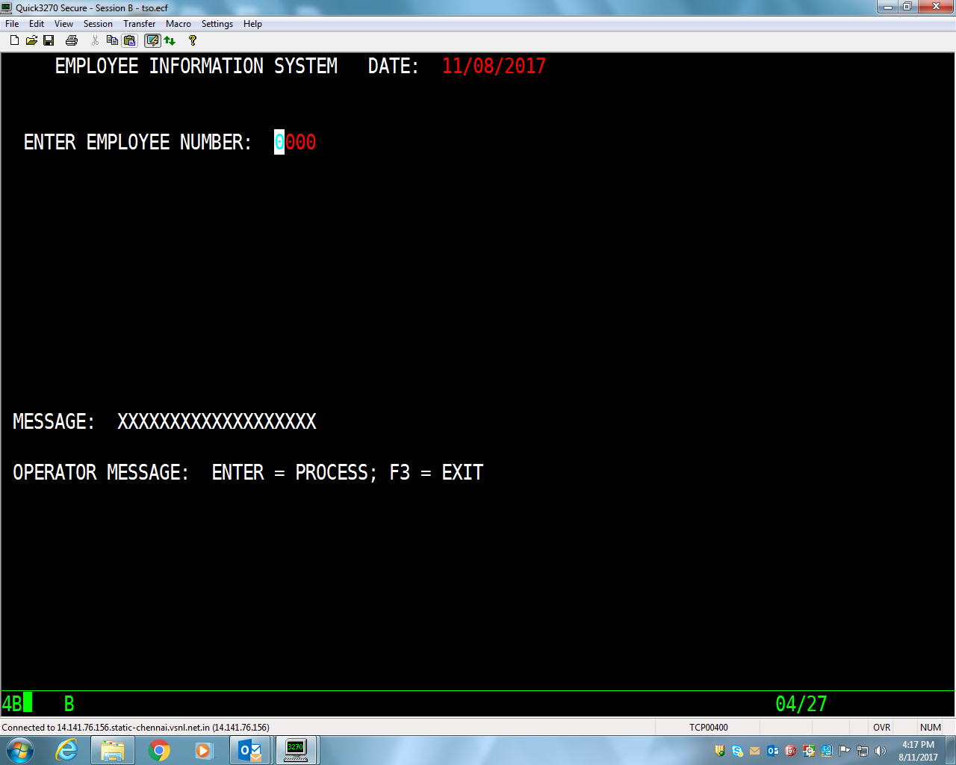

Bms is in DSRP016.CICS.BMS(P16AS09)

Cobol program in DSRP016.CICS.SOURCE(P16AP09)