GRAPHS

A b c d

|  |  |  |  |
| --- | --- | --- | --- |
| 0 | 1 | 1 | 1 |
| 1 | 0 | 0 | 1 |
| 1 | 0 | 0 | 1 |
| 1 | 1 | 1 | 0 |

Adjacent matrix & list and linked list representation 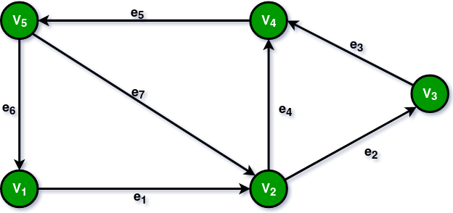

|  |  |  |  |  |  |  |
| --- | --- | --- | --- | --- | --- | --- |
|  | V1 | V2 | V3 | V4 | V5 | Out Degree |
| V1 | 0 | 1 | 0 | 0 | 0 | 1 |
| V2 | 0 | 0 | 1 | 1 | 0 | 2 |
| V3 | 0 | 0 | 0 | 1 | 0 | 1 |
| V4 | 0 | 0 | 0 | 0 | 1 | 1 |
| V5 | 1 | 1 | 0 | 0 | 0 | 2 |
| In  Degree | 1 | 2 | 1 | 2 | 1 |  |

DFS