Assessment 1: Design and Development of BI Solution

Student 1, ID number
Student 2, ID number

Time: Mon 5-7PM

Data Profiling

Accident Profiling

Our exploratory data profiling of the Victoria Crash Statistics dataset started by loading the accident-original.csv into Python script. Inspecting the initial footprint and inferred data types revealed several representation issues:

- Dataset shape: the initial ingestion confirmed exactly 199,699 records across 23 attributes.
- Primary key uniqueness: ACCIDENT_NO contains 199,699 unique values with zero duplication, establishing a clean 1-to-1 crash entity mapping.
- Categorical misclassification: Pandas incorrectly cast nominal/ordinal codes (e.g., ACCIDENT_TYPE, SEVERITY, ROAD_GEOMETRY) as continuous int64 integers. If left uncorrected, this distorts summary statistics by treating distinct categories as a mathematical scale.
- Temporal formatting: ACCIDENT_DATE and ACCIDENT_TIME were ingested as unparsed strings.

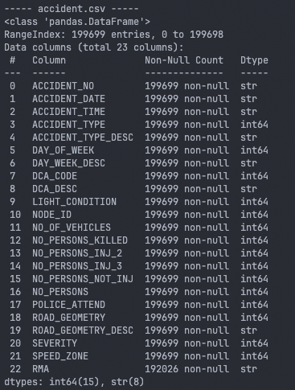
Evaluating data completeness exposed that standard null-auditing tools present an incomplete view of data quality due to hidden sentinel placeholders:
- Overt missing data: RMA (Road Management Authority) is the only overtly missing column, lacking 7,673 records (3.84%).
- Hidden sentinels (Speed Zone): 14,901 non-physical codes (777, 888, 999) make up 7.46% of SPEED_ZONE, artificially inflating the raw mean to 135.8 km/h.
- Hidden sentinels (Unknowns): Category code 9 (“Unknown”) masks true incompleteness across fields like LIGHT_CONDITION (5,472 records) and POLICE_ATTEND (728 records).
- Invalid Geographic IDs: NODE_ID contains 85 invalid non-positive values.

Auditing discrete distributions and summary statistics highlighted structural imbalances across accident categories:
- Speed zones: Urban limits dominate (60 km/h: 65,109 crashes; 50 km/h: 32,869 crashes), while sparse classes (like 75 km/h: 20 records) pose overfitting risks.
- Accident profiles: collisions with vehicles represent 65.15% of the data (ACCIDENT_TYPE code 1), and non-intersection events account for 51.82% (ROAD_GEOMETRY code 5).
- Casualty Skewness: While the median crash involves 2 persons, maximum casualty metrics exhibit extreme right-tail skewness (reaching up to 21 vehicles and 97 persons involved).

Cross-field logical validation exposed structural flaws and data-entry contradictions:
- Date parsing errors: DAY_OF_WEEK contains conflicting numbering systems. 79.47% use Sunday=1, 18.23% use Monday=1, and 2.30% (4,584 records) use an invalid code 0, pointing to date conversion failures.
- Ghost crashes: 6 records impossibly logged NO_OF_VEHICLES as 0.
- Severity contradiction: 1 record is coded as a Serious injury (Code 2), yet lists the actual coutn of serious injuries (NO_PERSONS_INJ_2) as exactly 0.

Diagnostic evaluations of the target variable and feature space uncovered severe modelling bottlenecks:
- Distribution skew: SEVERITY is highly imbalanced. Fatal collisions (Code 1) are just 1.67%, while non-injury events (Code 4) are virtually missing, confirming this is an intentionally filtered casualty database.
- Statistical outliers: Z-score testing (|z| > 3) flagged up to 1.67% of rows for extreme casualty counts. These represent factual mass-casualty events rather than measurement errors.
- Data redundancy: The correlation matrix exposed strong redundant relations (r=0.73) between ACCIDENT_TYPE and DCA_CODE, indicating overlapping definitions that will complicate isolated analysis.

Finally, a relational integrity check against the vehicle dataset audited the foreign key dynamics for our future SQL architecture:
- Referential integrity: 100% of vehicle records successfully map back to an ACCIDENT_NO.
- Orphaned crashes: 9 distinct accident records possess absolutely no matching vehicle entry in the vehicle dataset.
- Actionable impact: These 9 orphaned rows, alongside the zero-vehicle and severity-contradiction anomalies, establish the empirical bases for our data-cleaning / rejection criteria.

Vehicle Profiling

The vehicle.csv contains 36 columns containing data on the accident number, how the vehicle was involved in the accident, what happened to the car as a result of the accident and descriptive information on the car such as make, model, weight, number of seats, colour of vehicle, the year the car was made, number of wheels and the fuel type. A lot of the numerical datasets are set as a float instead of an integer which should be converted at some point.
The percentage of missing values highlights that there is a lot of information missing from the descriptive information of the vehicles. Vehicle Power is missing completely and isn’t required. Both carry and cubic capacity and vehicle weight have a lot of missing values.
The biggest anomaly appears to happen in the manufactured year where it shows that maximum values is 3001, an impossible figure as this dataset should be no more than 2026 (the year in which this data is analysed. It also shows that 50% of all vehicles in this dataset are from 2008 or earlier.

We are then able to see the top five vehicle types and vehicle makes which will help with checking work later on.

Data Cleaning and Transformation
This section documents the rigorous Extract, Transform, and Load (ETL) cleaning pipeline applied to the original datasets (accident.csv and vehicle.csv) to resolve quality issues identified during initial profiling. The objective is to produce a structurally sound, highly accurate dataset ready for ingestion into the normalized data warehouse prototype.

Dataset: Accident (accident-original.csv)
- Initial ingestion and Baseline validation
- The script successfully ingested 199,699 rows across 23 columns.
- Establishing a baseline raw dataframe at this stage ensures that no records are accidentally lost during the transformation pipeline, allowing for a strict mathematical reconciliation at the end of the process.
- Handling missing data and sentinel values
This step will handle both overt missingness and coded placeholders since the standard null audits fail to detect missing data hidden behind numeric sentinel codes.
- Safely imputed 7,673 formally missing values (3.84%) in the RMA column with the string “Unknown” to maintain data volume.
- Binned 14,901 placeholder codes (777, 888, 999) that were masking the true numerical mean into strict categorical brackets (e.g., “60 km/hr”), mapping the sentinels to explicit text descriptions.
- Retained single-digit 9 codes representing “Unknown” statuses in LIGHT_CONDITION (5,472 rows), POLICE_ATTEND (728 rows), and ROAD_GEOMETRY (275 rows) for exact string mapping rather than forcing them into missing NaN values.

- Duplicate and Unary column checks
- The script verified 0 identical rows and 0 duplicated ACCIDENT_NO primary keys.
- Audits confirmed there were no completely empty columns (>90% missing) or unary columns (containing only a single distinct value) requiring removal at this stage.

- Data type conversion
Aggressive type-casting was applied across the dataset to protect the integrity of the downstream relational databse.
- ACCIDENT_DATE was successfully parsed into standardized datetime64[us] objects with zero conversion failures.
- Seven nominal and ordinal columns (such as ACCIDENT_TYPE and DCA_CODE) were converted from int64 to string object types to strictly prevent analytical tools from attempting invalid mathematical operations on categorical ID codes.

- Renaming columns and mapping descriptions
- Columns were renamed for clarity, such as updting NO_PERSONS_INJ_2 to NO_PERSONS_SERIOUS_INJ to match the data dictionary.
- Human-readable text descriptions were mapped to their respective codes to generate brand-new columns for SEVERITY_DESC, POLICE_ATTEND_DESC, LIGHT_CONDITION_DESC, and ROAD_GEOMETRY_DESC.

- Strict relational filtering (rejected rows)
To enforce database constraints, logically flawed rows were filtered out of the primary dataset and quarantined into a separate rejection file.

- Filtered out 6 crashes impossibly reporting 0 vehicles involved.
- Filtered out 1 crash coded as a serious injury event that recorded 0 serious injuries.
- Cross-referenced vehicle.csv to expose and filter out 9 orphaned accident records with absolutely no matching vehicles.
- Safely diverted exactly 10 unique rows to a rejected dataset, leaving a perfectly clean core dataset of 199,689 rows.

- Outlier handling and text standardization
- Flagged 2,959 rows for extreme total persons involved and 3,330 rows for fatalities using Z-score testing (|z| > 3), keeping these factual mass-casualty events in the dataset to preserve reality for analytical awareness.
- Stripped hidden whitespace padding from text columns (ACCIDENT_TYPE_DESC, ROAD_GEOMETRY_DESC, RMA) and standardized them to uppercase, returning a 100% clean consistency check.

- Rebuilding temporal accuracy
- Completely rebuilt the DAY_OF_WEEK column using the validated ACCIDENT_DATE datetime objects to fix deeply conflicting numbering systems (Sunday=1 vs. Monday=1) present in the raw data.
- Successfully corrected 40,993 incorrect day values (20.5%) and proved via validation testing that each numeric day exactly matched its calendar string name.

- Reconciliation and schema optimisation
- Proved through a strict mathematical ledger that all 199,699 original rows were perfectly accounted for (199,689 cleaned + 10 rejected), verifying that casualty totals remained identical and no individuals were lost.
- Dropped perfectly derivable columns (like NO_PERSONS) and redundant foreign keys (NODE_ID) to prepare for loading into the normalized SQL database.
- Exported the highly optimized, cleaned dataset with exactly 22 columns, fully ready for Azure Data Factory ingestion.

Dataset: Vehicle (vehicle-original.csv)

Azure Storage Architecture and Data Lake Design
The storage architecture leverages Azure Blob Storage (ifn65520262a1storage/blob-container). To strictly distinguish data quality states within this single container, we utilize a deliberate file-naming taxonomy:
- Original (*-original.csv): Immutable raw datasets preserving data lineage and enabling pipeline recovery.
- Cleaned (*_cleaned.csv): Sanitized staging data ready for data warehouse ingestion.
- Rejected (*_rejected.csv): Quarantined invalid records, allowing data stewards to audit errors without halting ETL workflows.
Link: https://ifn65520262a1storage.blob.core.windows.net/blob-container

Design and Create the Destination Table Structure for ETL

The database employs a normalised relational schema centered around a core dimension table (AccidentDetails), with dependent tables storing specific casualty outcomes and vehicle characteristics.

Server: ` sqlserver-assessment1`
Database: ` db_assessment1`
Credentials: User / IFN655@2026

The database is organised into four primary relational tables the contain row-level, granular data

Table 1: “AccidentDetails”

Serves as the primary dimension table. It stores the foundational details of every crash event, including the date, time, lighting, road geometry, and dynamically binned speed zone limits. It relies on highly optimized TINYINT and SMALLINT data types to reduce storage overhead.

Its Primary Key is ACCIDENT_NO. All other tables stem from this core identifier.

Table 2: “AccidentOutcomeSummary”

A specialised table storing the human casualty outcomes (killed, serious injury, other injury) and total vehicle counts for each crash. Separating this from Table 1 adheres to database normalisation best practices.

One-to-One relationship. Each crash has exactly one casualty outcome record. AccidentOutcomeSummary uses ACCIDENT_NO as both its Primary Key and its Foreign Key mapping back to AccidentDetails.

Table 3: “Vehicle_Characteristics”

Stores the static, mechanical, and descriptive properties of each vehicle involved in a crash (e.g., make, model, year of manufacture, seating capacity). All columns found to be highly missing or irrelevant in the profiling performed during Task 1(e.g., VEHICLE_POWER) were intentionally removed.

One-to-Many relationship. A single crash can involve one or multiple vehicles. Vehicle_Characteristics uses a Composite Primary Key of (ACCIDENT_NO, VEHICLE_ID) to uniquely identify a specific car within a specific crash. It uses ACCIDENT_NO as a Foreign Key to ensure the car belongs to a valid crash event.

Table 4: “Vehicle_Crash_Involvement”

Captures the dynamic, event-specific result of a vehicle during a crash, including driver intent, intial point of impact, and number of occupants at the time of the crash.

One-to-One relationship. To ensure dynamic crash data is never recorded for a vehicle that doesn’t physically exist in the database, Vehicle_Crash_Involvement shares the exact same Composite Primary Key (ACCIDENT_NO, VEHICLE_ID). This composite key also acts as a strict Foreign Key pointing directly to Vehicle_Characteristics.

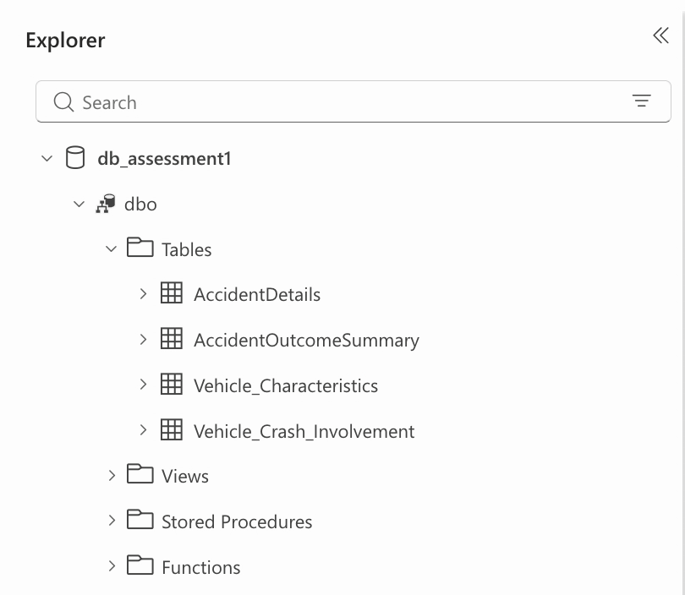

Data Pipeline and Transformations (ETL)
This section describes the Azure SQL Database relational design for the cleaned Victoria Crash Statistics dataset, focusing on transactional integrity, optimised data types, and referential constraints for downstream analytics.
The normalised schema has a central dimension table (AccidentDetails) supported by tables detailing specific injury outcomes and vehicle features.

$$Insert Screenshot of your Entity-Relationship Diagram (ERD) here, clearly showing the Primary Keys (PK), Foreign Keys (FK) and data types$$

Deliverable 2: Description of Each Destination Table

The database keeps detailed, row-level data in four core relational tables:

Table 1: Accident Details

Purpose: The central database hub for basic crash event information (date, time, lighting, geometry, and binned speed zones). It utilises highly optimised TINYINT and SMALLINT data types to minimise storage overhead.

Table 2: AccidentOutcomeSummary

Purpose: Human casualty outcomes and number of vehicles in each crash are recorded, and provided separately from Table 1 to follow best practices of database normalisation.

Table 3. Vehicle Characteristics

Objective: Static and mechanical vehicle characteristics (make, model, year, capacity) Columns which have been found to be highly missing or irrelevant in the profiling of Task 1 (such as VEHICLE_POWER) are intentionally excluded.

Table 4: Involvement in Vehicle Crashes

Purpose: Includes the results for a vehicle involved in an event, such as driver intent, location of first impact, and number of occupants at time of collision.

Deliverable #3: Description of Table Relationships

Primary Keys (PK) and Foreign Keys (FK) are used by the database to ensure strict referential integrity and prevent orphaned records in the data warehouse.

AccidentDetails (Central Hub):

Main dimension table. It is linked to all other tables by its Primary Key, ACCIDENT_NO.

1-1 Relationship (Casualty Outcomes to Crash)

AccidentOutcomeSummary ↔ AccidentDetails

One crash = one casualty record. AccidentOutcomeSummary uses ACCIDENT_NO as a concurrent Primary and Foreign Key mapping directly to AccidentDetails

1 To Many Relationship( Crash To Vehicles):

AccidentDetails ↔ VehicleCharacteristics

Crashes may involve more than one vehicle. VehicleCharacteristics has a Composite Primary Key (ACCIDENT_NO, VEHICLE_ID) for uniqueness, with ACCIDENT_NO as a Foreign Key.

1-to-1 Relationship (Vehicle to Crash Involvement) :

VehicleCharacteristics <--> VehicleCrashInvolvement

VehicleCrashInvolvement has the (ACCIDENT_NO, VEHICLE_ID) Composite Primary Key that is a strict Foreign Key to VehicleCharacteristics in an effort to prevent orphaned dynamic data.

Deliverable 4: SQL Scripts

The schema was generated by using the following Data Definition Language (DDL) scripts in Azure SQL Database to establish required data types, field lengths and constraints.

Generate Insights using Power BI

The above grpah shows the number of crashes in different speed zones by the severity of the crashes. A surprising stat may be that the highest number of crashes occur in areas that are 60km/h, only 3% of these crashes resulted in a fatality. When compared to the enxt highest level of crashes, 100km/h zones, the number of fatal crashes is 10% of the total. We can take form this that whilst a person si elss likely to crash in high-speed areas, they are more likely to die. Further comparison shows that you’re less likely to crash at 80km/h and have a similar chance of dying as you do at 60km/hr (4% compared to 3%) and at 50km/hr you have only a 2% chance of dying. If you go down to 40km/h, there are even less crashes with only 1% of crashes reuslting in fatalties.
This shows that by reducing total speeds, we can lower the number of crashes and fatalities on the road.
The graph above shows the increase in number of older vehicles on the road that were involved in crashes resulting in injury from under 2,00- in 2012 to over 8,000 in 2025. By grouping by total amount of crashes, we can see that the increases are non-linear. Passenger cars are the most dangerous of the older vehicles over this time period, followed by motorbikes and light vehicles (unknow not included).
The overall increase in crashes involving older vehicles points to a decline in safety features and standards compared to modern day vehicles. For newer cars have automatic braking to help avoid accidents. Not having features like this could result in more crashes as it is more reliant on the drivers own skill.

Provide a set of recommendations for the given scenario
Recommednation for speed zones: In order to improve safety on roads, w recommedn reducing the speed limits on roads that are 100km/h down to 80km/h or 75km/h and roads that are 60km/h down t 50km/h and in suburban streets, 40km/h. This slight reductionin speed zones will result in safer roads with less risk of crashing and fatalities caused by those deaths.
Older vehicles: Whilst there may be more odler vehicles on the road, the lack of safety features may be making them more dangeorus for th drivers. We recommend starting to track and re-evaluate oler vehciles absed on safety to determine if they are still fit to eb dirven on the road.

Provide the report and presentation

Data Quality Improvement Proposal

