Design and Development of BI Solution

Group #
Student 1, ID number
Student 2, ID number

Mon 5-7PM

Task 1. Understand the source data and generate a Data Profile for the given source dataset

Accident.csv

Formats and Data Types

ACCIDENT_DATE and ACCIDENT_TIME were loaded as plain text (strings) rather than valid datetime objects, preventing immediate time-series analysis.
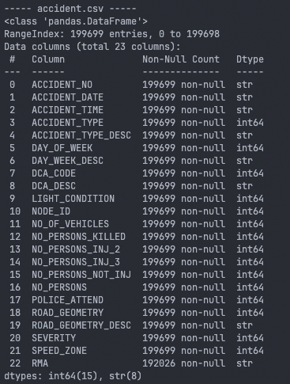

Consistency and Accuracy

SPEED_ZONE mixes real speed limits with numeric codes (777 for ‘other’, 888 for ‘off road’, and 999 for ‘unknown’). Since pandas interpreted these as integers, the mean speed zone was artificially inflated to 135.77 km/h.

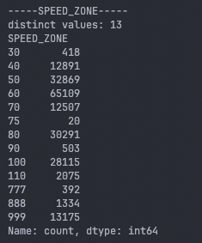

DAY_OF_WEEK contains conflicting numbering systems (Monday=1 in some rows, Sunday=1 in most, and a code 0), resulting in 81.76% (136,289 rows) of the column disagreeing with the actual calendar date.

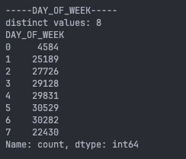

6 crashes reported having 0 vehicles involved, and 1 crash was coded as a serious injury despite having no serious injuries recorded.

Completeness

RMA contained 7,673 missing values (3.84%).

NODE_ID contained 85 negative or zero values which cannot point to real locations.

Outliers and Distributions

NO_PERSONS z-score test flagged 2,959 number of rows and 3,330 in NO_PERSONS_KILLED as outliers. However, quartile and box-plot analysis confirmed these are not errors but rather genuine severe crashes (e.g., fatal crashes or multi-vehicle pile-ups).

Vehicle.csv

Perform data cleaning and preparation activities to prepare your data

Load the data to Azure Storage for ETL

Resource

Container

Config

Server: ` sqlserver-assessment1`

Database: ` db_assessment1`

Credentials: User / IFN655@2026

Design and Create the Destination table structure for ETL

AccidentDetails

AccidentOutcomeSummary

Vehicle_Characteristics

Vehicle_Crash_Involvement

Evidence of the database tables created

Perform the transformations

Generate Insights using Power BI

Provide a set of recommendations for the given scenario

Provide the report and presentation

Data Quality Improvement Proposal

