PROJECT REPORT
Console-Based Asteroid Shooter Game

Programming Fundamentals / Lab Project

Course | Programming Fundamentals CL1002
Group Members | - 25K-6502 Abdullah Wasi  - 25K-6507 Bilal Ahmed Khan  - 25K-6500 Saim Khurram
Submission Date | 28-4-2026
Tool Used | Visual Studio Code / GCC (MinGW), C Language
GitHub | https://github.com/bak71007-CS/Project.git

1. Executive Summary
Overview
This project presents a fully functional, console-based Asteroid Shooter game written in the C programming language. The game runs entirely within a terminal window and requires no external graphics libraries. The player controls a spaceship at the bottom of the screen, moves it left and right, fires bullets, and destroys falling asteroids before they make contact. The project was designed to demonstrate how core Programming Fundamentals concepts.
Key Achievements
- Flicker free rendering achieved using Windows API cursor repositioning instead of system("cls").
- Non-blocking keyboard input using kbhit() and getch() for a smooth real-time game loop.
- Bullet management implemented as a stack data structure with O(1) push and removal.
- Progressive difficulty: asteroid speed, spawn frequency, and on-screen quantity all scale with the player's score using a hyperbolic curve formula.
- Swept-range collision detection that eliminates missed hits caused by fast-moving bullets skipping over asteroid cells.

2. Introduction
Background
Console-based games have long served as effective teaching tools in introductory programming courses. They allow to observe the direct impact of their code — loops that drive a game forward, conditions that check for collisions, and functions that keep logic organized — without the complexity of a graphical framework. This project draws on that tradition by implementing a retro-inspired asteroid shooter game that runs inside any standard Windows terminal.
Project Objectives
- Develop a playable, console-based asteroid shooter game in C.
- Apply PF concepts: functions, loops, conditional statements, arrays, pointers, and structs.
- Implement a stack data structure to manage in-flight bullets.
- Deliver a smooth user experience through flicker-free rendering and non-blocking input.
- Demonstrate increasing difficulty through score-based dynamic scaling.

3. Project Description
Scope: Inclusions
- Console-based game window with a visible bordered playfield (40 x 20 characters).
- Player-controlled spaceship ([A]) with left/right movement and shooting.
- Asteroids (O) that spawn at the top and fall downward at a speed tied to the current score.
- Bullets (^) fired upward from the player's position, managed as a stack.
- Score tracking displayed live in a HUD above the playfield.
- Game Over screen with final score and Restart / Quit options.
- Start screen with ASCII art title and control instructions.

Scope: Exclusions
- No graphical user interface (GUI).
- No sound effects or animations beyond ASCII characters.
- No multiplayer mode.
- No complex AI behaviour or multi-type enemy patterns.

Technical Overview
The entire game is contained in a single main.c file for easy compilation. It uses only standard C libraries plus two Windows specific headers:
- <windows.h> — provides SetConsoleCursorPosition() for flicker-free rendering and Sleep() for frame timing.
- <conio.h> — provides kbhit() and getch() for non-blocking keyboard input.
- Compiled and run using Visual Studio Code (GCC/MinGW) on Windows.
‘

4. Methodology
Development Approach
The team followed a component-based, incremental development approach. The game was broken into isolated features — rendering, input, game logic, collision, and difficulty scaling..
The game loop follows a strict four-step cycle per frame: Input → Logic → Draw → Sleep. This separation ensures that input reading, state updates, and rendering never interfere with one another.
Roles and Responsibilities
Bilal Ahmed Khan (25K-6507) | Research phase, program architecture design, overall game structure, and final integration
Abdullah Wasi (25K-6502) | Player movement, keyboard input handling, bullet stack implementation, and rendering engine.
Saim Khurram (25K-6500) | Asteroid spawning logic, collision detection, and difficulty scaling functions.

5. Project Implementation
Design and Structure
All game state is encapsulated in a single GameState struct that is passed by pointer to every function. This avoids relying on global variables and follows the structured programming model. The struct contains the player position, score, frame counter, game-over flag, bullet stack, and asteroid array.
The bullet system uses a dedicated BulletStack struct (an array of Bullet items plus an integer top). Push adds a new bullet in O(1) time. Removal uses a swap-with last strategy, also O(1), which avoids shifting the entire array on every deletion.
Key Functions
Function | Purpose
Setup() | Initialises all game state: player position, score, frame counter, bullet stack, asteroid array.
Input() | Reads keyboard events without blocking using _kbhit() and _getch(). Updates player position or fires a bullet.
Logic() | Moves bullets and asteroids, calls CheckCollisions(), spawns new asteroids based on GetSpawnRate().
Draw() | Moves cursor to (0,0) and overwrites each row in the playfield line-by-line. No screen clearing.
CheckCollisions() | Swept-range bullet-asteroid check plus asteroid-player overlap check. Uses nested loops over the stack and array.
SpawnAsteroid() | Finds a free slot in the asteroid array. Respects the current cap returned by GetAsteroidCap().
GetAsteroidDelay() | Returns the per-frame movement delay for asteroids. Shrinks as score rises (hyperbolic curve).
GetAsteroidCap() | Returns how many asteroids may be on-screen at once. Grows from 2 to 10 as score increases.
GetSpawnRate() | Returns the number of frames between asteroid spawns. Decreases with score.

Flicker-Free Rendering
Usually, games clear the whole screen to draw the next frame, which makes it blink. Instead, we just move the typing cursor back to the top and write over the old text. This makes the movement look smooth.
Collision Detection
Because bullets move fast, they might "jump" over an asteroid in one frame. We fixed this by checking every spot the bullet touched as it moved. We also check if an asteroid touches any part of your ship.
Difficulty Scaling
Three parameters scale dynamically with the player's score using the same hyperbolic formula:
value = BASE +/- (RANGE * score) / (score + THRESHOLD)
This curve drops or rises sharply at low scores (rewarding early play) and flattens toward a maximum as the score climbs. As a result, asteroid movement speed, spawn frequency, and the maximum number of on-screen asteroids all increase together, creating a continuously escalating challenge.

Challenges Faced
- Name Conflict: Our ShowCursor() function clashed with a function of the same name declared in <winuser.h>. Resolved by renaming ours to RestoreCursor().
- Bullet Skip Over: Fast-moving bullets (speed = 3) could jump over an asteroid in a single frame. Fixed by implementing the swept-range collision check described above.
- Stack Removal Edge Case: Removing the last bullet from the stack caused a redundant self-copy. Fixed by checking I != bs->top before the swap.

6. Results
Project Outcomes
The final program is a fully playable, single-file console game that meets all objectives defined in the project proposal. The game starts with a simple ASCII art welcome screen, transitions into a smooth real-time game loop, and ends with a Game Over screen showing the final score along with restart and quit options. All rendering is flicker-free and input is fully non-blocking.

Difficulty Progression Summary
Score | Asteroid Speed | Max On-Screen | Spawn Gap (frames)
0 | Slow (delay 6) | 2 | 8
50 | Medium (delay 3) | ~6 | ~5
150 | Fast (delay 2) | ~8 | ~3
300+ | Max (delay 1) | 10 | 2

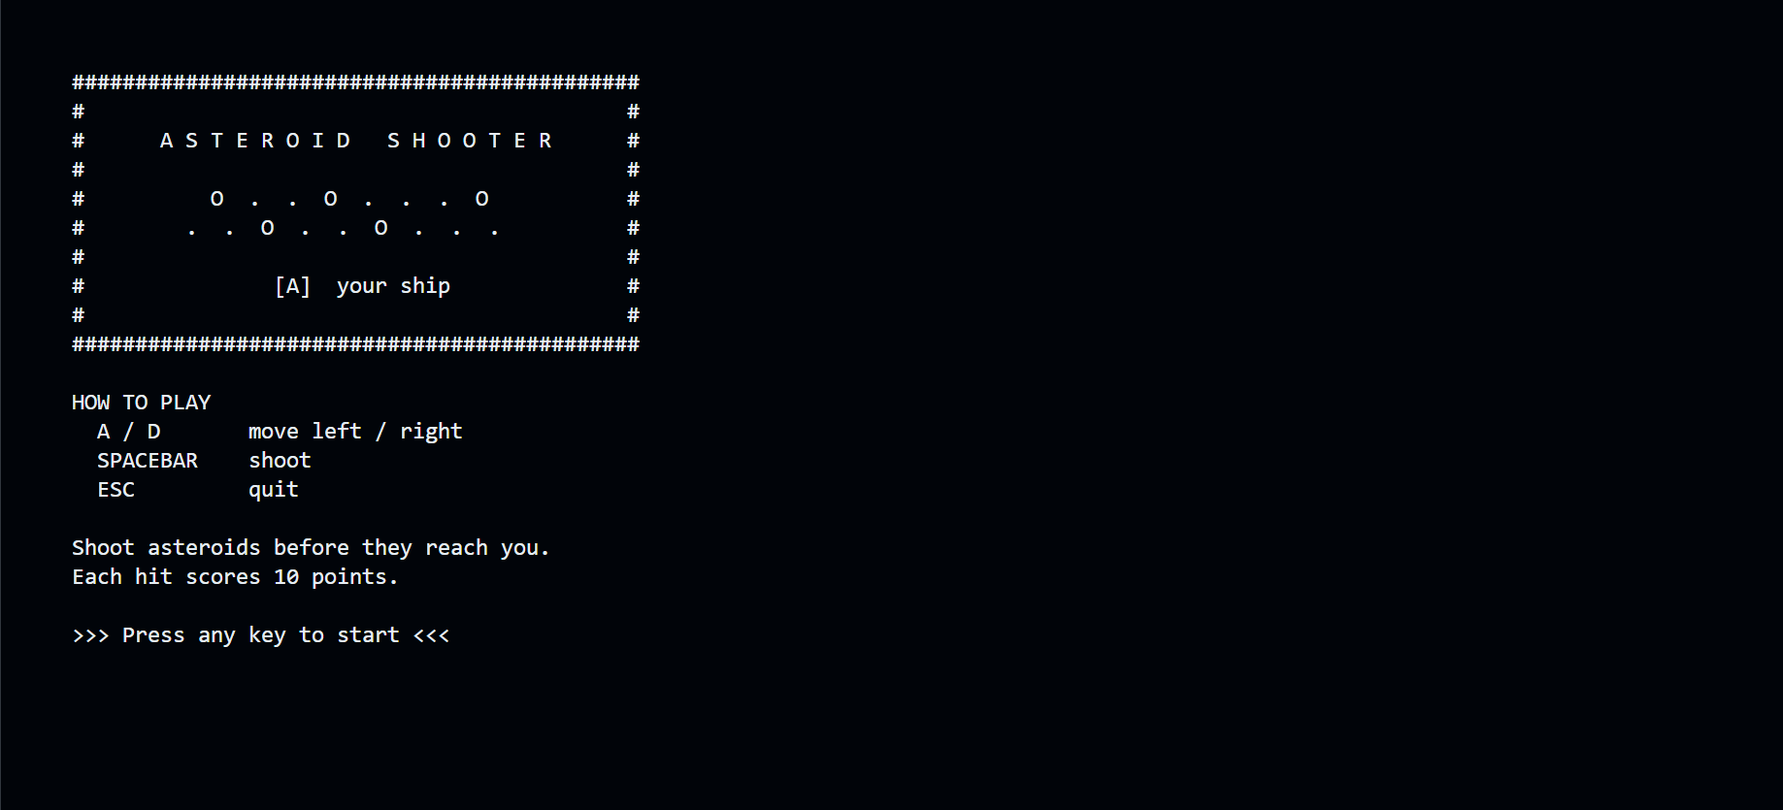
Game Ouputs:

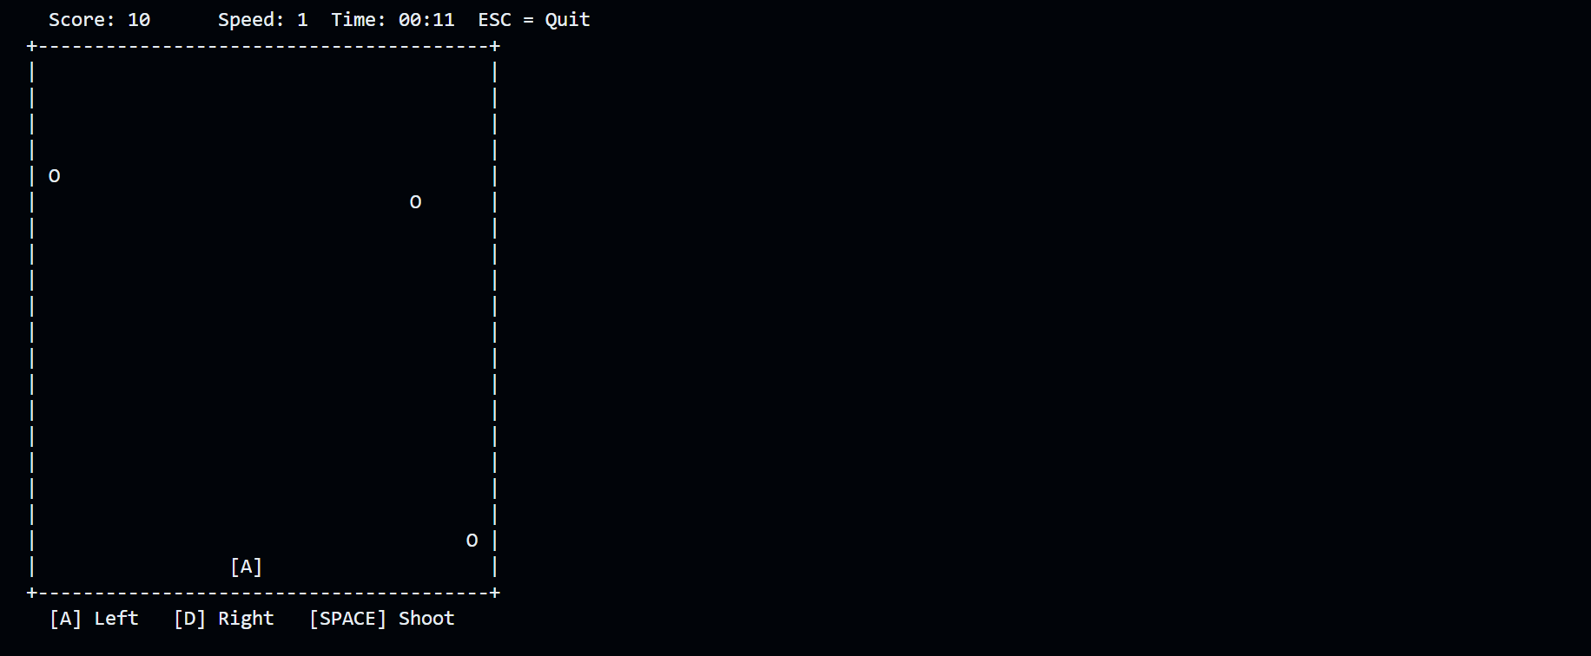
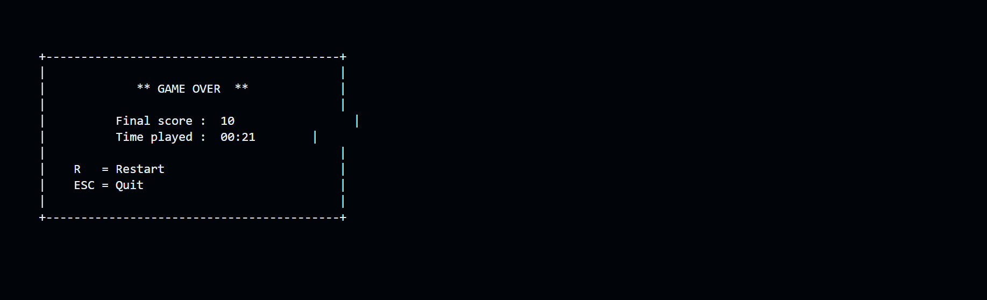
Testing and Validation
- Collision accuracy tested by shooting at stationary asteroids across all x positions.
- Speed scaling verified by playing to score 300 and observing the asteroid delay drop from 6 to 1 as expected.
- Boundary conditions tested: player movement clamping at left and right walls, bullets deactivating at the top border, asteroids that miss the player deactivating at the bottom.
- Stack behaviour validated: firing 10 bullets in rapid succession fills the stack; the 11th shot is silently ignored without crashing.
- Restart loop tested: pressing R on the Game Over screen correctly resets all state and restarts cleanly.

7. Conclusion
Summary of Findings
The Asteroid Shooter project successfully demonstrates that core Programming Fundamentals concepts are sufficient to build a complete, real-time interactive application. The use of a GameState struct with pointer-based parameter passing, a stack for bullet management, array pointers passed to functions, and hyperbolic scaling formulas.
Final Remarks
The project reinforced the principle that well-organized, modular code is far easier to debug, extend, and reason about than a monolithic main() function. We are proud of this project and look forward to adding more features later, like saving high scores to a file, adding different types of enemies, or making it a two-player game. This experience showed us that we can build real, working software using the basic skills we learned in class.
Future improvements could include a high-score persistence system (file I/O), multiple asteroid types with different sizes and speeds, and a local two-player mode — all of which remain achievable within the console-only constraint and within the scope of techniques learned in this course.

