Supplementary Materials for "A Review on the role of livestock ontologies in animal health management and disease surveillance"

This document provides detailed insights into the systematic review process conducted for the study titled "A Review on the role of livestock ontologies in animal health management and disease surveillance". The review focused on ontology-based approaches for disease surveillance and health management in livestock farming, aiming to address challenges and emerging trends in this domain. Using ASReview LAB, 286 records were systematically reviewed, resulting in the identification of 115 relevant records. This document also includes a description of the databases search queries and step-by-step instructions for replicating the review process.
Databases and Search Strategy
The literature search utilized PubMed, IEEE Xplore, and Google Scholar to identify relevant peer-reviewed articles and literature. Since academic databases are continuously updated with new research, it is important to note that the number of articles retrieved at the time of search may change in future searches using the same queries. This study focused on research published between 2011 and 2025, and the search results reflect the number of articles available at the time of retrieval.
Search queries were designed to address infectious disease management in livestock (pigs, poultry, and cattle), ontology-based methods, and challenges in livestock health management. Keywords included "Health Ontology,” “Livestock Health Ontology," "Disease Surveillance," "Precision Livestock Farming," "Farming," "Agriculture," "Animal Health Surveillance,", "Health Surveillance,” “Infectious Diseases," "Disease Management," "Farm Management,” and "Data Management Challenges."
PubMed Search Queries
Quer1: ("Livestock Health Ontology" OR "Disease Surveillance" OR "Animal Health Surveillance" OR "Early Detection" OR "Infectious Diseases") AND ("Farm Animals" OR "Cattle" OR "Poultry" OR "Pig") AND (Agriculture OR "Animal Agriculture") AND "Ontology". This query targeted studies focusing on the role of ontologies in livestock health management, including disease surveillance and early detection for farm animals. Articles. At the time of retrieval (Date: 12/03/2025), the search yielded approximately 61 relevant.

Query 2: (("ontologies" OR "ontology-based" ) AND ("animal" OR "livestock" ) AND ("disease surveillance" OR "health surveillance" OR "Animal Trait " OR "infectious diseases")). This query explored ontology-based approaches and their application in disease surveillance for livestock species, yielding 14 articles.

Query 3 : ("precision livestock farming" OR "PLF" OR "livestock management systems") AND ("farm management" OR "disease surveillance" OR "disease management") AND ("challenges" OR "barriers" OR "issues") AND ("pigs" OR "poultry" OR "cattle"). This query focused on identifying challenges and barriers in livestock management systems and PLF technologies for disease management, retrieving 3 articles.

Query 4 ("farm Health data management systems" OR "agriculture health data management" OR "livestock management systems") AND ("data access" OR "data sharing" OR "data governance" OR "data integration" OR "data privacy") AND ("challenges" OR "barriers" OR "issues"). This query examined challenges related to health data management in livestock farming, including issues of data sharing, governance, and privacy, yielding 27 articles.

Query5: ("livestock health" OR "animal health" OR " Disease Surveillance") AND ("ontology" OR "ontologies") AND ("challenges" OR "limitations" OR "barriers"). This query focused on the challenges and limitations of ontology-based approaches in livestock health and disease surveillance, retrieving 5 articles.

IEEE Xplore Search Queries
IEEE Xplore queries were modified slightly for specific focus areas:

Query 1: ontology for animal infectious diseases. This query targeted studies addressing the development and use of ontologies for managing infectious diseases in animals, yielding 2 relevant papers.

Query 2: Livestock Farming ontology. This query focused on ontology applications in livestock farming, identifying 8 conference and journal articles from 2012 to 2024.

Query 3: Livestock Farming data challenges. This query explored challenges related to data in livestock farming, including integration, governance, and privacy, resulting in 107 articles.

Post-Search Processing and Analysis
After conducting the database searches and retrieving the articles, the collected references were compiled into an RIS file for further processing by using Zotero reference manager. The RIS file, titled "Collected papers 286 - A Review on the Role of Ontologies in Modern Agriculture.ris", contains the bibliographic data for the 286 records were screened after removing duplicates. This file can be loaded into reference managers or ASReview for systematic screening and analysis.
ASReview Project File Details
To streamline the review process, the ASReview LAB tool was utilized. The project file " a-review-on-the-role-of-ontologies-in-modern-agriculture.asreview" contains all the review settings, records, and inclusion/exclusion decisions. The Prior knowledge to warmup the AI is 28 relevant and 10 irrelevant records
Researchers can replicate the review process by following these steps.
- Install ASReview:
Run the command: pip install asreview.
- Open ASReview lab:
Start the interface by typing asreview lab in the command prompt.
- Import the project file:
Load the project file into the ASReview LAB interface to view the screening process and decisions made during the review.
- Export Relevant datasets/records:
Use the export section to download records for further analysis.
The following datasets were generated during the review process using ASReview LAB:
- asreview_dataset_all_a-review-on-the-role-of-ontologies-in-modern-agriculture.ris/xlsx:
This dataset contains all 286 records, including both labeled and unlabeled data.
- asreview_dataset_relevant_a-review-on-the-role-of-ontologies-in-modern-agriculture.ris/xlsx:
This dataset includes only the 115 records identified as relevant during the review process.
These datasets provide a comprehensive view of the reviewed literature and can be used for further analysis or replication of the study.
ASReview Analytics
The ASReview LAB tool generated analytics and visualizations to summarize the review process. Screenshots of these analytics, such as Figure 1: ASReviewAnalytics.png shows relevant or irrelevant papers with percentage of relevant papers. Figure 2 ASReviewLABprogressDensity.png shows number of review records and Figure 3 ASReviewLABprogressRecall.png provide further insights into the systematic review process.

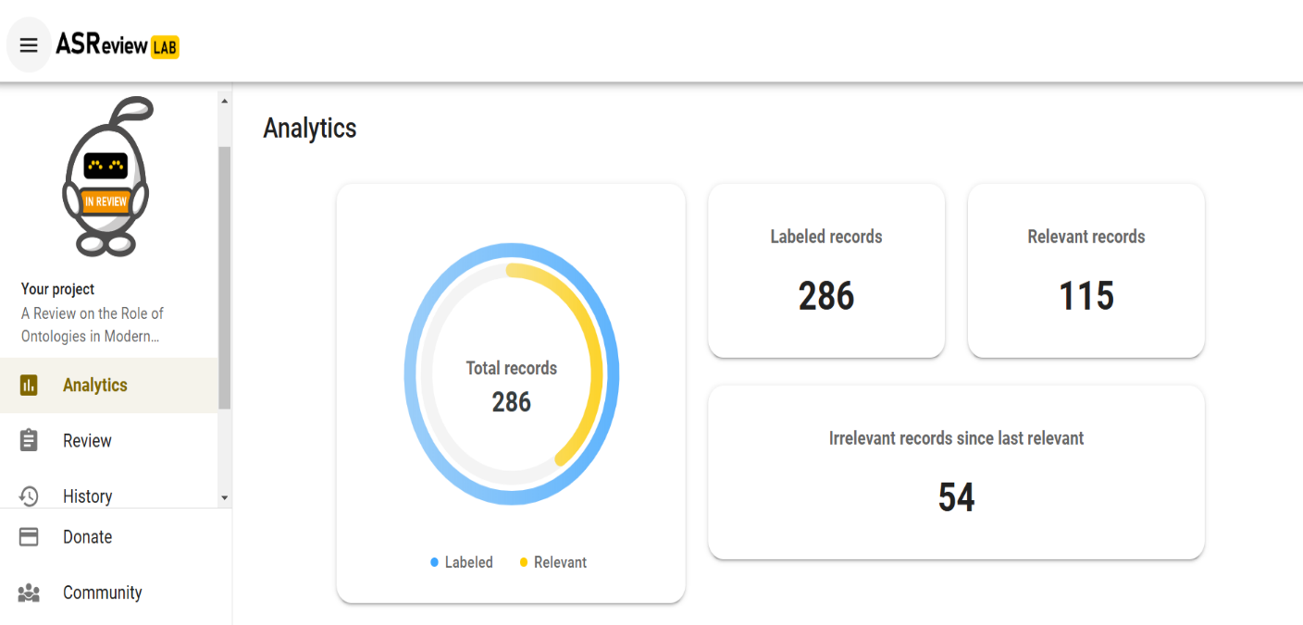
Figure 1: ASReviewAnalytics.png

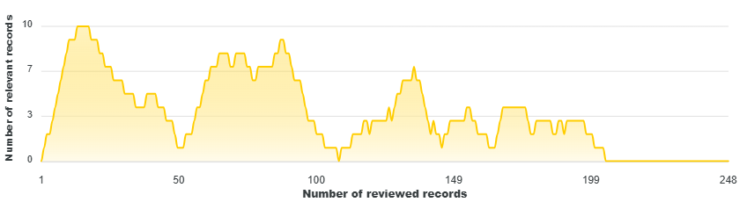
Figure 2: ASReviewLABprogressDensity.png
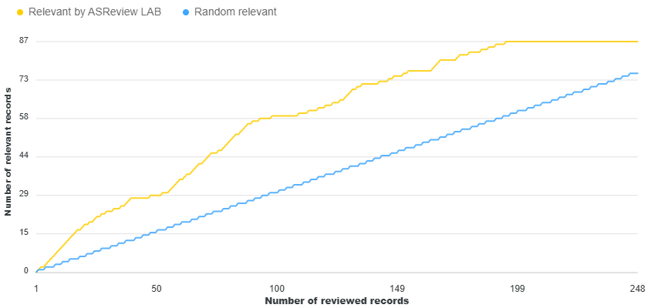
Figure 3: A ASReviewLABprogressRecall.png

