Discussion

Introduction
The rapid evolution of generative artificial intelligence (AI) is reshaping numerous areas of medicine. Large language models (LLMs) now demonstrate advanced capabilities in natural-language processing, reasoning, and potential clinical decision support (Goh et al. 2024). Prior research has primarily evaluated LLM performance across medical specialties using multiple-choice question (MCQ) assessments (Kung et al. 2023a). However, travel medicine—a field characterized by dynamic epidemiological landscapes, region-specific risks, and evolving vaccine recommendations—remains underexplored in this context.
Recent studies show that models such as GPT-4 perform well on high-stakes medical examinations, including the United States Medical Licensing Examination (USMLE) and subspecialty board exams (Singhal, Tu, Gottweis, Sayres, Wulczyn, Amin, Hou, Clark, Pfohl, Cole-Lewis, Neal, et al. 2025). While MCQs have recognized limitations as a benchmarking tool (Mbakwe et al. 2023), they provide a pragmatic starting point for comparing different LLMs and prompting strategies in this specialty. Future benchmarks could be expanded to include open-ended questions and clinical vignettes, more accurately reflecting the complexity of medical reasoning.
One technique that consistently improves LLM performance is chain-of-thought reasoning, which prompts models to generate intermediate steps before selecting a final answer. Yet this strategy can increase inference time, encourage overthinking on simple tasks, and amplify confidence in incorrect answers (Fu et al. 2025). Such overconfidence has also been documented in medical contexts, raising concerns about the models’ metacognitive reliability (El Labban et al. 2024).
In previous work, we proposed a “decalogue” of principles for the safe and effective use of generative AI in travel medicine (Baglivo et al. 2024a). Although the field continues to evolve—with new reasoning strategies and domain-specific models emerging—these foundational principles remain pertinent. Establishing a dedicated benchmark for travel medicine is critical not only to assess current AI capabilities but also to inform model selection in line with these principles.
This study is an initial step toward aligning technological innovation with clinical needs in travel medicine. By developing a standardized evaluation framework, we aim to contribute to the progress of travel-medicine, positioning this field as a proactive adopter of AI tools (Flaherty and Piyaphanee 2022).

Objective of the Study
The primary objective of this study is to evaluate and compare the performance of selected LLMs on multiple-choice questions (MCQs) drawn from a travel-medicine certification examination. Specifically, we aim to:
- Assess the accuracy of diverse AI models in addressing travel-medicine scenarios.
- Compare the performance of LLMs with and without explicit reasoning (chain-of-thought) in answering travel-medicine MCQs with multiple prompts.
- Establish a foundational benchmark to evaluate state-of-the-art models in travel medicine.

Methods

Study design
A comparative evaluation of large-language models (LLMs) was conducted on a domain-specific benchmark of travel-medicine questions. Each model was asked to solve the same set of multiple-choice travel-medicine clinical vignettes under distinct prompting conditions. Performance was assessed across three complementary dimensions—accuracy, adherence to the required answer format, and internal consistency—using a fully reproducible analysis pipeline.
The benchmark comprised 42 single-best-answer questions representative of real-world scenarios encountered in travel health practice. Items were collected from freely accessible online repositories, mainly from the sample question banks curated by the International Society of Travel Medicine (https://www.istmfoundation.net/cth_samplequestions) and the American Society of Tropical Medicine and Hygiene certificate programme (https://www.astmh.org/education-resources/certificate-programs). They covered diagnosis, prevention, and therapeutic decision-making for parasitic, bacterial, and viral conditions. The question list is reported in Supplementary Table X.

Large language models
A total of 40 LLMs were selected,includingproprietary frontier systems (for example, OpenAI o3, Google Gemini 2·5 Pro, Anthropic Claude 3·5 Sonnet), high-performance hosted deployments of open-source models, and locally executed, quantised replicas suitable for desktop-class hardware. These local models ran offline on a MacBook Pro equipped with an Apple M1 Pro processor and 32 GB of unified memory, using LM Studio as the inference interface (https://lmstudio.ai/docs/basics) and the MLX runtime (https://github.com/apple/mlx) for model execution. Where applicable, the most recent public checkpoints were queried through their native application-programming interfaces. Temperature was fixed at 0·5 for all calls to balance determinism with variability; OpenAI’s o-series models ignore this parameter by design. The list of models is reported in Supplementary Table X.

Experimental procedure
Three prompting strategies were investigated:
- Concise answer (cold) - the model was instructed to reply with a single letter corresponding to the chosen option.
- Free explanation (free) - a brief rationale was permitted, provided that the response ended with the chosen option. This approach is supported by work showing that allowing language models to verbalise a short explanation can boost accuracy (Tam et al. 2024a).
- Chain-of-thought (reasoning) - the model was invited to articulate its reasoning step by step before stating the final answer. Chain-of-thought prompting is a well-established strategy for eliciting reasoning in large language models (Wei et al. 2022).
Models whose decoding stack already includes an internal chain-of-thought module—such as OpenAI’s o-series, DeepSeek R1, and certain Gemini variants—were exempted from the third modality to avoid redundancy. These systems are trained to perform latent deliberation at inference time, a strategy empirically shown to enhance answer quality and cost-efficiency (Snell et al. 2024; DeepSeek-AI 2025).
Every combination of question, model, and prompting condition was tested five times, yielding interactions. Each response was processed programmatically to extract the final option letter, as well as to record processing time and token consumption. If the response format did not permit automatic extraction, a secondary parsing step was performed using the large language model gemini-2.0-flash-001. Responses that remained unparseable after this secondary step were classified as unparseable.
Responses were matched against the correct answer and classified into four mutually exclusive categories: correct, incorrect, unparseable (no valid option detected), and generation error. Additionally, correct and incorrect responses were annotated according to whether they were directly machine-parsable or required secondary parsing by a large language model.

Statistical models
The classification results were analysed with three multilevel Bayesian models, covering three metrics: accuracy, parsing success, and consistency. The Bayesian modelling approach has the advantage of providing more generalisable results compared to crude descriptive statistics, making the results less dependent on the specific sample of questions used. All models were fitted in Stan through the brms interface and included a random intercept for items, a random intercept by model, as well as a random slope for the interaction between prompting modality and model. Variance components were assigned weakly-informative Student-t priors with three degrees of freedom and scale 1.5, whereas correlation matrices were given an LKJ prior with shape parameter 2, which gently shrinks correlations towards zero (Gelman 2006; PyMC Community 2023). Two Hamiltonian Monte Carlo chains were run for 4 000 iterations (1 000 warm-up) and convergence was assessed with $\hat{R}\left(<1.01\right)$ and effective sample sizes.

Accuracy
To measure accuracy, the probability of a correct response was estimated for each item, model, prompt combination over $N$ replications.
Let $\left(i=1,…,N\right)$ index each unique item, model, prompt combination. For each cell $i$, $Y_{i}$ is the number of correct replications out of $T_{i}$ trials. These counts were modelled with a binomial hierarchical model:
$$
$$
This model corresponds to the brms formula:
correct | trials(total) ~ 0 + (modality | model_id) + (1 | item) with family = binomial().
with model_id being the model identifier, modality the prompting strategy, and item the question.
Posterior samples of $π_{i}$ provide the accuracy score for each combination of model, question, and prompting strategy.

Parsing success
To evaluate the reliability of the answer format, for every individual replication, an ordinal response $Y_{n}∈\{0,1,2\}$ encoding parsing success was considered, with:
- $0$ (none) - parsing failed,
- $1$ (rescued) - the answer needed parsing by an auxiliary LLM,
- $2$ (clean) - parsed without intervention.
Let $n=1,…,N$ index individual replications. The ordinal outcome $Y_{n}∈\{0,1,2\}$ was modelled using a cumulative logit formulation with two ordered thresholds, $κ_{0}<κ_{1}$:
$$Pr\left(Y_{n}≤c\right)={\text{logit}}^{-1}\left(κ_{c}-η_{n}\right), c∈\{0,1\}.$$
The two cumulative probabilities imply three probabilities, one per parsing category:
The linear predictor $η_{n}$ formulation and priors were identical to those adopted for the accuracy model.
This model corresponds to the brms call:
y ~ (prompt | model_id) + (1 | item) with family = cumulative("logit")
Posterior category probabilities $\left(π_{n0},π_{n1},π_{n2}\right)$ derived from the model were condensed to a continuous parsing-success score on the unit interval:
$$S_{n}=\frac{0 π_{n0}+1 π_{n1}+2 π_{n2}}{2},$$
so that $S_{n}=1$ denotes a certainly clean reply and $S_{n}=0$ a certainly none outcome.

Consistency
Reproducibility was quantified by counting how many distinct options $d_{i}$ were selected across the $T=5$ replications of each (question, model, prompt) cell, indexed by $i$. Because the possible answers are four (A, B, C, D), the observed range is $d_{i}∈\{1,…,4\}$.
The count $d_{i}$ was treated as the number of “successes” in an improper binomial experiment with $T=5$ trials:
$$d_{i}∼\text{Binomial}\left(5, ρ_{i}\right).$$
Although the independence assumption is not strictly satisfied, since two identical answers in the same cell reduce the chance of further distinct letters, the binomial likelihood nevertheless provides a convenient monotone link between $ρ_{i}$ and the degree of variability; the resulting uncertainty is therefore somewhat underestimated.
The distinct-option rate followed the same hierarchical structure and priors as the accuracy model.
This model corresponds to the brms call:
y | trials(total) ~ 0 + (modality | model_id) + (1 | item) with family = binomial()
Posterior draws for the expected number of distinct letters, ${\tilde{d}}_{i}=5 ρ_{i}$, were converted to a unit-interval consistency score by rescaling to the theoretical maximum of four distinct options:
$$C_{i}=1-\frac{{\tilde{d}}_{i}}{4},$$
so that $C_{i}=1$ marks perfect reproducibility (all replications choose the same letter) and $C_{i}=0$ corresponds to the extreme case in which all four options are observed within the five attempts.

Statistical analysis
To evaluate overall performance, the posterior distributions of the three scores were marginalised over different dimensions of the experimental design. For each draw from the posterior distribution, the mean score was computed across all levels of the variable(s) being marginalised away. This process yielded full posterior distributions for three complementary summaries:
- Model-level estimates, obtained by marginalising over items and prompting modalities.
- Prompting-modality estimates, obtained by marginalising over items and models.
- Model-modality interaction estimates, obtained by marginalising over items.
From these marginalised distributions, the posterior median was computed as the point estimate of performance and the 95% quantile credible interval (CrI) for uncertainty quantification.
To investigate the relationships between the different performance dimensions, Spearman’s rank correlation coefficients ($ρ_{s}$) were computed between the model-level posterior scores for accuracy, parsing success, and consistency. The correlation was calculated separately for each draw from the posterior distribution, yielding a full posterior distribution for $ρ_{s}$ for each pair of metrics.
Finally, the trade-off between model accuracy and financial cost was analysed. Model-level accuracy estimates were plotted against the provider’s published price per million tokens. The Pareto frontier was identified, defined as the set of models for which no other model offered both higher accuracy and lower cost. To visualise the optimal trade-off, a logistic curve was fitted to the points on the frontier using a quasi-binomial generalised linear model.
All analyses were conducted using R v4.5.0. The code is available at https://github.com/mattia-p/llm-travel-medicine.

Results

Performance overview and key drivers
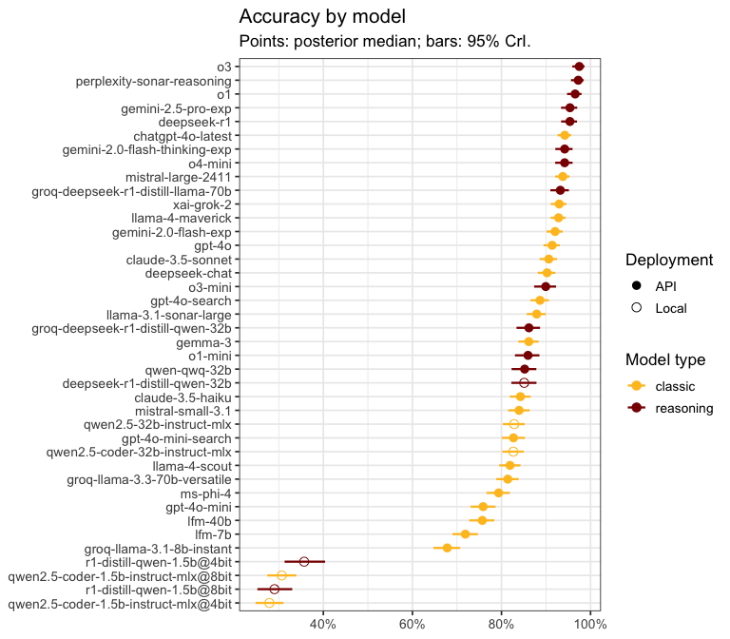
Figure 1: Model accuracy on the travel-medicine benchmark. Points show the posterior median accuracy, with bars representing the 95% credible intervals. Models are ordered by performance.
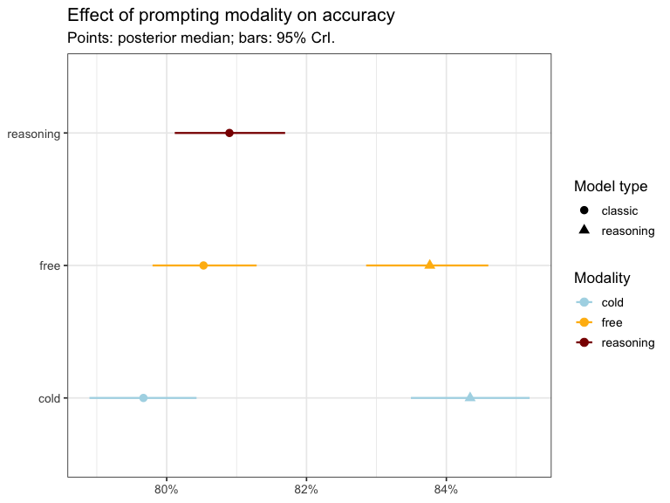
Figure 2: Effect of prompting modality on model accuracy. Points show the posterior median and bars the 95% credible intervals.
Across the 40 large-language models evaluated, posterior accuracy ranged from 97.5% [95.9%-98.6%] for OpenAI’s o3 to 27.9% [24.8%-31.0%] for the smallest local replica (qwen2.5-coder-1.5b-instruct-mlx@4bit) (Figure 1).
Large parameter count reasoning models dominated: in addition to o3, o1 96.5% [94.7%-98.0%], Perplexity Sonar-Reasoning 97.2% [95.6%-98.5%], and Gemini-2.5-Pro 95.4% [93.4%-97.0%] were among the top performers.
Instruction-tuned classics plateaued roughly 4 percentage points lower, led by GPT-4o 91.4% [89.5%-93.1%] and Mistral-Large-2411 93.8% [92.0%-95.3%].
Local models performed overall worse, mostly due to limits in deployable sizes that restricted deployment to very small models (e.g., 1.5B parameters). The smallest 1.5B quantization languished at 27.9% [24.8%-31.0%]. The largest deployable size on the researchers’ machines was a 32B Qwen distillation of DeepSeek-R1, which achieved 85.1% [82.2%-87.9%] but nevertheless performed slightly worse than the same model accessed via the Groq API (86.2% [83.4%-88.7%]), probably due to the aggressive quantization (4-bit) necessary to make it fit in memory.
Within provider families, accuracy climbed with successive iterations: OpenAI’s line rose from GPT-4o 91.4% [89.5%-93.1%] through o1 96.5% [94.7%-98.0%] to o3 97.5% [95.9%-98.6%]; Google’s advanced from Gemini-Flash 92.0% [90.1%-93.7%] to Gemini-Pro 95.4% [93.4%-97.0%]. Similar improvements were observed for LLama and Mistral models.
Search augmentation helped when well integrated: Sonar-Reasoning (a DeepSeek-R1 finetune with search capabilities) surpassed its base model (97.2% vs 86.2%), whereas the search-enabled GPT-4o variant underperformed the base (88.7% vs 91.4%).
Prompting altered these figures only marginally (Figure 2). Classic models improved from 79.7% with a cold prompt to 80.9% under explicit reasoning instructions, whereas reasoning models performed best with the concise cold prompt (84.3% vs 83.8% for a free prompt). But the largest performance gap was between reasoning models and classics, independent of prompt modality.

Parsability of responses and consistency
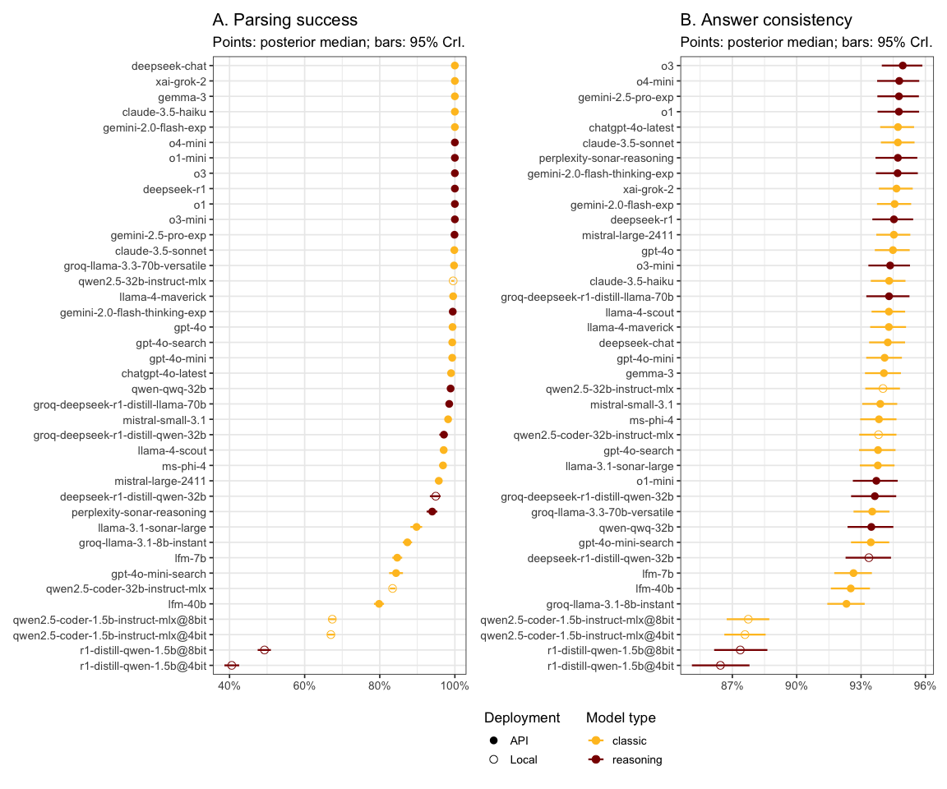
Figure 3: Model performance on secondary metrics. (A) Parsing success, measured as parsing success score. (B) Answer consistency, measuring the reproducibility of answers across identical prompts. Points are posterior medians, bars are 95% credible intervals.
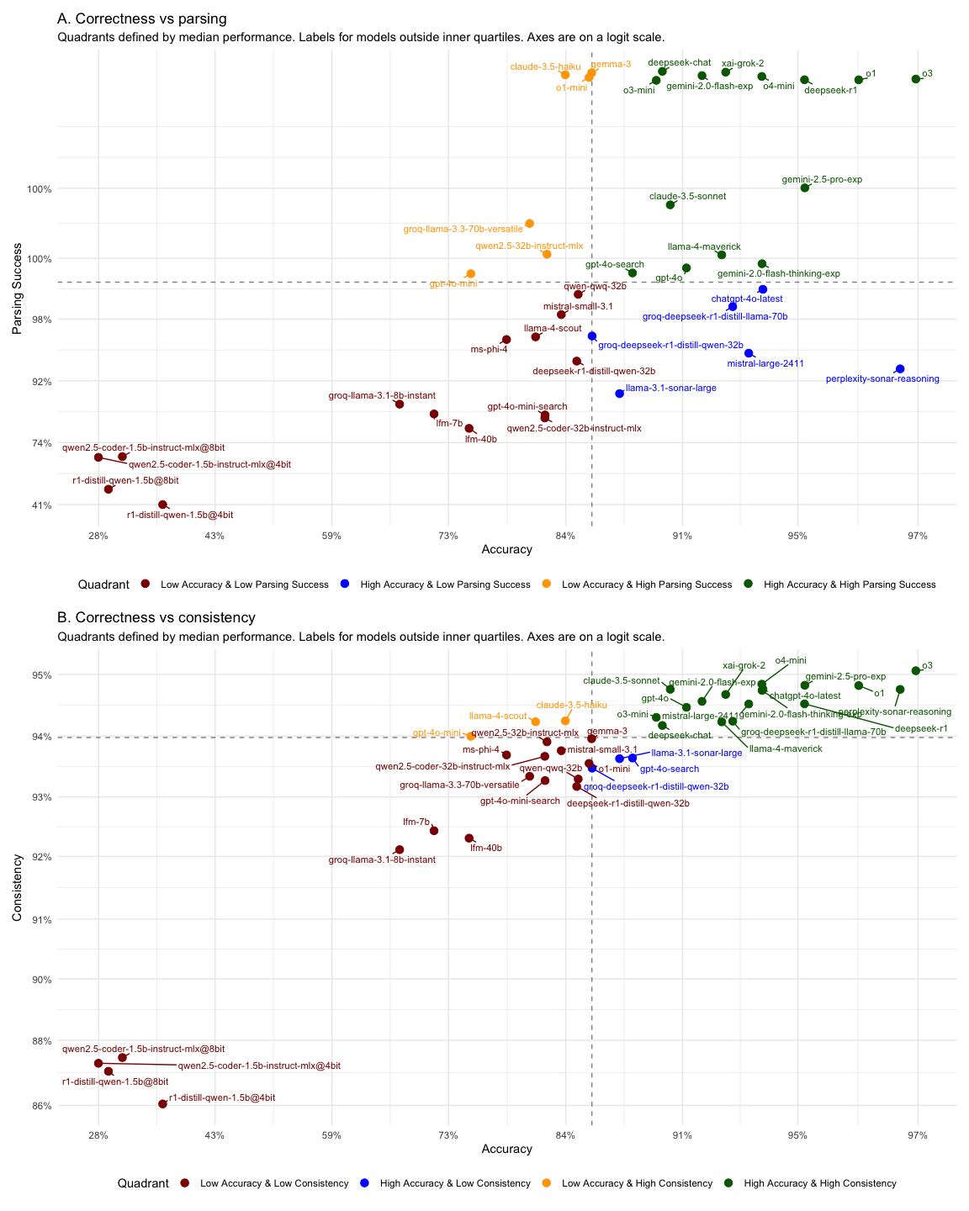
Figure 4: Relationship between accuracy and other performance metrics. (A) Accuracy versus parsing success. (B) Accuracy versus answer consistency. Each point represents a model, categorised into quadrants based on median performance.
Most models followed formatting instructions and produced the expected output format, which allowed for automated parsing of the answers (Figure 3A). Parsability exceeded 90% for 30 of the 40 models evaluated. The distribution was decidedly bimodal: at one extreme, large high-performing frontier models such as o3 (100.0%), gemini-2.5-pro (99.9%), and deepseek-r1 (100.0%) yielded rates well above 95%; at the other, small locally-running models showed a strong drop in parsability, achieving barely half that rate with scores around 50%.
In general, accuracy and instruction-following were moderately correlated (r = 0.62; 95% CrI 0.56-0.67). However, a well-structured output did not guarantee correctness. When plotted against each other (Figure 4A), the models divided into four groups: the best models dominated the upper-right (accurate and well-formed) quadrant, while notable exceptions populated the off-diagonal quadrants. For example, GPT-4o Mini and Claude 3.5 Haiku attained an almost perfect parse rate but underperformed in terms of accuracy; on the other hand, Perplexity Sonar Reasoning was extremely reliable in providing correct answers but had more difficulties in following formatting instructions.
Response consistency was also generally good, ranging from 86.4% (r1-distill-qwen-1.5b@4bit) to 94.9% (o3) (Figure 3B). The correlation between accuracy and consistency was expectedly high ($ρ_{s}$ = 0.75; 95% CrI 0.62-0.85; Figure 4B): large reasoning models dominated the high-accuracy, high-consistency quadrant (upper-right) while mostly incorrect and unstable models populated the bottom-right. Very few models were in the top-left quadrant (mostly smaller versions of high-performing models, such as o4-mini and Claude 3.5 “Haiku”, but also Llama 4 “Scout”) or the bottom-right quadrant (accurate but inconsistent, notably two search-enabled models, Perplexity Sonar Large and GPT-4o-search).

Cost-accuracy trade-off
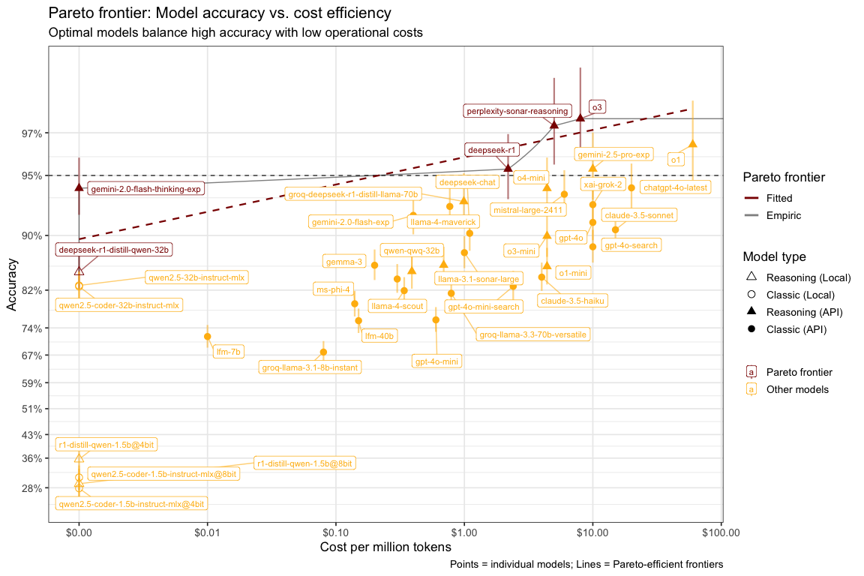
Figure 5: Cost-accuracy trade-off and Pareto frontier. The frontier (red line) highlights models offering the best accuracy for a given cost. The y-axis is on a logit scale and the x-axis on the log10 scale of cost per million tokens.
The cost-accuracy analysis identified 5 Pareto-optimal models (Figure 5) spanning four orders of magnitude in price. Accuracy increased almost monotonically from roughly 85.1% [82.2%-87.9%] for a free local 32-B DeepSeek R1 distillation (at no cost) to 97.5% [95.9%-98.6%] for OpenAI’s o3 (at $8 per million tokens). Crucially, a drastic (~80%) recent price cut for o3 positioned it at the apex of the efficiency frontier.
At the extreme low-cost end, Gemini 2.0 “Flash” achieved 94.2% [92.1%-96.0%]. Its inclusion on the frontier owes mostly to its temporary free access for experimentation during the study period (nominal cost $0); performance, while strong, still trailed the very best models by roughly two percentage points.
In contrast, o1 delivers a similar accuracy of 96.5% but at a far steeper cost of $60 per million tokens, leaving it well below the frontier. Intermediate points such as DeepSeek-R1 (95.4% at $2.19) and Perplexity Sonar Reasoning (97.2% at $5) illustrate that large gains in accuracy can be obtained for modest additional spend, whereas costs beyond ≈$10 per million tokens yield diminishing returns. Overall, Perplexity Sonar Reasoning and o3 currently offer the most favourable balance between accuracy and operational expense, with o3 being more stable and reliable (see Figure 4).

Item-level analysis
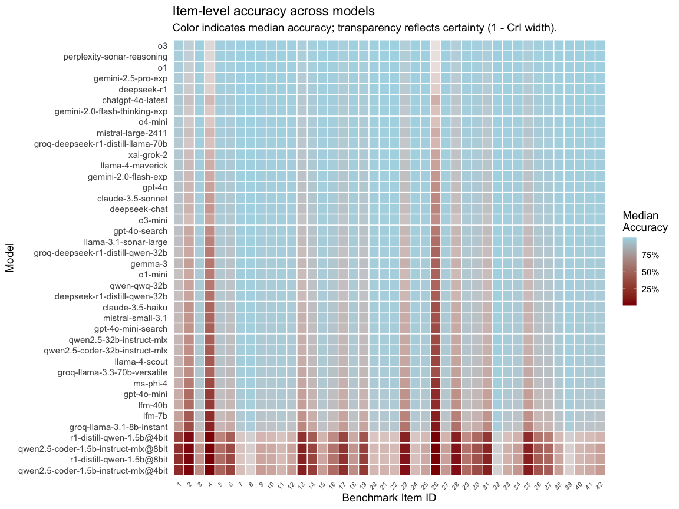
Figure 6: Item-level performance across all models. Each cell shows the median posterior correctness for a given model and question. Color intensity reflects correctness, and transparency indicates certainty (narrower credible intervals are more opaque).
Per-question model performance was highly heterogeneous (Figure 6). Median accuracy spanned from 17.5% for the hardest question (item 26, a neurological-symptoms scenario with a past exposure to center-west Africa rural setting, suggestive of Onchocerciasis) up to virtually perfect performance on the easiest trio (#39 (99.1%), #8 (99.2%), #32 (99.4%)), covering routine travel-medicine advice and basic epidemiology.
Only 12% of models crossed the 50% posterior threshold on item 26. In the raw responses, option A (“Skin snips”) was chosen 40%, D (“Giemsa-stained smears of blood drawn at night”) 32%, and the correct option C (“Antifilarial antibody levels”) only 23%. o3 was internally consistent yet wrong, selecting A in 100% of its replications. The spread across alternatives indicates genuine uncertainty rather than a single systematic misconception. Notably, solution A is the first-line diagnostic approach for suspected Onchocerciasis.
Moreover, for items #2 (diagnosis of suspected malaria with diarrheal symptoms) and #4 (treatment of fever and diarrhea), the second and third most challenging items after #26, the o3 model consistently provided correct responses, yet exhibited posterior medians (approximately 90% and 77%, respectively) far from a 100% success rate and with wider credible intervals. This pattern reflects the regularizing properties of the hierarchical Bayesian model, which exhibits increased uncertainty when a model’s performance substantially deviates from the population average, as each question was modelled with its own intercept and no model/item interaction was included for better generalization.
Conversely, items such as #39 (99.1%), #8 (99.2%), #32 (99.4%) were solved by virtually all systems, indicating that a sizeable fraction of the benchmark targeted plain retrieval rather than complex reasoning. Variation (range of posterior medians) exceeded 90 percentage points for several mid-difficulty questions, underscoring that model architecture and scale interact strongly with item traits. Overall, a small subset of challenging prompts (e.g., items #26 (17.5%), #4 (24.4%), #2 (46.2%)) accounted for the bulk of performance discrimination across models.

Discussion
Large language models (LLMs) released in 2024-2025 demonstrate a decisive leap in domain competence. In our evaluation, the best‐performing families, OpenAI o‑series, Google Gemini 2·5 Pro, and Perplexity Sonar Reasoning, achieved performances around 95 - 98% on the travel‑medicine benchmark. Published evidence reinforces this trend: a recent public‑health assessment found that frontier systems exceeded 90% accuracy on 23 global‑health benchmarks (Asiedu 2025). These scores approach professional‑certification thresholds, confirming the trend already observed for general medical examinations, where GPT‑4 and Med‑PaLM 2 routinely exceed 85% accuracy on the MedQA and USMLE datasets (Kung et al. 2023b; Singhal, Tu, Gottweis, Sayres, Wulczyn, Amin, Hou, Clark, Pfohl, Cole-Lewis, and al. 2025; Liu et al. 2024). Differently from most works in the field, our benchmarking was performed using multilevel Bayesian models, which provide some level of regularisation and generalisation beyond the specific set of questions (Gelman and Hill 2007; Bürkner 2017).
Prompting conditions continued to influence accuracy, yet with diminishing returns at the top end. Chain‑of‑thought (CoT) prompts modestly improved mid‑tier models, echoing earlier demonstrations that explicit reasoning benefits smaller or less specialised LLMs (Tam et al. 2024b). However, model size and characteristics are the main performance drivers. Intrinsically reasoning models such as o3 and Gemini 2·5 Pro which are trained to reason internally before answering, outperform all other models in our benchmark, independent of the prompting conditions. This observation suggests that, for high‑capacity systems, performance may now be limited more by pre‑training coverage and alignment than by surface prompt engineering. Incorporating external knowledge—or grounding answers in real‑time search as Perplexity Sonar does—offers an alternative avenue for gains: the Sonar model equalled OpenAi systems while operating at markedly lower cost,highlighting the value of real time data access for knowledge based tasks (“Introducing the Sonar Pro API” 2024).
Open‑source innovations are closing the gap with proprietary systems. Llama-4, DeepSeek-R1, and MistralAI models reached > 90% accuracy in our benchmark while operating at a fraction of the cost of larger proprietary models. Retrieval‑augmented generation amplifies these gains: coupling DeepSeek-R1 with Perplexity’s live‑search (Perplexity Sonar Reasoning model) pushed accuracy to 97% and delivered source‑linked justifications, features essential for clinical auditing.
While smaller, local models still tend to underperform, the 32-B DeepSeek R1 distillation performance is a promising sign of their growing capabilities. Beyond accuracy, local models are cost-efficient and provide greater security and convenience—an especially important advantage in healthcare, where privacy and ethical considerations often influence model choice.
High benchmark scores translate into clinically meaningful competence. It has been shown that GPT‑4, now considered an “old model”, already answers real‑world patient questions with higher factual accuracy than physicians in controlled settings (Ayers et al. 2023), and achieves decision‑support parity with specialists in emergency ophthalmology (Vrdoljak et al. 2025). Focusing on travel-medicine, early evidence from a Mayo Clinic pilot shows that LLMs produced actionable travel-medicine advice with notable improvements when using enhanced knowledge bases and refined prompting (O’Horo et al. 2025). Furthermore, patient surveys report strong trust and satisfaction and even preference over human physicians, given that chatbots provide more empathic language (Chen et al. 2025).
Travel medicine poses unique demands: geographically variable prophylaxis, dynamic outbreak data and a spectrum of tropical pathogens seldom covered in Western curricula. Prior anecdotal audits found that ChatGPT offered broadly correct but generic advice (Choudhary and Priyanka 2023), prompting calls for structured development standards. Baglivo et alrecently proposed a decalogue for safe travel‑health chatbots, emphasising source transparency and region‑specific updates (Baglivo et al. 2024b). Our rigorous, question‑level evaluation supports their optimism: modern LLMs, especially those augmented with live search, can match specialist knowledge on canonical items while keeping output costs manageable.
Nevertheless, the present study has two main limitations. First, although the benchmark captures diverse scenarios, we cannot exclude that some question‑answer pairs were present in the LLMs’ pre‑training data. Future work should incorporate sequestered, newly written items or adversarially generated cases to probe genuine reasoning and up‑to‑date synthesis. Second, our analysis focused on multiple‑choice accuracy; real consultations require personalised risk stratification and shared‑decision support, tasks that warrant separate evaluation. Third, model fluency in languages other than English remains untested here and is crucial for equitable global deployment.

Conclusion
The sharp rise in medical accuracy—from sub‑60% for early GPT‑3 to near‑98% for 2025‑era models—signals a turning point. Health systems and public‑health agencies should recognise LLMs as emerging allies for patient safety, capable of reinforcing guideline adherence, supporting clinicians in low‑resource settings and expanding access to pre‑travel advice. Realising this potential will require ongoing auditing, transparent reporting of model updates and integration with epidemiological surveillance, yet our findings indicate that the knowledge foundations are already in place.

References
Asiedu, Mercy. 2025. “Benchmarking Large Language Models for Global Health.” Google AI Blog.
Ayers, John W., Adam Poliak, Mark Dredze, Eric C. Leas, Zechariah Zhu, Jessica B. Kelley, Dennis J. Faix, et al. 2023. “Comparing Physician and Artificial Intelligence Chatbot Responses to Patient Questions Posted to a Public Social Media Forum.” JAMA Internal Medicine 183 (6): 589–96. https://doi.org/10.1001/jamainternmed.2023.1838.
Baglivo, Francesco, Luigi De Angelis, Gianluca Cruschelli, and Caterina Rizzo. 2024a. “A Decalogue for Personalized Travel Health Assistance with AI-Driven Chatbots.” Journal of Travel Medicine 31 (4). https://doi.org/10.1093/jtm/taae026.
———. 2024b. “A Decalogue for Personalized Travel Health Assistance with AI-Driven Chatbots.” Journal of Travel Medicine 31 (4): taae026. https://doi.org/10.1093/jtm/taae026.
Bürkner, Paul-Christian. 2017. “Brms: An r Package for Bayesian Multilevel Models Using Stan.” Journal of Statistical Software 80 (1): 1–28. https://doi.org/10.18637/jss.v080.i01.
Chen, David, Kabir Chauhan, Rod Parsa, Zhihui Amy Liu, and et al. 2025. “Patient Perceptions of Empathy in Physician and Artificial Intelligence Chatbot Responses to Patient Questions about Cancer.” Npj Digital Medicine 8: 275. https://doi.org/10.1038/s41746-025-01671-6.
Choudhary, Om Prakash, and Priyanka. 2023. “ChatGPT in Travel Medicine: Friend or Foe?” Travel Medicine and Infectious Disease 53: 102574. https://doi.org/10.1016/j.tmaid.2023.102574.
DeepSeek-AI. 2025. “DeepSeek-R1: Incentivizing Reasoning Capability in LLMs via Reinforcement Learning.” arXiv Preprint arXiv:2501.12948.
El Labban, Mohamad, Stevan Oluic, Hussein Guleid, Mohamed Hassan, Rawan Diab, and Mohamad Ali Rida. 2024. “Polymyalgia Rheumatica Following Respiratory Syncytial Virus (RSV) Vaccination.” European Journal of Case Reports in Internal Medicine. https://doi.org/10.12890/2024_004636.
Flaherty, Gerard Thomas, and Watcharapong Piyaphanee. 2022. “Predicting the Natural History of Artificial Intelligence in Travel Medicine.” Journal of Travel Medicine 30 (1). https://doi.org/10.1093/jtm/taac113.
Fu, Tairan, Javier Conde, Gonzalo Martı́nez, Marı́a Grandury, and Pedro Reviriego. 2025. “Multiple Choice Questions: Reasoning Makes Large Language Models (LLMs) More Self-Confident Even When They Are Wrong.” arXiv preprint arXiv:2501.09775. https://arxiv.org/abs/2501.09775.
Gelman, Andrew. 2006. “Prior Distributions for Variance Parameters in Hierarchical Models.” Bayesian Analysis 1 (3): 515–33. https://doi.org/10.1214/06-BA117.
Gelman, Andrew, and Jennifer Hill. 2007. Data Analysis Using Regression and Multilevel/Hierarchical Models. Cambridge University Press.
Goh, Ethan, Robert Gallo, Jason Hom, Eric Strong, Yingjie Weng, Hannah Kerman, Joséphine A. Cool, et al. 2024. “Large Language Model Influence on Diagnostic Reasoning: A Randomized Clinical Trial.” JAMA Network Open 7 (10): e2440969. https://doi.org/10.1001/jamanetworkopen.2024.40969.
“Introducing the Sonar Pro API.” 2024. Perplexity AI blog.
Kung, Tiffany H., Morgan Cheatham, Arielle Medenilla, Czarina Sillos, Lorie De Leon, Camille Elepaño, Maria Madriaga, et al. 2023a. “Performance of ChatGPT on USMLE: Potential for AI-Assisted Medical Education Using Large Language Models.” PLOS Digital Health 2 (2): e0000198. https://doi.org/10.1371/journal.pdig.0000198.
———, et al. 2023b. “Performance of ChatGPT on USMLE: Potential for AI-Assisted Medical Education Using Large Language Models.” PLOS Digital Health 2 (2): e0000198. https://doi.org/10.1371/journal.pdig.0000198.
Liu, Mingxin, Tsuyoshi Okuhara, XinYi Chang, Ritsuko Shirabe, Yuriko Nishiie, Hiroko Okada, and Takahiro Kiuchi. 2024. “Performance of ChatGPT Across Different Versions in Medical Licensing Examinations Worldwide: Systematic Review and Meta-Analysis.” Journal of Medical Internet Research 26: e60807. https://doi.org/10.2196/60807.
Mbakwe, Amarachi B., Ismini Lourentzou, Leo Anthony Celi, Oren J. Mechanic, and Alon Dagan. 2023. “ChatGPT Passing USMLE Shines a Spotlight on the Flaws of Medical Education.” PLOS Digital Health 2 (2): e0000205. https://doi.org/10.1371/journal.pdig.0000205.
O’Horo, John C., Haris Akhtar, Vish Anantraman, Muhammad Ammar, Juro Gottweis, and Douglas Challener. 2025. “P-1869. Utilizing Large Language Models for Enhanced Decision Support in Travel Medicine Clinic: Our Experience at Mayo Clinic.” Open Forum Infectious Diseases 12 (Suppl 1): ofae631.2030. https://doi.org/10.1093/ofid/ofae631.2030.
PyMC Community. 2023. “LKJ Cholesky Covariance Priors for Multivariate Normal Models.” https://www.pymc.io/projects/examples/en/latest/howto/LKJ.html.
Singhal, Karan, Tao Tu, Juraj Gottweis, Rory Sayres, Ellery Wulczyn, Mohamed Amin, Le Hou, Kevin Clark, Stephen R. Pfohl, Heather Cole-Lewis, Darlene Neal, et al. 2025. “Toward Expert-Level Medical Question Answering with Large Language Models.” Nature Medicine 31 (3): 943–50. https://doi.org/10.1038/s41591-024-03423-7.
Singhal, Karan, Tao Tu, Juraj Gottweis, Rory Sayres, Ellery Wulczyn, Mohamed Amin, Le Hou, Kevin Clark, Stephen R. Pfohl, Heather Cole-Lewis, and et al. 2025. “Toward Expert-Level Medical Question Answering with Large Language Models.” Nature Medicine 31: 943–50. https://doi.org/10.1038/s41591-024-03423-7.
Snell, Charlie, Eric Wallace, Dan Klein, and Sergey Levine. 2024. “Scaling LLM Test-Time Compute Optimally Can Be More Effective Than Scaling Model Parameters.” arXiv Preprint arXiv:2408.03314.
Tam, Zhi Rui, Cheng-Kuang Wu, Yi-Lin Tsai, Chieh-Yen Lin, Hung-yi Lee, and Yun-Nung Chen. 2024a. “Let Me Speak Freely? A Study on the Impact of Format Restrictions on Performance of Large Language Models.” arXiv Preprint arXiv:2408.02442.
———. 2024b. “Let Me Speak Freely? A Study on the Impact of Format Restrictions on Performance of Large Language Models.” arXiv Preprint arXiv:2408.02442.
Vrdoljak, Josip, Zvonimir Boban, Marino Vilović, Marko Kumrić, and Joško Božić. 2025. “A Review of Large Language Models in Medical Education, Clinical Decision Support, and Healthcare Administration.” Healthcare 13: 603. https://doi.org/10.3390/healthcare13060603.
Wei, Jason, Xuezhi Wang, Dale Schuurmans, Maarten Bosma, Brian Ichter, Fei Xia, Ed H. Chi, Quoc Le, and Denny Zhou. 2022. “Chain-of-Thought Prompting Elicits Reasoning in Large Language Models.” arXiv Preprint arXiv:2201.11903. https://doi.org/10.48550/arXiv.2201.11903.

