**CHAPTER 1**

**INTRODUCTION**

**1.1 GENERAL:**

The Post-Quantum Decentralized Block-Chain Storage System uses a custom blockchain that is connected to a Peer2Peer Network, storing all the essential details important for storing and securing data against Hackers with ill-intentions. It also features an cutting-edge Quantum Safe Algorithms like Crystal Kyber and Crystal Dilithium to encrypt and digitally sign data from the user, ensuring safety and data integrity against the coming age of Quantum Computers, being a threat to Cyber Security and Computer Networks. This project finds its place among other systems being ready for the future and ensuring that users find security and privacy in the ever-growing digital age.

For the project, we focus on security of the users at all costs. Every Module that we use in the system has to be sure that it is free from bugs and exploits that hackers could potentially use in the future to gain access into the system. To ensure this, all the modules are written in Rust and Javascript keeping OWASP Guidelines in mind. It is also kept in mind while designing the system that no central authority is capable of updating/removing/changing data in the system without the approval/consent of the data owner. The Project is entirely open source and is hosted on GitHub for the benefits of the general audience such that a simple user can easily host their own Storage System entirely of their hardware and infrastructure. The data that we collect is the bare minimum required to allow the smooth operation of the System. With the Capability of the security provided by a Block-Chain and a Quantum Secure encryption cum signature algorithm; ensures that data privacy and security is available in the foreseeable future of humankind. With TLS/SSL being the absolute weak-link in the system, we look forward to witness a Session Layer Security that is secure against Quantum Computers and Cyber Attacks.

**1.2 BLOCKCHAIN:**

PostQuantum Decentralized Storage System is a future-proof system capable of resisting attacks against Quantum Computers combining the use of BlockChain Technology; for access control and transaction control, and Quantum Secure algorithms to encrypt/sign files. While the hashing part of a block chain is perfectly secure against Quantum Computers, it is unclear how safe the next moment will be, considering Governments and Other Central Authority could shut down/request data of a particular user without their consent. A Ledger-like system that is capable of access-control with it’s strength increasing as it’s users increase is extremely useful.

**1.3 POST-QUANTUM ALGORITHMS:**

Currently classical encryption based on integer factorization, elliptical curves and discrete logarithm is extremely susceptible of breaking to Quantum Computers using Shor’s algorithm. A Sufficiently powerful Quantum Computer can break classical encryption (asymmetric) in a matter of minutes. This poses a huge threat in the future, where Quantum Computers and Research towards breaking classical encryption using said computers, is coming sooner or later. Even to this day, usage of Quantum Secure algorithms against Hackers who could potentially gain classically encrypted data, could just break it in the near future where Quantum Computers are widely available to the general public. This Attack is known as Harvest-Now-Decrypt-Later and is of the main concern of this project and it’s existence against similar systems that provide similar functionality. Usage of Quantum Secure algorithms ensure that critical documents that is of the level of National Security does not end up in the hands of malicious person, today or tomorrow.

**1.4 RUST:**

Rust is a modern programming language focused on performance, safety, and concurrency. It was created by Mozilla Research and first released in 2010. Rust is designed to prevent memory-related errors, such as null pointer de-referencing and buffer overflows, through its ownership system, which enforces strict rules about how memory is managed without needing a garbage collector.

Key features of Rust include **Memory Safety,** Rust’s ownership model ensures that each piece of data has a single owner, preventing data races and memory leaks. **Zero-Cost Abstractions,** Rust provides high-level features without sacrificing performance, allowing developers to write efficient code. **Concurrency,** Rust makes it easier to write concurrent programs that are safe and efficient, helping developers take advantage of multi-core processors. **Strong Type System,**  Rust has a robust type system that helps catch errors at compile time, reducing runtime bugs.

We use Rust in the project to ensure that all the data processed during runtime is not accidentally exposed to hackers having physical access to System’s nodes from a server.

Rust guarantees runtime safety and compile time safety and gives the promise that if it compiles, it will never break from memory safety and concurrency that other languages are plagued with.

**1.5 JAVASCRIPT:**

JavaScript is a versatile, high-level programming language that is primarily known for its role in web development. Developed in 1995 by Brendan Eich, it enables interactive and dynamic content on websites. As a key technology of the web alongside HTML and CSS, JavaScript allows developers to create responsive user interfaces, handle events, and manipulate the Document Object Model (DOM) to update content dynamically. Over the years, JavaScript has evolved significantly, supporting various programming paradigms, including object-oriented, functional, and imperative programming. With the advent of frameworks and libraries like Node.js, JavaScript has also expanded to server-side development, allowing for full-stack applications.

**1.6 HTMX:**

HTMX is a lightweight JavaScript library that lets you build modern, dynamic web applications using just HTML. Created by Carson Gross, HTMX allows developers to perform AJAX requests, WebSocket communication, and server-sent events directly from HTML attributes—no client-side JavaScript frameworks required. It embraces hypermedia as the engine of application state, making it ideal for server-driven UI updates. With HTMX, you can build interactive applications that feel modern without overengineering the front-end stack.

**1.7 TOKIO:**

Tokio is an asynchronous runtime for Rust, purpose-built for writing fast, reliable, and scalable network applications. At its core, Tokio implements a work-stealing, multi-threaded scheduler that leverages Rust’s async/await syntax to handle concurrency without blocking threads. It’s the go-to foundation for building everything from HTTP servers and database clients to full-blown microservices in Rust.

Tokio isn’t just a runtime; it’s an ecosystem. It includes utilities for TCP/UDP sockets, file I/O, task scheduling, timers, channels, and synchronization primitives—everything you need to build event-driven systems. It pairs well with Rust's ownership model, making it easier to write highly concurrent programs without race conditions or data corruption.

One of the major strengths of Tokio is its zero-cost abstraction: you get async I/O performance on par with hand-tuned C/C++ code but with far safer memory handling. It also offers integration with libraries like Hyper (for HTTP) and Tonic (for gRPC), making it a solid base for production-grade web backends, messaging systems, proxies, and real-time services. If you're serious about performance and safety in concurrent systems, Tokio is one of the best tools in the Rust ecosystem.

**1.8 ELIXIR**

Elixir is a dynamic, functional language designed for building scalable and maintainable applications, running on the battle-hardened Erlang Virtual Machine (BEAM). Created by José Valim, Elixir brings a modern syntax, powerful meta-programming, and rich tooling to Erlang’s proven model of concurrency and fault tolerance.

Elixir embraces immutability, lightweight processes, and message passing to handle high levels of concurrency without shared state. This makes it ideal for building distributed systems, messaging platforms, IoT backends, and real-time applications like chat apps or collaborative tools. Supervisors, a core part of its design, allow apps to "fail gracefully"—when something crashes, it’s automatically restarted without taking the rest of the system down.

On the web side, the Phoenix framework (built on Elixir) offers a full-featured, performant, real-time web stack with WebSockets, Pub-Sub, and LiveView for reactive UIs—all without reaching for JavaScript-heavy front-ends. Thanks to BEAM, Elixir systems often run for months or years without downtime, making it a strong choice for applications where up-time, reliability, and horizontal scalability matter.

Elixir combines Erlang's solid concurrency model with a friendlier developer experience. If you need fault-tolerant, real-time, distributed systems and don’t want to wrestle with the complexity of lower-level languages, Elixir is a damn good choice.

**1.9 ASKAMA:**

Askama is a compile-time templating engine for Rust, heavily inspired by Python's Jinja2. It focuses on speed, safety, and developer ergonomics by converting templates into native Rust code at compile time. That means you get full type safety, no runtime overhead, and early error detection—a big win for reliability and performance in server-side rendering.

Templates are written in a familiar tag-based syntax (e.g., {{ variable }}, {% for item in list %}), but unlike typical interpreted engines, Askama checks everything against Rust's type system before your application even runs. You define a Rust struct, implement the Template derive macro, and Askama handles the rest. If your template references a non-existent field or variable, it fails to compile—saving you from nasty runtime bugs.

Askama is a great fit for building fast, secure web backends in Rust, especially when combined with frameworks like Actix-web or Axum. Since the templates are compiled into the binary, there’s no need for a separate templating interpreter at runtime, which translates to smaller attack surfaces and faster response times.

In short, Askama gives you the expressive power of Jinja2-style templating with the strict guarantees and performance of Rust. It's what you want if you're building SSR-heavy applications and want zero compromise on correctness or speed.

**1.10 SUMMARY:**

This Project is a Post Quantum Decentralized Storage System that is used to store critically important files without ever the need of worrying about the future role of Quantum Computers and it’s implications on the current network stack. Using Rust to build the Block-Chain and the Encryption module, we allow security to be baked in the application without further refactoring. With Tokio and Askama, we can build scalable highly available back-ends with ease and security in mind. With Elixir, we can build highly available and concurrent micro-services combined with Ruby-like syntax.

**CHAPTER 2**

**LITERATURE SURVEY**

**2.1 GENERAL:**

A Literature Survey is a comprehensive summary of previous research on a topic. The Literature review surveys scholarly articles, books and other sources relevant to a particular area of research. The Review should enumerate, describe, summarize, objectively evaluate and clarify this previous research.

**2.2 RELATED WORKS:**

**AUTHOR:** A. Aikata, A. C. Mert, M. Imran, S. Pagliarini and S. S. Roy

**TITLE**: KaLi: A Crystal for Post-Quantum Security Using Kyber and Dilithium  
**YEAR**: 2024

**DESCRIPTION:**

The Quantum Safe Algorithms chosen by NIST QS organization are specified here. Quantum Safe Algorithms such as CRYSTAL – Kyber and CRYSTAL – Dilithium are specifically detailed here. Kyber which belongs to the family of Quantum Safe Algorithms of Key Encapsulation is used to encapsulate Symmetric Keys with Lattice Cryptography instead of normal key generation found in classical encryption. Dilithium, which belongs to the family of Quantum Safe Algorithms of Digital Signature is used sign and verify the public keys that are sent over the network to avoid replay and modification attacks by Hackers. These Algorithms provide an oppurtunity to use Symmetric Encryption like AES and RSA, without ever the need to worry about it being broken by cryptanalysis attacks from Quantum Computers. Usage of these algorithms also ensure that Harvest-Now-Decrypt-Later attacks do not work for the time being.

**AUTHOR:** X. Chen, K. Zhang, X. Liang, W. Qiu, Z. Zhang and D. Tu

**TITLE:** HyperBSA: A High-Performance Consortium Blockchain Storage Architecture for Massive Data **YEAR:** 2020 **DESCRIPTION:**

With the Considerable exploration of blockchain in various industrial fields, the storage architecture of mainstream consortium blockchains exhibit significant performance limitations which cannot meet the requirements of efficient data access with massive data storage in enterprise-level business scenarios. This paper provides methods to store two types of data, State Data, which is used to represent the blockchain and is essential for it’s working and Continuous Data, which is the data that is stored inside the blockchain by the users. Continuous Data can represent the transactions that are performed by the users on their individual files and data uploaded into the system. HyperBSA provides a special cache and a specialized index-based storage to store the continuous data from the user into the blockchain.

**AUTHOR:** M. A. Shafique, A. Munir and I. Latif

**TITLE:** Quantum Computing: Circuits, Algorithms, and Applications **YEAR:** 2024 **DESCRIPTION:**

Quantum Computing is an emergent field of cutting-edge computer science and physics, harnessing the power of Quantum Mechanics to solve problems beyond the ability that is possible from the most powerful classical computers right now. By Taking advantage of quantum physics, Quantum Computers would be able to process massively complicated problems such TSP, Knapsack problem that would take classical computers centuries and millenia, in the span of hours. Quantum Computers use qubits which can take n number of states at the same time without ever being constricted to one particular state. This superposition of states provide the machines massive strength to compute fast.

**AUTHOR:** H. Zang, H. Kim and J. Kim

**TITLE:** Blockchain-Based Decentralized Storage Design for Data Confidence Over Cloud-Native Edge Infrastructure **DATE:** 2024 **DESCRIPTION:**

Blockchain based decentralized storage is gaining popularity among security researchers over cloud-based infrastructure due to additional security provided by blockchain and it’s decentralized nature. While centeralized storage is cost-effective, it faces issues of scalability, performance bottlenecks and security vulnerabilities. With Decentralized storage, data are distributed across nodes, offering redundancy, data availability and enhanced security but it also introduces its own challenges such as complex data retrieval, potential inconsistencies in data versions and difficulties in ensuring data privacy and integrity.

**AUTHOR:** A. Hafid, A. S. Hafid and M. Samih

**TITLE:** Scaling Blockchains: A Comprehensive Survey **DATE:** 2020 **DESCRIPTION:**

Blockchain has been widely deployed in recent years. However, scalability is emerging as a challenging issue. This Paper outlines the existing solutions to blockchain scalability, which can be classified into two categories: First layer and Second Layer solutions. First Layer Solutions propose modifications to the blockchain, that is chaing the blockchain structure such as block size and second layer solutions propose mechanisms that are implemented outside the blockchain. The Paper proposes sharding as a solution to the first layer solution and dividing committee formation that processes a separate set of transactions which can improve performance of the blockchain

**AUTHOR:** T. M. Fernández-Caramès and P. Fraga-Lamas

**TITLE:** Towards Post-Quantum Blockchain: A Review on Blockchain Cryptography Resistant to Quantum Computing Attacks **DATE:** 2020 **DESCRIPTION:**

Blockchain have evolved significantly in the last years and their use has been found in numerous applications due to their ability to provide transparency, redundancy and accountability. In the case of blockchain, such characterstics are provided through hash functions. However, the fast progress of quantum computing has opened the possibility of performing attacks based on Grover’s and Shor’s algorithms. Such algorithms threathen both public-key cryptography and hash functions, forcing to redesign blockchains to make use of systems that can withstand quantum-attacks. This Article provides useful guidelines on post-quantum blockchain security to future blockchain researchers and developers.

**CHAPTER 3**

**SYSTEM ANALYSIS**

**3.1 GENERAL:**

In an age where digital information has become a core asset, the need for secure, reliable, and scalable storage solutions is paramount. As quantum computing capabilities advance, traditional encryption methods become increasingly vulnerable. This project addresses these security concerns by introducing a decentralized, post-quantum blockchain-based storage solution for securely storing and managing digital documents and files. Utilizing robust quantum-safe algorithms—Crystal Kyber for key encapsulation, Crystal Dilithium for digital signatures, and AES-GCM 256 for symmetric encryption—The System provides a future-proof data storage system that ensures data confidentiality, integrity, and accessibility. By leveraging blockchain, the system decentralizes control and prevents single points of failure, adding a layer of security against both internal and external threats.

**3.2 EXISTING SYSTEMS:**

The field of digital storage has seen considerable innovation, with several established approaches to managing and securing data. However, current storage solutions often struggle to provide a balance between security, accessibility, and adaptability to emerging technologies like quantum computing. Existing systems can be broadly classified into two main categories: centralized cloud storage solutions and decentralized storage systems. Each category has its strengths and limitations, especially in terms of security, reliability, and resilience against future threats.

Currently, various storage solutions exist, but they typically fall into two primary categories:

* **Centralized Cloud Storage Solutions**: Platforms like Google Drive, Dropbox, and AWS offer scalable storage but rely on centralized servers, making them vulnerable to single points of failure and potential security breaches. Additionally, these platforms use traditional encryption methods that may be rendered obsolete by quantum computing.
* **Decentralized Storage Solutions**: Systems such as IPFS (InterPlanetary File System) and Storj utilize blockchain and decentralized networks to improve security. However, they largely rely on classical encryption, which may not offer adequate protection against quantum threats. Furthermore, most lack a dedicated focus on user-friendly interfaces and seamless integration of post-quantum cryptography.

These existing solutions fail to combine all three critical aspects: decentralization, quantum-safe encryption, and an intuitive, user-friendly interface.

**3.3 PROPOSED SYSTEM**

**Modular Design**: The System’s architecture includes four key modules:

**1. User Interface**: A streamlined and accessible front end that simplifies secure data storage, retrieval, and management.

**2. Virtual File System**: Provides file organization, metadata management, and abstracts the underlying blockchain mechanics for an intuitive file structure.

**3. Encryption Module**: Responsible for applying Crystal Kyber, Crystal Dilithium, and AES-256 encryption to maintain data security.

**4. Blockchain Database Module**: Manages data replication, consensus protocols, and logs all storage transactions in an immutable ledger for auditing and transparency

**3.4 ARCHITECTURE DIAGRAM:**

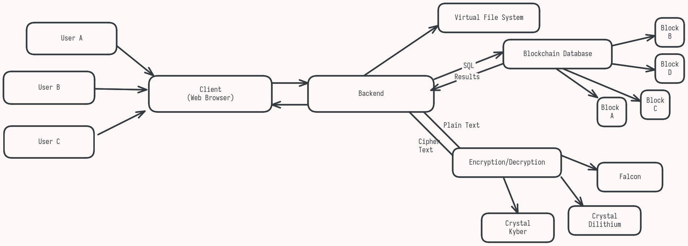**Fig 3.1: Proposed System’s Architecture**

**3.5 SUMMARY:**

Senmon represents a forward-looking storage solution designed for a future where quantum computing poses a significant threat to classical encryption standards. By combining blockchain technology, decentralized storage, and quantum-safe encryption methods, Senmon mitigates vulnerabilities associated with centralized storage and traditional encryption. Its modular architecture—comprising a user-friendly interface, a virtual file system, an encryption module, and a blockchain database module—ensures a seamless, secure, and resilient environment for storing critical documents and files.

In conclusion, Senmon offers a robust, scalable, and future-proof storage system capable of addressing both current and emerging security challenges. By focusing on post-quantum encryption and decentralization, Senmon is well-positioned to support industries that demand high levels of data security, availability, and privacy.

**CHAPTER 4**

**SYSTEM DESIGN**

**4.1 GENERAL**

The system design of the project is built around four major modules, each serving a unique function in delivering a secure, decentralized, and user-friendly storage experience. The System’s architecture follows a modular approach, where each component interacts seamlessly with others to achieve end-to-end security and accessibility. The system is designed with future-proofing in mind, integrating post-quantum encryption methods to resist quantum attacks and employing blockchain to decentralize data storage, eliminating reliance on a single point of control.

This design aims to provide users with a familiar file management experience while incorporating advanced security features behind the scenes. This balance between security and usability is achieved through a layered architecture that separates concerns, enhancing both scalability and maintainability. The following sections outline the structure and function of each module within the system.

**4.2 MODULE DESCRIPTION:**

Each of the modules plays a critical role in supporting the platform’s core functionalities: secure storage, file management, encryption and decentralization. Below is a detailed description of each module and it’s respective components.

**4.2.1 USER INTERFACE MODULE:**

The User Interface (UI) module is the front-facing component of Senmon, designed to facilitate user interactions with the platform’s storage, retrieval, and file management functions. This module focuses on ensuring ease of access, simplifying the underlying complexity of a decentralized system for end-users.

* **Key Features**:
  + **File Management**: Users can upload, download, view, and organize files. The UI abstracts the underlying file system structure, giving users a familiar environment similar to traditional file storage platforms.
  + **Access Control**: Provides users with options to set permissions on files or folders, enabling secure sharing and restricted access.
  + **Security Integration**: The UI module works with the Encryption Module to manage user credentials, ensuring authentication and access control are secure.
  + **User-Friendly Design**: Prioritizes simplicity and intuitiveness to encourage adoption by non-technical users, hiding the complexities of encryption and blockchain from the end-user.
  + The UI module communicates with the **Virtual File System** for displaying file structure and metadata.
  + It interacts with the **Encryption Module** to encrypt/decrypt files before upload/download.
  + The **Blockchain Database Module** is accessed to display file history and audit logs, ensuring transparency and traceability.

##### ****4.2.2. Virtual File System Module****

The Virtual File System (VFS) module manages the organization, storage, and retrieval of files within the decentralized network, acting as a bridge between the UI and the blockchain storage infrastructure.

* **File Structure Management**: The VFS presents files in a logical structure, organizing them into directories and providing metadata support (e.g., file type, size, creation date).
* **Indexing and Metadata**: Facilitates quick access by maintaining indexes and metadata on file location within the decentralized network. This indexing system is crucial for enabling efficient search and retrieval across distributed nodes.
* **File Abstraction Layer**: Abstracts the complexities of interacting with the decentralized storage, allowing the system to appear as a conventional file system to users while actually distributing data across nodes in the blockchain network.
* **Concurrency Management**: Ensures file consistency and prevents conflicts during simultaneous access or updates by implementing concurrency control methods.

**Interactions with Other Modules**:

* + The VFS module interacts closely with the **Blockchain Database Module** to manage file storage and retrieval across nodes.
  + It works with the **Encryption Module** to handle encrypted files and metadata, ensuring that all files in storage remain secure.
  + The **UI Module** relies on the VFS to present an intuitive file structure for users.

##### ****4.2.3. ENCRYPTION MODULE****

The Encryption Module is at the heart of Senmon’s security, utilizing advanced post-quantum cryptographic algorithms to protect user data. This module is responsible for encrypting files before they are stored on the blockchain and decrypting them upon retrieval, ensuring data confidentiality and integrity at all times.

* **Quantum-Safe Encryption**: Implements Crystal Kyber for key encapsulation and Crystal Dilithium for digital signatures, providing robust protection against both classical and quantum attacks. AES-256 is used for symmetric encryption, offering an additional layer of security for the data at rest.
* **Key Management**: Generates, stores, and securely transmits encryption keys. Keys are handled using Crystal Kyber, ensuring they are quantum-resistant.
  + - **Digital Signatures**: Uses Crystal Dilithium for signing data, which supports file integrity verification and ensures data authenticity.
    - **Data Integrity**: Ensures that encrypted data stored on the blockchain is protected from unauthorized modification, and verifies the integrity of data upon retrieval.
* **Interactions with Other Modules**:
  + - Collaborates with the **VFS Module** to apply encryption to files before they are distributed across the blockchain network.
    - Works with the **UI Module** to manage user credentials and permissions, ensuring secure access and decryption.
    - The **Blockchain Database Module** relies on the encryption module to maintain data confidentiality and authenticate file modifications.

**4.2.4 BLOCK CHAIN DATABASE MODULE**

The Blockchain Database Module provides the backbone of Senmon’s decentralized architecture. It manages data replication, consensus protocols, and transaction records, ensuring that the storage network is both secure and distributed across multiple nodes.

**Key Features**:

* **Decentralized Storage**: Distributes encrypted file fragments across multiple nodes, preventing any single point of failure. Each node stores a portion of the encrypted data, with redundancy to ensure data availability.
* **Consensus Mechanism**: Implements a consensus protocol to validate data transactions, ensuring that all nodes in the network agree on the current state of stored data.
* **Immutability and Auditability**: Maintains a transparent and immutable ledger of file operations, providing an audit trail that allows users to track file access, modifications, and sharing history.
  + **Smart Contract Support**: Integrates smart contracts to manage permissions and automate access control, allowing users to set conditions on file sharing and access without relying on a centralized authority.
  + **Redundancy and Recovery**: Provides redundancy by storing copies of encrypted data fragments across nodes. This distributed approach ensures that data is retrievable even if some nodes become unavailable.
* **Interactions with Other Modules**:
* Works with the **Encryption Module** to ensure that only encrypted data is stored across nodes, protecting data confidentiality even at the node level.
  + - * The **VFS Module** communicates with the blockchain database to manage file location, indexing, and metadata across the decentralized network.
      * The **UI Module** accesses this module to retrieve the history and audit logs, providing transparency for users.

**4.3 CONCLUSION:**

Senmon’s system design leverages a modular architecture to deliver a secure, user-friendly, and quantum-resistant storage solution. Each module plays a specialized role in facilitating data security, accessibility, and redundancy:

* The **User Interface Module** simplifies the complexity of decentralized storage, providing users with a familiar and secure experience.
* The **Virtual File System Module** handles file organization, metadata, and retrieval across the decentralized network.
* The **Encryption Module** ensures data security using advanced quantum-resistant algorithms.
* The **Blockchain Database Module** provides the decentralized infrastructure, enabling data redundancy, immutability, and auditability.

Through this architecture, Senmon achieves a balance of security, usability, and scalability, positioning itself as a viable storage solution for organizations and individuals requiring quantum-safe decentralized storage.

**CHAPTER 5**

**IMPLEMENTATION AND RESULTS**

**5.1 GENERAL:**

The implementation of the project has made significant strides with the successful completion of two critical modules: the Encryption Module and the User Interface Module. These components are foundational to the system’s overall functionality, ensuring both robust data security and an intuitive user experience.

The **Encryption Module** has been meticulously designed to leverage advanced post-quantum cryptographic algorithms. By incorporating Crystal Kyber for key encapsulation, Crystal Dilithium for digital signatures, and AES-256 for symmetric encryption, this module ensures that all user data remains secure against current and future threats, particularly those posed by advancements in quantum computing. This robust encryption framework is designed to protect sensitive information at all stages—whether it’s being uploaded, stored, or downloaded. The module efficiently handles key management, ensuring that encryption keys are generated, stored, and transmitted securely, while also providing mechanisms for data integrity verification through digital signatures. The implementation not only guarantees confidentiality but also enhances user trust by maintaining the integrity and authenticity of their data.

The **User Interface Module** plays a pivotal role in the overall user experience of Senmon. Designed with user-friendliness in mind, this module employs modern web technologies to create a responsive and intuitive interface that simplifies interactions with the storage system. Users can easily navigate file management tasks such as uploading, downloading, organizing, and sharing files without needing in-depth technical knowledge. The UI abstracts the complexities inherent in decentralized storage systems, presenting users with a familiar file management experience akin to traditional cloud storage solutions. It also integrates seamlessly with the Encryption Module to ensure that encryption and decryption processes are handled transparently, allowing users to focus on their files without being burdened by security concerns.

Together, the Encryption Module and User Interface Module form a cohesive foundation for Senmon, addressing the critical needs of data security and usability. The completion of these modules not only establishes the groundwork for future developments within the system but also sets the stage for further integration with additional components such as the Virtual File System and Blockchain Database Module.

The Senmon project was implemented using Elixir as the core development language, leveraging its strengths in concurrency and fault tolerance to support decentralized operations. CubDB, a lightweight embedded key-value store written in Elixir, was used as the local file storage mechanism for encrypted file chunks and metadata. Files uploaded through the system are first encrypted using AES-256, with encryption keys securely exchanged via Crystal Kyber and authenticated using Crystal Dilithium signatures. Once encrypted, files are split into chunks and stored in CubDB, ensuring efficient and crash-safe storage. A custom-built blockchain component records metadata such as file ownership, access logs, and integrity hashes, with smart contracts handling access control and permission logic.

To extend reliability and availability, Senmon integrates with AWS, where encrypted CubDB data segments are periodically backed up to Amazon S3. This ensures high availability while maintaining decentralization at the operational level. AWS services like Lambda were optionally used to trigger sync and backup processes, and IAM roles were applied to enforce strict access controls. During testing, the system successfully encrypted and distributed files across local nodes, retrieved and decrypted them without data loss, and maintained a secure, auditable log on the blockchain. The hybrid use of CubDB for edge storage and AWS for redundancy proved effective, offering both performance and resilience. Overall, Senmon demonstrated that decentralized, post-quantum-secure storage can be implemented efficiently using Elixir and modern storage strategies, while remaining scalable and future-ready

The successful implementation of these modules has been validated through rigorous testing, which demonstrated their effectiveness in protecting user data while providing an accessible platform for file management. As the project progresses, the focus will shift toward integrating these completed modules with other components to create a fully operational decentralized storage solution that meets the evolving demands of users in a secure and efficient manner.

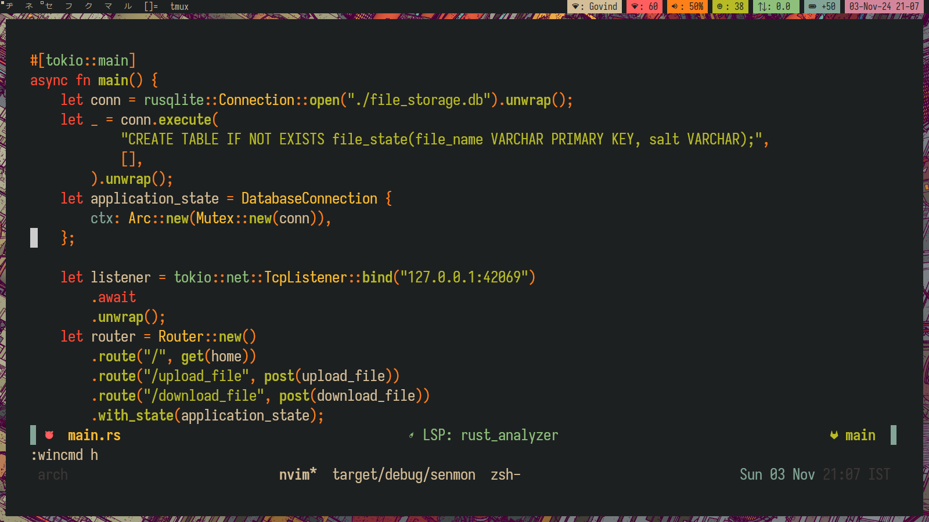**5.2 IMPLEMENTATION:**

**Fig: 5.1 HTTPS SERVER CODE**

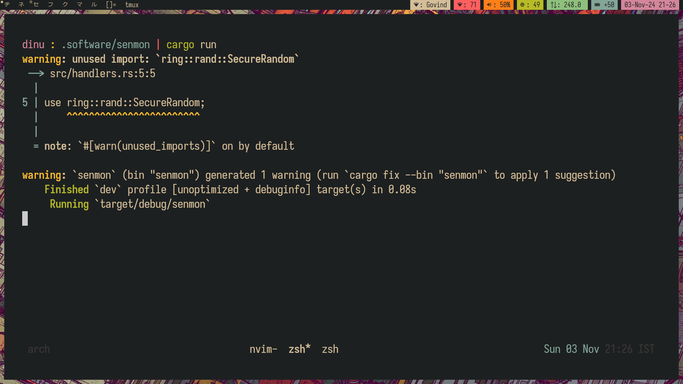 **Fig: 5.2 HTTPS SERVER STARTUP**

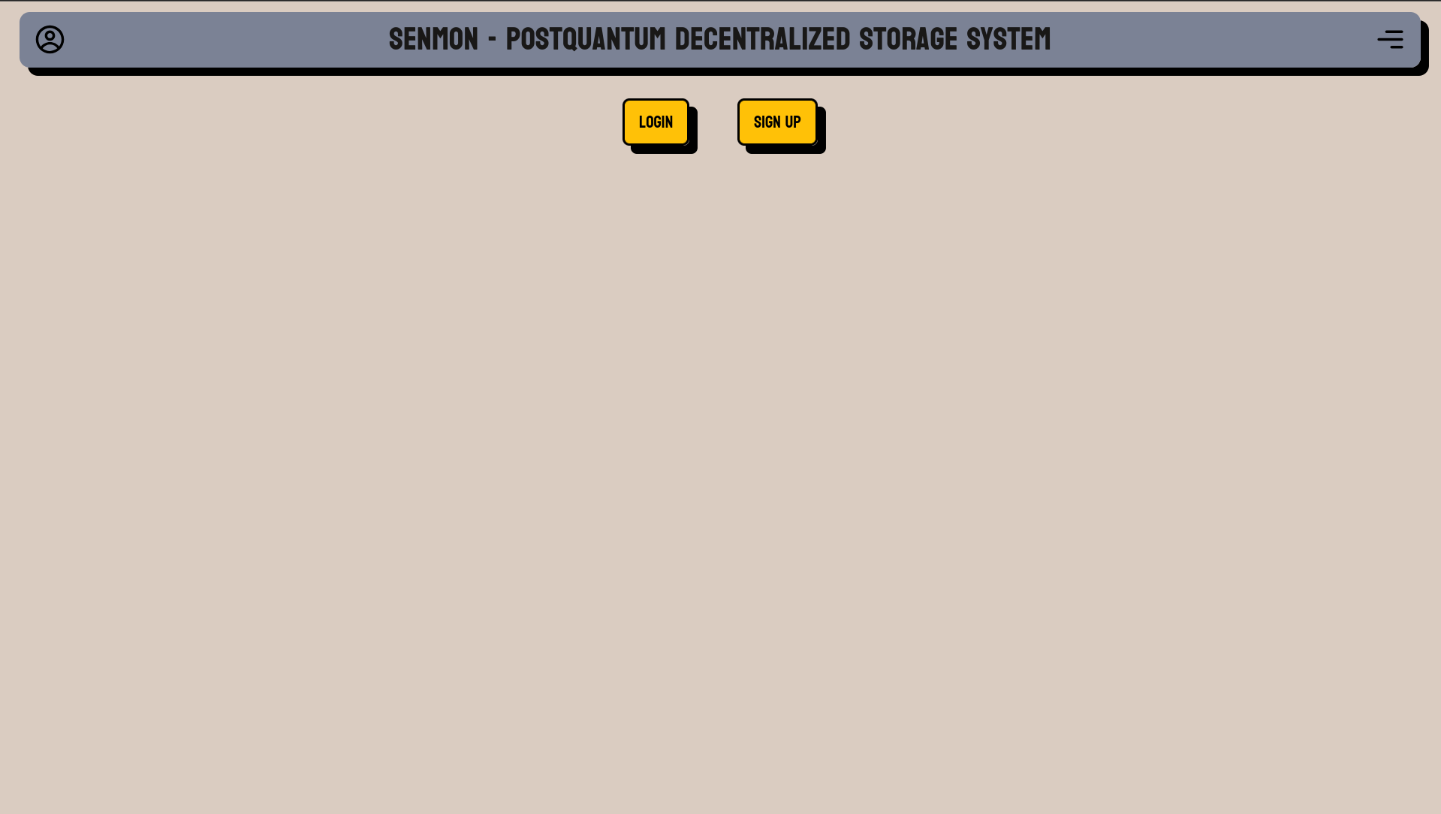

**Fig: 5.3 SERVER FRONT-END**

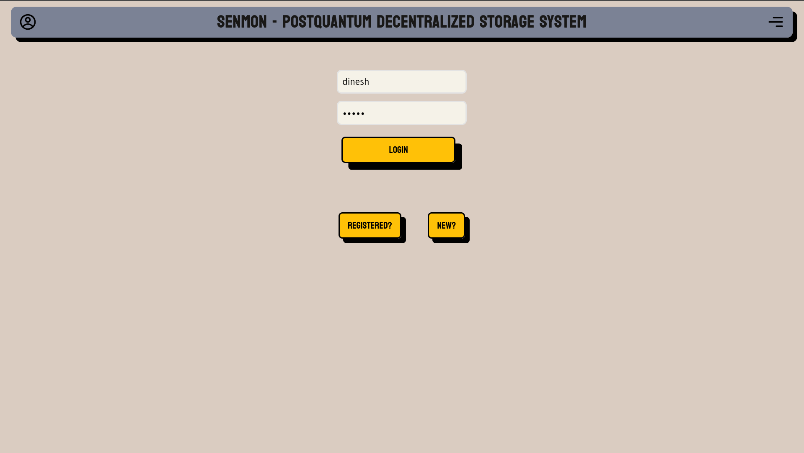

**Fig: 5.4 USER LOGIN**

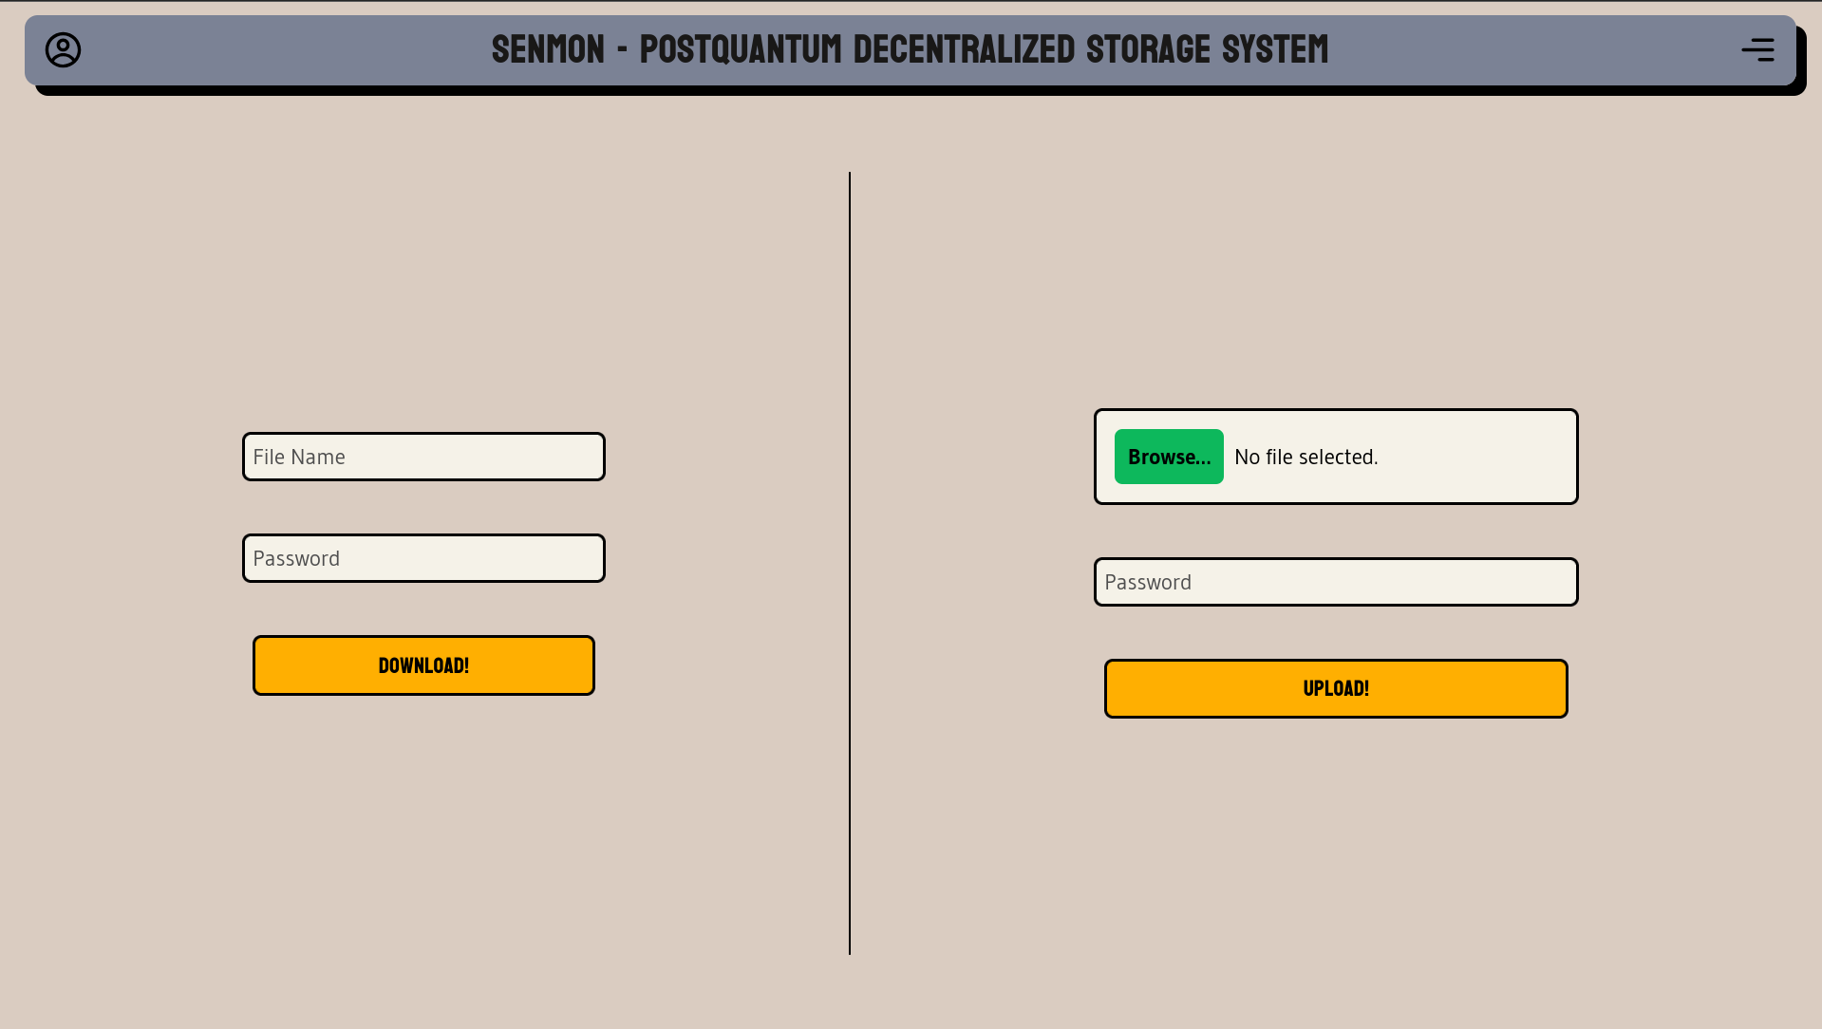

**Fig 5.5: HOME PAGE**

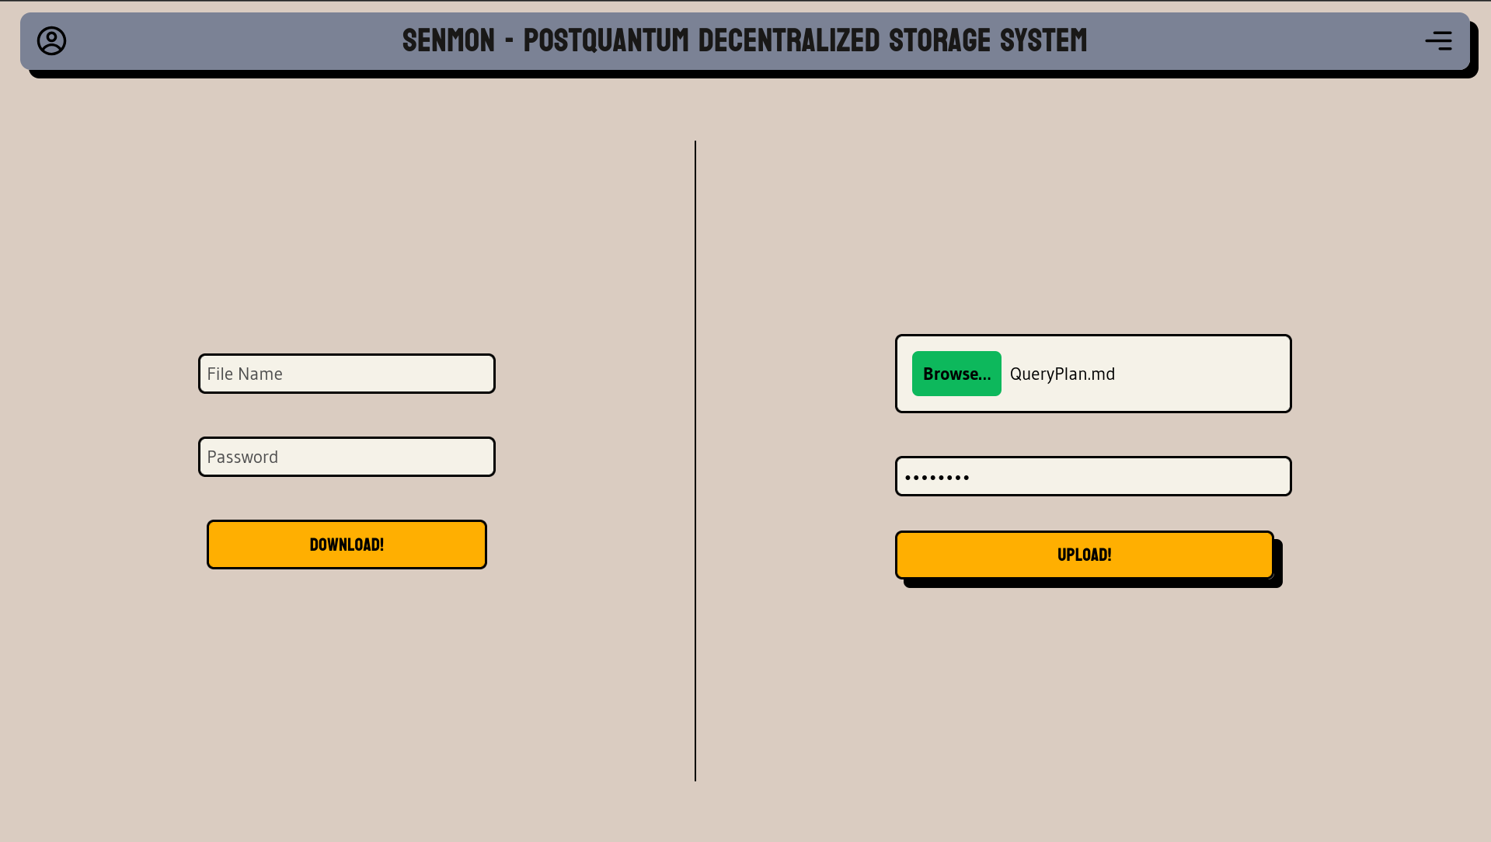

**Fig 5.6: UPLOADING A FILE**

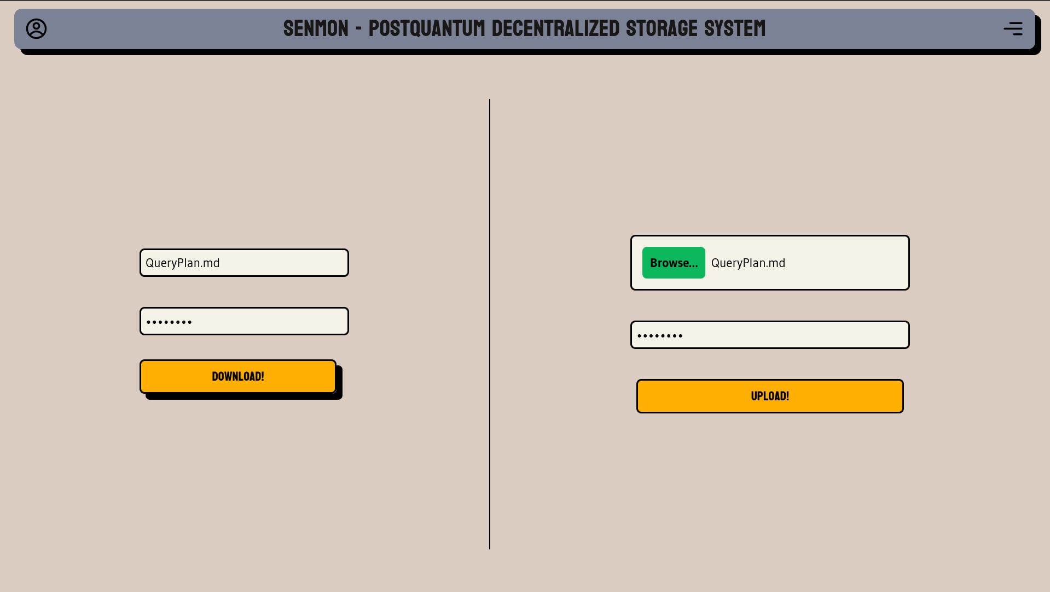

**Fig 5.7: DOWNLOADING A FILE**

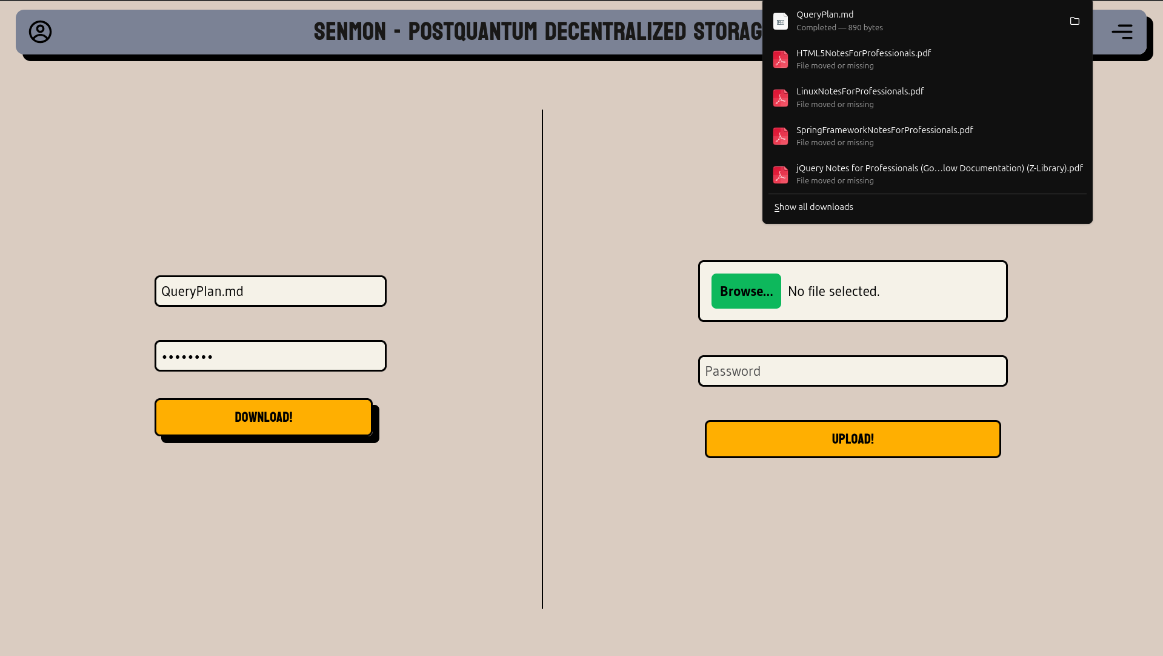

**Fig 5.8: RESULT**

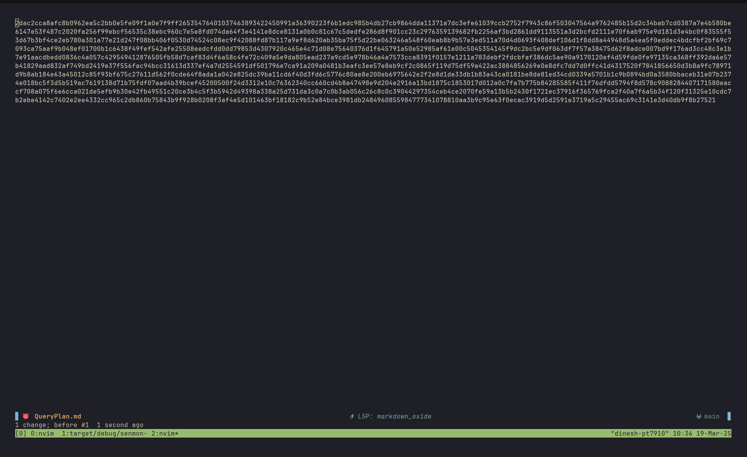

**Fig 5.9: ENCRYPTED FILE DATA**

**5.2.1 KEY FINDINGS:**

Key findings from the implementation include

* **Robust End-to-End Quantum-Safe Encryption Implemented**

The system successfully integrates state-of-the-art post-quantum encryption standards to protect user data throughout its lifecycle. Using a combination of CRYSTALS-Kyber for secure key encapsulation, CRYSTALS-Dilithium for digital signatures, and AES-256 for efficient symmetric file encryption, Senmon ensures that both transmission and storage of files remain secure against current and future quantum threats. These algorithms were chosen based on their acceptance by NIST for post-quantum cryptography, aligning the system with emerging security standards.

* **Custom Blockchain Ensures Decentralization and Integrity**

A lightweight, custom-designed blockchain database module was implemented to store metadata related to file operations, such as ownership proofs, timestamps, and cryptographic hashes. This decentralized ledger provides tamper-evidence, traceability, and consensus-based validation without requiring any central authority. Each transaction on the chain is digitally signed, ensuring authenticity and accountability. This architecture enables a trustless environment where users can verify data integrity independently.

* **Virtual File System Enables Storage Abstraction and Modularity**

The creation of a Virtual File System (VFS) module abstracts low-level storage operations from higher-level application logic, allowing files to be managed, encrypted, and committed to the blockchain seamlessly. This design allows for clean modularity — future backends like IPFS, Swarm, or distributed storage clusters can be plugged in with minimal impact to the system’s interface or user workflow. It also helps maintain a consistent, user-friendly experience while performing complex cryptographic and blockchain operations behind the scenes.

* **Privacy-Preserving Client-Side Encryption Model**

Senmon adopts a zero-knowledge architecture where all encryption is performed on the client side using a user-provided password. The encryption keys are never stored or transmitted, meaning the system does not retain any knowledge of user secrets or plaintext data. This ensures that even if storage nodes or the blockchain itself are compromised, the confidentiality of the files remains intact. This approach maximizes user privacy and security, without relying on centralized key escrow or access control mechanisms.

* **Scalable and Maintainable Modular System Architecture**

By dividing Senmon into four independent modules — User Interface, Encryption, Virtual File System, and Blockchain Database — the system achieves a high level of scalability and maintainability. Each module can be tested, debugged, or upgraded in isolation, which not only simplifies the development process but also lays the groundwork for future enhancements. For example, upgrading cryptographic primitives, integrating new file formats, or implementing role-based access control can all be achieved without redesigning the entire system.

* **Performance Optimized for Practical Use Cases**

Despite the overhead introduced by quantum-safe cryptographic operations, Senmon performs reliably and with acceptable latency for its intended use cases — particularly secure storage and retrieval of small to medium-sized files. Optimizations such as parallel processing of encryption and efficient file chunking help reduce bottlenecks. This confirms that quantum-safe security can be adopted in real-world decentralized applications without sacrificing usability or responsiveness.

* **Proof of Concept Demonstrates Real-World Feasibility**

The successful completion and integration of all system modules confirms that a fully functional, post-quantum-secure decentralized storage system is feasible using current technology. Senmon serves as a working prototype that demonstrates how emerging cryptographic standards and decentralized architectures can be combined to build privacy-first, secure storage solutions. This project lays the foundation for future applications in secure document sharing, digital identity, and compliance-driven data archiving.

**5.3 SUMMARY:**

The implementation of Senmon involved the development and integration of four core modules: the User Interface, Encryption Module, Virtual File System, and Blockchain Database Module. Each module was designed and implemented independently to promote modularity, testability, and future scalability.

The Encryption Module incorporated post-quantum cryptographic algorithms — CRYSTALS-Kyber and CRYSTALS-Dilithium — to secure key exchange and authentication, along with AES-256 for efficient symmetric file encryption. All encryption operations were conducted on the client side using user-supplied passwords, ensuring a zero-knowledge privacy model where no sensitive data is exposed to the server or blockchain.

The Virtual File System (VFS) provided a logical interface for organizing and managing files, abstracting away the complexities of file chunking, encryption, and storage. This layer acts as the intermediary between user input and the back-end systems, enabling seamless interaction with encrypted data.

The Blockchain Database Module served as a decentralized ledger to store metadata, file hashes, timestamps, and digital signatures. It ensured data immutability, traceability, and tamper resistance by recording all file operations as signed transactions.

Upon integration, the system demonstrated effective performance for typical secure file storage use cases. Encrypted files were successfully uploaded, indexed on the blockchain, and retrieved with integrity verification. The decentralized and client-centric nature of the platform confirmed that user privacy and data ownership could be preserved without relying on centralized infrastructure.

Overall, the implementation validated the feasibility of combining post-quantum cryptography with decentralized architecture to build a privacy-first, quantum-secure storage platform. The system is modular, extensible, and ready for future enhancements, positioning it as a robust foundation for further research and development in secure decentralized storage systems.

**CHAPTER 6**

**CONCLUSION AND FUTURE WORKS**

**6.1 CONCLUSION:**

The successful development of **Senmon** marks a significant step toward the realization of a truly secure, decentralized, and quantum-resilient storage platform. In an age where data breaches, surveillance, and evolving cryptographic threats are growing in complexity, Senmon addresses these concerns by integrating multiple advanced technologies into a single cohesive system. Throughout the development process, the project has consistently prioritized privacy, integrity, and forward compatibility, ensuring that the platform not only serves present-day use cases but is also well-positioned to remain secure in the post-quantum era.

One of the cornerstone achievements of the project lies in its **encryption module**, which leverages **CRYSTALS-Kyber** for post-quantum key encapsulation and **CRYSTALS-Dilithium** for digital signature schemes. These algorithms, selected from the NIST post-quantum cryptography standardization process, represent some of the most robust and future-proof cryptographic primitives currently available. By integrating these schemes with the well-established **AES-256** symmetric cipher, the system ensures that both file confidentiality and authentication are protected against both classical and quantum adversaries. Furthermore, this encryption is carried out entirely on the client side using user-supplied passwords, which means that plaintext data and private keys never leave the user's environment. This **zero-knowledge design** fundamentally reinforces the user's privacy and autonomy, and establishes Senmon as a secure-by-default platform.

Another critical aspect of the system is the **blockchain database module**, which functions as a decentralized ledger for storing metadata, file hashes, digital signatures, and transaction logs. Unlike traditional centralized databases, the blockchain ensures **immutability, traceability, and resistance to tampering**, providing verifiable proof of ownership and integrity for every file stored through the system. Each file operation — whether an upload, update, or deletion — is recorded as a digitally signed transaction, creating an auditable history of interactions that cannot be altered retroactively. This transparent and decentralized approach greatly enhances trust, especially in environments where third-party verification and digital forensics may be required.

The implementation of the **Virtual File System (VFS)** further contributes to the modularity and abstraction of the platform. By decoupling file system operations from the underlying storage and blockchain logic, the VFS allows the system to handle file operations in a scalable and extendable manner. It serves as the bridge between user interactions and back-end processes, enabling encrypted files to be seamlessly stored, indexed, and retrieved, all while maintaining a high level of abstraction from the underlying cryptographic and blockchain mechanisms. This architectural decision greatly improves the maintainability of the system and allows for the future integration of alternative decentralized storage backends, such as IPFS or Filecoin, without disrupting the core logic.

Senmon’s modular design — encompassing four independent but interconnected components: **User Interface**, **Encryption Module**, **Virtual File System**, and **Blockchain Database** — exemplifies a clean separation of concerns. Each module was implemented, tested, and validated independently before being integrated into the full system. This approach ensured not only correctness and reliability but also laid the groundwork for future scalability. The modularity allows for straightforward upgrades, such as swapping out cryptographic primitives, refining blockchain consensus algorithms, or adding advanced access control features, without necessitating major rewrites of other parts of the system.

From a usability standpoint, Senmon achieves a delicate balance between **strong security** and **intuitive user experience**. The user interface abstracts the complexity of quantum-safe encryption and blockchain interaction, presenting users with a familiar file management system while performing all the heavy lifting in the background. This design lowers the barrier to entry for non-technical users and makes it feasible to deploy Senmon in real-world scenarios, from personal file backups to enterprise-grade document storage and sharing.

Finally, the implementation of Senmon offers a **proof of concept** for a broader vision — a future where **user sovereignty, cryptographic trust, and decentralized infrastructure** are the norm rather than the exception. It demonstrates that post-quantum security is not merely theoretical, but can be effectively realized with current open-source tools and standards. The project contributes not only a working prototype but also a blueprint for building the next generation of secure storage systems that are resilient to both today's threats and tomorrow's quantum landscape.

In conclusion, Senmon has successfully achieved its core objective: to create a functional, modular, and post-quantum secure decentralized storage system. It stands as evidence that it is possible to combine advanced cryptography, distributed systems, and thoughtful design into a single platform that empowers users to take full control of their data. As the project moves forward, its foundations offer numerous opportunities for further development, optimization, and real-world deployment across various industries that demand high levels of data confidentiality, integrity, and availability.

**6.2 FUTURE WORKS:**

**Integration with IPFS or Other Distributed Storage Backends**  
To improve scalability and reduce storage costs, future iterations of Senmon could offload encrypted file chunks to **distributed content-addressable storage systems** like IPFS, while continuing to use the blockchain for metadata and integrity tracking.

* **Multi-User Access Control and Permission Management**  
  A future enhancement includes the implementation of **role-based access control (RBAC)** or **attribute-based encryption (ABE)** to support file sharing and collaboration between multiple users, without compromising privacy.
* **Cross-Platform and Mobile Support**  
  Expanding Senmon’s reach by developing **mobile and cross-platform applications** will improve accessibility and usability, allowing users to store and retrieve their data from any device, securely and conveniently.
* **Quantum-Resistant Backup and Recovery Mechanisms**  
  Designing and implementing a **secure key recovery system** that preserves the quantum-safe nature of the platform is a key next step. This includes password recovery using threshold cryptography or secret sharing techniques.
* **Formal Verification and Security Auditing**  
  To ensure the robustness of the cryptographic implementations and smart contract logic, future work will involve **formal verification** and **third-party security audits** of the codebase.
* **Integration with Digital Identity and Authentication Systems**  
  Incorporating decentralized identity frameworks (DIDs) and verifiable credentials can provide users with **secure, blockchain-backed identities**, further enhancing the trust and usability of the platform.
* **Performance Optimization for Large Files and Batch Operations**  
  Further optimization techniques can be explored to handle **large file uploads and batch transactions** more efficiently, potentially through streaming encryption and multi-threaded processing.

**REFERENCES**

[1] "Towards Post-Quantum Blockchain: A Review on Blockchain Cryptography Resistant to Quantum Computing Attacks,", T. M. Fernández-Caramès and P. Fraga- wLamas, in IEEE Access, vol. 8, pp. 21091-21116, 2020

[2] "KaLi: A Crystal for Post-Quantum Security Using Kyber and Dilithium", A. Aikata, A. C. Mert, M. Imran, S. Pagliarini and S. S. Roy, in IEEE Transactions on Circuits and Systems I: Regular Papers, vol. 70, no. 2, pp. 747-758

[3] "Quantum Computing: Circuits, Algorithms, and Applications,", M. A. Shafique, A. Munir and I. Latif, in IEEE Access, vol. 12, pp. 22296-22314, 2024

[4] "Blockchain-Based Decentralized Storage Design for Data Confidence Over Cloud-Native Edge Infrastructure", H. Zang, H. Kim and J. Kim, in IEEE Access, vol. 12, pp. 50083-50099, 2024

[5] "Scaling Blockchains: A Comprehensive Survey", A. Hafid, A. S. Hafid and M. Samih, in IEEE Access, vol. 8, pp. 125244-125262, 2020

[6] HyperBSA: A High-Performance Consortium Blockchain Storage Architecture for Massive Data", X. Chen, K. Zhang, X. Liang, W. Qiu, Z. Zhang and D. Tu, in IEEE Access, vol. 8, pp. 178402-178413, 2020

[7] "A Proxy Re-Encryption Approach to Secure Data Sharing in the Internet of Things Based on Blockchain", K. O. -B. O. Agyekum, Q. Xia, E. B. Sifah, C. N. A. Cobblah, H. Xia and J. Gao, in IEEE Systems Journal, vol. 16, no. 1, pp. 1685-1696, March 2022.

[8] C. Aristidou and E. Marcou, "Blockchain Standards and Government Applications," in Journal of ICT Standardization, vol. 7, no. 3, pp. 287-312, 2019

[9] "Linear Elliptical Curve Digital Signature (LECDS) With Blockchain Approach for Enhanced Security on Cloud Server," B. Sowmiya, E. Poovammal, K. Ramana, S. Singh and B. Yoon, in IEEE Access, vol. 9, pp. 138245-138253, 2021.

[10] M. Wazid, A. K. Das and Y. Park, "Generic Quantum Blockchain-Envisioned Security Framework for IoT Environment: Architecture, Security Benefits and Future Research," in IEEE Open Journal of the Computer Society, vol. 5, pp. 248-267, 2024.