

Oblique Projection

3D Computer Graphics and Animation Programming Assignment 2



Ida Bagus Bhaskara (001201500076)

Vera Debora Vitamas (001201500076)

Jonathan Surya Sandjaya (001201500055)

CIT 2 2015

**Table of Contents**

Cover Page 1

**Table of Contents 2**

Chapter 1 Introduction 1

Chapter 2 Basic Theory 1

2.1 Animation 1

Chapter 3 Implementation 1

3.1 Main Interface of the Application 1

3.2 Features of the Applicaton 2

Chapter 4 Design 2

4.1 Variables used in the Program 2

Chapter 5 Evaluation 2

5.1 Test 2

Chapter 6 Work Log 2

Chapter 7 Conclusion and Remarks 2

# Introduction

# Basic Theory

## Animation

# Implementation

## Main Interface of the Application

This application has one interface, which it uses as its main interface. The interface is pictured below:

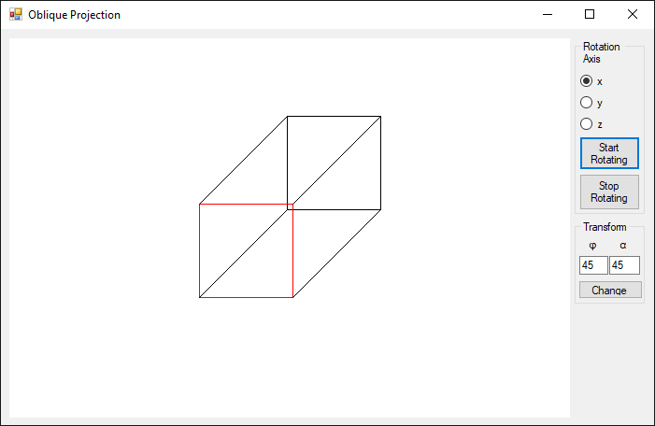

7

6

5

4

3

2

1

The interface consists of the following components:

1. Canvas Picture Box

The canvas is used to display the cube using the application.

1. Rotation Axis Radio Buttons

The r

## Features of the Applicaton

The application has several features, namely:

# Design

## Variables used in the Program

The following variables are used in this program:

# Evaluation

To ensure that the application works as it is designed, test cases are conducted. These test cases are as follows:

## Test

# Work Log

The work log is extracted directly from Visual Studio’s Git Log History, which is also available publicly at <https://github.com/bakanui/ObliqueProjection/commits/master>.

|  |  |  |  |  |
| --- | --- | --- | --- | --- |
| No | Author | Date | Time | Commit Message |
| 1 | Bhaskara Ida Bagus | 1/26/2018 | 5:39:49 PM | Initialized project |
| 2 | Vera Debora Vitamas | 1/29/2018 | 1:57:02 PM | Trying to create matrix structure |
| 3 | Vera Debora Vitamas | 1/29/2018 | 3:30:21 PM | Trying Matrix Multiplication |
| 4 | Vera Debora Vitamas | 1/29/2018 | 7:05:34 PM | Trying to initialize cube |
| 5 | Bhaskara Ida Bagus | 2/2/2018 | 11:05:35 PM | Add report template |
| 6 | Bhaskara Ida Bagus | 2/3/2018 | 3:24:05 PM | Buggy cube; shows a square instead of a cube |
| 7 | Bhaskara Ida Bagus | 2/3/2018 | 3:50:18 PM | Square is now a Cube, but not Oblique |
| 8 | Jonathan Surya Sandjaya | 2/4/2018 | 8:12:53 PM | Cube is now oblique |
| 9 | Bhaskara Ida Bagus | 2/4/2018 | 9:14:46 PM | Phi and Theta can now be set by user, buggy rotation |
| 10 | Bhaskara Ida Bagus | 2/4/2018 | 10:19:30 PM | Declaring DegToRad as a function |
| 11 | Bhaskara Ida Bagus | 2/5/2018 | 11:26:05 PM | Rotation in the x axis works |
| 12 | Bhaskara Ida Bagus | 2/6/2018 | 6:30:29 PM | Beautifying UI, Rotation on x, y, and z axis can now be done |
| 13 | Bhaskara Ida Bagus | 2/6/2018 | 6:45:40 PM | Fix Rot Matrix, Renaming theta to alpha |
| 14 | Bhaskara Ida Bagus | 2/6/2018 |  | Update work log in report |

# Conclusion and Remarks