**PRO192- Practice Exam SE17A02 19/07/2022**

Duration : 85 minutes

Develop Student management OOP application with following components and requirements

1. **Create MVC console application in NetBean:**
   1. Define class Student with following attributes and methods: **(2 marks)**  
      + StudentID, First name, Last Name Date of birth, Gender   
      + Constructors, get/set(), toString()   
      + implement method for Comparable base on Last name   
      **Hint**: Using LocalDate for Date of Birth, with sample code below:   
      *DateTimeFormatter formatter = DateTimeFormatter.ofPattern("dd/MM/yyyy");   
      LocalDate localDate = LocalDate.parse("16/08/2016", formatter);*
   2. Define class StudentList with following attributes and methods: **(4 marks)**  
      + List of Student  
      + Read text file to load data for StudentList – student.txt is provided (1 mark)   
      + Search student by different criteria (1 mark)  
      + Print any List of Student (1 mark)  
      + Add new Student from console (1 mark)
   3. Develop Student Management class for application **(4 marks)**  
      + Main menu for application include: Display all students, Search student, Add new student (2 mark)   
      Hint: An abstract Menu class is provided for use in the application. Override method excecute()  
      + Method for seaching student with searching menu , [print out list of student sorted by searching criteria] (2 marks)
2. **Technical requirements**:  
   + Create package **model** for Student and StudentList class.  
   + Create package **view** for Menu and StudentManagement class.  
   + Checking error for input data.  
   + User interface as sample images below

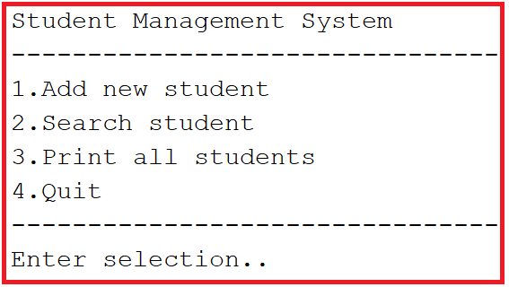

When choose search book:  
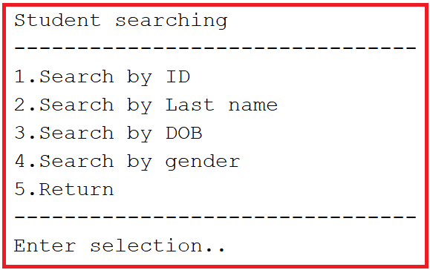

**Notice: Student must strictly follow all requirements as describe above for marking,   
Any modification the requirement detail is not allowed and will get no mark!**