
LIMKOKWING UNIVERSITY OF CREATIVE TECHNOLOGY
SIERRA LEONE
Department of Information & Communications Technology
PROG209 – EVENT DRIVEN PROGRAMMING
Individual Assignment (10%)
Basic Interactive GUI using Java Swing
Student Name | Sahr [add your full name]
Student ID | [add your student ID]
Programme | [add your programme, e.g. BSc Software Engineering]
Module | PROG209 Event Driven Programming
Examiner | Amandus Benjamin Coker
Semester | September 2026 to February 2027
Submission | Week 4
GitHub Repository | [paste your GitHub repository link]

TABLE OF CONTENTS
1. Introduction 1
2. Objectives 1
3. Wireframe Design 2
4. Source Code 3
4.1 BaseWindow.java 3
4.2 SwingAssignment.java 4
5. Output Screenshots 6
6. Conclusion 7
7. References 8

1. Introduction
Event-driven programming is a style of programming in which the flow of a program is controlled by events, such as a mouse click, a key press or a window being closed. Instead of running from top to bottom and stopping, an event-driven program waits for the user to act and then responds. Graphical User Interface (GUI) applications are the most common example of this style.
Java Swing is the GUI toolkit included in the Java Standard Edition. It provides ready-made components such as windows, panels, labels, text fields and buttons. In Swing, a JFrame is the main window of the application, a JPanel is a container used to group and arrange components, and a JLabel displays a short piece of text and/or an image. An ImageIcon loads an image file so it can be displayed on a component or used as the application icon.
This document presents a basic interactive GUI application developed for the PROG209 Event Driven Programming individual assignment. The application opens an 800 x 800 window titled "Java Swing Assignment" with a custom application icon and displays the message "Welcome to Java Swing First Individual Assignment by Sahr". The program applies the object-oriented concepts of inheritance and constructors. As an addition, the user can change the text of the JLabel and the background colour of the JPanel at run time.

2. Objectives
The objectives of this assignment, taken from the assignment brief, are to:
- Design a wireframe of the user interface using Figma.
- Create a class called SwingAssignment containing a JFrame named frame, a JPanel named panel and a JLabel named label.
- Display the text "Welcome to Java Swing First Individual Assignment by Sahr" on the label, add the label to the panel and add the panel to the frame.
- Give the frame the title "Java Swing Assignment" and a size of 800 x 800 pixels, and close the application when the close button is clicked.
- Use a custom application icon and implement ImageIcon.
- Implement inheritance and constructors.
- Add functionality to change the text of the JLabel and the background of the JPanel.
- Push all project files to GitHub and add the lecturer as a collaborator.

3. Wireframe Design
Before writing any code, a wireframe was designed in Figma to plan the layout of the window. A wireframe is a simple, low-fidelity sketch that shows where each element will be placed without focusing on colours or final styling. The Figma frame was set to 800 x 800 pixels to match the size of the JFrame.
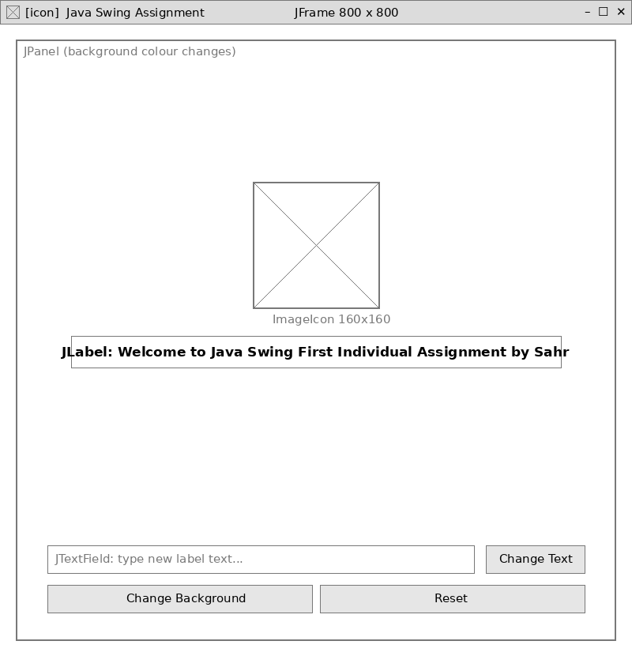
Figure 1: Wireframe of the application layout

4. Source Code
The complete source code is shown below and is also available in the GitHub repository. The project is organised with both Java files and the icon inside the src folder.

4.1 BaseWindow.java
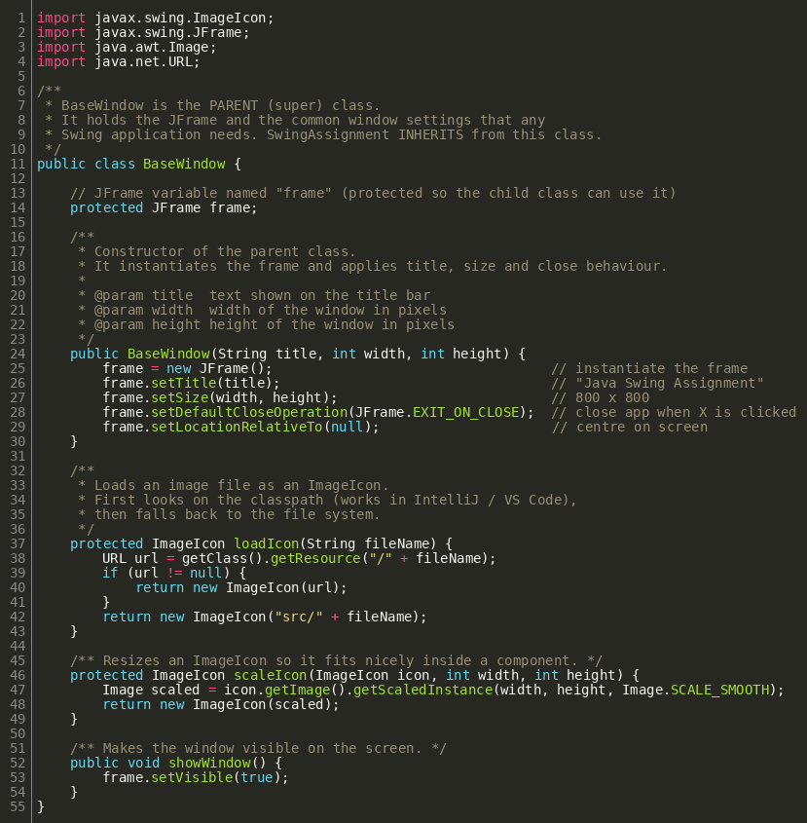
Figure 2: Source code of BaseWindow.java

4.2 SwingAssignment.java
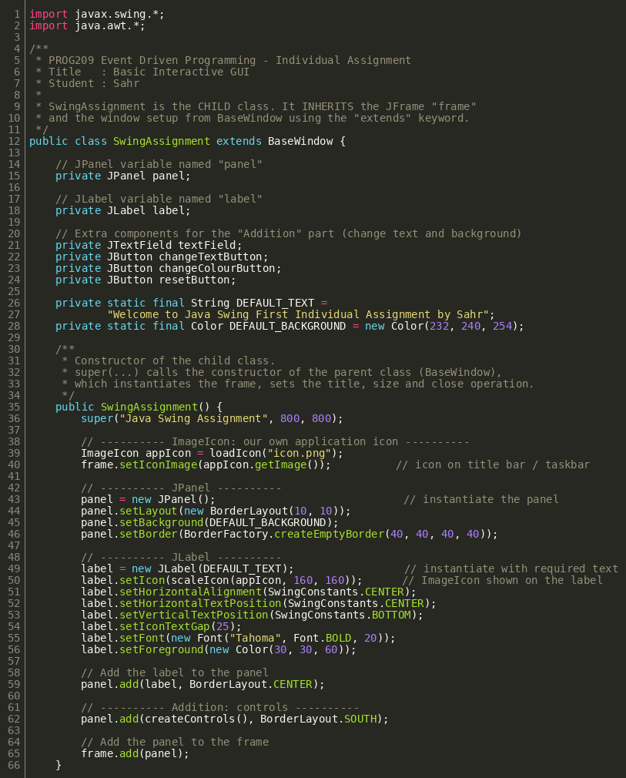
Figure 3: Source code of SwingAssignment.java (part 1)
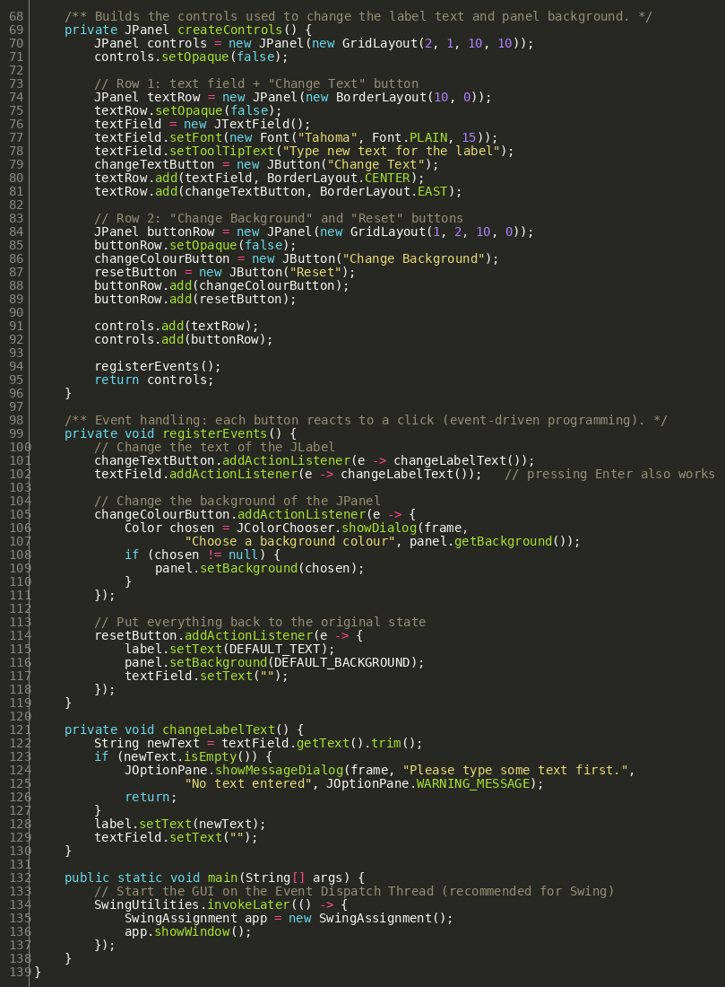
Figure 4: Source code of SwingAssignment.java (part 2)

5. Output Screenshots
The following screenshots show the application running and each feature working.
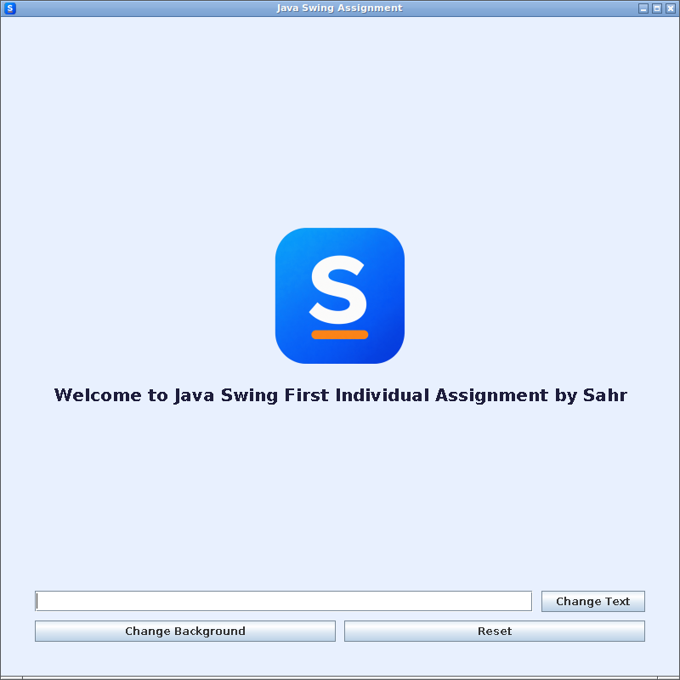
Figure 5: Application on launch, showing the title, icon, image and welcome message
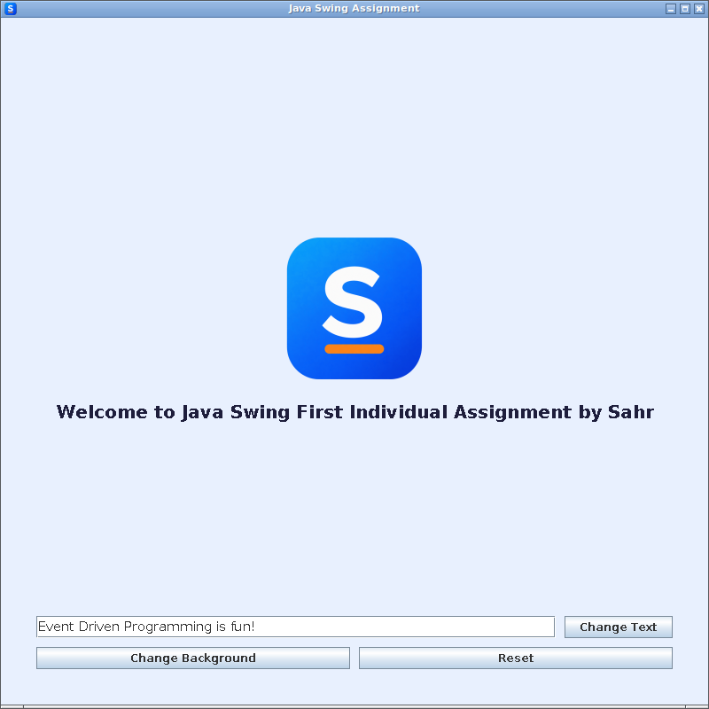
Figure 6: New text typed into the text field before clicking Change Text
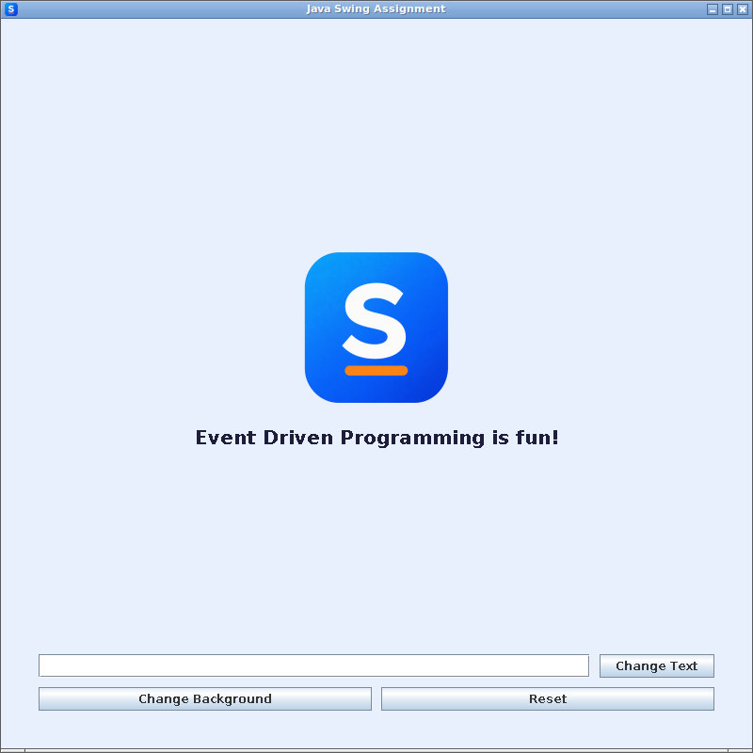
Figure 7: Label text changed after clicking Change Text
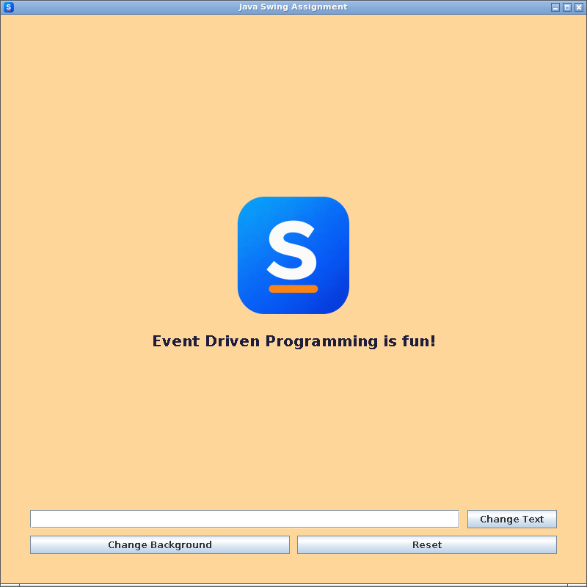
Figure 8: Panel background changed after choosing a colour with Change Background

6. Conclusion
This assignment produced a basic interactive GUI application in Java Swing that meets all the requirements of the assignment brief. The application uses a JFrame as the main window, a JPanel to hold the components and a JLabel to display the welcome message together with an image. An ImageIcon provides both the custom application icon and the image on the label.
Inheritance was applied by creating the parent class BaseWindow and the child class SwingAssignment, and constructors were used to set up the window and its components, with super() linking the two. The additional buttons demonstrate event-driven programming, as the program responds to user actions by changing the label text and the panel background.
Through this assignment, I gained practical experience in planning an interface with a wireframe, building a GUI with Swing components, applying object-oriented principles and handling user events. I also practised using Git and GitHub to manage and submit source code. In future, the application could be extended with menus, more input validation and saving user preferences.

7. References
Figma (2026) Figma Help Center. Available at: https://help.figma.com (Accessed: 10 October 2026).
GitHub (2026) GitHub Docs: Inviting collaborators to a personal repository. Available at: https://docs.github.com (Accessed: 10 October 2026).
Liang, Y.D. (2020) Introduction to Java Programming and Data Structures. 12th edn. Hoboken, NJ: Pearson.
Oracle (2024) Java Platform, Standard Edition API Specification: javax.swing. Available at: https://docs.oracle.com/en/java/javase/21/docs/api/java.desktop/javax/swing/package-summary.html (Accessed: 10 October 2026).
Oracle (2024) The Java Tutorials: Creating a GUI With Swing. Available at: https://docs.oracle.com/javase/tutorial/uiswing/ (Accessed: 10 October 2026).
Oracle (2024) The Java Tutorials: How to Write an Action Listener. Available at: https://docs.oracle.com/javase/tutorial/uiswing/events/actionlistener.html (Accessed: 10 October 2026).
Oracle (2024) The Java Tutorials: Inheritance. Available at: https://docs.oracle.com/javase/tutorial/java/IandI/subclasses.html (Accessed: 10 October 2026).

