DEVELOPMENT OF A HATE SPEECH DETECTOR BASED ON HYBRIDIZED BERT-ATTENTION MECHANISM AND CONTEXT ANALYZER

By

DAVID SARKIBAKA, Shedrack
2017/1/66025CT

DEPARTMENT OF COMPUTER SCIENCE
FEDERAL UNIVERSITY OF TECHNOLOGY MINNA

JANUARY, 2024
DEVELOPMENT OF A HATE SPEECH DETECTOR BASED ON HYBRIDIZED BERT-ATTENTION MECHANISM AND CONTEXT ANALYZER

BY

DAVID SARKIBAKA, Shedrack
2017/1/66025CT

PROJECT SUBMITTED TO THE DEPARTMENT OF COMPUTER SCIENCE, SCHOOL OF INFORMATION AND COMMUNICATION TECHNOLOGY, FEDERAL UNIVERSITY OF TECHNOLOGY, MINNA, NIGERIA IN PARTIAL FULFILLMENT OF THE REQUIREMENT FOR THE AWARD OF THE DEGREE OF BACHELOR OF TECHNOLOGY IN COMPUTER SCIENCE

JANUARY, 2024.
DECLARATION
I hereby declare that this project titled: “Development of A Hate Speech Detector Based on Hybridized BERT-Attention Mechanism and Context Analyzer” is a collection of my original project work and it has not been presented for any other qualification anywhere. Information from other sources (published or unpublished) has been duly acknowledged.

DAVID SARKIBAKA, Shedrack
2017/1/66025CT Signature and Date
Federal University of Technology,
Minna, Nigeria.

CERTIFICATION
The project tiled: “Development of A Hate Speech Detector Based on Hybridized Bert-Attention Mechanism and Context Analyzer” by: DAVID SARKIBAKA, Shedrack (2017/1/66025CT), meets the regulations governing the award of the degree of Bachelor of Technology of the Federal University of Technology, Minna.

Dr. E.F. AMINU
Project Supervisor Signature and Date

Dr. (Mrs.) O.A. Abisoye
Head of Department Signature and Date

External Examiner Signature and Date

DEDICATION
I wholeheartedly dedicate this project to first God almighty for his mercies, grace, wisdom and strength; Second to my beloved parents Mr. David James and Mrs. Comfort Musa and my lovely siblings for their prayers, encouragements, moral and financial support throughout the time of my study. Third, to my supervisor Dr. E. F. Aminu, for his invaluable ideas, support and for the approval of this project. May God continue to bless and promote you all in your endeavors. Amen.

ACKNOWLEDGEMENTS
My utmost gratitude goes to Almighty God for his overwhelming love, infinite mercies and sufficient grace upon my life all through my academic pursuit. My special gratitude also goes to my exceptional supervisor Dr. E.F. Aminu, and also Mrs. A. Ekundayo who sincerely and actively guided me all through the phases of this research work, may God almighty never stop blessings you and your endeavors. I extend my heartfelt gratitude to my beloved parents Mr. David James and Mrs. Comfort Musa for their unwavering support, prayers, boundless love, and the sacrifices they made to ensure my success. I am profoundly grateful to my dearly beloved, Cecilia Nnalade John, whose love, care, and unwavering support have been a constant source of strength and motivation.
I am indebted to the Head of Department (HOD) and the esteemed faculty members and staff of the Computer Science Department in persons of Prof. J. K. Alhassan, Dr. (Mrs.) O.A. Abisoye, Dr. S. A. Bashir, Dr. S. A. Adepoju, Dr. O. A. Ojerinde, Dr. E. F. Aminu, Mal. A., M. Saliu, Mr. C. U. Ugwuoke Mr. M. I. Kolo, Mal. M.K Muhammad, Mr. I.S Shehu, Mrs. A. Ekundayo, Mr. Y. Lasotte and Mr. S. Alkali. Their guidance, imparted knowledge, and invaluable advice throughout my Btech program.
Special appreciation goes to my friends, Majeed, Emmanuel, Dogara, and Fred, especially, whose unwavering support, insightful advice, and encouragement were pivotal throughout this project as a domain expert
I extend my heartfelt thanks to my elder brother, Nelson, for his continuous financial support throughout my academic years, ensuring that I could focus on my studies. Additionally, I express gratitude to my elder brother, Victor, for his financial support and unwavering enthusiasm for technology, which has inspired me greatly. And also, my project colleagues, Aaron, AbdulQadri, Abdul, Buhari, Dimeji, Ezra, KingDavid, Hassan, Halima, Mark, Ogah Mike, Victoria, and Winifred for their unfeigned love and contributions towards the success of this project.

ABSTRACT
Hate speech remains a pervasive societal issue within digital spaces, posing significant challenges to online safety and fostering inclusive environments. This project addresses this critical concern by leveraging advanced natural language processing (NLP) techniques to develop an innovative hate speech detection system. To ensure a comprehensive and robust dataset, meticulous data augmentation was conducted using back translation facilitated by the deep-translator library, enriching the dataset's diversity and size. A hybridized approach that combines the uniqueness of BERT attention mechanisms and a context analyzer to capture intricate contextual relationships within textual data is employed. The hate speech detection model was trained for 20 epochs, comprising two layers with a frozen BERT layer. The training utilized the Adam optimizer and employed softmax for classifying the multi-labeled classes of hate speech, this yielded the total accuracy of 0.99 on the 20th epoch. The evaluation metrics of the trained model reveal promising performance: Macro Precision of 0.79875, Macro Recall of 0.71587, and Macro F1-score of 0.74825. The utilization of the hybridized BERT model not only identifies explicit hate speech but also detects subtle nuances and underlying meanings, providing a holistic understanding of harmful content. Therefore, this project represents a significant stride towards combating online hate speech. By harnessing state-of-the-art NLP techniques, the project endeavors to create a sophisticated, context-aware hate speech detection system.

TABLE OF CONTENT
CONTENT PAGE
Cover Page i
Title Page ii
Declaration iii
Certification iv
Dedication v
Acknowledgment vi
Abstract vii
Table Of Content viii
List of Tables ix
List Of Figures x
CHAPTER ONE: INTRODUCTION 1
1.1. Background to Study 1
1.2 Statement of Problem 7
1.3. Aim and Objectives of Study 7
1.4. Significance of Study 8
1.5. Motivation of Study 8
1.6. Scope and Limitations of Study 9
1.7. Organization of Study 9
CHAPTER TWO: LITERATURE REVIEW 10
2.1 Overview of Hate Speech 11
2.2. Hate Speech Detection 12
2.3. Artificial Intelligence (AI) 13
2.4. Machine Learning (ML) 14
2.5.1 How Machine Learning Works 15
2.5.2 Machine Learning Methods 16
2.5.3 Machine Learning Algorithms 17
2.6 Related Works 24
CHAPTER THREE: SYSTEM ANALYSIS AND DESIGN 31
3.1 The feature of the proposed system 31
3.3 The Proposed Hybridized Algorithm 31
3.3.1 System architecture of the proposed system 32
3.3.1.1 The User/Programmer 33
3.3.1.2 Data Augmentation 33
3.3.1.3 Text and label extraction 34
3.3.1.4 Tokenization using BERT: A Pre-processing Technique in NLP 34
3.3.1.6 Dense layer 35
3.3.1.7 Model Compilation 37
3.3.2 Sequence diagram of the proposed system 37
3.3.3 Flowchart diagram of the proposed system 39
CHAPTER FOUR: SYSTEM IMPLEMENTATION AND TESTING 41
4.1 Choice of Programming Language 41
4.2 System Requirement 42
4.2.1. The system requirements are divided into two parts: hardware and software requirements 42
4.3 The Implemented System 43
CHAPTER FIVE: SUMMERY, CONCLUSION AND RECOMMENDATION 57
5.2 Recommendation 59
5.3 Suggestion for further work 59
References 61
Appendices 66

LIST OF TABLES
TABLE PAGE
4.1 Results 72

LIST OF FIGURES

FIGURES PAGE
3.1: The proposed Hate-Speech Detector System conceptual design framework 33
3.2: Sequence diagram of the proposed system 38
3.3: Flowchart diagram of the proposed system 40
4.1: Shows the command is used to install the "transformers" library in a Python environment 44
4.2: Shows some important importation of necessary libraries 45
4.3: Shows the head and tail of the dataset 45
4.4: Shows the data augmentation process of the dataset 46
4.5: Shows the new augmented dataset 47
4.4: Shows the label extraction and a normalization algorithm used to normalize the dataset 47
4.6: Shows the result of the normalization algorithm used 48
4.7: Shows the loading of pre-trained BERT model and BERT tokenizer 48
4.8: Shows a function for the tokenization 49
4.9: Shows the splitting of the dataset into training and testing sets 50
4.10: Shows the model’s architecture 51
4.11: Shows the fitting and training of the model 53
4.12: Shows the accuracy of the model on the training dataset and on the validation set 54
4.13: Shows the loss of the model on the training and the validation dataset 55
4.14: Show the evaluation from the work of Mollas et al (2021) 55
4.15: Show the confusion matrix of each class of hate speech for the proposed BERT model 56
4.16: Shows the evaluation matrices for all classes 56
4.17: Shows the Macro Evaluation scores for all for this model 57

CHAPTER ONE
1.0. INTRODUCTION

1.1. Background to the Study
In everyday language, "hate speech" refers to disparaging language aimed at a group or an individual based on fundamental characteristics like gender, race, or religion, potentially leading to societal unrest. This definition extends beyond the confines of "incitement to discrimination, hostility, or violence," as outlined by international human rights standards, and lacks legal conclusiveness (Oussalah & Jahan 2023). Hate speech can manifest through various mediums, both online and offline, including images, cartoons, memes, objects, gestures, and symbols. It is often directed at specific individuals or groups and is categorized as "pejorative" or "discriminatory," displaying bias, prejudice, or intolerance. Hate speech focuses on the actual or perceived "identity factors" of individuals or groups, encompassing language, economic or social background, ethnicity, nationality, race, color, descent, gender, disability, health status, or sexual orientation, among other traits (Mollas et al., 2021).
Crucially, hate speech is limited to targeting individuals or groups of individuals, omitting discussions involving States, their institutions, symbols, public figures, or conversations about religious leaders and beliefs. In the United States, hate speech is shielded by the free speech provisions of the First Amendment, although it has been a subject of extensive legal debate, particularly in relation to college campus speech codes. Numerous countries, such as the United Kingdom, Canada, and France, have prohibited hate speech, defining it as verbal expressions that aim at minority groups and have the potential to incite violence or social unrest. In response to criticism regarding their failure to curb hate speech, both Facebook and Twitter have implemented policies prohibiting the use of their platforms for attacks based on characteristics such as race, ethnicity, gender, and sexual orientation, as well as threats of violence against individuals. According to these guidelines, language intended to demean, dehumanize, or insult members of a designated group is reasonably categorized as hate speech. While extreme language that incites or threatens violence may also be included, restricting its application to such instances would overlook a substantial portion of hate speech. It's essential to recognize that not all instances of offensive language fit this description, as people often employ expressions that are highly hurtful to specific groups but in a qualitatively different manner. For instance, some African Americans commonly use the term "ngga2" in everyday online language (Fortuna & Nunes, 2018), individuals use terms like "he" and "bitch" when quoting rap lyrics, and teenagers may use homophobic slurs like "fag" during video game play. Such language is prevalent on social media (Shi et al., 2020), emphasizing the critical importance of this boundary condition for any effective hate speech detection system.
Statistics on hate speech exhibit variations across regions, contexts, and time periods, yet consistently highlight the widespread and impactful nature of this problem. According to a United Nations report, hate speech has seen an upward trend, with online platforms playing a significant role in its propagation. In Europe, data from the European Union Agency for Fundamental Rights indicates that a considerable number of surveyed individuals have encountered hate speech online. Likewise, the Anti-Defamation League (ADL) reported a troubling surge in hate speech incidents targeting religious and racial minorities in the United States.
In response to alarming trends such as the escalating xenophobia, racism, and intolerance, along with instances of violent misogyny, antisemitism, and anti-Muslim sentiments worldwide, UN Secretary-General António Guterres introduced the United Nations Strategy and Plan of Action on Hate Speech on June 18, 2019. This groundbreaking initiative by the UN, designed to comprehensively address hate speech, provides a strategic framework for the Organization to support and complement the efforts of individual States. The strategy emphasizes the importance of countering hate in a holistic manner while upholding the principles of freedom of opinion and expression. Furthermore, it highlights the need for collaborative efforts with relevant stakeholders, including civil society groups, media entities, technology firms, and social media platforms. As a further measure, the General Assembly, in 2021, adopted a resolution designating June 18 as the International Day for Combating Hate Speech.
From the provided definition and content, it is evident that certain elements are closely associated with hate speech, including cyberbullying, sexism, racism, offensive language, gender discrimination, religion-based hate speech, and radicalization. The proliferation of hate speech online has gained momentum due to internet companies' delays in manually reviewing content, presenting persistent challenges for both the research community and policymakers. The domain of automatic textual hate speech identification has witnessed significant research in recent years, thanks to advancements in natural language processing (NLP) technology. However, delving into NLP requires addressing the broader topics of machine learning and artificial intelligence (AI).
Artificial intelligence (AI), as defined by John McCarthy, is "the science and engineering of making intelligent machines, especially intelligent computer programs." McCarthy further emphasizes that AI involves using computers to comprehend human intelligence, noting that it extends beyond observable physiological techniques (Doherty, 2018). The initiation of discussions on AI is often credited to Alan Turing's influential work, "Computing Machinery and Intelligence," published in 1950. Turing, widely recognized as the "father of computer science," poses the fundamental question of whether machines can exhibit intelligence. He introduces the renowned "Turing Test," in which a human evaluator distinguishes between computer-generated and human text responses. Despite ongoing debates, this test holds historical and philosophical significance (Hoffmann, 2022).
Artificial intelligence (AI) integrates computer science with extensive datasets to address problems, encompassing subfields such as machine learning and deep learning. These subfields involve the development of algorithms that create expert systems for predictions or classifications based on input data. The evolution of AI has been marked by varying degrees of attention, with OpenAI's ChatGPT representing a significant milestone. Earlier advancements concentrated on computer vision, whereas the current breakthrough is in natural language processing. Generative models have expanded their capabilities beyond language, demonstrating proficiency in understanding software code, molecular structures, images, and diverse data types. This shift signifies the continuous evolution of AI.
Conversely, machine learning, a subset of artificial intelligence (AI) and computer science, seeks to emulate human learning processes by leveraging data and algorithms to enhance accuracy progressively. IBM has played a significant role in the history of machine learning, with the term itself coined by Arthur Samuel, an IBM researcher, during his work on checkers. A pivotal moment occurred in 1962 when Robert Nealey, a checkers expert, faced an IBM 7094 computer and experienced a defeat, marking a notable milestone in the progress of AI (Aljabri, 2023). Technological advancements have catalyzed the development of products rooted in machine learning, exemplified by applications like Netflix's recommendations and advancements in self-driving cars. This progress has been fueled by the substantial growth in storage capacity and processing power over the decades.
Machine learning plays a pivotal role in data science, where algorithms, trained with statistical methods, are employed for classifying, predicting, and extracting insights through data mining. These insights contribute to informed decision-making and business growth, particularly in the face of increasing volumes of big data. The demand for data scientists is expected to rise in this context. TensorFlow and PyTorch serve to expedite the development of algorithms in machine learning. The field encompasses various methodologies, including Supervised Learning, Unsupervised Learning, Semi-Supervised Learning, and Reinforcement Learning (IBM, 2023). These methodologies incorporate a diverse range of algorithms such as neural networks, linear regression, logistic regression, clustering, decision trees, and random forest, among others. However, for the specific focus of this study, the primary emphasis is on the BERT algorithm.
BERT, an acronym for Bidirectional Encoder Representations from Transformers, stands out as a prominent open-source machine learning framework specifically designed for natural language processing (NLP). This framework addresses the complexities of understanding context and meaning within text, particularly when dealing with ambiguous language. BERT achieves this by harnessing contextual cues from the surrounding text, allowing computers to decipher nuanced linguistic nuances. At its core, BERT leverages the transformative capabilities of Transformers, a robust deep learning model characterized by intricate connections between input and output elements. These connections are dynamically weighted through attention mechanisms, a process that underpins the model's contextual comprehension (Lutkevich, 2020). What sets BERT apart from previous language models is its bidirectional reading competence. Unlike models limited to sequential text processing in either the left-to-right or right-to-left direction, BERT's innovation lies in its ability to simultaneously analyze text in both directions. This bi-directionality is crucial for capturing the holistic context of a given textual passage.
In summary, BERT's integration of bidirectional reading, the Transformers architecture, and transfer learning positions it as a cornerstone in the effort to improve machines' understanding and processing of human language intricacies. BERT's contextual comprehension, fine-tuning capabilities, adaptability, and sophisticated architecture make it a compelling choice for hate speech detection. While other models like FastText, Word2Vec, and GloVe have their merits, BERT's performance and suitability for complex NLP tasks make it a robust solution for the objectives of this project. BERT's bidirectional context modeling allows it to capture nuanced relationships within sentences, facilitating accurate identification of hate speech influenced by surrounding context. Its capacity to discern fine-grained language details aids in distinguishing subtle forms of hate speech (Cerwall, 2021). Pre-trained on a vast text corpus, BERT's foundation in language knowledge supports effective fine-tuning, reducing the need for extensive labeled hate speech data. BERT's inherent excellence, adaptability to evolving language trends, and multilingual support enhance its effectiveness in detecting hate speech across diverse contexts and sentence structures. Its ability to automatically generate meaningful embeddings reduces the reliance on manual feature engineering, streamlining the workflow. Benefiting from recent advancements in NLP, BERT provides insights beyond older models, making it a contemporary and powerful tool for hate speech detection (Delvin et al., 2018).

Statement of Research Problem

This project highlights the need for a more sophisticated method to account for the nuances of hate speech and changing linguistic trends, even though current algorithms like FastText, Word2Vec, and GloVe have made significant contributions to the field of natural language processing (Kovács et al., 2021). The goal of this research is to create a hybridized BERT-Attention Mechanism and Context Analyzer model, building on the effectiveness of BERT's contextual comprehension and fine-tuning capabilities. This method incorporates an inventive synthesis of BERT's bidirectional context modeling, attention mechanisms, and contextual analysis (Qiu et al., 2020). By combining these components, this study hopes to provide hate speech detection algorithms an unmatched capacity to recognize minute details, adjust to changing linguistic contexts, and ultimately contribute to a safer and more respectful online discourse.

1.3. Aim and Objectives of Study
The aim of this research is to develop a hate speech detector based on hybridized BERT-attention mechanism and context analyzer. The following goals must be accomplished in order to actualize this aim
- Design a Hybridized Algorithm for BERT-Attention Mechanism and Context Analyzer
- Implement the hybridized algorithm in Objective (i) for the proposed model
- Evaluate the proposed Hate-speech Detection Model

1.4. Significance of Study

Hate speech is a worrying aspect of internet discourse that creates social separation and discrimination, among other problems. Conventional approaches struggle to grasp changing linguistic patterns and context (Kovács et al., 2021). This research uses a novel hybridized BERT-Attention Mechanism and Context Analyzer model to transform hate speech detection. The model aims to provide improved contextual comprehension, refined detection skills, dynamic adaptation, and less data labeling work by utilizing cutting-edge NLP techniques. In addition to addressing online safety, it advances the area of natural language processing (NLP) and handles ethical concerns. Its goal is to transform online talks and create a polite, understanding, and tolerant digital world.

1.5. Motivation of Study

The urgent need to address the growing issue of hate speech in the internet domain is what spurred this study. The pervasive incorporation of digital communication platforms into our daily existence has magnified the influence of hate speech, with noteworthy consequences for both individuals and the unity of society. This research is dedicated to transforming the digital landscape, with the goal of establishing a welcoming and constructive online community. The work intends to create a strong hate speech detection model that recognizes subtle instances of hate speech while taking changing linguistic trends into account by employing cutting-edge Natural Language Processing techniques. With your help, we hope to create a more welcoming and safer online environment where people of all backgrounds can interact without fear of prejudice or violence.

1.6. Scope and Limitations of Study
This study's main objective is to develop a hybrid BERT-Attention Mechanism and Context Analyzer model for use as a hate speech detector. It entails creating models, preparing data, assessing performance, and adjusting for particular circumstances of hate speech. Potential domain specificity, the impact of data availability on model efficacy, difficulties in identifying extremely complex instances, potential ethical bias, real-time deployment optimization, the viability of algorithm comparison, linguistic constraints, the necessity for dynamic online adaptation, and the changing nature of online communication are all areas that the proposed project will not address.
1.7. Organization of Study
Chapter One establishes the foundation for the study by delving into a comprehensive background and articulating the problem statement in detail. Emphasis is placed on elucidating the study's objectives and significance, particularly within the context of addressing challenges in Hate Speech Detection. The chapter concludes with a nuanced discussion, carefully addressing the study's scope, limitations, and presenting precise operational definitions for key terms.
Transitioning to Chapter Two, an extensive literature review unfolds, drawing insights from various works by researchers. This comprehensive examination encompasses the transformative role of Hate Speech Detection Based on Hybridized BERT Attention Mechanism and Context Analyzer. The exploration extends to categorizing and elucidating the applications of BERT, focusing on its potential to detect hate speech
Chapter Three marks a pivotal shift toward examining design and implementation approaches utilized in the study. This section justifies the chosen algorithms and libraries, shedding light on how these decisions align with the overarching goals of the project. The chapter unveils the methodology, serving as a guide for the systematic translation of conceptualization into a tangible system.
In Chapter Four, the spotlight is on modeling the proposed solution, utilizing Python and Jupyter. This section outlines the step-by-step processes undertaken to actualize the project, providing transparency into the decision-making processes and rationale behind the chosen approach. Additionally, it includes the results achieved through testing.
Chapter Five signifies the culmination of the study, presenting a concise summary of the research and its consequential outcomes. The chapter concludes with a comprehensive discussion, offering valuable insights into the implications of the findings. Furthermore, it provides recommendations for potential avenues of research within the domain of BERT in hate speech detection, thereby guiding and inspiring future explorations.

CHAPTER TWO

2.0 LITERATURE REVIEW

2.1 Overview of Hate Speech
Hate speech is sometimes classified using general phrases like "toxicity," "offensive language," or "abusive language" (Poletto et al., 2021). This is a deeply unsettling kind of expression characterized by the expression of intense animosity, prejudice, or hatred towards persons or groups because of perceived characteristics, which may include things like race, ethnicity, religion, gender, sexual orientation, handicap, or nationality. It poses a significant challenge to maintaining the ideals of equity, diversity, and societal inclusion (Jigsaw, 2019).
Finding a middle ground between protecting the right to free speech and preventing harm is a topic of constant debate. Addressing hate speech requires a multifaceted approach that includes legal action, educational programs, and the development of empathy and mutual understanding among individuals and communities. Online hate speech is a growing concern because of its social impacts. Hate speech encompasses a wide range of spoken, written, or symbolic forms of communication that are often disseminated through various channels, including social media, public addresses, written works, and online discussion platforms (Soral et al., 2018).
Distinctive forms of hate speech comprise:
- Cyberbullying: This type of hate speech is characterized by the use of digital communication platforms to harass, threaten, or degrade others. It frequently entails sending hurtful or abusive messages, comments, or posts to the target.
- Sexism: Prejudice or discrimination against an individual on the basis of their gender is known as sexism. It may take the form of disparaging remarks, gender stereotypes, or treating people differently depending on their gender.
- Racism: Racism is the term used to describe prejudice, discrimination, or animosity that is directed towards people or groups because of their race or ethnicity. It involves propagating unfavorable ideas and stereotypes about particular racial groups.
- Offensive Language: When someone uses words or expressions that are cruel, rude, or improper, they are usually trying to provoke or offend other people.
- Profanity: In some circumstances, employing language that is vulgar, obscene, or blasphemous is deemed disrespectful or unacceptable.
- Abusive words: This refers to verbally abusing or dehumanizing other people; it frequently involves insults, threats, or harsh words that may be upsetting to the victim's feelings.
- Gender Discrimination: This is the practice of treating people unfairly or differently on the basis of their gender, which can limit opportunities or reinforce prejudices.
- Religion: Hate speech directed towards religion refers to the expression of animosity or discrimination against people or groups on the basis of their religious affiliations or beliefs.
- Radicalization: This refers to the dissemination of extreme ideologies or points of view, frequently with the goal of inciting violence or recruiting people for radical causes.

2.2. Hate Speech Detection
The relatively frequent use of profanity and abusive language on social media makes it harder to identify hate speech (Wang et al., 2014). Because of minute grammatical differences, it is often difficult to discern hate speech from other inappropriate words. For instance, tweets using the term "n*gger" are more likely to be labeled as hate speech than tweets containing the term "n*gga" (Kwok & Wang, 2013). There are many ambiguous scenarios; for example, the term "gay" may be used negatively in contexts unrelated to hate speech (Wang et al., 2014). This information is typically not available from the text (Fortuna et al., 2022). Due to internet firms' delays in performing human inspections, hate speech has become more prevalent online and continues to present issues to the research community and legislators.
Many studies on automatic textual hate speech identification have been conducted recently thanks to advancements in natural language processing (NLP) technology; nevertheless, in order to have a meaningful conversation about NLP, one must first grasp fundamental ideas like machine learning and artificial intelligence (AI).

2.3. Artificial Intelligence (AI)
While artificial intelligence (AI) has been defined in a number of ways recently, John McCarthy defined it as follows in 2004: "it is the science and engineering of creating intelligent machines, particularly intelligent computer programs." (Doherty, 2018). Artificial intelligence (AI) has been defined as "a field of science and engineering concerned with the computational understanding of what is commonly called intelligent behavior, and with the creation of artefacts that exhibit such behavior," according to research on AI in medicine (Ramesh et al., 2004).
Although understanding human intellect using computer means is the same goal, artificial intelligence (AI) is not restricted to methods that may be observed by biological means. But even before this statement, the discussion of artificial intelligence is said to have begun with Alan Turing's seminal work "Computing Machinery and Intelligence," which was released in 1950. "Can machines think?" is the key question that Turing, who is sometimes called the "father of computer science," poses. The well-known "Turing Test," in which a human assessor tries to discern between text responses generated by a computer and those generated by a person, is then presented by him (Hoffmann, 2022). Even though this test has come under intense criticism since it was first introduced, it is historically significant for AI and is still a matter of discussion in philosophy because it uses concepts from language.
Fundamentally, the field of artificial intelligence combines computer science with large, reliable datasets to make problem-solving easier. It includes subfields that are frequently discussed alongside artificial intelligence, like machine learning and deep learning. These subfields work with algorithms that build expert systems based on input data for classifications or predictions.
Artificial intelligence has had periods of increased interest over time, but even detractors acknowledge that Large Language Models—like OpenAI's ChatGPT—mark a significant turning point in the field. Previous advances in generative AI focused on computer vision, but the current wave is leading to advances in natural language processing. But generative models are not limited to language; they can also understand the subtle structural differences between chemicals, software code, natural photographs, and many other kinds of data.

2.4. Machine Learning (ML)
Computer science and artificial intelligence (AI) are the broad categories that machine learning belongs under. Its main goal is to replicate human learning processes by using data and algorithms, gradually increasing its accuracy over time.
The history of IBM and machine learning is extensive. Arthur Samuel, an IBM employee, came up with the term "machine learning" through his study of checkers. The defeat of self-proclaimed checkers master Robert Nealey in a 1962 match against an IBM 7094 computer marked a crucial turning point in the development of artificial intelligence, despite the fact that this feat may seem insignificant in light of current capabilities (Aljabri, 2023).

Significant advancements in storage and processing power over the last few decades have led to the development of ground-breaking machine learning-based technologies like Netflix's recommendation engine and driverless cars.

Machine learning is a key element in the rapidly expanding field of data science. In data mining projects, statistical techniques are used to train algorithms for classification, forecasting, and the discovery of significant discoveries. Afterwards, these insights aid in decision-making for businesses and apps, potentially impacting important growth metrics. Given their critical role in finding pertinent business questions and the associated data that has to be answered, data scientists should see an increase in demand as the use of big data grows (IBM, 2023). TensorFlow and PyTorch are two popular frameworks used to construct machine learning algorithms, which expedites the problem-solving process.

2.5.1 How Machine Learning Works

i. A Decision Process: Machine learning algorithms are widely utilized for prediction and categorization. Your algorithm will generate an approximation of a pattern in the data using specific input data that may or may not be labeled.

ii. An error function examines the model's predictions. An error function can evaluate the model's accuracy by comparing it to known examples.

iii. A Model Optimization Process: If the model better fits the data points in the training set, weights are modified to lessen the difference between the model estimate and the known sample. The algorithm will continue to go through this "evaluate and optimize" process, automatically changing weights until a predefined accuracy level is met.

2.5.2 Machine Learning Methods
By IBM’s standards, Machine learning models fall into three primary categories.
- Supervised Machine Learning: Using labeled datasets to train algorithms in precise data classification and outcome prediction is the foundation of supervised learning, also known as supervised machine learning. Through a process of cross-validation, the model adjusts its parameters as it receives input data, guaranteeing a balanced fit that avoids overfitting or underfitting. With the use of this technique, businesses can address a wide range of practical issues on a grand scale, such keeping spam apart from inboxes in their own folder. Supervised learning techniques include random forests, neural networks, naïve Bayes, logistic regression, linear regression, and support vector machines (SVM).
- Unsupervised Machine Learning: Often referred to as "unsupervised learning," this technique uses machine learning algorithms to analyze and categorize information that do not have labels. These algorithms provide insights into hidden patterns or groups within the data without requiring human participation. This technique can be applied to consumer segmentation, cross-selling tactics, exploratory data analysis, and pattern identification since it can highlight patterns and similarities in data. It is also used to minimize features in models using dimensionality reduction approaches. Principal Component Analysis (PCA) and Singular Value Decomposition (SVD) are two widely used methods for this. Additional algorithms used in unsupervised learning include probabilistic clustering techniques, k-means clustering, and neural networks.
- Semi-Supervised Learning: This method provides an agreeable compromise between the supervised and unsupervised learning approaches. It uses a smaller labeled dataset during training to inform the classification and feature extraction procedures from a larger, unlabeled dataset. When supervised learning algorithms are unable to handle the large volume of labeled data that is available, or when labeling data is too resource-intensive, semi-supervised learning serves as an effective solution.

2.5.3 Machine Learning Algorithms
A number of machine learning algorithms are commonly used. These include:
- Neural networks: These networks of interconnected processing nodes imitate the human brain's operations. Because of its ability to recognize patterns, neural networks are frequently utilized in voice, image, natural language translation, and image generation applications.
- Linear regression: This technique predicts numerical values based on their linear connection. The method could be used, for example, to forecast housing values in the neighborhood based on prior data.
- Logistic regression is a supervised learning method that predicts binary responses like "yes" or "no." Applications such as spam classification and production line qualitymanagement can benefit from it.
- Clustering: In order to group data, clustering algorithms use unsupervised learning to find patterns in the data. By pointing out distinctions between data items that humans have missed, computers can assist data scientists.
- Decision trees: they can categorize data and predict numerical values (regression). A tree diagram can be used to represent the branching sequence of linked decisions found in decision trees. Decision trees, unlike neural networks, are easy to validate and audit. This is one of their benefits.
- Random forest: is a machine learning system that mixes many decision trees to predict a value or category.

While these algorithms have great capability in the field of machine learning, they currently lack the ability to tackle the complexities of natural language problems.
2.5.4 Natural Language Processing (NLP)
Natural language processing (NLP), a fascinating and rapidly emerging topic in artificial intelligence, aims to enable computers to comprehend, interpret, and produce human language. This branch of artificial intelligence sits at the intersection of languages, computer science, and machine learning. Its applications are pervasive and have the potential to transform a variety of sectors. Since the first half of the twentieth century, science fiction has frequently portrayed the concept of computers being able to comprehend natural languages and communicate with humans (Hoffmann, 2022).
Since the beginning of the twenty-first century, the realization of this goal has become more conceivable. Artificial intelligence approaches, paired with scientific language research, have moved beyond the bounds of academia and research labs to play critical roles in a variety of industrial and commercial settings. Nowadays, many websites provide automatic translation services, mobile phones can understand spoken inquiries and instructions, and search engines such as Google use basic language approaches to improve query fulfillment and results relevance.
Nonetheless, we have a long way to go before reaching complete machine comprehension of natural language. Although computerized translations have advanced, they still require inspection and modification by qualified human translators. Furthermore, no computer system has yet achieved the threshold of effectively replicating human conversation, as demonstrated by the elusive "Turing Test." Some believe that research should shift away from pursuing the illusion of human-like interaction and toward producing practical applications customized to specific needs (Toosi et al., 2021).

2.5.4.1 Natural Language Processing Models
- Recurrent Neural Networks (RNNs): RNNs are a type of NLP model that uses hidden states to extract context from sequential data. They can be used in a variety of applications, including language modeling, sentiment analysis, and text classification. Transformers have mostly replaced RNNs in many jobs due to their failure to capture long-term associations due to vanishing gradient concerns.
- CNNs: Originally developed for image processing, they have been adapted to evaluate text. They are very useful for applications such as sentiment analysis and text classification. Convolutional layers are a technique employed by CNNs to detect local patterns and properties in text input.
- Hidden Markov Models (HMMs) are commonly employed for speech recognition and part-of-speech tagging, which need sequential data modeling. They represent sequences via a series of hidden states and observed emissions.
- Conditional Random Fields (CRFs): CRFs are commonly used for sequence labeling, including named entity recognition and syntax parsing. They model the conditional likelihood of labeling based on input features.
- Rule-based systems apply specified linguistic rules to conduct NLP tasks like information extraction and grammar verification. Despite becoming less popular in modern NLP, they are nevertheless employed in niche applications.
- Bag-of-Words (BoW) Models: BoW models treat text as a collection of individual words and their frequencies, without considering word order or context. They calculate the probability of a given text belonging to a particular category.

2.5.4.2 Transformer Models
Transformer models have significantly increased our ability to understand and produce human language. They represent a groundbreaking development in the field of natural language processing (NLP). These models have transformed a lot of NLP professions and are now employed in a variety of fields. In contrast to earlier NLP models, transformers process data sequences using an approach known as "self-attention". Transformers may successfully acquire contextual information and long-term relationships because to this dynamic attention mechanism, which also allows transformers to adapt to a wide range of linguistic structures. The revolutionary paper "Attention Is All You Need" introduced transformer models (Vaswani et al., 2017).
An attention function can be described as mapping a query and a collection of key-value pairs to an output, where all of the components are vectors. The results are generated as a weighted sum of the values, with the weight of each value defined by the query's compatibility function with the matching key (Vaswani et al., 2017). Transformer models are classified into numerous categories, each with its own architectural variation and intended for a distinct NLP job.

2.5.4.3 Text-to-Text Transfer Transformer (T5)
T5, developed by Google AI, depicts text inputs and outputs in a single "text-to-text" format. It has produced excellent results in a variety of NLP tasks by framing them as text-to-text challenges, such as translating a sentence into another language or creating a summary from a document.

2.5.4.4 Generative Pretrained Transformer (GPT)
The mission statement of OpenAI, an AI research facility, is to advance and create AI that benefits humans. Established in 2015, it is regarded as DeepMind's competitor. Microsoft has struck an exclusive licensing arrangement with OpenAI for its GPT-3 (Scott, 2020). Microsoft is a significant investor in OpenAI, having contributed $1 billion (OpenAI, 2019). GPT, a third-generation autoregressive language model, uses deep learning to generate text that is akin to human language. To put it another way, it is a computing system that, when provided a source input known as the prompt, is designed to generate word, code, or other data sequences (Chiriatti & Floridi, 2020).
GPT-3 uses 175 billion parameters. It is trained on Microsoft Azure's AI supercomputer (Scott 2020). According to Wiggers (2020), the estimated cost of this expensive training is $12 million. GPT models are autoregressive and unidirectional. They can only assess the context to the left of a word when it is being generated. This unidirectional context may impair their understanding of the text, particularly for tasks requiring bidirectional context.

2.5.4.5 Bidirectional Encoder Representations from Transformers (BERT)
BERT is designed to train on both left and right context in all layers to prepare deep bidirectional representations from unlabeled text. As a result, without requiring significant changes to the task-specific architecture, the pre-trained BERT model may be upgraded with just one additional output layer to provide cutting-edge models for a wide range of tasks, including question answering and language inference (Delvin et al., 2018).
BERT is an open-source machine learning program designed specifically for natural language processing (NLP). Its major goal is to help computers interpret the meaning of ambiguous language in text by depending on the context supplied by neighboring words. BERT was initially trained on Wikipedia content and can be fine-tuned using question-and-answer datasets.
Previously, language models could only handle text input in one of two ways: left to right or right to left, but not both at the same time. BERT, on the other hand, stands out for its ability to process text in both directions at the same time. This unique capacity, enabled by the advent of Transformers, is known as bidirectionality.
Using this bidirectional feature, BERT pre-trains on two independent but interconnected NLP tasks: masked language modeling and next sentence prediction.
BERT addresses the previously mentioned unidirectionality constraint by employing a "masked language model" (MLM) pre-training target, inspired by the Cloze problem (Qiu et al., 2020).

2.5.4.6 BERT Architecture

BERT's model design is built on a multi-layer bidirectional Transformer encoder, which was first introduced by Vaswani et al., (2017) and included in the tensor2tensor library. Because Transformer systems are extensively used, and our implementation closely mimics the original, we will not provide a detailed description of the model architecture. Interested readers might consult Vaswani et al., (2017) and other useful resources, such as "The Annotated Transformer."

We primarily present findings for the following model sizes: BERTLARGE (L=24, H=1024, A=16, Total Parameters=340M) and BERTBASE (L=12, H=768, A=12, Total Parameters=110M). For comparison, BERTBASE was chosen to have the same model size as OpenAI GPT. It's important to recall that the GPT Transformer uses limited self-attention, allowing each token to focus only on its left context, but the BERT Transformer uses bidirectional self-attention.

2.5.4.7 How BERT Works
The basic goal of any NLP technique is to understand human language in its natural state. In the case of BERT, this usually entails predicting a word within a sentence that has a missing word, known as a blank. Models typically require considerable training on specialized, labeled datasets, necessitating painstaking manual labeling by linguistic teams.
However, BERT attempted a different strategy, focusing solely on an unlabeled, plain text corpus that included the whole English Wikipedia and the Brown Corpus. It continues to learn autonomously from this unlabeled material, gradually improving its knowledge as it is used in real-world settings like Google search. This initial pretraining gives a base layer of "knowledge" on which to build. BERT can then adapt to the ever-expanding universe of searchable content and user queries, fine-tuning to fit unique user needs. This mechanism is known as transfer learning. As previously stated, BERT's capabilities are based on Google's Transformers research. The model's transformer component is responsible for its improved capacity to understand context and language ambiguity. Instead of processing words individually, the transformer considers each word in connection to the other words in the phrase. This comprehensive view allows the BERT model to perceive the entire context of a word, improving its understanding of human intent.
This is in contrast to standard language processing approaches like as word embedding, in which models such as GloVe and word2vec map each word to a vector, indicating only a portion of the word's meaning. These word embedding models require large labeled datasets. While they are capable of performing a variety of generic NLP tasks, they fall short when it comes to context-heavy, predictive activities such as question answering since words are assigned fixed meanings.
In contrast, BERT uses a technique called masked language modeling, which stops words from "seeing themselves." In other words, BERT is driven to identify the masked word purely from its context. BERT defines words based on their contextual surroundings rather than fixed identities, which aligns with English linguist John Rupert Firth's theory that "You shall know a word by the company it keeps."

2.6 Related Works
Based on Kwok and Wang (2013) work on detecting Tweets against Blacks. The bag-of-words approach utilized was insufficient for accurately classifying anti-black tweets, highlighting the need to improve classification algorithms. Using the 10-fold cross-validation procedure, they obtained an average accuracy of 76% and an average error rate of 24%. However, their classification system is based only on unigrams, ignoring aspects such as text sentiment. For example, their findings revealed that adjectives like "black," "white," and "filthy" are commonly used in hate speech against black people. However, when taken out of context, these terms may not necessarily convey racial implications. Because their classifier does not consider bigrams to capture word associations, tweets containing these terms may be mistakenly classified as racist, potentially reducing overall accuracy.
Davidson et al., (2016) conducted research on Automated Hate Speech Detection and the Problem of Offensive Language. The best-performing model has high overall precision (0.91), recall (0.90), and F1 score (0.90). However, it was discovered that roughly 40% of hate speech is misclassified, with precision and recall scores for the hate class of 0.44 and 0.61, respectively. The majority of misclassifications occur in the upper half of this matrix, indicating that the model is more likely than human coders to classify tweets as less hateful or insulting. A lesser percentage of tweets are incorrectly classified as more offensive or hateful than their real category, with approximately 5% of hostile tweets and 2% of harmless tweets mislabeled as hate speech.
Poletto1, (2020) conducted a systematic review of resources and benchmark corpora for detecting hate speech. Since 2016, there have been numerous resources and benchmark corpora for various languages, demonstrating an increasing interest in abusive language on social media and hate speech identification. However, this discipline has hurdles because to distinct target nuances, classification requirements, and potential biases in data generation. While past surveys advocated for a shared framework and benchmark resources, considerable advances have been achieved in developing heterogeneous benchmark datasets for abusive language identification. Addressing the stability and performance of detection models across languages and domains is promising Research direction. Furthermore, a standard taxonomy is required to connect many related concepts. Biases in corpus construction and annotation, such as racial biases, raise serious concerns and demand attention. Error analysis, particularly in shared tasks, can reveal insights into dataset quality and annotation systems, as fine-grained annotations become more widespread in benchmark corpora. A consistent annotation approach is still an aim for the field.
The model was applied to the HASOC2019 corpus data in Kovács et al., (2021) study, The Challenges of Hate Speech Detection in social media, and they were able to reach a macro F1score of 0.63 in hate speech detection on the HASOC test set. However, DNNs' capacity to train effectively is associated with a higher risk of overfitting. especially when there is little training data (like in the case of HASOC). adding the HASOC 2019 challenge as an example, they investigated the effect of adding more data—both labeled and unlabeled—on the task of automatically detecting hateful and offensive speech. They accomplished this by applying a number of classic machine learning approaches, as well as multiple deep learning models that integrated RoBERTa, and FastText and attained results that were state-of-the-art at the time of submission.
Taking into account Sigurbergsson and Derczynski (2023), study on the detection of hate speech and offensive language in Danish, a Danish dataset containing user-generated comments from Facebook and Reddit is annotated to capture various types and targets of offensive language. They developed four automatic classification algorithms, all of which were designed to work with Danish and English as well. The top-performing system has a macro-averaged F1-score of 0.74 for the offensive language in English and 0.70 for the Danish language. The best performing system for Danish achieves a macro averaged F1-score of 0.73, whereas the best performing system for English achieves a macro averaged F1-score of 0.62 when identifying whether or not an offensive post is targeted. Finally, the top-performing algorithms for English and Danish achieve a macro-averaged F1-score of 0.56 and 0.63 for detecting the target type in a targeted offensive post.
To prevent the model from encoding information on the protected attribute, they used an adversarial aim inspired by Xia et al., (2020) work on reducing racial bias in hate speech detection. Although it seldom fully disentangles traits, adversarial training is well known for its capacity to modify models to acquire representations that are insensitive to unwanted properties such as subjects and demography. They got a macro-average accuracy of 90.68 and a macro-average F1 score of 76.05. There was a false positive rate of 17.69 for offensive language and 2.60 for hate speech.
Experiments and conclusions from Mosca et al., (2021) work on Understanding and Interpreting the Impact of User Context in Hate Speech Detection were conducted based on a comparison of two detection models—one that only uses text features and the other that also considers context information. They simplified and standardized their text processing to better capture their behavioral variances. Alternatively, the second model uses data from three sources: the user's vocabulary, the follower’s network, and the tweet's text. The starting input is identical to what the text models are fed. The second tries to mimic the author's overall writing style by pulling all of their tweets from the dataset. They used explain-ability techniques to demonstrate (1) how user features influence the model's decision and (2) how they affect the feature space learned by the model.
Drawing on Saleh et al., (2020) work on Hate Speech Detection using BERT and Hate Speech Word Embedding with Deep Model, this study investigates the feasibility of using domain-specific word embedding in a Bidirectional LSTM-based deep model for automated hate speech detection and classification. They also investigate the use of the transfer learning language model (BERT) to address the issue of binary classification in hate speech. On a combined balanced dataset of existing hate speech datasets, the studies found that domain-specific word embedding with the Bidirectional LSTM-based deep model yielded a 93% f1-score, while BERT reached up to 96% f1-score.
Mathew et al., (2021), investigated HateXplain: A Benchmark Dataset for Explainable Hate Speech Detection using cutting-edge models and discovered that even highly performing models in classification do not achieve high scores on explainability metrics such as faithfulness and model plausibility. They also discovered that models trained with human reasoning outperform other algorithms in terms of reducing unintentional bias against target populations. HateXplain [Attn] in BERT has an accuracy of 0.698 and a macro F1 score of 0.687. BiRNN-HateXplain [Attn] achieved an F1 score of 0.629 and a macro accuracy of 0.629. CNN-GRU [LIME] obtained an F1 score of 0.606 and a macro accuracy of 0.627.
Kumar Roy et al., (2020) developed an automated system for detecting hate speech using a Deep Convolutional Neural Network (DCNN). The suggested DCNN model extracts semantic content from tweets using a convolution operation and the GloVe embedding vector. Using the suggested DCNN model and 10-fold cross-validation, the best predicted recall values for HS and NHS were 0.88 and 0.99, respectively, with F1 Score and Precision of 0.97 and 0.92.
Mullah et al., (2021) provides a review of advances in machine learning algorithms for hate speech detection on social media. Contains datasets from University Sains Malaysia, IEEE Explore, ACM, ScienceDirect, and Scopus. These databases were used since they are well-known and the University Sains Malaysia Library subscribes to them. The search retrieval procedure used key terms or phrases to detect hate speech, abusive and aggressive comments, cyberbullying, profanity, and poisonous comments on social media. In diverse and imbalanced data sets, accuracy is not the best option; thus, extra evaluation characteristics may be used. The precision was 0.67, the F-measure was 0.72, and the recall was 0.80.
Florio et al., (2020) used their work on Time of Your Hate: The Challenge of Time in Hate Speech Detection on social media to test various training strategies to see how adding more data that is temporally distant from the test set and potentially different in terms of topic and language use affects classification performance. The model trained on the Incremental and Haspeede+ datasets produced numerical results. Using ALBERTo, the macro F1 score increased from 0.694 to 0.667, whereas using SVM, it increased from 0.634 to 0.611.
Using a range of hate speech datasets, they evaluated the efficacy of their own and other hate speech detection approaches, taking into account MacAvaney et al., (2019) work on Hate speech detection: Challenges and Solutions. They suggested employing a multi-view SVM model to classify hate speech. The model was trained using a multiple-view stacked Support Vector Machine (mSVM) with the Stormfront, TRAC (Facebook), HatebaseTwitter, and HatEval datasets. However, only two of their suggested modes were used. On mSVM for stormfront, it achieved an accuracy of 0.8033 and a macro F1score of 0.8031. It achieved a macro F1 score of 0.5368 on mSVM and an accuracy of 0.6121 on TRAC.
All photographs were scaled to 500 pixels at their shortest size based on Gomez et al., (2020) research on Exploring Hate Speech Detection in Multimodal Publications. During training, 299 × 299 patches are randomly mirrored and cropped using online data augmentation. They trained a single layer LSTM with a 150-dimensional hidden state to classify hate/not-hate messages or tweets, employing a CNN as the image features extractor and an Imagenet pre-trained Google Inception v3 architecture. The Google Vision API Text Detection module was then used on the txt image. In this study, multiple models were trained; however, the Feature Concatenation Model (FCM) displayed great performance for image text, tweet text, and images, obtaining an F1 score of 0.704 and an accuracy of 68.4. Similarly, the Spatial Concatenation Model (SCM) demonstrated strong performance, achieving an F1 score of 0.702 and an accuracy of 68.5.
Zimmerman et al., (2018) investigated a very simple CNN network in their paper Improving Hate Speech Detection with Deep Learning Ensembles, which was influenced by previous research (Kim, 2014). The convolution layer consists of 150 filters and a single three-token window. The max pooling layer feeds input into a single hidden layer with a capacity of 250 units. The abusive speech dataset does not use regularization; however, a dropout rate of 0.2 is implemented after max pooling. This leads in a better-performing ensemble when sub-models are combined, with an average gain of 1.97% on F-1. To summarize, the ensemble strategy outperforms a single model 98% of the time, with 99% certainty.

CHAPTER THREE

3.0 SYSTEM ANALYSIS AND DESIGN

3.1 The Feature of the Proposed System
i. The dataset for the system was acquired from open-source repositories, including social media sites and communities.
ii. The hate speech detector offers idea mapping and intelligent querying for industrial applications, serving as a baseline for intelligent systems.
The technology analyzes user comments and provides feedback, allowing moderators to take appropriate action based on the results.
3.2 The Proposed System Dataset
The dataset used for system development and evaluation of the proposed system was obtained from 'ETHOS' (multi-label hate speech detection dataset), a textual dataset with two variants: binary and multi-label, based on YouTube and Reddit comments validated using the Figure-Eight crowdsourcing platform. The domain experts and repository owners thoroughly examined this dataset for verification (Molla et al., 2021).
3.3 The Proposed Hybridized Algorithm
// Define the number of classification classes (num_classes = 7).
//Define input layer for text sequences: input_text = DefineInputLayer(shape=(max_sequence_length,), data_type=tf.int32).
// To obtain the BERT model's output, use the following code: bert_output = ApplyBERTModel(input_text).

// Freeze the BERT layers.

FreezeLayers(bert_model.layers) // Create fully connected layers using tanh activation.

x = add dense layer (bert_output, units=256, activation='tanh')

x = AddFlattenLayer(AddDenseLayer(x, units=128, activation='tanh')

To add the classification output layer, use the following code: output = AddOutputLayer(x, num_classes, activation='softmax').

// To create a model, use the following code: model = CreateModel(input_text, output).

// Compile the model using the proper loss and optimizer.

CompileModel(model, loss='categorical_crossentropy', optimizer='adam', metrics=['accuracy']).

3.3.1 System Architecture of the Proposed System
After loading the dataset, the deep_translate module is used to enrich it with translations using the Google translation API. The dataset's remark column is rigorously translated into French before being retranslated back to English, resulting in an augmented dataset with greater linguistic diversity. The enriched data is then tokenized and preprocessed before being used to build a BERT-based machine learning model architecture. This architecture is then trained on the enriched dataset to recognize hate speech patterns and linguistic nuances. After training, the model is evaluated to determine its performance in hate speech identification, yielding comprehensive metrics. The updated model seeks to display an enhanced aptitude in recognizing nuanced language constructs, thereby increasing its usefulness in identifying hate speech across diverse language nuances.
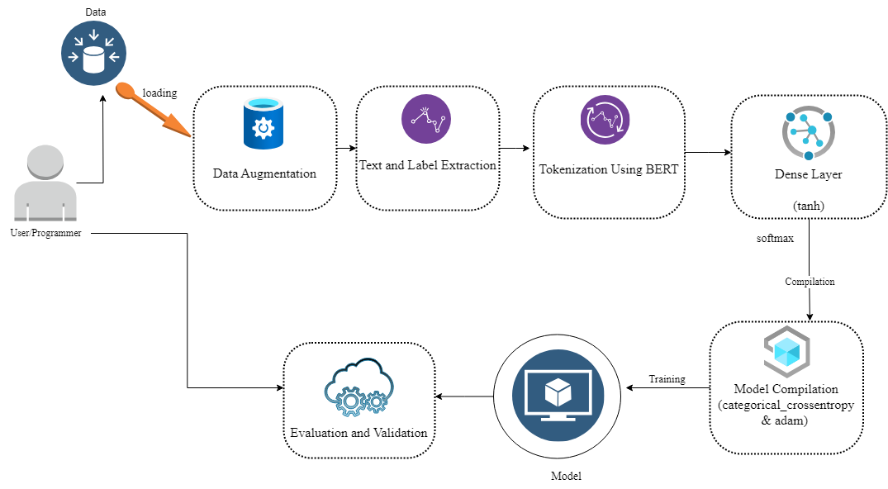
Figure 3.1 Depicts the Proposed Hate-Speech Detector System Conceptual Design Framework.

Consider Figure 3.1 above, which depicts a conceptual design of the Hate Speech Detector. The design specifies several components and their interactions, such as the moderator, user interface, categorization layer, BERT-Attention Mechanism, Embedding Layer, and so on. The next subsection explains each component's role in the design.

3.3.1.1 The User/Programmer

The user could be a person, tools, or algorithms that performs actions based on the specific type of hate speech detected, evaluating and validating the model's performance.

3.3.1.2 Data Augmentation
Back translation was used to supplement the dataset. Back translation is the process of translating a sentence from one language to another and then back to the original. This might result in variations in the translated content due to variances in linguistic semantics, syntax, and word choice between languages. This method aids in the creation of new sentences that are similar yet somewhat different. There were two reasons for doing this:
- Increase Dataset Size: Back Translation helps in enlarging the dataset by creating new, synthetic text samples, thereby providing more data for model training.
- Diversity and Robustness: The variations introduced by translation and back translation can help the model become more robust by exposing it to different sentence structures, word choices, and nuances, which may improve its generalization ability.

3.3.1.3 Text and Label Extraction

Texts from the dataset are extracted, as are their accompanying labels. The labels cover seven different categories of hate speech, with variable percentages of hate speech expressed in the text.

3.3.1.4 Tokenization using BERT: A Pre-processing Technique in NLP
Pre-processing in natural language processing (NLP) entails cleaning and altering raw text input for use in NLP tasks. It includes numerous steps:
- Lowercase text promotes uniformity by treating words with different cases as the same entity (e.g., "Word" and "word").
- ii. Removing unnecessary punctuation and symbols.
- Removing Numbers: To simplify text analysis, numbers might be eliminated if irrelevant.
- Handling Contractions: Words like "can't" can be enlarged for consistency, however this step may differ depending on the assignment.
- Eliminating Stop Words: Remove common words like "and," "the," etc. to emphasize more significant words.
- Stemming and lemmatization: These techniques break down words into their basic or root forms, such as "running" to "run". Lemmatization assures that the words are legitimate.
Pre-processing ensures that text data is uniform, clean, and ready for analysis.
Tokenization: This procedure divides down text into smaller components known as tokens. Tokens might be words, sentences, subwords, or characters, depending on the assignment.
An example of word-level tokenization:
- From the user: "Pre-processing is essential for NLP tasks."
- Output tokens: ["Pre-processing", "is", "essential", "for", "NLP", "tasks", "."].
Tokenization is essential for many NLP activities since it allows for representation as numerical vectors (word embeddings) that may be fed into machine learning algorithms or neural networks.
3.3.1.5 Word Embedding
Word embedding converts words into fixed-size numerical vectors, capturing semantic relationships based on their usage in text corpora. Unlike sparse one-hot encoding, word embeddings are dense and lower-dimensional, learned from large text data.
Word2Vec, a popular algorithm, maps semantically similar words close together in the embedding space. It enhances NLP tasks like machine translation, text generation, and sentiment analysis.

3.3.1.6 Dense Layer
The dense layers in are essential for enabling the neural network to learn complex patterns, introduce non-linearity, reduce dimensionality, and map the learned features to the specific classes in your multi-class classification problem. They play a crucial role in transforming the abstract representations from the earlier layers into meaningful predictions.
A dense layer is a fully connected layer where each neuron in the layer receives input from every neuron in the previous layer. It is necessary because:
- Capturing Complex Patterns: Dense layers are excellent at capturing complex patterns in data. After the initial layers (like BERT's transformer layers) extract hierarchical features from the text, dense layers help in learning intricate patterns and relationships between these features. This is crucial for understanding the nuances in the text data.
- Non-linearity and Activation Function: The tanh activation function applied in the dense layers introduces non-linearity into the model. Neural networks rely on non-linear activation functions to learn and approximate complex, non-linear relationships within the data. The non-linearity allows the model to capture more intricate patterns in the input data.
- Dimensionality Reduction: The dense layers can act as a form of dimensionality reduction. The output from the BERT model might be in a high-dimensional space, and dense layers help reduce this high dimensionality to a manageable level. This reduction can make the model computationally efficient while retaining essential features for classification.
- Learning Task-Specific Representations: Dense layers help in transforming the abstract, high-level features extracted by the preceding layers (such as BERT) into task-specific representations. In your case, the model is learning to map these features to the specific classes/categories defined by num_classes.
- Activation Function for Output Layer: The final dense layer with the softmax activation function is particularly important. Softmax converts the raw output scores into probabilities. Each neuron in the output layer corresponds to a class, and softmax ensures that the output values represent probabilities, making it suitable for multi-class classification tasks.

3.3.1.7 Model Compilation
The model is built using the categorical cross-entropy loss function, which is appropriate for multi-class classification applications. The Adam optimizer is used for training, and accuracy is chosen as the metric to assess the model's performance during training.

3.3.2 Sequence diagram of the proposed system
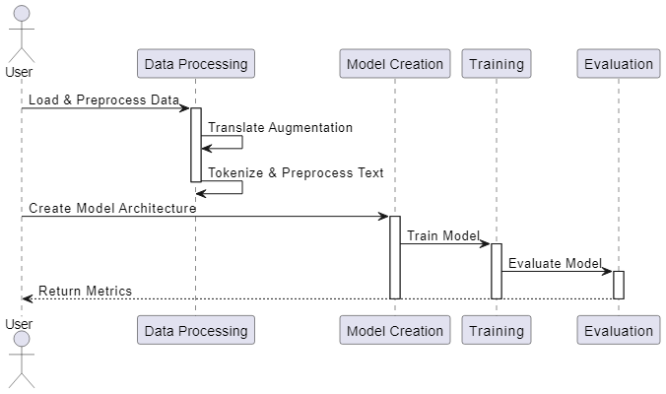
Fig 3.2: Sequence diagram of the suggested system
Figure 3.2 depicts the system's sequential actions. The sequence diagram depicts the flow of actions and data across the system's modules and components, from raw text input to the creation of a trained machine learning model saved in a file for later usage. Each module plays an important role in data processing and transformation, ultimately leading to the development of an effective neural network model for text classification.
a. User:
- Identifies the user engaging with the system.
b. Data Processing (DP):
- Handles data-related tasks like loading, preprocessing, and augmentation.
- Receives user request to load and preprocess data.
c. Model Creation (MC):
- Creates and defines the machine learning model architecture.
d. Training (T):
- Use preprocessed data to train the constructed model.
- Activation occurs following the Model Creation phase.
e. Evaluation (E):
- Assesses the performance of the trained model using metrics.
- Evaluates the trained model after the Training phase.

3.3.3 Flowchart Diagram of the Proposed System
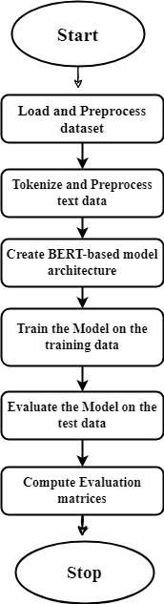

Fig 3.3: Flowchart diagram of the proposed system
The image in Figure 3.3 depicts the procedures performed by the user and the model to assess whether a comment is hate speech or not. The flowchart depicts the sequential flow of your project's tasks, decisions, and procedures, beginning with raw text input and progressing through preprocessing, tokenization, word embedding, neural network model building, training, and finally saving the trained model for future use. Each stage is critical in converting raw text data into a trained machine learning model capable of generating predictions on new data. It begins with:

- User to Data Processing:
i. The user requests Data Processing to load and preprocess their data.
ii. Data Processing includes translation augmentation, text tokenization, and other necessary data preprocessing.
- User Request for Model Creation:
i. The user requests that the model architecture be created.
ii. Model Creation defines the architecture of the machine learning model using preprocessed data.
- Model Creation to Training:
i. The Model Creation phase transfers the described model to the Training phase.
ii. Models are trained using processed data.
- Training to Evaluation:
i. Once trained, the model is sent to the evaluation phase.
- Evaluation measures the performance of the Training to Evaluation:
  - After the model is trained, it is passed to the Evaluation phase.
  - Evaluation assesses the performance of the trained model using various metrics.
- Evaluation to User:
  - Finally, the Evaluation phase sends the evaluated metrics back to the User for review and analysis.

CHAPTER FOUR

4.0 SYSTEM IMPLEMENTATION AND TESTING

4.1 Choice of Programming Language
Python is the programming language utilized to implement the suggested system. Python stands out as the best language for natural language processing (NLP) and machine learning projects because of its extensive ecosystem and multiple benefits. Its extensive library support, including TensorFlow, PyTorch, NLTK, and spaCy, provides critical tools for developing complicated models and rapidly processing text data. Python's readability and simplicity make it easy to understand and produce code, which is essential for complex tasks. Furthermore, its huge and active developer community provides a multitude of tools, tutorials, and open-source projects, making problem solving easier and keeping up with the latest improvements.
Python excels at data analysis and visualization with packages such as pandas, NumPy, and Matplotlib, which allow for rapid data manipulation and exploration. Its adaptability enables the seamless integration of various project components, resulting in a smooth workflow and cooperation. Python also has sophisticated machine learning tools, such as TensorFlow and PyTorch, which make it easier to create deep learning models and experiment with different architectures. Python also enables a variety of deployment methods, making it ideal for real-time forecasts and large-scale data processing. Its rapid prototyping capabilities allow academics and data scientists to experiment quickly, resulting in incremental improvements to model performance. These elements combine to make Python the best option for your NLP and machine learning projects, since it provides the required tools, community support, and flexibility.

4.2 System Requirement

The system requirements are divided into two parts: hardware and software requirements.

4.2.1. Hardware Requirements
  - CPU: A multi-core processor (e.g., Intel Core i5 or i7) is necessary for parallel processing, particularly in data pre-processing and training.
  - GPU (optional, but recommended): A suitable NVIDIA GPU (such as the NVIDIA GeForce GTX or RTX series) with CUDA support speeds up deep learning training procedures dramatically. Libraries such as TensorFlow and PyTorch can use GPU resources to accelerate computations. If your models are complex and training times are a concern, investing in a GPU can help.
  - Machine learning tasks typically demand at least 8 GB of RAM. However, for larger datasets and complicated models, 16 GB or more is advised to enable smooth processing and avoid memory constraints.
  - SSD (Solid State Drive) outperforms HDD (Hard Disk Drive) for better data read/write rates. Machine learning projects frequently entail dealing with large datasets and models, therefore fast storage is critical for effective data access.

4.2.2Software Requirements
i. Python: Install the newest version of Python on your PC.
ii. IDE (Integrated Development Environment): Use popular IDEs like Jupyter Notebook, JupyterLab, PyCharm, or VSCode to code and experiment.
iii. Install required libraries (e.g. TensorFlow, PyTorch, scikit-learn, pandas, NumPy) using package managers such as pip.
iv. Downloading datasets, pre-trained models, and library updates requires an internet connection. It also provides access to internet resources and forums for problem solutions.
Consider using version control systems (e.g. Git, GitHub, GitLab) to monitor changes, collaborate with team members, and maintain project history.

The Implemented System
The whole implementation of the hate speech detector based on the hybridize BERT-attention mechanism and context analyzer must go through a design life cycle.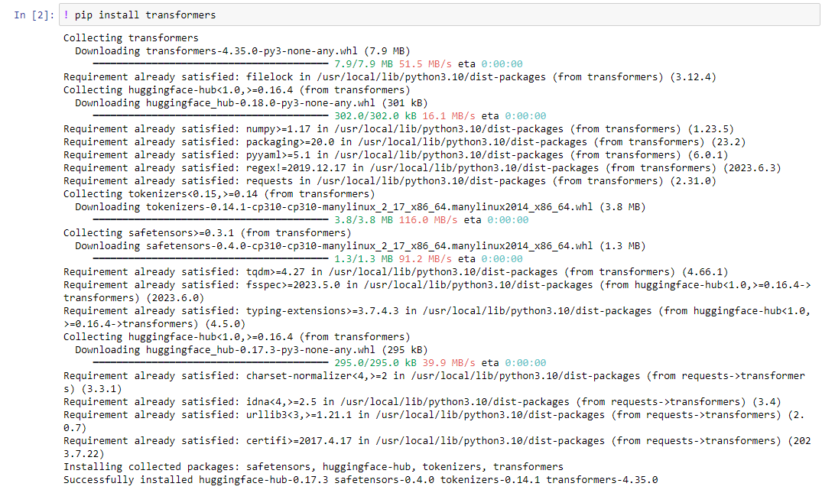
Figure 4.1: Displays the command used to install the "transformers" library in a Python environment.
Hugging Face produced the "transformers" library, which contains a set of pre-trained natural language processing (NLP) models, including cutting-edge models such as BERT, GPT, RoBERTa, and others. These models are commonly employed for a variety of NLP applications, including text categorization, named entity recognition, question answering, and language production.
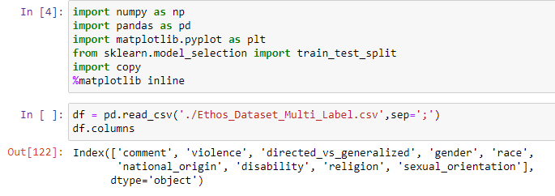
Figure 4.2: Shows importation of necessary libraries
The libraries for visualization, data framing, and machine learning were imported, and the dataset was loaded into a variable called df, with each attribute displayed.
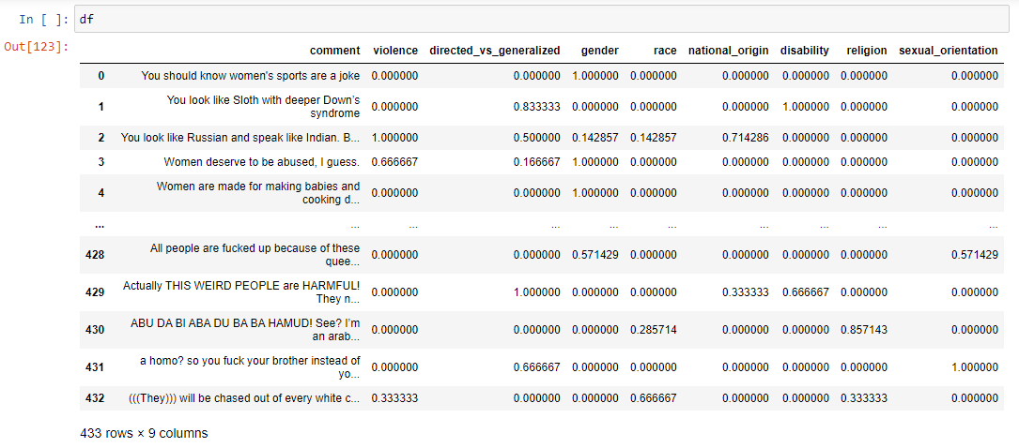
Figure 4.3: Shows the head and tail of the dataset
The first and last four rows of the complete dataset were shown, which included all of the dataset's attributes. Each comment is allocated a proportion of different hate speech.
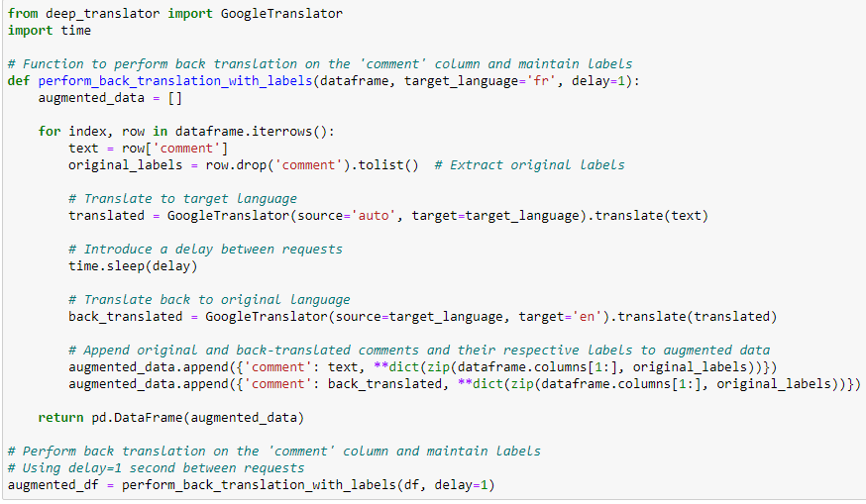
Figure 4.4: Shows the data augmentation process of the dataset.
During the project's phase, the comment column was translated in a systematic manner using the deep_translate module, which makes use of the Google translation API. Each comment was thoroughly reviewed and properly translated into French. To ensure efficient API utilization and avoid overloading the service, a 1-second wait between translations was established. Following this, all comments were re-translated back into English, resulting in a comprehensive augmented dataset. This augmentation process aims not only to increase the dataset size, but also to expose the model to a variety of linguistic nuances and complex terminology. The goal of incorporating this diverse dataset was to improve the model's understanding of subtle language nuances and facilitate its ability to acquire similar linguistic constructs, hence increasing its hate speech detection capabilities.
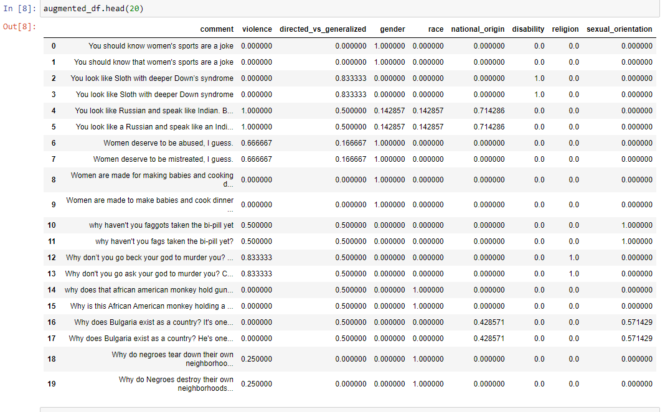
Figure 4.5: Shows the new augmented dataset
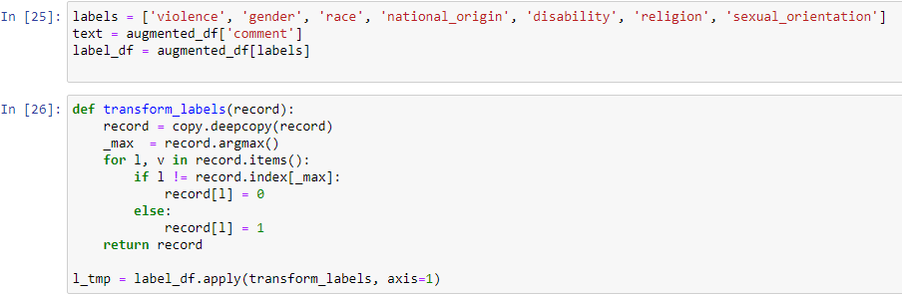
Figure 4.4: Shows the label extraction and a normalization algorithm used
The labels were extracted and saved to a variable called 'label', and a program was built to normalize the dataset into a multiclass binary classification dataset, which was then converted into a binary form using the argmax function. This was accomplished by cycling over each index and assigning 1 to the property with the highest percentage value, while truncating the values of all other indexes to 0. The function was then applied to the specified labels.
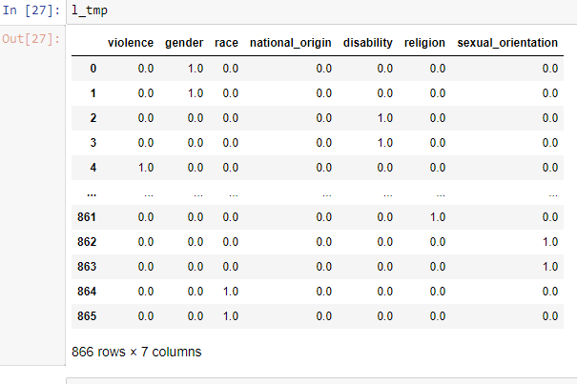
Figure 4.6: Shows the result of the custom normalization algorithm used.
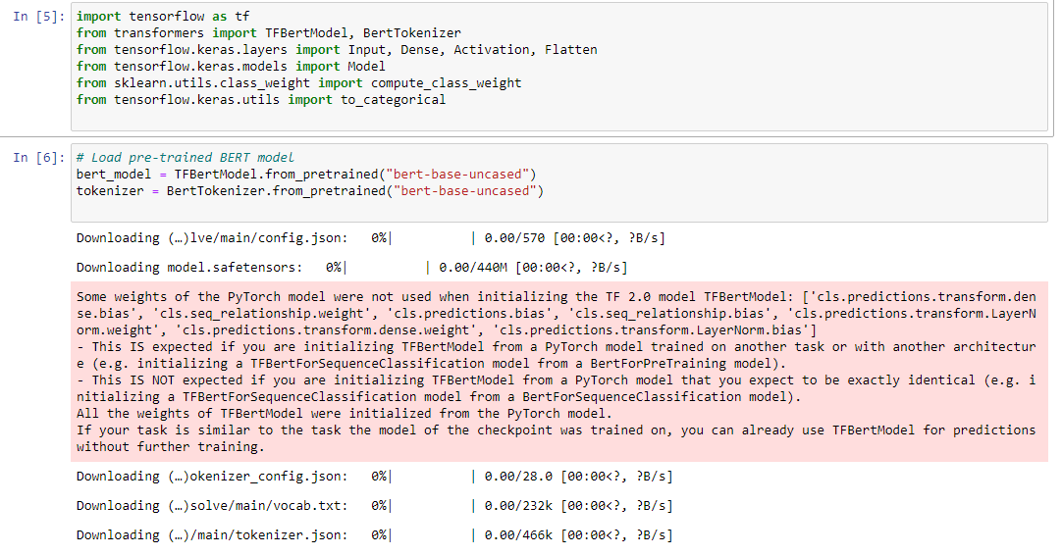
Figure 4.7: Shows the loading of pre-trained BERT model and BERT tokenizer

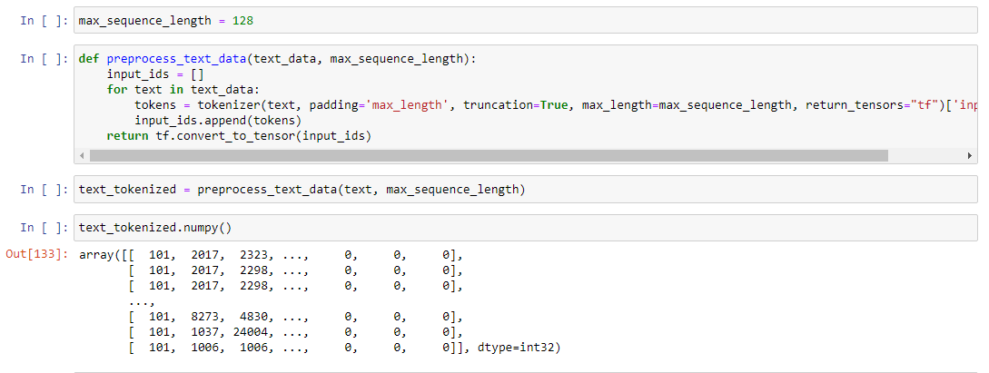
Figure 4.8: Shows a custom function for the data tokenization
This section of code aims to prepare text data for input into a natural language processing (NLP) model. This entails tokenizing the text, which means breaking it down into smaller components known as tokens and translating them into numerical representations that the machine learning model can understand.
The maximum sequence length is 128, which is the maximum amount of tokens that each text sequence should include after tokenization. The "preprocess_text_data" function is intended to prepare raw text data for use in machine learning models. This function takes a list of text strings (text_data) and the "max_sequence_length" parameter as input. Within the function, each text string is tokenized using the tokenizer object. The padding='max_length' and truncation=True parameters ensure that all sequences adhere to the defined'max_sequence_length' by padding shorter sequences or truncating longer ones. The tokenized representations that result are saved in a list called "input_ids".
Following the processing of all text strings, this list is turned into TensorFlow tensors using tf.convert_to_tensor(). These tensors, denoted by the variable "text_tokenized", now contain the processed input data, with each sequence converted into a numerical format suitable for training or feeding into the natural language processing model. This pre-processing step is critical because it turns raw textual information into a format that machine learning algorithms can understand, allowing for rapid training and accurate predictions later in the project.
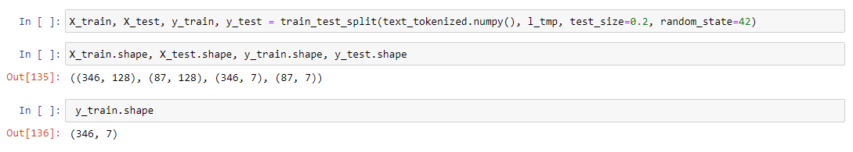
Figure 4.9: Shows the dataset split into training and testing sets
The 'train_test_split' function is used to divide the preprocessed and tokenized text data (text_tokenized) and their related labels (l_tmp) into separate sets for training and testing. The technique first converts the tokenized text data from TensorFlow tensors to NumPy arrays using the numpy() method, which allows for compatibility with scikit-learn routines. The l_tmp variable stores the binary labels associated with the processed text data, which were previously prepared for multi-label classification. The test_size=0.2 parameter specifies that 20% of the data should be used for testing, with the remaining 80% for training the machine learning model.
Additionally, using random_state=42 assures that the data splitting is reproducible, as using the same random seed results in consistent data division across multiple executions of the code. As a result, four separate sets are generated: X_train (the training data containing tokenized text sequences), X_test (the testing data used to evaluate the model's performance), y_train (the associated training labels), and y_test (the testing labels). These segregated datasets allow the model to be trained on a subset of the data and evaluated for prediction accuracy on unknown data, both of which are critical steps in determining the model's usefulness and reliability in real-world applications.
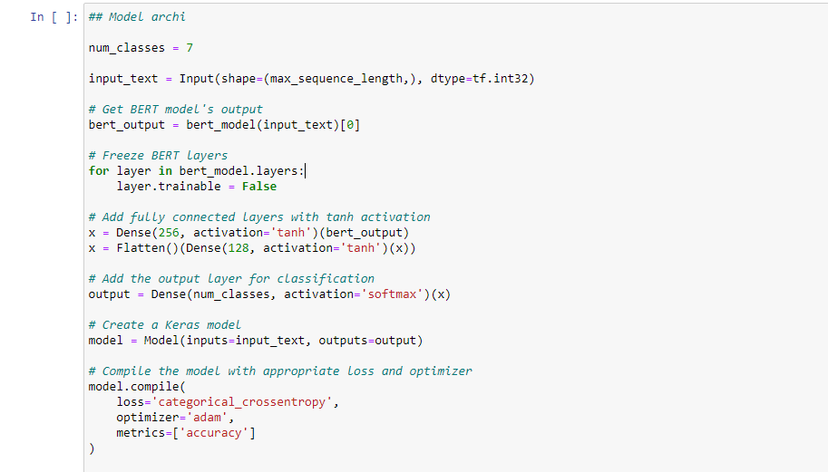
Figure 4.10: Shows the model’s implementation architecture
The neural network model architecture is defined for the multi-label classification challenge utilizing BERT embeddings.
The first line, num_classes = 7, indicates that the categorization task consists of seven classes. Each class refers to a distinct category or label.The following line defines an input layer for the neural network. input_text = Input(shape=(max_sequence_length), dtype=tf.int32) specifies that the input data will be sequences of length'max_sequence_length'. This input shape matches the pre-processed tokenized text data.
The next lines use the pre-trained BERT model (bert_model) to generate an output based on the given input text. bert_output = bert.model(input_text)[0] captures the BERT model's output tensor, which represents the input sequences' contextual embeddings.
To prohibit changes to the pre-trained BERT layers during the training process, a loop freezes all BERT model layers: 'for layer in bert_model.layers: layer.trainable = False'. This phase ensures that the BERT embeddings remain fixed when the additional layers are trained.
The neural network architecture evolves with the addition of dense fully linked layers. The line x = Dense(256, activation='tanh')(bert_output) creates a dense layer of 256 units with the hyperbolic tangent (tanh) activation function. Next, another dense layer with 128 units and tanh activation is added: x = Flatten()(Dense(128, activation='tanh')(x). These layers let the model learn complicated patterns and representations from BERT embeddings.
The final output layer is defined as output = Dense(num_classes, activation='softmax')(x), which uses the softmax activation function. The softmax function distributes probabilities to each class, indicating the likelihood that the input belongs to that category.
The code then creates the Keras model with the specified input and output layers: model = Model(inputs=input_text, outputs=output). This model represents the full architecture, from input to output.
Finally, the model is built with the categorical cross-entropy loss function (loss='categorical_crossentropy'), the Adam optimizer (optimizer='adam'), and the accuracy metric for assessment. This setup prepares the model for training by describing how it measures performance and adjusts weights during the optimization process. The generated model is now ready for training and can be fine-tuned or graded according to the classification task at hand.
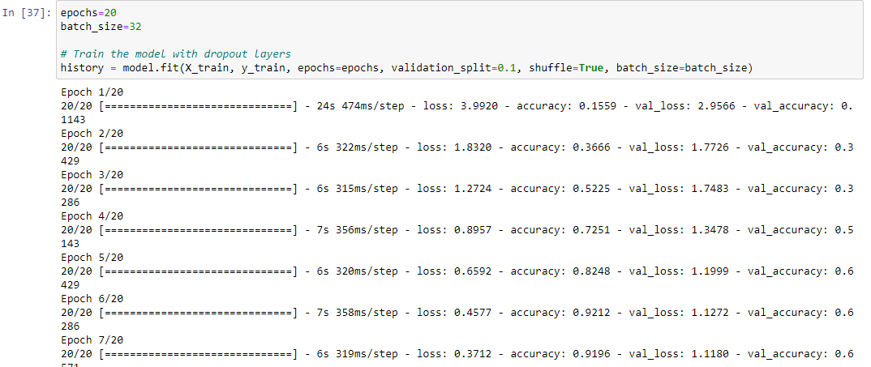
Figure 4.11: Shows the fitting and training of the model
The neural network model is trained with the given parameters and training data. The epochs=20 line specifies the number of epochs, which indicates how many times the model will process the complete training dataset while training. An epoch is defined as a complete trip across the entire training dataset. In this scenario, the model will iterate through the dataset 15 times, giving it the opportunity to learn from the data over time.
The batch_size=32 line specifies the batch size, which controls the number of samples used in each iteration. The batch size is set to 32, indicating that the model will process 32 samples at once before updating its weights. Batch training has various advantages, including reduced memory utilization and faster training times.
The subsequent code block history equals model.fit(X_train, y_train, epochs=epochs, validation_split=0.1, shuffle=True, batch_size=batch_size) starts the training procedure. X_train represents the input training data (tokenized text sequences), while y_train denotes the training labels. The validation_split=0.1 option specifies that 10% of the training data will be used for validation while training. The shuffle=True parameter guarantees that the training data is shuffled before each epoch, preventing the model from memorizing the sample order, which could lead to overfitting. Finally, the batch_size option indicates the batch size utilized during training, which matches the previously determined value.
During training, the model learns to map input sequences to their labels while improving its internal parameters (weights and biases) using the provided loss function and optimization algorithm. The history variable records and stores training progress as well as performance measures like accuracy, loss, validation accuracy, and validation loss.
This training procedure enables the neural network to iteratively improve its capacity to categorize text data by modifying its parameters to minimize the loss function. After training, the model's performance on unknown data may be assessed, offering insights into its suitability for the given classification task.
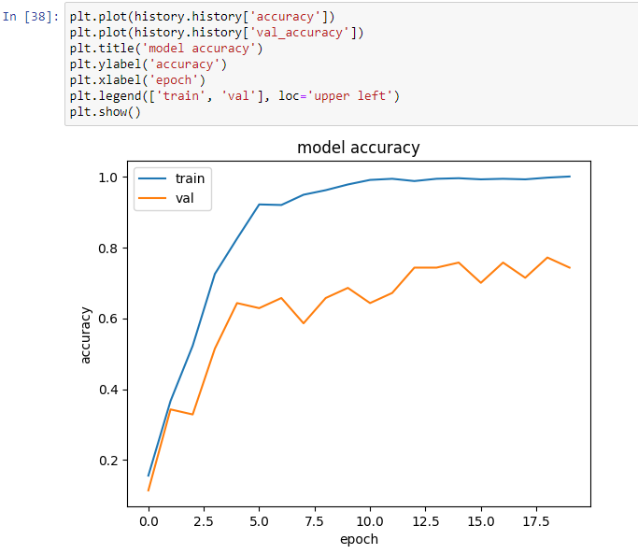
Figure 4.12: Shows the accuracy of the model on the training dataset and on the validation set
As shown, the model performs admirably on both the training and validation sets, and it generalizes and learns with each epoch, as evidenced by a consistent rise in accuracy.

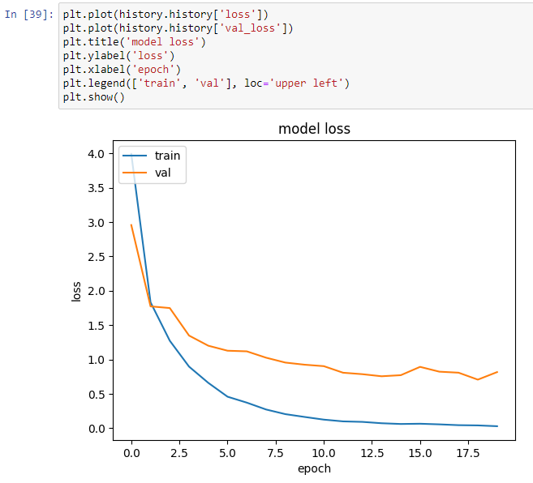
Figure 4.13: Shows the loss of the model on the training and the validation dataset
The graph demonstrates a consistent decrease in loss after each epoch, indicating that the model is learning to make fewer errors in both the training and validation datasets.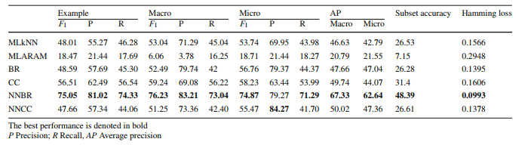
Figure 4.14: Show the evaluation from the work of Mollas et al (2021).
Different models were built to test this dataset and different results were gotten.
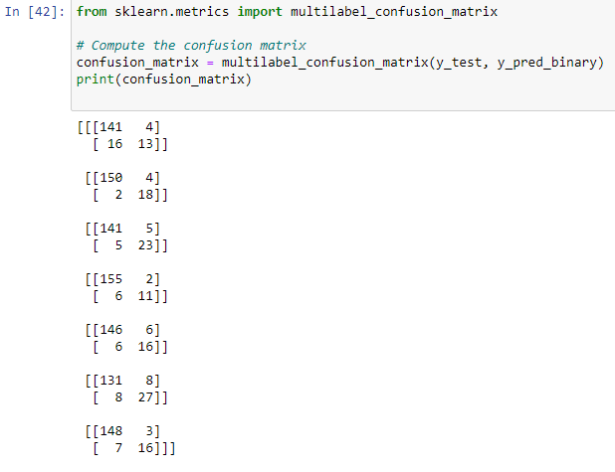
Figure 4.15: Show the confusion matrix of each class of hate speech for the proposed BERT
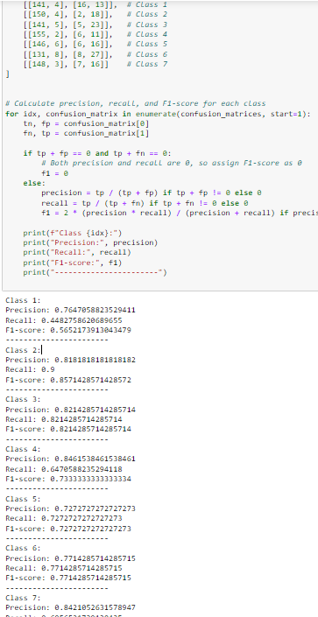
Figure 4.16: Shows the evaluation matrices for all classes
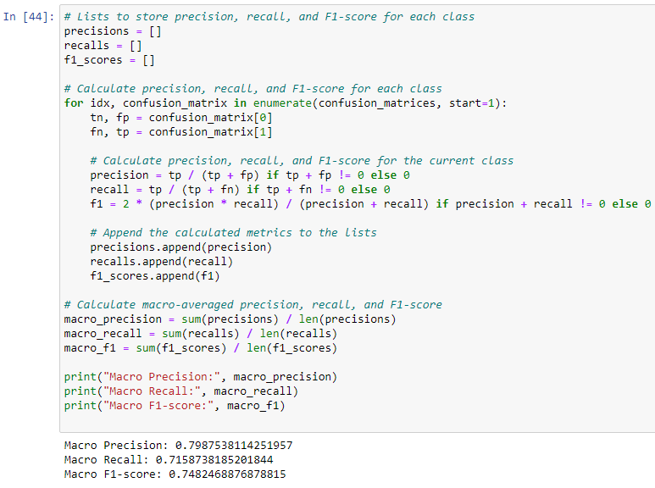
Figure 4.17: Shows the Macro Evaluation scores for all for this model.

CHAPTER FIVE

5.0 SUMMARY, CONCLUSION AND RECOMMENDATION
5.1 Summary
Hate speech is a serious societal issue, and this initiative addresses it by using advanced natural language processing techniques to counteract it online. Hate speech, a type of damaging communication, continues to spread across digital platforms, posing substantial difficulties to online communities and individuals. In response to this growing concern, the project aims to develop an innovative hate speech detection system based on a hybridized method that combines the capabilities of the BERT (Bidirectional Encoder Representations from Transformers) attention mechanism with a context analyzer.
5.2 Conclusion
The core of this study is a complete understanding of hate speech and its nuances in many circumstances. Hate speech includes many sorts of discriminatory rhetoric directed at specific social groups based on characteristics such as race, gender, religion, and sexual orientation. To provide a broad and strong dataset, careful efforts were made to supplement the current data. Data augmentation approaches, including back translation supported by the deep-translator library, were used. This technique allowed for the development of more data points, increasing the dataset's size and variety, which is critical for training an effective hate speech detection algorithm.
Using cutting-edge BERT attention mechanisms, the study attempts to capture the intricate contextual relationships within textual data, allowing for a more detailed examination of hate speech patterns. Furthermore, the addition of a context analyzer improves the model's capacity to distinguish between hate speech and legitimate utterances, resulting in improved detection accuracy.
The system creates a strong and efficient hate speech detection model by meticulously pre-processing, tokenizing, and training textual data. The hybridized BERT attention mechanism not only identifies obvious hate speech but also recognizes subtle nuances and hidden meanings, allowing for a more comprehensive understanding of harmful information.
The addition of a context analyzer improves the model's predictive powers by allowing it to differentiate between real expressions and potentially harmful language, considerably contributing to online safety and building inclusive digital environments.
This effort represents a big step forward in the ongoing campaign against online hate speech. Using cutting-edge natural language processing techniques, the project intends to develop a complex, accurate, and context-aware hate speech detection system. This initiative is consistent with the larger societal purpose of developing courteous online interactions, promoting diversity, and reducing the negative impact of hate speech on vulnerable communities, thus contributing to a safer and more tolerant digital landscape.
This work represents a significant step forward in the fields of natural language processing and online safety. By combining the strength of BERT attention mechanisms with a context analyzer, this novel approach exhibits a thorough awareness of the intricacies of hate speech, allowing for reliable identification and classification of harmful information. The project's comprehensive strategy, which includes pre-processing, tokenization, and advanced modeling approaches, ensures that the system is strong and reliable in distinguishing between genuine phrases and offensive language. As hate speech remains a problem in digital settings, this research not only contributes considerably to continuing efforts to address online toxicity, but it also sets the groundwork for developing more inclusive and courteous online environments. This initiative stands out for its sophisticated technologies and nuanced understanding of hate speech.

5.2 Recommendation

Based on the thorough analysis and implementation carried out in this research, it is proposed that the hate speech detection model be refined further by experimenting with new techniques such as ensemble learning or hyper-parameter fine-tuning. Furthermore, completing detailed evaluations on real-world, diverse datasets helps improve the model's generalizability. Collaborating with languages and social science professionals can provide useful insights for improving preprocessing stages and context analysis. Furthermore, regular monitoring and updating of the model is required to respond to changing language patterns and emergent hate speech methods. Finally, including explainable AI methods can improve transparency by allowing people to comprehend the model's judgments, increasing confidence and usefulness in real-world applications.

5.3 Suggestion for Further Work
Given the difficulties discovered during this experiment, it is recommended that future work focus on tackling the issue of class imbalance, which is widespread in hate speech detection. Exploring advanced techniques like oversampling and synthetic data synthesis could help build a more balanced dataset, resulting in better model performance. Furthermore, conducting a thorough examination of false positives and false negatives to discover the specific sorts of hate speech that the model suffers with can aid in the creation of more effective preprocessing and feature engineering tactics. Collaboration with domain experts to improve the contextual analysis and sentiment interpretation can help the model recognize subtle subtleties in language. Furthermore, researching interpretable machine learning methods would provide clearer insights into model decisions and predictions. Finally, continual monitoring and adaption of the model to shifting hate speech trends and online groups is critical for the system's long-term efficacy.

References
Aljabri, M., Zagrouba, R., Shaahid, A., Alnasser, F., Saleh, A., & Alomari, D. M. (2023). Machine learning-based social media bot detection: A comprehensive literature review. Social Network Analysis and Mining, 13(1), 20.
Ben Lutkevich, 2023 BERT language model https://www.techtarget.com/searchenterpriseai/definition/BERT-language-model
Davidson, T., Warmsley, D., Macy, M., & Weber, I. (2017, May). Automated hate speech detection and the problem of offensive language. In Proceedings of the international AAAI conference on web and social media (Vol. 11, No. 1, pp. 512-515).
Fetahi, E., Hamiti, M., Susuri, A., Shehu, V., & Besimi, A. (2023, June). Automatic Hate Speech Detection using Natural Language Processing: A state-of-the-art literature review. In 2023 12th Mediterranean Conference on Embedded Computing (MECO) (pp. 1-6). IEEE.
Florio, K., Basile, V., Polignano, M., Basile, P., & Patti, V. (2020). Time of your hate: The challenge of time in hate speech detection on social media. Applied Sciences, 10(12), 4180.
Fortuna, P., & Nunes, S. (2018). A survey on automatic detection of hate speech in text. ACM Computing Surveys (CSUR), 51(4), 1-30.
Ghojogh, B., & Ghodsi, A. (2020). Attention mechanism, transformers, BERT, and GPT: tutorial and survey.
Gomez, R., Gibert, J., Gomez, L., & Karatzas, D. (2020). Exploring hate speech detection in multimodal publications. In Proceedings of the IEEE/CVF winter conference on applications of computer vision (pp. 1470-1478).
Harris, M. D. (1985). Introduction to natural language processing. Reston Publishing Co.
Hatexplain: A benchmark dataset for explainable hate speech detection. In Proceedings of the AAAI conference on artificial intelligence (Vol. 35, No. 17, pp. 14867-14875).
Hayes, P., & Ford, K. (1995, August). Turing test considered harmful. In IJCAI (1) (pp. 972-977).
Hoffmann, C. H. (2022). Is AI intelligent? An assessment of artificial intelligence, 70 years after Turing. Technology in Society, 68, 101893.
IBM 2023, what is machine learning?
https://www.ibm.com/topics/machine-learning
Kitchenham, B. (2004). Procedures for performing systematic reviews. Tech. rep.: Keele University, Department of Computer Science.
Kovács, G., Alonso, P., & Saini, R. Challenges of hate speech detection in social media-SN computer science.
Kwok, I., & Wang, Y. (2013, June). Locate the hate: Detecting tweets against blacks. In Proceedings of the AAAI Conference on Artificial Intelligence (Vol. 27, No. 1, pp. 1621-1622).
Mathew, B., Saha, P., Yimam, S. M., Biemann, C., Goyal, P., & Mukherjee, A. (2021, May).
MacAvaney, S., Yao, H. R., Yang, E., Russell, K., Goharian, N., & Frieder, O. (2019). Hate speech detection: Challenges and solutions. PloS one, 14(8), e0221152.
McCarthy, J. (2004). What is artificial intelligence?
Mosca, E., Wich, M., & Groh, G. (2021, June). Understanding and interpreting the impact of user context in hate speech detection. In Proceedings of the Ninth International Workshop on Natural Language Processing for Social Media (pp. 91-102).
Mullah, N. S., & Zainon, W. M. N. W. (2021). Advances in machine learning algorithms for hate speech detection in social media: a review. IEEE Access, 9, 88364-88376.
Poletto, F., Basile, V., Sanguinetti, M., Bosco, C., & Patti, V. (2021). Resources and benchmark corpora for hate speech detection: a systematic review. Language Resources and Evaluation, 55, 477-523.
Qiu, X., Sun, T., Xu, Y., Shao, Y., Dai, N., & Huang, X. (2020). Pre-trained models for natural language processing: A survey. Science China Technological Sciences, 63(10), 1872-1897.
Roy, P. K., Tripathy, A. K., Das, T. K., & Gao, X. Z. (2020). A framework for hate speech detection using deep convolutional neural network. IEEE Access, 8, 204951-204962.
Samuel, A. L. (2000). Some studies in machine learning using the game of checkers. IBM Journal of research and development, 44(1.2), 206-226.
Saleh, H., Alhothali, A., & Moria, K. (2023). Detection of hate speech using BERT and hate speech word embedding with deep model. Applied Artificial Intelligence, 37(1), 2166719.
Shi, W., Zhang, M., Zhang, R., Chen, S., & Zhan, Z. (2020). Change detection based on artificial intelligence: State-of-the-art and challenges. Remote Sensing, 12(10), 1688.
Sigurbergsson, G. I., & Derczynski, L. (2019). Offensive language and hate speech detection for Danish. arXiv preprint arXiv:1908.04531.
Taylor, W. L. (1953). “Cloze procedure”: A new tool for measuring readability. Journalism quarterly, 30(4), 415-433.
Toosi, A., Bottino, A. G., Saboury, B., Siegel, E., & Rahmim, A. (2021). A brief history of AI: how to prevent another winter (a critical review). PET clinics, 16(4), 449-469.
Xia, M., Field, A., & Tsvetkov, Y. (2020). Demoting racial bias in hate speech detection. arXiv preprint arXiv:2005.12246.
Zimmerman, S., Kruschwitz, U., & Fox, C. (2018, May). Improving hate speech detection with deep learning ensembles. In Proceedings of the eleventh international conference on language resources and evaluation (LREC 2018).

Appendix
# -*- coding: utf-8 -*-
"""Notebook.ipynb

Automatically generated by Colaboratory.

Original file is located at
https://colab.research.google.com/drive/1nhtJYc9NNJBFwqfAvAeFCVWiqeV2cW5n
"""

! pip install transformers

# Commented out IPython magic to ensure Python compatibility.
import numpy as np
import pandas as pd
import matplotlib.pyplot as plt
from sklearn.model_selection import train_test_split
import copy
# %matplotlib inline

df = pd.read_csv('./Ethos_Dataset_Multi_Label.csv',sep=';')
df.columns

df

!pip install deep-translator

from deep_translator import GoogleTranslator
import time

# Function to perform back translation on the 'comment' column and maintain labels
def perform_back_translation_with_labels(dataframe, target_language='fr', delay=1):
augmented_data = []

for index, row in dataframe.iterrows():
text = row['comment']
original_labels = row.drop('comment').tolist() # Extract original labels

# Translate to target language
translated = GoogleTranslator(source='auto', target=target_language).translate(text)

# Introduce a delay between requests
time.sleep(delay)

# Translate back to original language
back_translated = GoogleTranslator(source=target_language, target='en').translate(translated)

# Append original and back-translated comments and their respective labels to augmented data
augmented_data.append({'comment': text, **dict(zip(dataframe.columns[1:], original_labels))})
augmented_data.append({'comment': back_translated, **dict(zip(dataframe.columns[1:], original_labels))})

return pd.DataFrame(augmented_data)

# Perform back translation on the 'comment' column and maintain labels
# Using delay=1 second between requests
augmented_df = perform_back_translation_with_labels(df, delay=1)

augmented_df.head(20)

labels = ['violence', 'gender', 'race', 'national_origin', 'disability', 'religion', 'sexual_orientation']
text = augmented_df['comment']
label_df = augmented_df[labels]

def transform_labels(record):
record = copy.deepcopy(record)
_max = record.argmax()
for l, v in record.items():
if l != record.index[_max]:
record[l] = 0
else:
record[l] = 1
return record

l_tmp = label_df.apply(transform_labels, axis=1)
l_tmp

l_tmp.isna().sum()

import tensorflow as tf
from transformers import TFBertModel, BertTokenizer
from tensorflow.keras.layers import Input, Dense, Activation, Flatten
from tensorflow.keras.models import Model
from sklearn.utils.class_weight import compute_class_weight
from tensorflow.keras.utils import to_categorical

# Load pre-trained BERT model
bert_model = TFBertModel.from_pretrained("bert-base-uncased")
tokenizer = BertTokenizer.from_pretrained("bert-base-uncased")

max_sequence_length = 128

def preprocess_text_data(text_data, max_sequence_length):
input_ids = []
for text in text_data:
tokens = tokenizer(text, padding='max_length', truncation=True, max_length=max_sequence_length, return_tensors="tf")['input_ids'][0]
input_ids.append(tokens)
return tf.convert_to_tensor(input_ids)

text_tokenized = preprocess_text_data(text, max_sequence_length)

text_tokenized.numpy()

X_train, X_test, y_train, y_test = train_test_split(text_tokenized.numpy(), l_tmp, test_size=0.2, random_state=42)

X_train.shape, X_test.shape, y_train.shape, y_test.shape
y_train.shape

## Model archi
num_classes = 7
input_text = Input(shape=(max_sequence_length,), dtype=tf.int32)

# Get BERT model's output
bert_output = bert_model(input_text)[0]

# Freeze BERT layers
for layer in bert_model.layers:
layer.trainable = False

# Add fully connected layers with tanh activation
x = Dense(256, activation='tanh')(bert_output)
x = Flatten()(Dense(128, activation='tanh')(x))

# Add the output layer for classification
output = Dense(num_classes, activation='softmax')(x)

# Create a Keras model
model = Model(inputs=input_text, outputs=output)

# Compile the model with appropriate loss and optimizer
model.compile(
loss='categorical_crossentropy',
optimizer='adam',
metrics=['accuracy']
)

epochs=15
batch_size=32

# Train the model with dropout layers
history = model.fit(X_train, y_train, epochs=epochs, validation_split=0.1, shuffle=True, batch_size=batch_size)

plt.plot(history.history['accuracy'])
plt.plot(history.history['val_accuracy'])
plt.title('model accuracy')
plt.ylabel('accuracy')
plt.xlabel('epoch')
plt.legend(['train', 'val'], loc='upper left')
plt.show()

plt.plot(history.history['loss'])
plt.plot(history.history['val_loss'])
plt.title('model loss')
plt.ylabel('loss')
plt.xlabel('epoch')
plt.legend(['train', 'val'], loc='upper left')
plt.show()

y_pred = model.predict(X_test)

threshold = 0.5 # Set your threshold value
y_pred_binary = (y_pred > threshold).astype(int)

from sklearn.metrics import multilabel_confusion_matrix

# Compute the confusion matrix
confusion_matrix = multilabel_confusion_matrix(y_test, y_pred_binary)
print(confusion_matrix)

from sklearn.metrics import precision_score, recall_score, f1_score

# List of confusion matrices for all 7 classes
confusion_matrices = [
[[61, 11], [10, 5]],
[[69, 5], [6, 7]],
[[69, 2], [14, 2]],
[[76, 2], [7, 2]],
[[73, 3], [10, 1]],
[[80, 0], [5, 2]],
[[68, 3], [16, 0]]
]

# Calculate precision, recall, and F1-score for each class
for idx, confusion_matrix in enumerate(confusion_matrices, start=1):
tn, fp = confusion_matrix[0]
fn, tp = confusion_matrix[1]

if tp + fp == 0 and tp + fn == 0:
# Both precision and recall are 0, so assign F1-score as 0
f1 = 0
else:
precision = tp / (tp + fp) if tp + fp != 0 else 0
recall = tp / (tp + fn) if tp + fn != 0 else 0
f1 = 2 * (precision * recall) / (precision + recall) if precision + recall != 0 else 0

print(f"Class {idx}:")
print("Precision:", precision)
print("Recall:", recall)
print("F1-score:", f1)
print("-----------------------")

# Lists to store precision, recall, and F1-score for each class
precisions = []
recalls = []
f1_scores = []

# Calculate precision, recall, and F1-score for each class
for idx, confusion_matrix in enumerate(confusion_matrices, start=1):
tn, fp = confusion_matrix[0]
fn, tp = confusion_matrix[1]

# Calculate precision, recall, and F1-score for the current class
precision = tp / (tp + fp) if tp + fp != 0 else 0
recall = tp / (tp + fn) if tp + fn != 0 else 0
f1 = 2 * (precision * recall) / (precision + recall) if precision + recall != 0 else 0

# Append the calculated metrics to the lists
precisions.append(precision)
recalls.append(recall)
f1_scores.append(f1)

# Calculate macro-averaged precision, recall, and F1-score
macro_precision = sum(precisions) / len(precisions)
macro_recall = sum(recalls) / len(recalls)
macro_f1 = sum(f1_scores) / len(f1_scores)

print("Macro Precision:", macro_precision)
print("Macro Recall:", macro_recall)
print("Macro F1-score:", macro_f1)
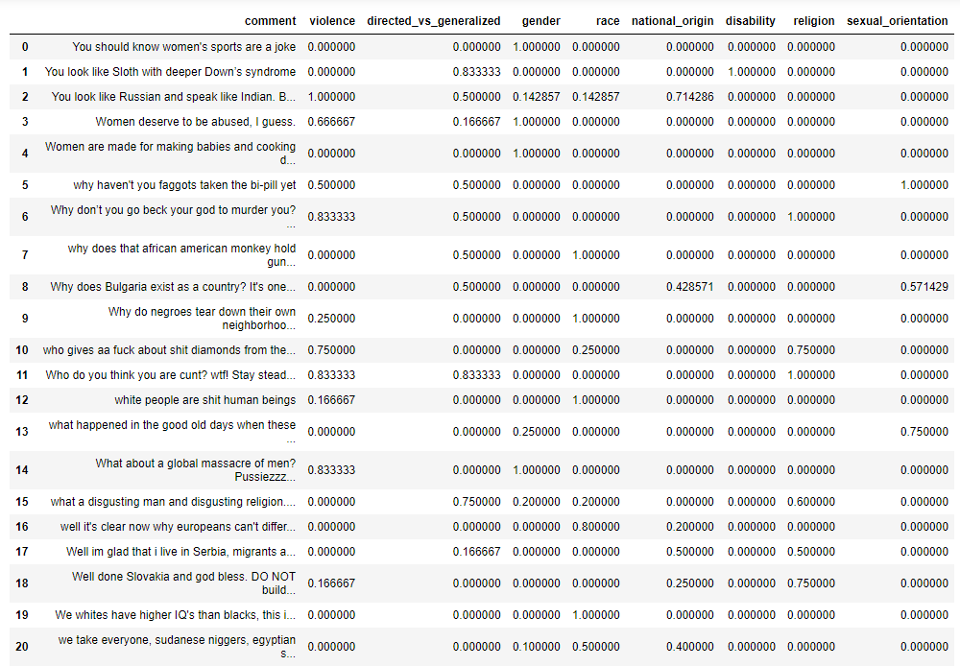
Sample Dataset
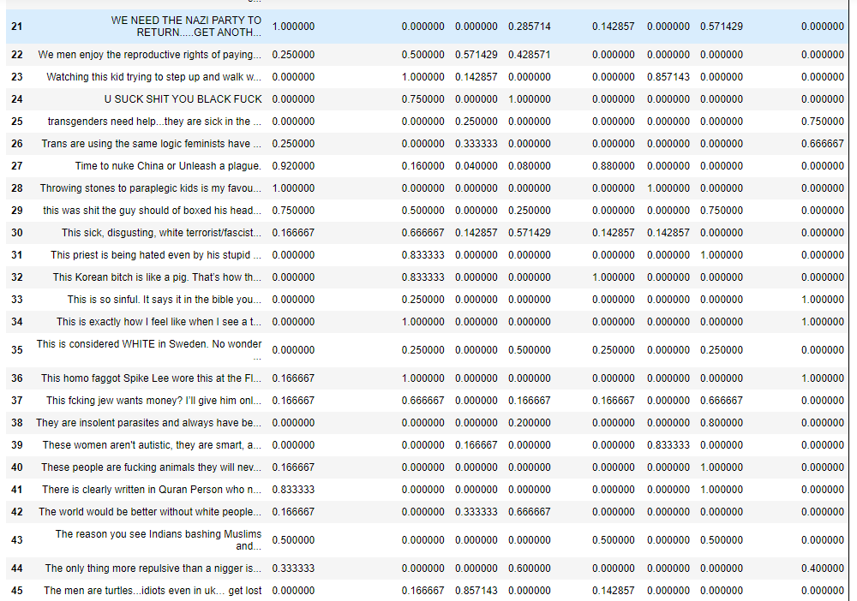
Sample Dataset
