Delphi Demo Sepcification

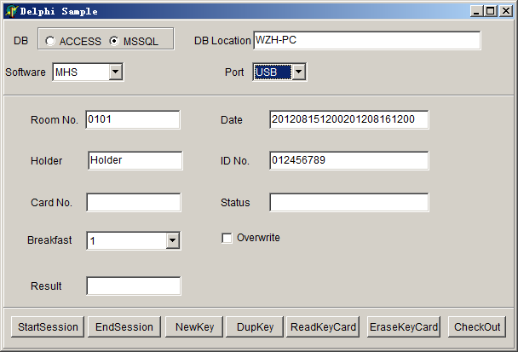

一、Parameters
1、DB: Database,ACCESS：Lock System MSSQL：Lock-S System
2、DB Location:
ACCESS：The location of the Lock System. For example:
C:\Program Files\HONGLG\MHA V8.0
MSSQL：Server Name as SQL Server installed, please refer to Connection Wizard dialog of Lock-S System.

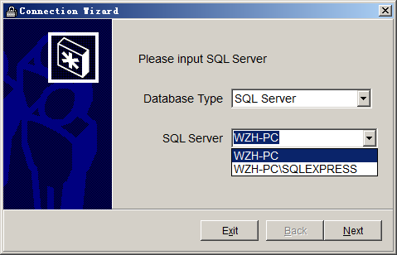
Not: For SQL Server 2005.., the default Server Name with a suffix
\SQLEXPRESS, for detail,please refer to your installation of SQL Server

3、Software: Please select MHS(for mifare), THS(for temic)
4、Port: Please select USB.

5、Room No. : Please refer to Lock No. of Lock-S System.
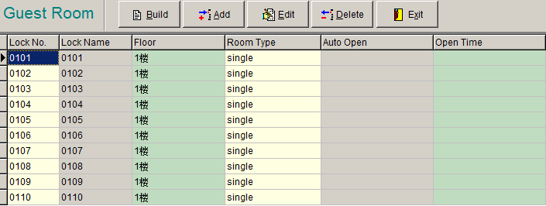
6、Date: Check-in and Check-out time, ‘201208151200201208161200’ represent Check-in time: 8/15/2012 12:00 pm, Check-out time:8/16/2012 12:00 pm.
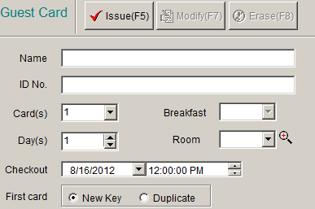
7、Holder、ID No. :The name and ID No. of holder.
8、Card No. : Automatically generated by the Lock-S System, not need to enter.
9、status: The guest card’s status returned by ReadKeyCard function. Please refer to LockDLL.DOC file.
10、Breakfast: Please refer to Guest Card dialog.
11、result: Retern value of functions,please refer to LockDLL.DOC file.
12、overwrite: Replace the data in current card or not. 1 - replace, erase automatically current card if it is not a new card (must be Guest card); 0 – do not replace, return if it is not a new card.

二、Functions
For these functions parameters detail, please refer to LockDLL.DOC file.
1. StartSession
Execute function StartSession (LONG LockCard,LPSTR DBServer,LPSTR LogUser，LONG DBFlag).
The function must be executed first. It initianizes DLL and connects to the database of Lock-S System.
Only after the successful implementation of this function, other functions can be called.
2．EndSession
Execute fuction EndSession (void);
Please execute the function last.
- NewKey
Execute fuction NewKey;
Issue new guest card, this funciton will erase existing guest cards, unlocking with the new guest card, original guest cards will be terminated.

- DupKey
Execute fuction DupKey;
“Duplicate” Guest card, when it is issued, the original guest card will not be affectted, both them will unlocking, and their effective time is same.

5. ReadKeyCard
Read card and display the information of the card

6. EraseKeyCard
Erase card, at the same time, renew data in database.

- CheckOut
Check out, only renew data in database, do not erase card.

Remark: The DEMO and Lock-S system share the database. The DEMO can read and erase the card issued by Lock-S system, in turn the same.

