Python GUI, Visual

What You Will Learn
- Create windows and message boxes
- Control window size and title
- Add text and buttons
- Make buttons react to user actions
- Naturally introduce Python logic later

Exercise 1 – Your First GUI: Message Box
Goal: Display a message on the screen using Python.

Code:

from tkinter import messagebox

messagebox.showinfo("Hello!", "Welcome to your first Python GUI ■")

This code directly opens a message box. You already created a GUI without a window.
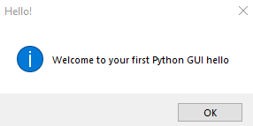

Exercise 2 – Create Your First Window
Goal: Open an empty application window.

Code:

import tkinter as tk

window = tk.Tk() window.mainloop()
Tk() creates the window. mainloop() keeps it running. Every GUI application needs it.

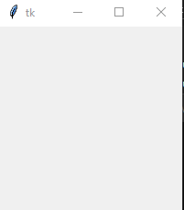

Exercise 3 – Customize Window Size and Title
Goal: Make the window personal.

Code:
import tkinter as tk window = tk.Tk()
window.title("My First App ■") window.geometry("400x300")

window.mainloop()

You changed the title and defined the window size (width x height).
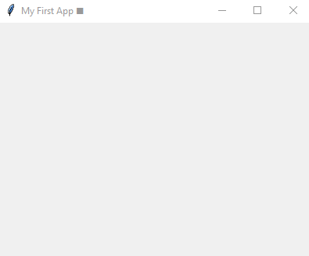

Exercise 4 – Display Text in the Window
Goal: Show text inside the GUI.

Code:

import tkinter as tk

window = tk.Tk() window.title("My App") window.geometry("400x300")

label = tk.Label(window, text="Hello World ■", font=("Arial", 16)) label.pack()

window.mainloop()

Labels are used to display text. pack() places elements automatically inside the window.


Exercise 5 – Add Your First Button
Goal: Add a clickable button.

Code:

import tkinter as tk

window = tk.Tk() window.title("Button App") window.geometry("400x300")

button = tk.Button(window, text="Click Me") button.pack()

window.mainloop()

You created your first button. It does nothing yet, but it is fully functional.
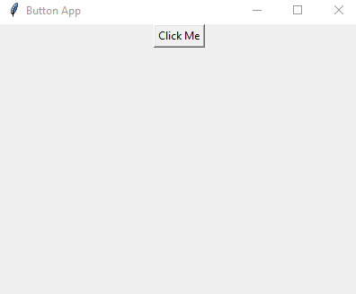

Exercise 6 – Button with Action
Goal: Make the button react when clicked.

Code:

import tkinter as tk
from tkinter import messagebox

def say_hello():
messagebox.showinfo("Hi", "You clicked the button ■")

window = tk.Tk() window.title("Smart Button") window.geometry("400x300")

button = tk.Button(window, text="Click Me", command=say_hello) button.pack()

window.mainloop()

The command option links a button to a function. This is how interaction works in GUIs.
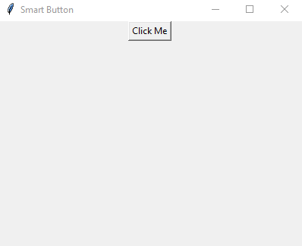

Mini Challenges
- Change the text on the button
- Modify the window size
- Add a second button to close the application

What Comes Next
- Colors and visual styling
- Using variables (counters, scores)
- if statements for decisions
- Better layouts (grid, place)
- Small projects: calculator, login screen, simple games

