# **Overview**

This section should give a basic overview of the project and the team(s) behind it. An overview should include:

* **About your team**

1. Minara Akhsam, 201834, 201834@astanait.edu.kz –CSS, HTML
2. Yerkezhan Ryskhanova, 201306, [201306@astanait.edu.kz](mailto:201306@astanait.edu.kz) –HTML, documentation
3. Aruzhan Konay, 201811, [201811@astanait.edu.kz](mailto:201811@astanait.edu.kz) - Express
4. Makhambet Galymov, 201263 , [201263@astanait.edu.kz](mailto:201263@astanait.edu.kz) -Bootstrap
5. Arailym Bakenova, 201184, [201184@astanait.edu.kz](mailto:201184@astanait.edu.kz) -JavaScript
   * **Communication strategy**
6. The first brainstorming and planning of the project, in general, was on Monday via Whatsapp
7. After distributing responsibilities, we checked the whole progress of each member using the Diskord platform
8. The final call was conducted on Teams where we discussed the last details of the project

* **Motivation** – The main aim of creating this project is to make the calculation of the football matches’ results easier and more clear
* **High-level project scope** – It is a brand-new website because it was created from the scratch, however some ideas of creating the table and navigation bar were taken from the previous projects
* **Target audience/market** – The main audience of our website is people who are interested and in football and the system of its calculation work

# **Project goals and team interests**

Project goals

* Draw attention and people’s interest in the football goal counting system
* Facilitate the work of counting goals in football matches
* Introduce people to the new football team

Team interests

* Understand HTML tags and CSS by building football goal counting system website
* Establish a solid understanding of website design principles, likewise enhance our JavaScript and Express skills and knowledge
* Improve team working skills by collaborating with different members of the group

# **Phases**

* Phase 1 – Basic football goal counting system website with HTML and CSS
* Phase 2 – Add styles and JavaScript in order to make the website work properly
* Phase 3 – Finish the whole project by adding the last elements of JavaScript and Express

# **Content structure**

**Site map**

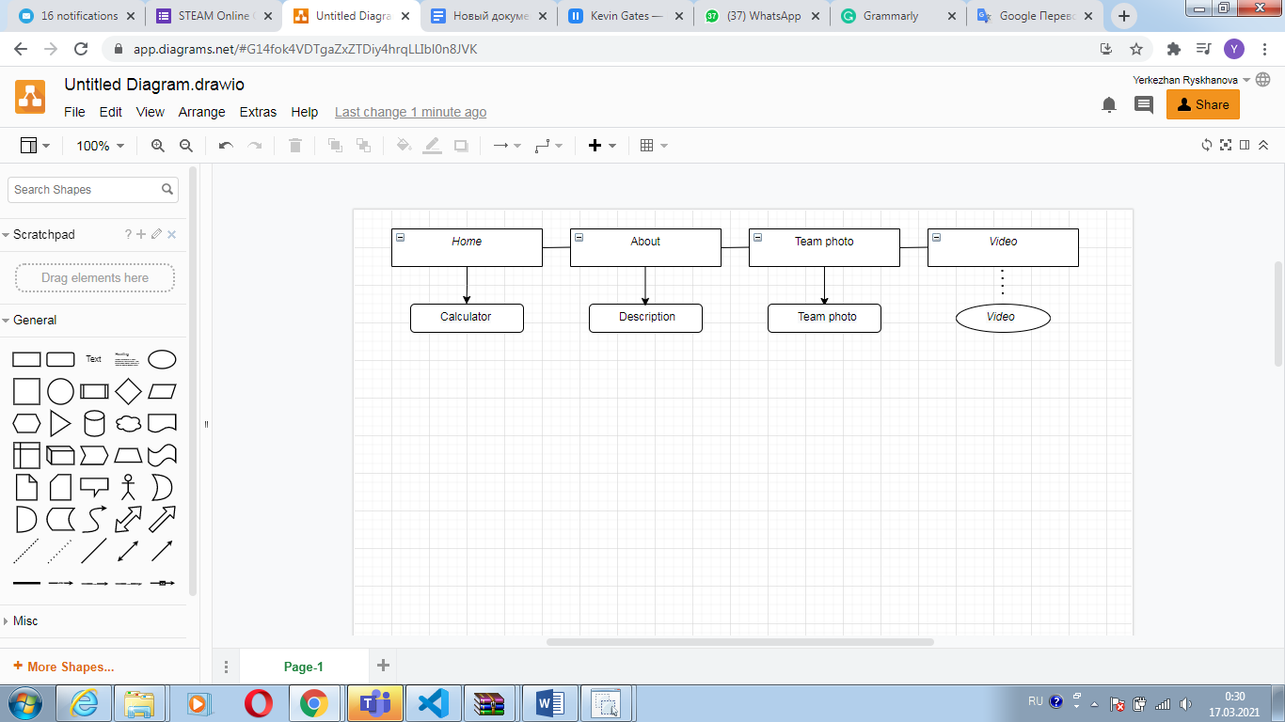

**Content types**

* Home
* About
* Team photo
* Events

**Design**

* Reference links
* Image files
* Sketch files

Style guide and/or annotations for information such as:

* colours
* typography rules
* hover states
* animations
* grid systems
* spacing

**Functionality**

Our website has three pages, namely “Home”, “About”, “Our team”. The Home page represents the calculator and its fields, furthermore, it is also able to calculate the final results of the football matches. Following, by clicking “About”, we can see the second page that illustrates the team photo and a short description of the new football team. Likewise, clicking “Our team” shows us the full image of our team members. Moreover, clicking on “Video” brings us to a Youtube video with the fascinating video of the most unbelievable goals in football history.

**Hosting**

1. Log in to the Github page
2. Create new repository
3. Upload all the HTML, JavaScript, etc documents
4. Copy the link after successful uploading
5. Submit the link on Moodle

**Accessibility**

Taking into consideration the website’s accessibility, we decided to use a more readable font so everyone would be able to read the text without a hitch. Likewise, we worked on the content meticulously, so it well-organized and very easy to use. The design of our website is clean and simple.

**Deadlines**

* Phase 1 – March 15, 19:00- brainstorming, the project planning, responsibilities distribution
* Phase 2 – March 16, 18:00 - Checking on the progress of every team member
* Phase 3 – March 17, 10:00 – Discussion of the last details of the project and defense likewise

# **Summary**

* Subsequently, we have achieved all our project goals, thanks to our teamwork and well-enhanced time management. Moreover, our project matches all the requirements. The website also fulfills our team interests, because we enhanced our HTML, CSS, Bootstrap, JavaScript, and Express skills. Established a solid understanding of website design principles and strengthened relationships among team members.
* We have faced several difficulties throughout the process because within several hours we tried to merge our pages together. Besides, it was difficult to work and communicate with each other because of miscommunication and final exams, which lead to not being able to co-work efficiently.
* According to the academic part, we have gathered all our knowledge from the whole course by using HTML, CSS, Bootstrap, and JavaScript with NodeJs likewise. Especially strengthened our knowledge in Express and NodeJs.